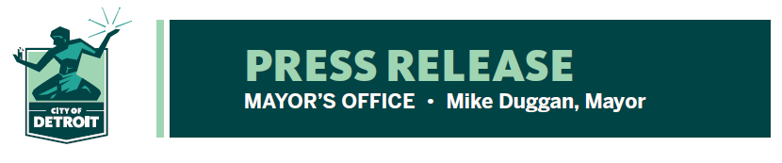

FOR RELEASE: February 16, 2022
MEDIA CONTACT: Barb Roethler: (313) 400-7107
barbara.roethler@detroitmi.gov
Margaret Carroll: (313) 300-3152
margaret.carroll@detroitmi.gov

KN-95 Mask Distribution Drive-Thru Locations
Thursday, February 17th, 2 PM – 6 PM

- Up to 10 masks per adult, per vehicle
- Masks are adult size only
- Drive-through at designated rec centers and Eastern Market-Shed 3, and to residents receiving vaccinations or tests at Health Department immunization and test sites
- Bulk supplies sent to businesses, shelters, nursing homes and senior living facilities
The Detroit Health Department will distribute free KN-95 masks to Detroiters from 2 PM – 6 PM on Thursday, February 17th in drive-through locations at designated Recreation Centers and Eastern Market – Shed 3. Up to 10 masks per adult in each vehicle will be distributed in the following locations:

Eastern Market Shed 3 2934 Russell Street
Adams Butzel Complex 10500 Lyndon
Butzel Family Center 7737 Kercheval
Farwell Recreation Center 2711 East Outer Drive
Kemeny Recreation Center 2260 S. Fort
Lasky Recreation Center 13200 Fenelon
Patton Recreation Center 2301 Woodmere
Samaritan Center 5555 Conner Street

Free KN-95 masks will also be distributed to patients when receiving their COVID-19 vaccination or tests.

The Detroit Health Department is providing businesses and community organizations, including nursing homes, senior housing and homeless shelters across the city with a supply of KN-95 masks while supplies last. All of the KN-95 masks are sized for adults only.

“We are urging all Detroiters to wear a KN-95 mask when they are out in public and continue to observe all safety protocols in order to protect against the spread of COVID-19,” said Chief Public Health Officer Denise Fair Razo. “We also encourage you to get vaccinated and get your booster. The vaccines are safe, effective and remain the most important tool we have to help us get back to normal.”

Free KN-95 masks have been made available throughout Michigan as part of the state’s Mask Up, Mask Right campaign.

Full details, including updates on closures due to inclement weather, can be found at: www.detroitmi.gov/health.

# # #

