MDHHS issues quarantine guidance for asymptomatic students
Prevention measures, including universal masking, reduce COVID-19 transmission and days away from school due to quarantine
FOR IMMEDIATE RELEASE
Sept. 8, 2021
Contact: Lynn Sutfin, 517-241-2112
LANSING, Mich. - To help ensure Michigan students and educators are as safe as possible in the classroom and keep students in school for in-person learning, the Michigan Department of Health and Human Services (MDHHS) has issued updated quarantine guidance.
"When layered prevention strategies such as masking, distancing, testing, isolation and quarantine are applied consistently, school-associated transmission of COVID-19 is significantly reduced - which keeps kids in the classroom so they can learn," said Elizabeth Hertel, MDHHS director. "However, if someone is exposed to COVID at schools, it's important for them to follow quarantine guidance to prevent spread to other children."
MDHHS recommends local health departments and schools work together to quickly isolate COVID-19 cases among students and staff, identify close contacts of those cases and adopt quarantine policies that reduce the risk of transmission in schools while allowing in-person learning. When evidence-based prevention measures, including universal masking, are in place, modifications may be made to the 10- to 14-day at-home quarantine.
"The best protection against COVID-19 are the three safe and effective vaccines we have available, and we urge all eligible Michiganders to get vaccinated," said Dr. Joneigh Khaldun, chief medical executive and chief deputy for health. "As many of our students are too young to be vaccinated, masks are an important tool to prevent the spread of the virus and allow for in-person learning to continue uninterrupted."
School quarantine guidance for asymptomatic students who were exposed to a student infected with COVID-19 varies depending on a variety of circumstances. In all cases, the student who has tested positive for COVID-19 should isolate and follow directions from their local health department. Any individual that displays COVID-19 symptoms, regardless of vaccination status, should be tested and isolate as directed.
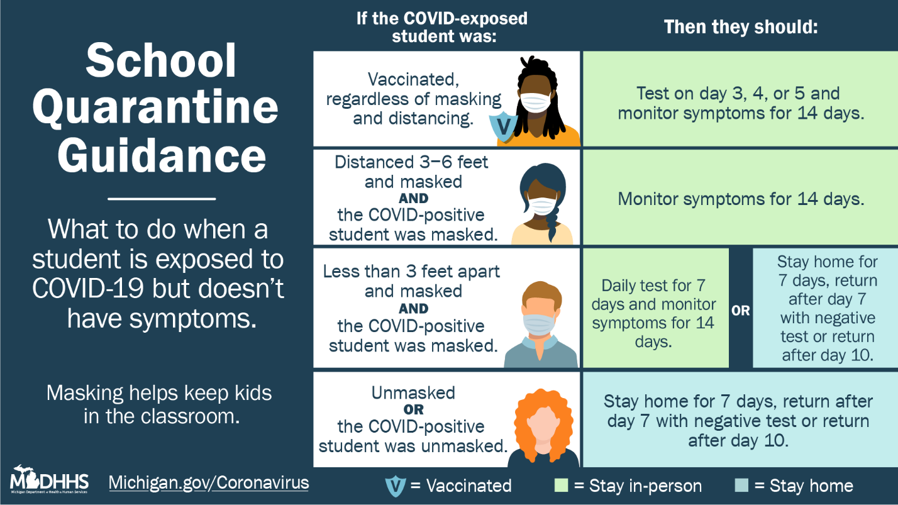
Under the new guidance, a student exposed to COVID-19 can remain in school under the following scenarios:
- A fully vaccinated student (regardless of whether they wore a mask) who came in close contact with a COVID-positive student. The exposed student can remain in school if they wear a mask and monitor symptoms for 14 days after their exposure. They should test for COVID-19 three to five days after their last exposure to the COVID-positive student. If the exposed student tests positive, then the student should isolate and follow directions from their local health department.
- An unvaccinated student who was masked and exposed to a COVID-positive student who was also masked in an indoor school setting, so long as the students remained at least three to six feet apart. The exposed student can remain in school if they wear a mask, but they should monitor symptoms for 14 days following the exposure.
- An unvaccinated student who was masked and exposed to a COVID-positive student who was also masked in an indoor school setting, but the students were less than three feet apart and the student tests daily.
  - The exposed student can remain in school if they wear a mask. They should monitor symptoms for 14 days and test daily before coming into the school building for the seven days following the exposure. They should continue to monitor for symptoms for a total of 14 days following the exposure.
  - The exposed student should work with their school district and local health department to determine options available for daily testing. If the student cannot complete daily testing for seven days following the exposure, the student should not remain in school and should follow the guidance below.
An unvaccinated student exposed to COVID-19 should not remain in school under the following scenarios:
- If the exposed or COVID-positive student, or both were not wearing a mask. Unvaccinated students who are unmasked are more likely to become ill because they are more likely to have been exposed to larger amounts of virus.
  - The exposed student should not remain in school, and instead the student should quarantine at home for 10 days following the exposure.
    - They may return after day 10 if they have not had any symptoms during those 10 days. They should continue to monitor for symptoms for a total of 14 days following the exposure.
    - The student may return after day seven if they test negative that day and do not have symptoms. They should continue to monitor for symptoms for a total of 14 days following the exposure.
- A student who was masked and exposed to a COVID-positive student who was also masked in an indoor school setting, but the students were less than three feet apart and the student does not test daily.
MDHHS is providing schools antigen testing supplies free of charge through the MI Safe Schools Testing program. Schools and individual school districts can request antigen test kits through the Mi Safer Schools: School Antigen COVID Test Ordering form. MDHHS will be leveraging our partnership with Intermediate School Districts to help distribute COVID-19 antigen tests based on the orders placed in the School Antigen COVID Test Ordering Form. Questions about test supply orders can be sent to your Intermediate School District and any other school testing related questions can be sent directly to MDHHS at MDHHS-COVIDtestingsupport@michigan.gov
To learn more about the COVID-19 vaccine, visit Michigan.gov/COVIDVaccine.
For more information about COVID-19 in Michigan, visit Michigan.gov/coronavirus.

