Airport Department
Daily Screening Policy & Safe Workplace Protocol
POLICY
All individuals arriving at the Coleman A. Young International Airport (KDET) must submit to a COVID-19 Coronavirus health screening, prior to entry. Workplace practices must be in place to minimize the risk of transmitting the virus.
DURATION
This Policy will be in effect until further notice.
PROCEDURE OVERVIEW
This document describes requirements applicable to all Airport facilities. Site-specific plans for meeting these requirements are in separate documents for each site, listed in the IMPACTED FACILITIES AND RELATED DOCUMENTS section.
- All procedures outlined below are required, without exception: First and foremost, ANYONE experiencing COVID-19 related symptoms (i.e. fever, sustained cough, shortness of breath), has been exposed to someone that is exhibiting symptoms, or has tested positive, SHOULD NOT attempt to enter any Airport facility. As this relates to employees, whether or not they are scheduled to work, they should NOT report to work and should contact HR (Maria Young, 313-378-7795) and/or their supervisor by telephone or email, immediately. Airport Management will schedule a COVID-19 test for the employee. Employees should “Stay at home” and self-isolate to minimize the potential spread to others. Should your health conditions worsen, please consult a physician ASAP.
- For whomever Step # 1 DOES NOT apply, when entering an Airport facility, individuals must enter through a designated, clearly marked, entrance. Other entrances must be secured to prevent entry. Unless it is cold out, remove hats or other head coverings prior to arrival, as they can affect the temperature readings.
- Each entrance will have a staging area, where individuals will be required to wait patiently, a minimum of 6 feet apart, until prompted to proceed to the next stage of the screening process.
- In the event that individuals arrive by other means (i.e. bicycle, motorcycle, on foot, or aircraft), they will be required to follow the procedures as specified in Step #2, above.
- In the event that large groups of individuals arrive at the same time, they will be required to wait either outside the facility, in an organized manner, a minimum of 6 feet apart, or in their transport vehicles, including aircraft, until instructed to enter the facility as specified in Step # 2, above.
- As part of the screening process, individuals will be asked if they have either tested negative or positive for COVID-1; are experiencing COVID-19 related symptoms; or know of having been in close contact with anyone exhibiting such symptoms. This screening will be sufficiently private that responses to questions cannot be overheard by others. For employees and contractors, proof of a negative test is required before returning to work.
- Also, as part of the screening process, individuals will be checked for a fever with an FDA approved thermometer.
NOTE: All new infrared thermometers must be checked against an oral thermometer and the observed difference permanently recorded. Each one is unique. This difference (if any) must be taken into account when determining an individual’s actual temperature.
NOTE: A fever temperature is defined as 100.5 degrees Fahrenheit (actual). If the temperature is at or above that threshold, recheck after 5 minutes of rest. If the second reading is below the threshold, the individual will be considered fever-free.
- Individuals pass the screening if they answer “No” to all questions and do not have a fever, as defined in #7 above. They will receive a “COVID-19 Screening Pass” that is good at all Airport sites for that day.
- Individuals who do not pass the screening cannot enter the facility. If someone appears to need an immediate medical assessment or appears unstable, call 911. Otherwise, in the case of an employee who does not pass:
- The employee will be sent home and Human Resources will be notified.
- Airport management will schedule a COVID-19 test for the employee.
- If the employee tests positive, Human Resources will contact them to determine if they qualify for the Families First Coronavirus Response Act (FFCRA).

In the case of a non-employee who does not pass:
- It will be suggested that they go home and contact their healthcare professional.
- If it is a contractor, their employer will be notified, and the employer can then request a COVID-19 test for the employee.
NOTE: In compliance with the ADA and HIPPA, all health information must remain confidential.
- Any employee who has been sent home due to exposure or to the results of the screening should self-isolate and follow the medical advice of their healthcare provider. Employees should contact HR to schedule another test when these conditions are true:
- You have had no fever for at least 72 hours (that is 3 full days of no fever without the use of medicine that reduces fevers); AND
- Your other symptoms have improved (e.g. your cough or shortness of breath have improved); AND
- At least 7 days have passed since your symptoms first appeared.
If the test is negative, HR will communicate a return-to-work date.

Key points of this procedure for employees are summarized in the following diagram:
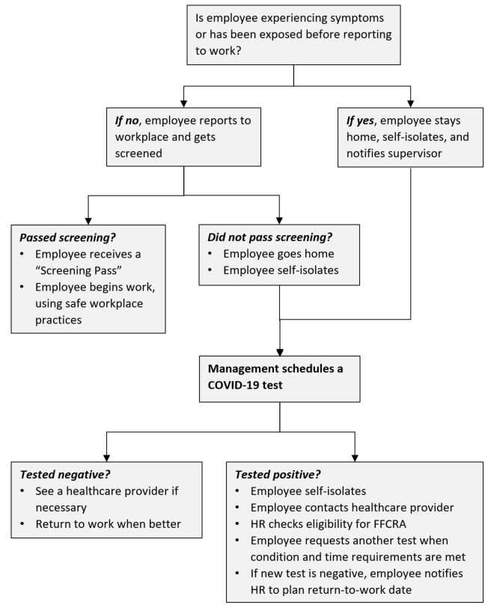

WORKPLACE PRACTICES
Passing the screening or test is only meaningful at the time the screening or test is conducted. You could still become contagious or symptomatic afterward.
Six foot social distancing practices must be followed in all airport facilities whenever possible. Masks are REQUIRED, and will be provided if available, when riding with others in vehicles, in confined spaces, common areas, or any time that reliably practicing social distancing is not possible.
All high-touch or high-traffic surfaces such as doorknobs, railings, frequently used drawer handles, and instrument/appliance controls should be sanitized every 2 hours.
Site-specific practices are defined in Site Plans for each site (see table at end of this document).
The latest information on preventing infection and transmission is available at https://www.cdc.gov/coronavirus/2019-ncov/prevent-getting-sick/prevention.html.
RESPONSE TO KNOWN OR SUSPECTED EXPOSURE
In the event that an employee self-reports that they have come into contact (immediate proximity for 10 minutes or more) with someone who has a presumptive positive case of COVID-19, they themselves will be considered to be a confirmed case. Therefore, for purposes of not potentially infecting others, HR will be required to communicate with all individuals known to have come into contact with said employee.
In the event that an employee has been exposed to the virus by virtue of exposure to coworkers, suppliers, or customers, the same precautions noted above will be taken.

JUSTIFICATION
The Equal Employment Opportunity Commission (EEOC) has recently confirmed that during the COVID-19 pandemic, employers can do the following without violating the provisions of the Americans with Disabilities Act (ADA) or the Rehabilitation Act:
- Ask employees if they are experiencing symptoms of COVID-19, provided that the information is maintained as a confidential medical record;
- Take employees’ body temperature;
- Instruct employees who exhibit COVID-19 related symptoms to either stay home or leave work;
- Require employees returning to work to provide a doctor’s note stating they are cleared to return.
In light of this guidance, the Airport Department is implementing this Policy to protect our staff, our suppliers, and our customers.

Emergency Supplies Coordinator
Denise Vaughn has been made the emergency supplies coordinator to effectively allocate and distribute PPE and sanitization supplies to all employees.

For all Emergency Supplies please Contact:

Denise Vaughn
Office Manager
Work Phone: (313) 628-2144
Cell: (313) 402-4556

A. This Emergency Supplies Coordinator will be responsible for:
- 1) Identifying the supply needs for their entire department
- 2) Submitting unified department orders for supplies to the centralized emergency supplies warehouse via a smartsheet form.
- 3) Coordinating the pickup of supplies from the emergency warehouse
- 4) Overseeing the distribution of supplies within their department once it has been received
- 5) Monitoring their entire department for supply & PPE needs
B. Supply Notification Plan
Denise is available 24 hours a day via phone at (313) 402-4556 to ensure all staff are able to perform their duties safely.

Employees should notify Ms. Vaughn when Airport Department stockpiles are 25% from being empty.

25% = 125 Masks
25% = 150 gloves
25% = 3 Stations for hand sanitizer
25% = 1 Thermometer
25% = Batteries as needed

C. Supply Distribution Plan
All emergency supplies will be distributed by City of Detroit Airport Operations Personnel upon request or when the 25% thresholds are met.

D.PPE & Supply Estimates
Using the PPE best practices outlined in Section V of these policies as a foundation, departments should track PPE and sanitation supplies, by job category, per week. These estimates will be reviewed by Chief Medical Consultant Robert Dunne to ensure it meets the appropriate standards and requirements. Please refer to checklist.

Work-Site and Vehicle Cleaning

Sanitation and Disinfection
All high-touch or high-traffic surface—such as doorknobs, railings, frequently used drawer handles, and instrument/appliance controls—are sanitized at least every two hours. A checklist for cleaning staff is posted.

Disinfectant wipes are used to clean commonly used surfaces every two hours (e.g. phones, keyboards, desks, etc.). For keyboards and other commonly used electronics, the devices are powered off and cleaned with a disinfectant wipe that is bleach-free and not overly damp. Employees working within vehicles should use disinfectant wipes on commonly used surfaces (gear shifter, steering wheel) before and after every shift.

The cleaning steps outlined below are taken routinely, based on frequency mentioned to disinfect workplace surfaces, chairs, tables, etc. and protect employees.

Area/Place Disinfection
Common surfaces (including control buttons, tools, and other common surfaces): Use hospital-grade disinfectant or fresh 10% chlorine bleach solution (sodium hypochlorite). Spray with hand held sprayer or wipe Minimum at the end of each shift.

Offices, desk, and conference rooms: Table and chair surfaces are sprayed with hand held sprayer or wipe at the end of each meeting and end of day.

General Objects often used and touched: Doors and windows, handles, faucets, sinks, and bathrooms will be sprayed with handheld spray or wipe at least four times per day.

Cafeteria/Vending Machines: Table and chair surfaces, dispensers and vending machines will be sprayed 3 or more times per shift to include after all breaks and meals.

Forklifts: Wipe area of common human interaction after each use.
Transport Vehicles: Common surfaces (e.g. seat surfaces, rails, seatbelts, door and window controls) will be sprayed and wiped down before and after each use.

All Floors and Walls: All general floors and walls at the airport will be frequently mopped throughout each day. Common areas will be mopped more frequently.

APPENDIX I

PPE & Supply Estimates

# Item Spec Quantity

1. Mask (surgical/N95) Disposable surgical/N-95 masks Min. 30-day supply | Min. 30-day supply  10 Boxes
2. Nitrile gloves Touchflex/ Surgical Nitrile Gloves Min. 30-day supply | Min. 30-day supply  1 Box XL, 5 Large, 5 Medium
3. Infrared thermometer Medical infrared thermometer/ Measures ranges 32°C to 42.5°C meets ASTM E965-1998 (2003) 2 per entry point | Min. 30-day supply  4
4. Disinfectant spray/wipes 10% bleach (sodium hypochlorite) solution made fresh daily, or a hospital-grade disinfectant (refer to approved disinfectant listing) Min. 30-day supply | Min. 30-day supply  1 Case of Disinfectant Spray  1 Case of Wipes
5. Hand sanitizer (refills) Sanitizer with Alcohol 70%/Local Brand “Sanitizer” Min. 30-day supply | Min. 30-day supply  1 Case
6. Hand soap Hand soap Min. 30-day supply | Min. 30-day supply  1 Case
7. Eye protection Shields or goggles Min. 30 day supply | Min. 30-day supply  Set of 20

APPENDIX II

COVID-19 Questions

Have you been around anyone with or exposed to the Corona Virus?

Can I take your temperature?

Have you been tested for the corona virus, and do you have the results with you?

Have you had a fever in the last week or any other symptoms related to the Corona Virus?
Examples: Fever, nausea, headache, dry cough, aches and pains or shortness of breath

Do you have a face covering/mask?

Are you going to any City of Detroit buildings or facilities while you are here in the City?
If yes/ Answer: Please understand that the while in the City of Detroit, you may have to answer these questions many times. We appreciate your understanding but want to prepare you before you run into any frustrating situations as we are only trying to protect you and our citizens from the virus.

Thank you for your understanding and we hope that your visit to our City is enjoyable.

