COVID-19 GSD Daily Screening Policy
Applies to all GSD Facilities

POLICY
All individuals arriving at a GSD facility must submit to a COVID-19 Coronavirus health screening prior to entry. Workplace practices must be in place to minimize the risk of transmitting the virus.
DURATION
This Policy will be in effect until further notice.
RELATED DOCUMENTS
- This document describes the GSD implementation of City-wide policies and procedures defined in City of Detroit Covid-19 Safe Workplace Standards.
- GSD site-specific policies and procedures are defined in Site Plans for each site, listed in the IMPACTED FACILITIES AND RELATED DOCUMENTS section below.
PROCEDURE OVERVIEW
All procedures outlined below are required, without exception:
- First and foremost, ANYONE who (a) is experiencing COVID-19 related symptoms (i.e. fever, sustained cough, shortness of breath); (b) has been exposed to someone that is exhibiting symptoms, or (c) has tested positive for COVID-19, SHOULD NOT attempt to enter any GSD facility.
- Entry to GSD facilities will be through a single designated, clearly marked entrance. Other entrances must be secured to prevent their use.
- Each entrance will have a staging area, where individuals will be required to wait patiently, a minimum of 6 feet apart, until prompted to proceed to the next stage of the screening process.
NOTE: If required, screenings can and will be conducted at a nearby facility and/or on the exterior of the facility, or at car-side; requiring individuals with vehicles to remain in them for the duration of the screening process.
- In the event that large groups of individuals arrive at the same time, they will be required to wait either outside the facility, in an organized manner, a minimum of 6 feet apart, or in their transport vehicles, until instructed to enter the facility.
- The screening process will consist of questions related to COVID-19 symptoms and testing, and a temperature check. This screening will be sufficiently private that responses to questions cannot be overheard by others.
NOTE: External factors such as outside air temperature, hats, smoking, or drinking hot/cold beverages can influence the accuracy of the temperature reading. Avoid these during the 5 minutes prior to the screening.
NOTE: All new infrared thermometers must be checked against an oral thermometer and the observed difference permanently recorded. Each one is unique. This difference (if any) must be taken into account when determining an individual’s actual temperature.
NOTE: A fever temperature is defined as 100.5 degrees Fahrenheit (actual). If the temperature is at or above that threshold, recheck after 5 minutes of rest. If the second reading is below the threshold, the individual will be considered fever-free.
- Individuals pass the screening if they answer “No” to all questions and do not have a fever. They will receive a “COVID-19 Screening Pass” that is good at all GSD sites for that day.
- Individuals who do not pass the screening cannot enter the facility. If someone appears to need an immediate medical assessment or appears unstable, call 911. Otherwise, in the case of an employee who does not pass:
- The employee will be sent home and Human Resources will be notified.
- GSD management will schedule a COVID-19 test for the employee.
- If the employee tests positive, Human Resources will contact them to determine if they qualify for the Families First Coronavirus Response Act (FFCRA).
In the case of a non-employee who does not pass:
- It will be suggested that they go home and contact their healthcare professional.
- If the non-employee is a contractor, their employer will be notified, and the employer can then request a COVID-19 test for the employee.
NOTE: In compliance with the ADA and HIPAA, all health information must remain confidential.
- Any employee who has been sent home due to exposure, or due to the results of the screening, should self-isolate and follow the medical advice of their healthcare provider. Employees should contact HR to request another COVID-19 test when they meet the return-to-work conditions described in City of Detroit Covid-19 Safe Workplace Standards. If the test is negative, HR will communicate a return-to-work date.

Key points of this procedure as it pertains to employees are summarized here:
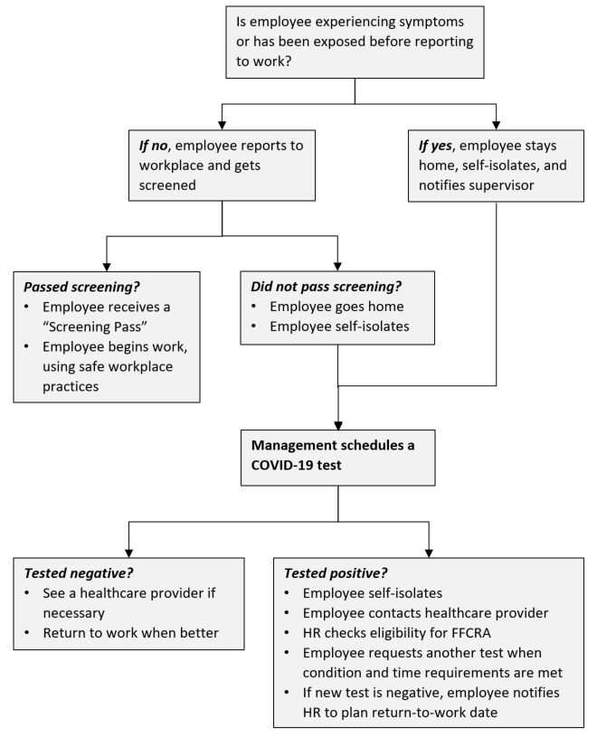
WORKPLACE PRACTICES
Passing the screening or test is only meaningful at the time the screening or test is conducted. You could still become contagious or symptomatic afterward.
Six foot social distancing practices must be followed in the workplace whenever possible. Masks are REQUIRED for GSD employees when in confined spaces or common areas, when riding with others in vehicles, or at any time that reliably practicing social distancing is not possible. Eye protection is REQUIRED for GSD employees whenever they are interacting with other workers or members of the public, or are driving in a vehicle with another person in the passenger seat.
See City of Detroit Covid-19 Safe Workplace Standards for additional guidelines and requirements related to safe workplace practices.

IMPACTED FACILITIES AND RELATED DOCUMENTS
SITE | CONTACT | DOCUMENT NAME
Huber | Crystal Perkins | COVID-19 Site Plan – Huber
Russell-Ferry | Marcus Poe | COVID-19 Site Plan – Russell-Ferry Garage
SMG Michigan & 19th | George Cotton | (Closed)
Fire Apparatus | James Donovan | COVID-19 Site Plan – Fire App Garage
Davison Garage | Marty Guinn | COVID-19 Site Plan – Davison Garage
Davison Office & Grounds Team | Rosemary Edwards | COVID-19 Site Plan – Davison Office and Grounds Team
Southfield Yard | Jay Biernat | COVID-19 Site Plan – Southfield Yard
Rouge Park Yard | Rosemary Edwards | COVID-19 Site Plan – Rouge Park Yard
Grounds Satellite Locations | Rosemary Edwards | COVID-19 Site Plan – Grounds Satellites
Belle Isle Greenhouse | Tim Karl | COVID-19 Site Plan – Greenhouse
Chandler Park Yard | David Sumners | COVID-19 Site Plan – Chandler Park Yard
Recreation Centers  Adams Butzel  Butzel Family  Clemente  Coleman Young  Crowell  Farwell  Heilmann  Kemeny  Lasky  Patton  Williams | Ricardo Marble | COVID-19 Site Plan – RC [rec center name]
GSD HQ (115 Erskine) | Jamal Harrison | COVID-19 Site Plan – GSD HQ

