STAFF REPORT: 09/10/2025 MEETING PREPARED BY: J. ROSS

ADDRESS: 2894-2900 E. GRAND BOULEVARD
APPLICATION NO: HDC2025-
HISTORIC DISTRICT: JAM HANDY/NORTH END-EAST GRAND BOULEVARD
APPLICANT/OWNER:
DATE OF STAFF SITE VISIT:
DATE OF PROVISIONALLY COMPLETE APPLICATION:

SCOPE:

EXISTING CONDITIONS
The current project includes the following three buildings located within the Jam Handy/North End-East Grand Boulevard Historic District:

2894 E Grand Boulevard
The building located at 2894 E Grand Boulevard is a one-story masonry structure that was erected to serve as a recording studio for the Jam Handy Organization in 1965. The building featur

PROPOSAL
- With the current submission, the applicant is seeking the Commission’s approval to replace the historic clay tile roof at both the house and garage with new clay tile roofing. Flashing will be copper. As previously noted, the applicant has initiated the removal of the existing roofing at the house without HDC approval and/or permit.
- Staff notes that the submitted HDC Application for Work Approval form (section 4, entitled “Detailed Scope of Work”) which is dated 6/12/2025 does state that the new roof would be either high-quality asphalt shingles or clay tile (if affordable) and that the dormers would be clad with cedar, tile, or a composite material. However, in subsequent email correspondence from the applicants dated 6/27/2025, they revised their application to note that they “…have decided to submit only the Ludowici Classic 14 tiles in Brookfield Green with matching flat slab tiles for the dormers. We are removing any materials previously submitted for asphalt shingles.” Mail - Jennifer Ross - Outlook

STAFF OBSERVATIONS AND RESEARCH
- The Boston-Edison Historic District was designated in 1973
- On 4/30/2025, HDC staff was made aware that the applicant was in the process of removing the current roofing system. A review of files maintained by the HDC and the Detroit Building Safety Engineering and Environmental Department (BSEED) revealed that a COA had not been issued for the work. BSEED therefore issued a stop work order and directed the property owner to contact HDC staff so that they might address the violation.
- Please see the below photos, which depict conditions prior to and after the unapproved removal of the roofing removal.

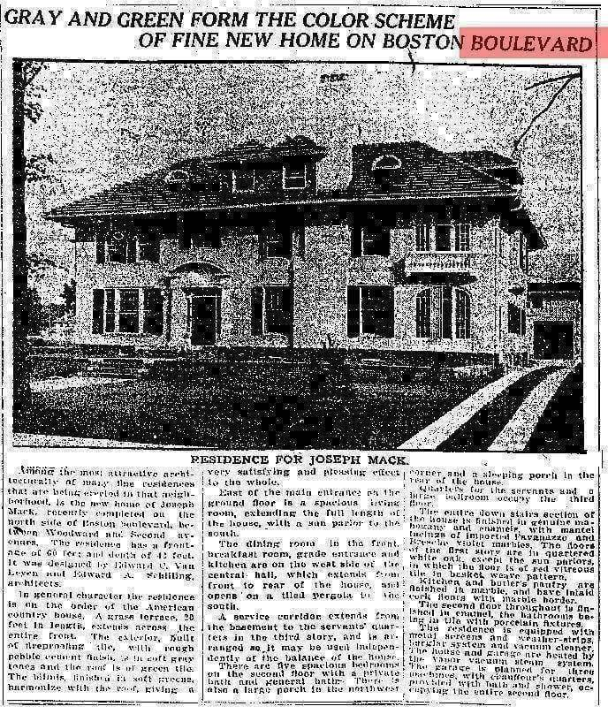
Detroit Free Press, 1912

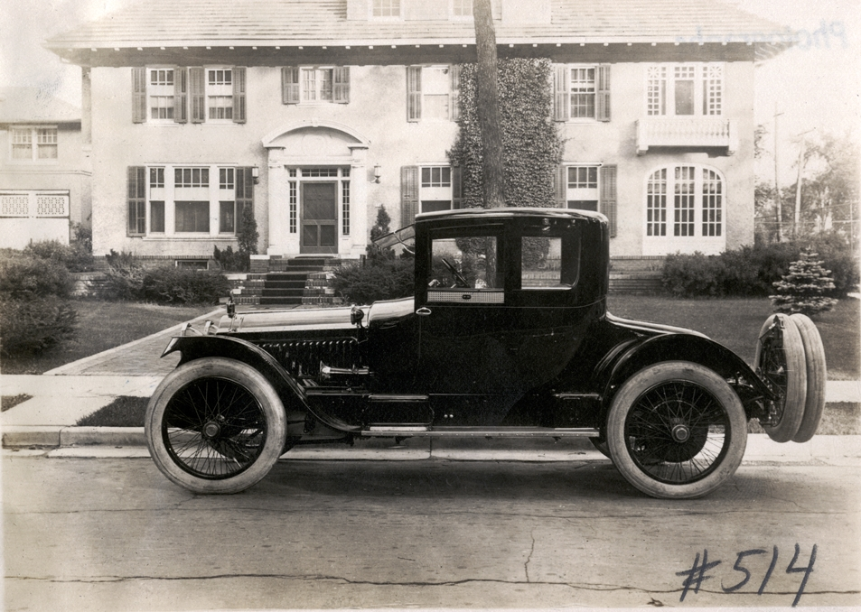
National Automotive Historic collection, ca. 1916

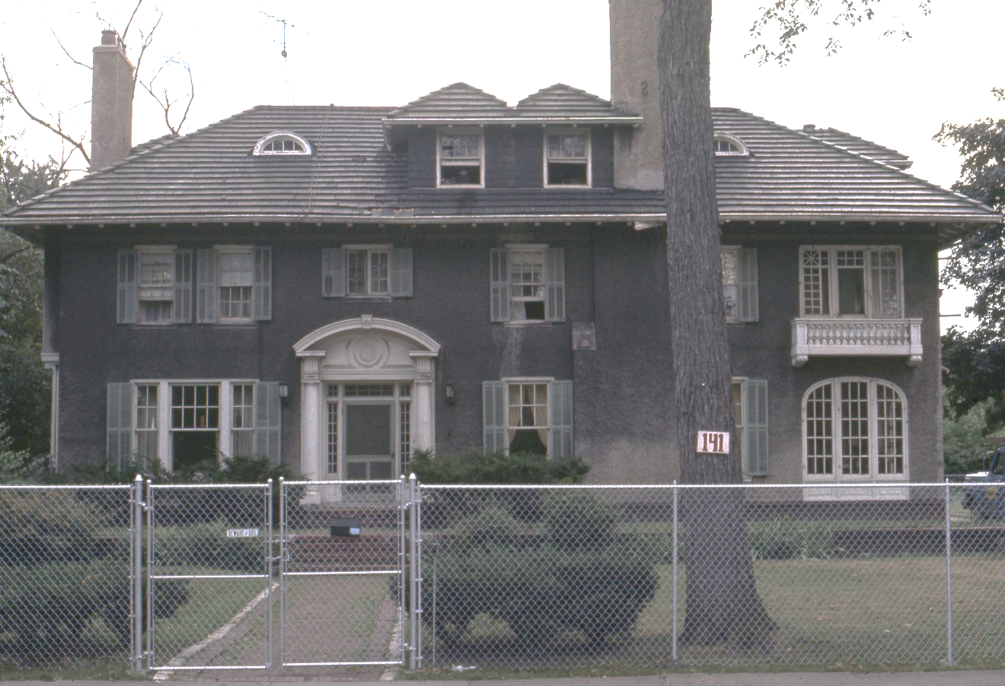
141 W. Boston. Condition at time of the district’s designation/in 1974. Photo by HDAB

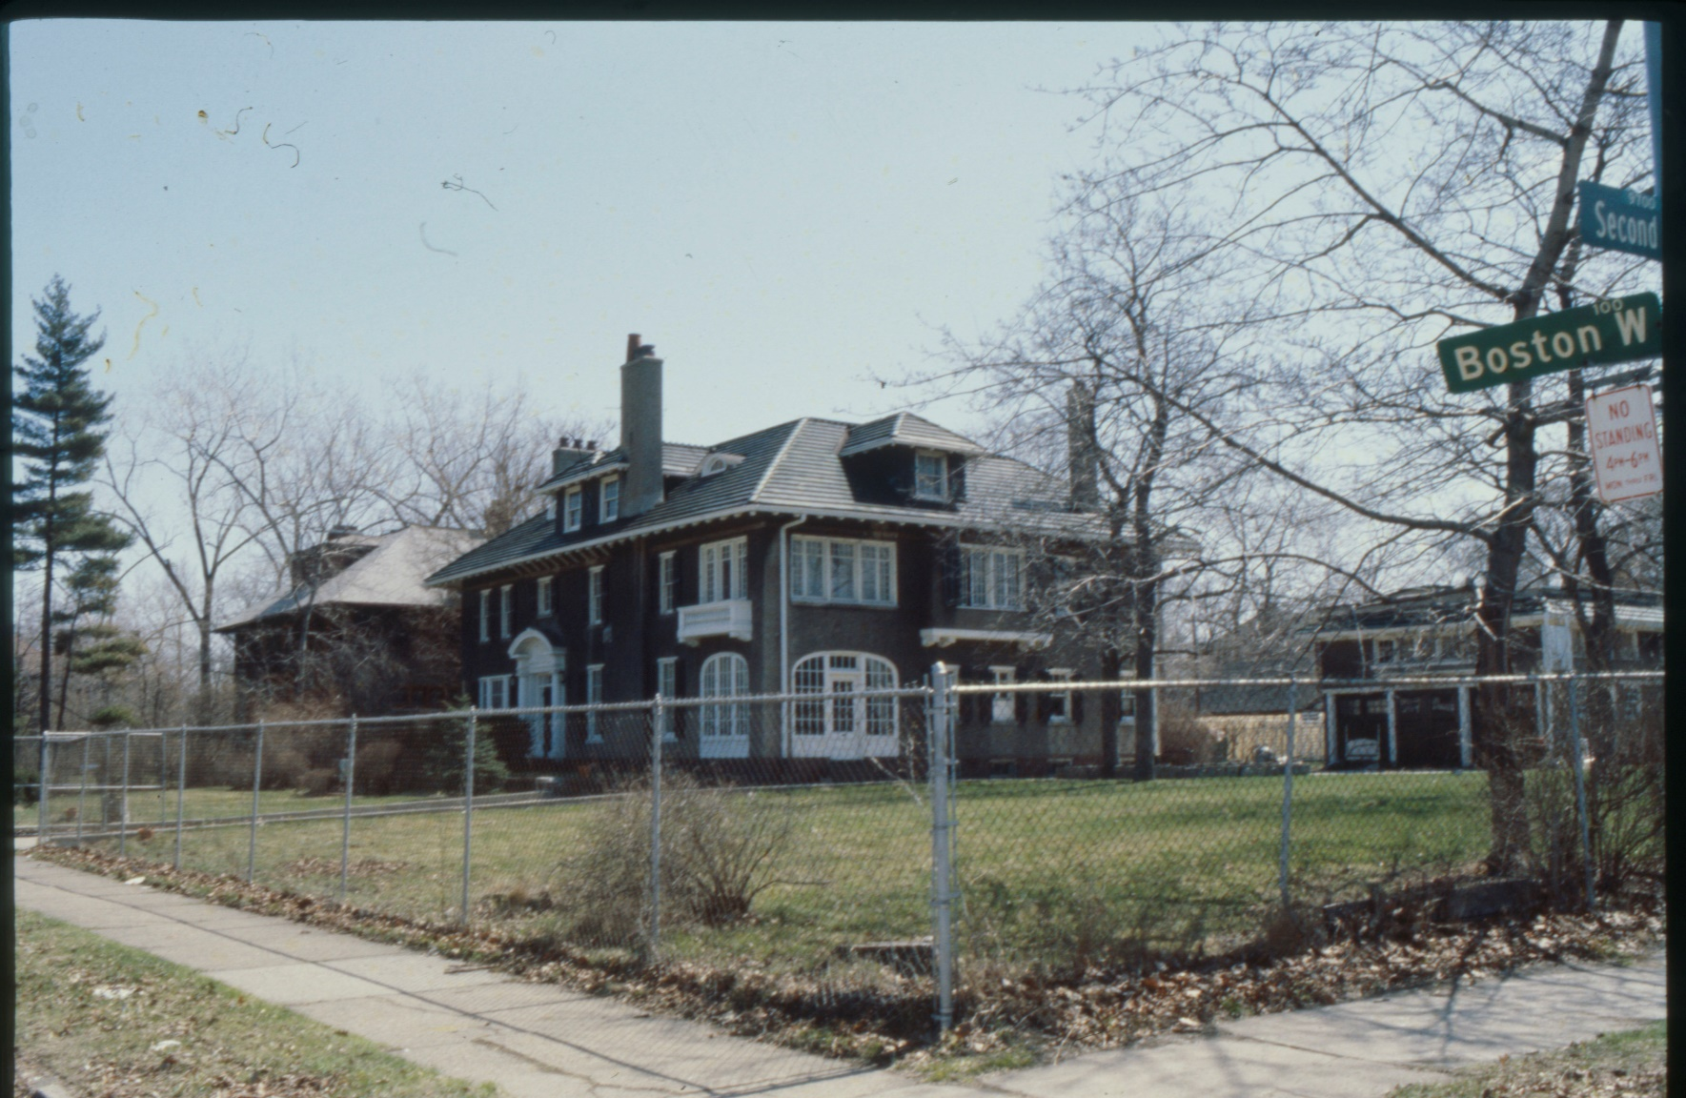
141 W. Boston. Photo taken in 1982 by HDC staff. Showing condition of the roof and the garage/carriage house to the rear

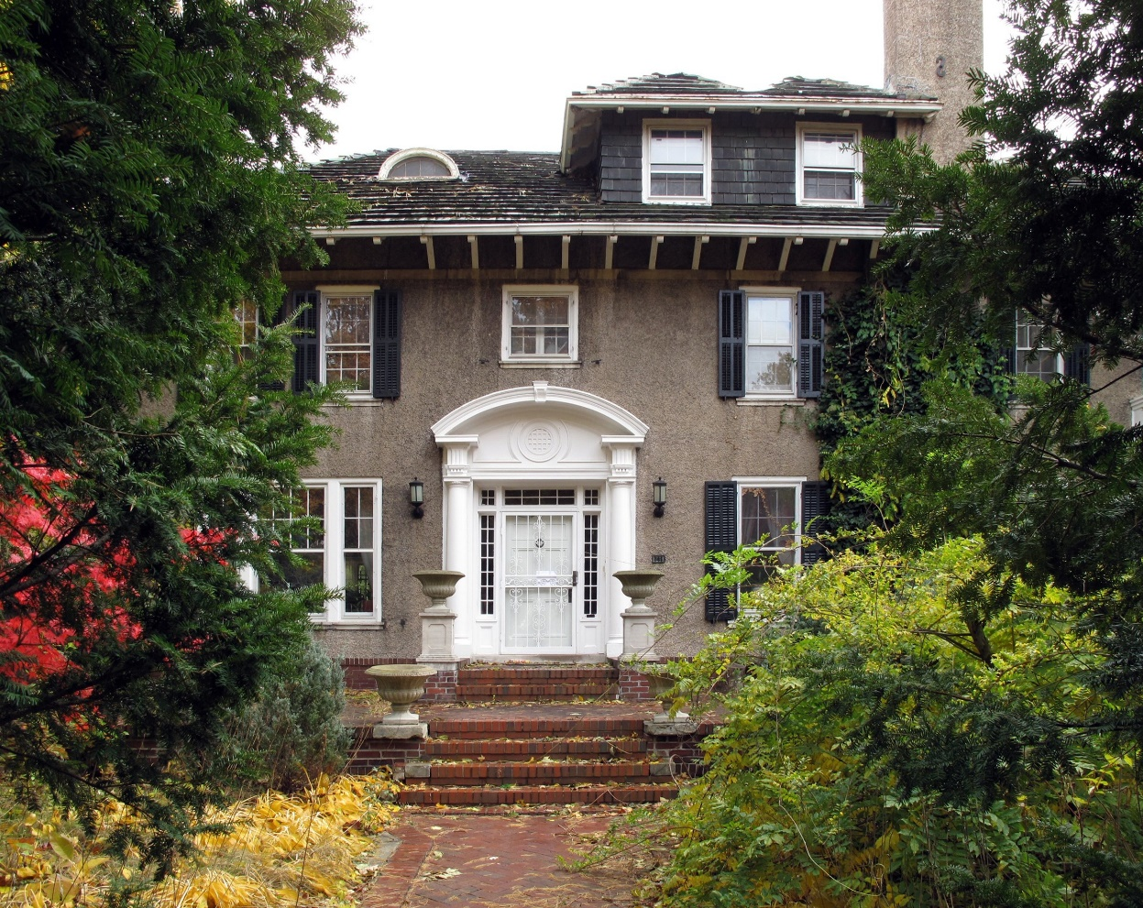
141 W. Boston, 2009. Flickr

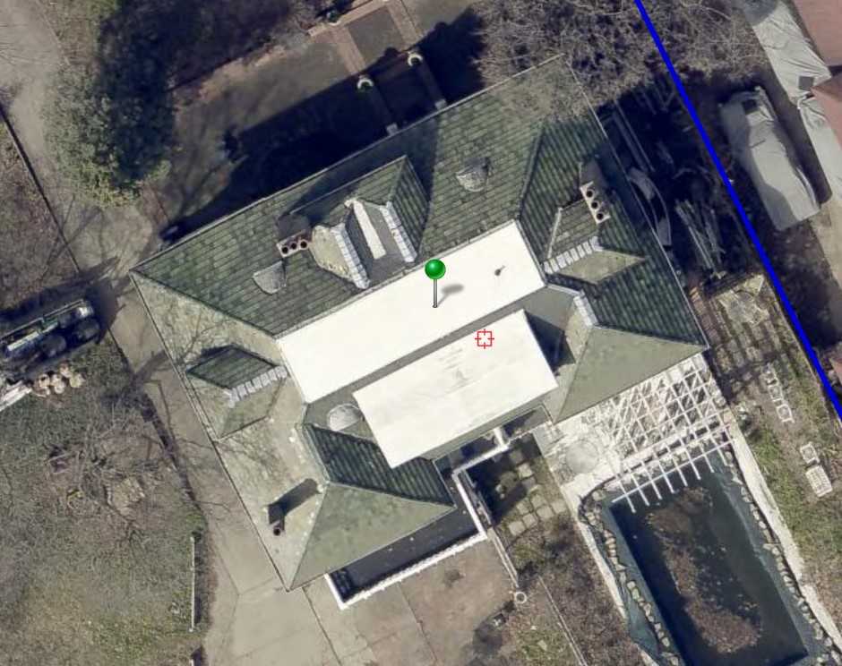
Eagle View aerial, 2024. Yellow areas indicate areas of past repairs

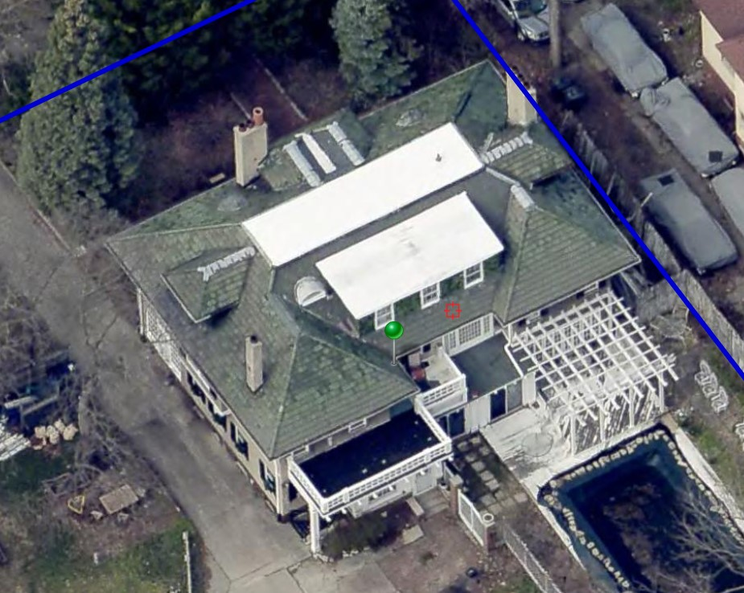
Eagle View aerial,, 2024. Looking NE.

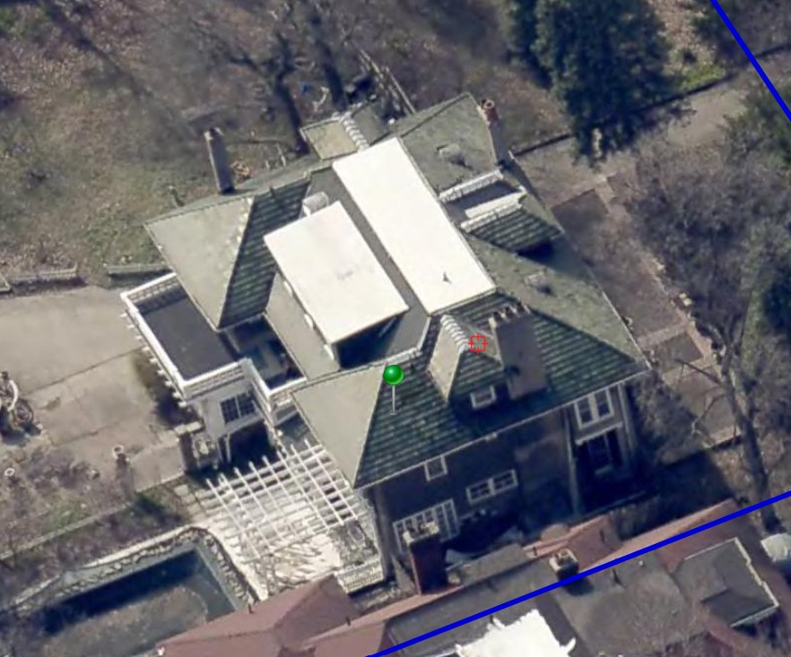
Eagle View aerial 2024. Looking NW.

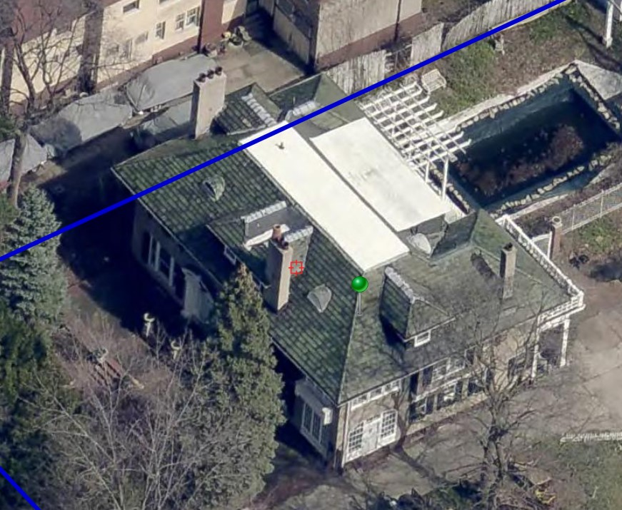
Eagle View aerial 2024. Looking SE.

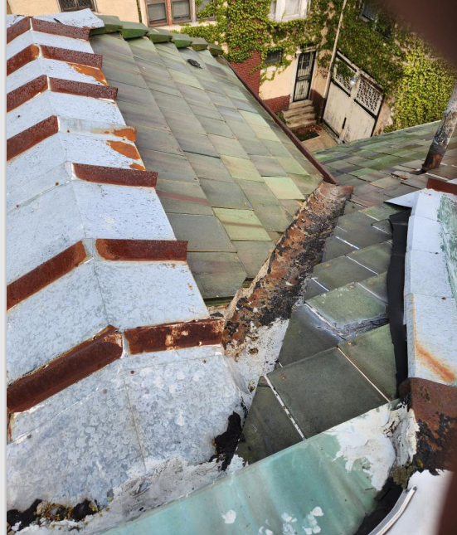
Photo by applicant. Showing area of past roof repair

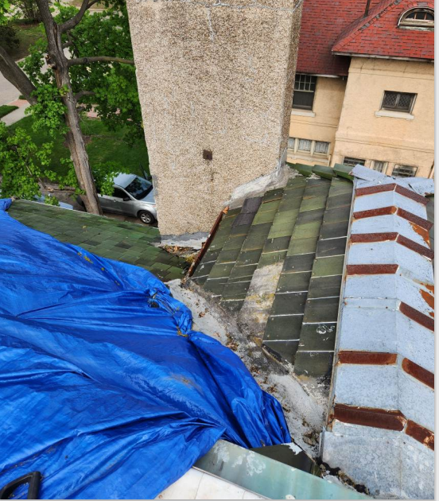
Photo by applicant. Showing area of past roof repair

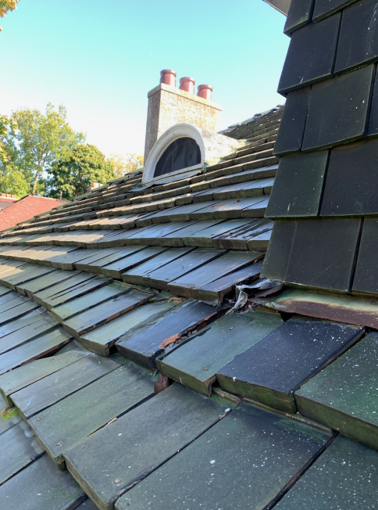
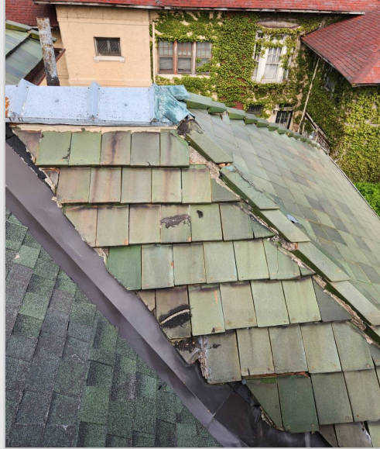
Photo by applicant. Showing condition of clay tile
Photo by applicant. Showing area of past roof repair. Note areas of asphalt roofing

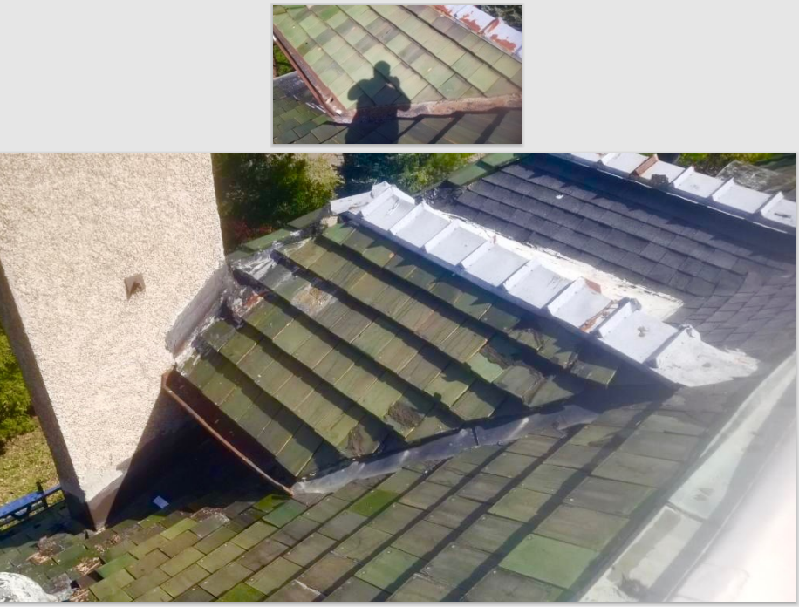
Photo by applicant. Showing area of roof repair at front paired dormers. Note small area of asphalt roofing

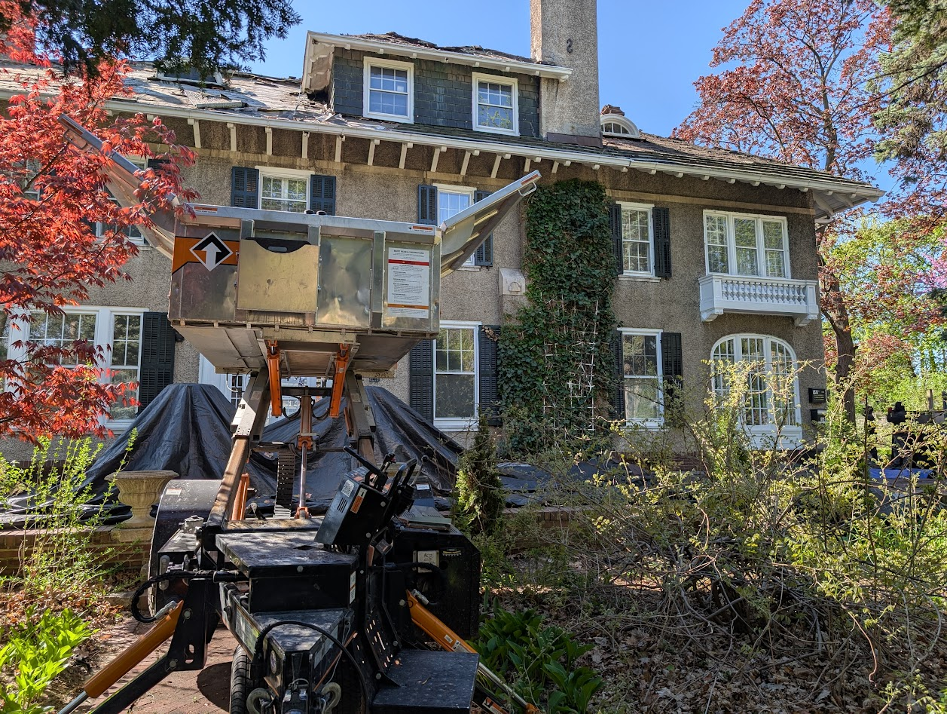
141 W. Boston. Photo taken on 4/30/2025 by HDC staff, showing current unapproved roof removal in progress

- The applicant submitted an application to the Commission for review at the 6/11/2025 regular meeting in which they sought an approval to replace the house’s roof with a new asphalt shingle and polymer shake roof HDC2025-00238_Cycle 1.pdf. The Commission Denied the proposal for the following reasons:
  - The application did not include an assessment/statement of condition of the roof from a qualified clay tile roof repair contractor which notes that the roof merits wholesale removal and replacement/is deteriorated beyond repair
  - The proposed new roofing materials presented an inadequate match for the house’s historic, character-defining clay tile roofing for the following reasons:
    - The proposed asphalt shingles were designed to resemble slate, not clay tile. Also, they did not adequately match the existing clay tiles in profile, dimension, texture, and color variation
    - The “polymer” shake proposed for the dormer side and front walls were designed resemble wood shake, not clay tile. Also, they did not adequately match the existing clay tiles in profile, dimension, texture, and color variation

Please refer to this link 141 W. Boston (06/11/2025) | City of Detroit to access the application and supporting materials, staff report, and Commission decision from the 6/11/2025 HDC regular meeting.
- With the current submission, the property owner has presented a new proposal in an effort to address the Commission’s above-stated reasons for denial of the initial application. Specifically, the current application includes the following:
  - Letter from contractor/Steve Debruyn which speaks to the condition of the house’s roof which includes photographs of the current roof HDC_Application_-_141_W_Boston_Blvd_HDC2025-0.pdf
  - Proposal to install clay tile roofing at the house’s main roof surface and the dormer front walls, and side walls; proposal to replace the existing clay tile at the garage/carriage house’s front roof surface with new clay tile
- As noted in the previous staff report which was prepared for the 6/11/2025 regular meeting, it is staff’s opinion that the material and visual qualities of a clay tile roof are intrinsically tied to each other. Even tile roof components, such as ridge end caps further accentuate the unique roof material and design. The dimensionality, patterning, profile and saturation of color of tile roofs make them distinctly important character-defining features of a building. At this residence, the use of green rectangular clay tiles offers a dramatic contrast against the minimal ornamentation of the house’s white stucco walls. Staff sees the deep eaves and eave brackets as proportional to the clay tile roof. Any alteration to the tiles, most notably their replacement with asphalt shingles, will alter the features and architectural proportions that characterize the property. It is staff’s opinion that the clay tile roof clearly is a distinctive, character-defining feature of the property as the entire composition of this house was designed to showcase the roof. Beginning with the façade’s centrally-located, raised porch with arched portico, one’s eye naturally travels upward to the vertical lines of the eave brackets which then leads a person to look (no matter the side of the house) to the hip roof and dormers.
- Staff did review the condition report of the house’s roof which has been submitted with the current application and concluded that this 115-year-old roof does appear to merit wholesale removal and replacement. Specifically, the roof does appear to suffer from broken, deteriorated, and missing tiles throughout; numerous unapproved past repairs; and unapproved replacement of sections of tile roofing with asphalt shingles at the front dormers and the rear of the roof. However, the application does not include documentation/which indicates that the clay tile roof at the garage merits repair. An assessment of the garage roof’s remaining clay tiles from the public right-of-way,

as well as the submitted photos indicate that the tiles which remain at the garage/carriage house’s pent roof appear to be in good condition.
- The applicant has provided photos that indicate that one of the rooftop dormers, located at the west side, has slate shingles at the front and side walls. The shingles at this dormer have been painted green to match the clay tiles at the main roof surface. However, staff does note that double dormer at the front/primary façade is clad with clay tiles. See the photos below for current conditions.

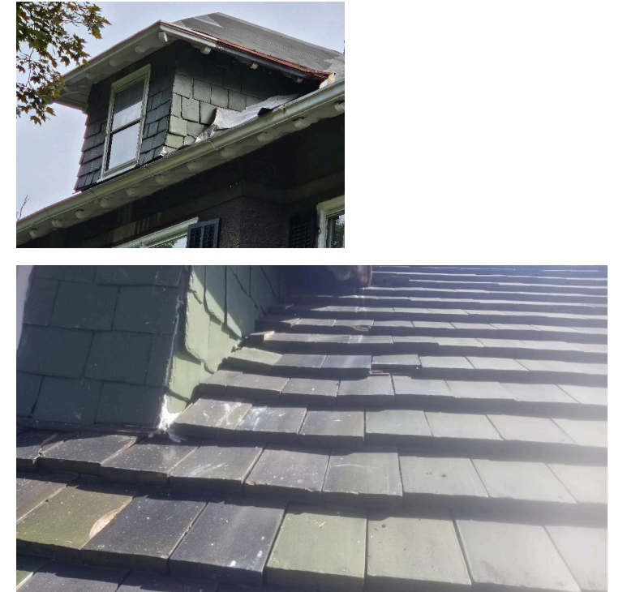
West side dormer, clad with slate, painted green. Photos provided by applicant

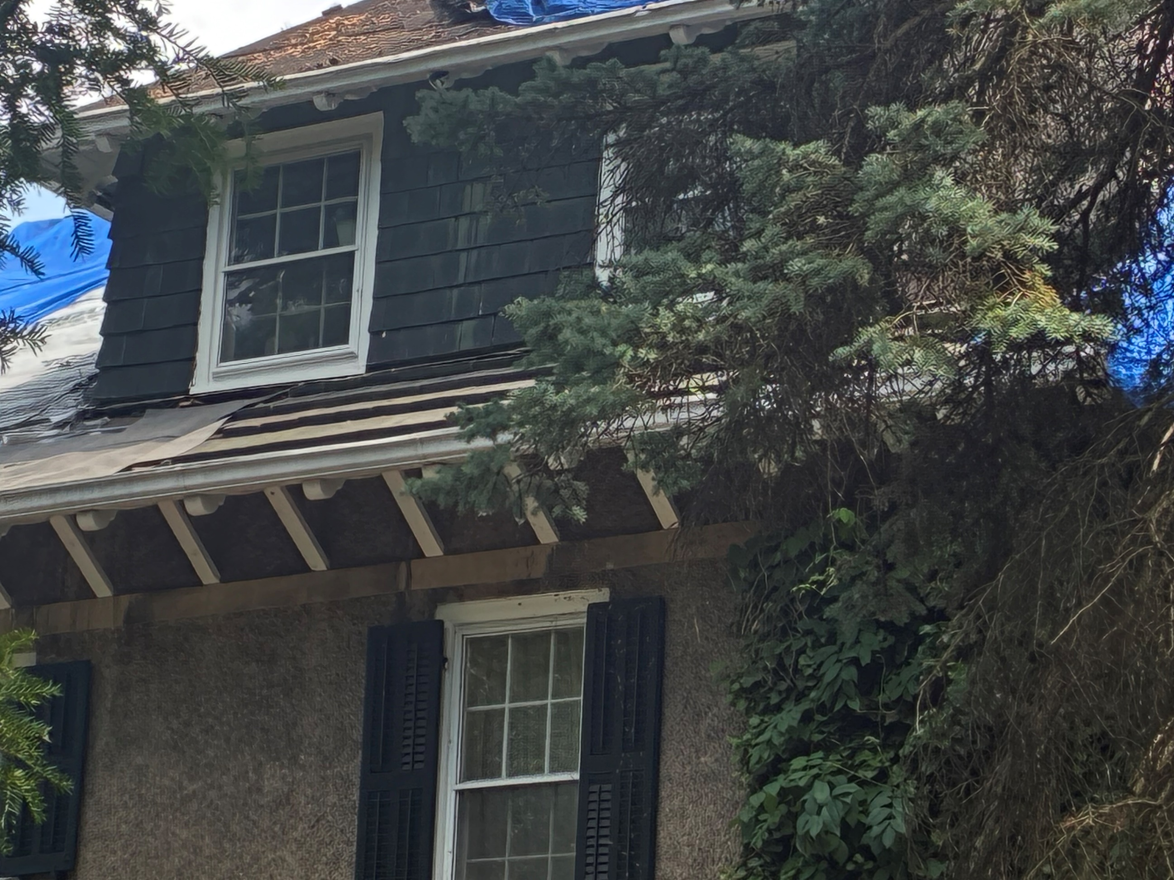
Front/primary façade double dormer. Clad with clay tile. Photo by staff, 6/27/2025

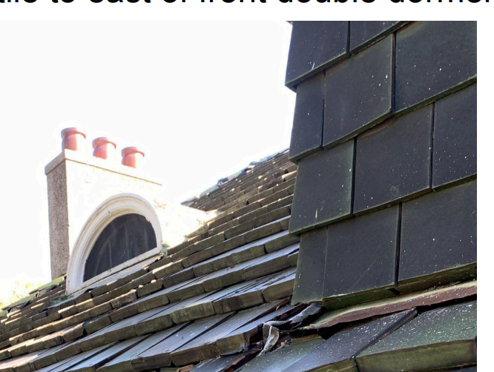
Front/primary façade double dormer. Clad with clay tile. Photo by applicant

- The application proposes to replace the existing clay tile roof at the house with new Ludowici Classic 14” tiles in Brookfield Green at the house’s roof. Colors of Ludowici - Brookville Green BlendBrookville Green | Colored Tile | Ludowici Roof Tile. Matching flat slab clay tiles will be installed at the dormer front and sidewalls. All flashing will be copper and all existing wood soffits, decorative brackets, and fascia will be repaired where deteriorated. It is staff’s opinion that this approach does meet the Standards for the following reasons:
  - The current roof does appear to merit wholesale repair due to its state of disrepair.
  - Per Standard #6, “…where the severity of deterioration requires replacement of a distinctive feature, the new feature shall match the old in design, color, texture, and other visual qualities and, where possible, materials.”
  - Staff notes that the current clay tile roof does display a variation of green colors. The color palette of the historic roofing was likely achieved via the application of a leaded glaze, which is no longer employed by clay tile roofing manufacturers due to the health that it represents. While exact color match to the original is not possible for this reason, the proposed tiles do appear to provide a slight level of color variation and will provide adequate match to the original in dimension, material, and texture as required by Standard #6 when proposing to replace a distinctive, character-defining feature which is deteriorated beyond repair.
  - As previously noted, one of the dormers, at the side elevation, is currently clad with slate tiles which have been painted green. The primary/street facing double dormer is clad with slate tiles. While the slate at the west side dormer is likely historic age, it has been painted green, presumably in an effort to match the appearance of the clay tile found at the main roof surface and the primary double dormers which are located at the front façade roof surface. Also, it is likely that the slate was not original to the house’s construction. Given the cumulative/overall result of the installation of a new clay tile roof at the property, it is staff’s opinion that the replacement of slate with clay tile at the west side dormer’s front and sidewalls would be a reasonable and appropriate approach.

- As noted above, the proposal includes the removal of the remaining clay tile at the garage/carriage house’s front façade pent roof/overhang. Staff notes that the tile at this location appears to be in good condition/does not appear to merit replacement. Therefore, as this tile does remain as a distinctive character-defining feature of the property and is in good condition in staff’s opinion, its removal does not meet the Standards.

ISSUES
- The remaining clay tile at the garage/carriage house’s front façade pent roof/overhang proposed for removal appears to be in good condition/does not appear to merit replacement. Therefore, as this tile does remain as a distinctive character-defining feature of the property and is in good condition in staff’s opinion, its removal does not meet the Standards

RECOMMENDATION(S)
Section 21-2-78, Determinations of Historic District Commission

Recommendation 1 of 1, Certificate of Appropriateness: Remove historic clay tile roof; install a new clay tile roof
Staff recommends that the proposed work will be appropriate according to the Secretary of the Interior’s Standards for Rehabilitation and the Boston Edison Historic District’s Elements of Design, with the condition that:
- Any trim at the roof’s eaves (to include the soffit, fascia, and brackets) which is targeted for replacement due to deterioration shall be replicated/replaced in kind.

- The remaining clay tile at the property’s carriage house/garage be retained/shall not be removed

