The scope of work as outlined in the Application dated 2/18/2025 states the following:
-the windows at the front façade will replicate the original, with the design based upon the designation photos
-the vinyl windows at the sides and rear will be kept but “pushed forward” to accommodate custom milled brick moldings. The Brick moldings will match original profile
However, the Applicant Response document submitted on 3/6/2025 lists all window openings sizes with the term “new wood window install” attached for every line. Can you please outline a final detailed scope of work for the project?
Also, please provide a window schedule for each window opening which includes a sketch and specs per line/opening/window:

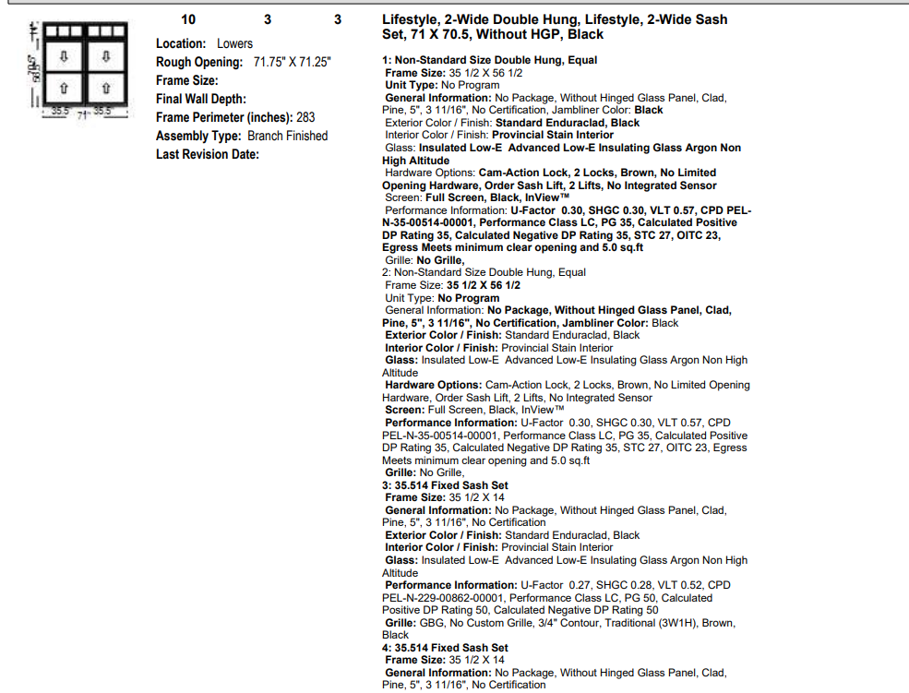

Finally, please provide drawings per the information outlined in below link which provide typical dimensions for all window types and associated trim/brickmould:
Documentation Requirements for Proposed Window Replacement - Historic Preservation Tax Incentives (U.S. National Park Service)

