701 West Canfield

West Canfield Historic District

Modifications to rear stair and porch design

Prior to the start of this project, the building sat vacant for over twenty years. Its renovation is only economically feasible through the adaptive use of all levels, including the attic, for residential, multi-family use. This resulted in a change of use from duplex to multi-family which triggered a requirement that all work meet current code requirements– including the addition of an egress path from the attic level to grade at the rear of the building.

A full building rehabilitation including all new building systems and restoration of interior architectural details is nearing completion. Importantly, the exterior of the building is substantially restored to its original appearance with extensive masonry restoration works, installation of a new shingle roof, restoration and replacement of wood trim, and installation of new windows that march originals. See attached photos.

In December 2020, the Commission approved the rehabilitation of the subject property, including a three-story tall rear deck and stair addition to provide access to all three floors.

After that approval, the design was submitted for SHPO/NPS review. This review resulted in two changes to the design.

First, a new, code-compliant stair at the interior of the building was not approved by SHPO/NPS due to changes it required to historic spaces and details at the interior of the building. Therefore, the rear exterior stair needed to become the code required egress stair. Per 2015 MBC 1011.7.2 and 2015 IFC 1031.3 (excerpted below), this stair needed to be protected from the rain. (The use of a steel stair with open treads was considered, but discouraged by SHPO/NPS and was not economically feasible.) As a result, a roof was required over the stairs at the attic level.

**2015 MBC 1011.7.2 Outdoor conditions.**   Outdoor stairways and outdoor approaches to stairways shall be designed so that water will not accumulate on walking surfaces.

**2015 IFC 1031.3 Obstructions.**    A *means of egress* shall be free from obstructions that would prevent its use, including the accumulation of snow and ice.

From the IFC Commentary: *Accumulations of snow and ice could prevent timely exiting from the building in the case of fire or other emergencies. Generally, if the exit is used regularly, the exit doorway area is kept free of ice and snow. Where a required exit is not used regularly, it may be necessary to protect the exit doorway area from the accumulation of ice and snow, either by construction of overhangs or enclosures, heated slabs or, when approved by the fire code official, by a reliable snow removal program that is aggressively enforced.*

Several roof design options were considered. The proposed design was selected because stair roof does not touch the original building, so it has no impact on the historic building fabric. The pitch of the roof was selected to match the pitch of the main building roof, creating a visual rhythm of the roofs from large to small, front to back.

Second, SHPO/NPS required that the stairs be oriented parallel to the rear decks rather than projecting from the decks as originally proposed.

SHPO/NPS approved the attached design. Given that it is the developers experience that SHPO/NPS interpretations of the Secretary of the Interiors Standards for Rehabilitation are usually more conservative than those of local HDCs, he incorrectly assumed that the SHOP/NPS approval was sufficient to also meet local requirements. He was wrong. He apologizes for any inconvenience.

The revised deck design and roof now being presented to the Commission were approved by the SHPO and NPS.

HDC APPROVED

SHPO/NPS APPROVED

HDC APPROVED

SHPO/NPS APPROVED

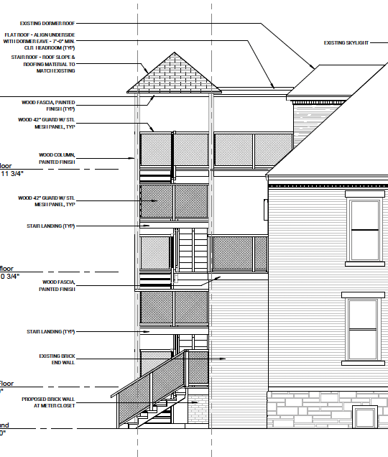HDC APPROVED SHPO/NPS APPROVED

Even with the design changes the proposed rear porch/egress stair meets The Secretary of the Interior’s Standards for Rehabilitation. The stair and porches are more compact and do not take up as much of the rear yard. The proposed addition does not destroy any historic materials or character defining features as it is on the rear elevation. Due to the nature of the site and the lack of public alley, the proposed addition will be minimally visible from anywhere in the district except the immediately neighboring properties. The proposed roof has a flat “connector” or “hyphen” in order to not compete with the historic roof. The sloped portion of the new roof matches the slope of the historic roof. It is not as tall as the historic roof. Therefore, the addition is subservient to the historic building.

The owner explored several options in order to satisfy the code and historic requirements. Using a metal structure and grated flooring was not feasible due to cost and would be less compatible with the materials of the house and district. The SHPO required a residential design and specifically stated, “The use of industrial/highly utilitarian concrete, steel and aluminum, structural railing or systems is not appropriate.

See attached renderings for views of the proposed deck.

EXCERPTS FROM EMAIL CORRESPONDENCE/DISCUSSIONS WITH SHPO/NPS/LIS

On Feb 10, 2021, at 12:12 AM, McKay, Robbert (LEO) <[McKayR@michigan.gov](mailto:McKayR@michigan.gov)> wrote:

Scott,

I have completed my review of this Part 2 application and There are a number of issue that I believe are inconsistent with the historic character of the property and the guidance continued in the Secretary of the Interiors Standards for Rehabilitation. Further, I believe that these issue are significant enough that if forwarded to NPS for formal review the project would be denied.

While more utilitarian in character the rear stairs also appear to be historically significant and sufficiently intact to warrant preservation. These stairs are in part significant as they clearly represent hierarchical nature of homes of this period and socioeconomic status.

Though slightly less problematic, the new rear porch is larger and detail in a way that I don not believe NPS will accept. Clearly the building appears to have has both first and second floor rear porches so these portion of the proposal are probably acceptable. The issue is the addition of the new porches at the attic level and the orientation of the new stairs. If there were stairs leading from the second story porch to grade it is unlikely that they were perpendicular to the porches. More likely they were either tucked into the corner of the porch adjacent to the masonry walls or the were parallel to the face of the porches. As designed the porches and stairs are very large and dominate the buildings rear elevation.

The third/attic porch is also problematic. Based on the design of the residence there does not appear to be any historical evidence supporting the extent of the porch or the stairs to this level. If the new stair and associated access points is required to provide emergency egress of the attic units, then the stairs and associated landings need to be sized to provided the required access without calling adding or undue attention to themselves. The entire porch/stair system will also need to be designed in a simple, modern but residential fashion. The use of industrial/highly utilitarian concrete, steel and aluminum, structural railing or systems is not appropriate.

I strongly recommend revising the proposed interior and rear porch designs before sending the application on to NPS.

From: **Lis Knibbe** <[eknibbe@knibbe.com](mailto:eknibbe@knibbe.com)>  
Date: Thu, Feb 18, 2021 at 10:56 AM  
Subject: 701 West Canfield  
To: Scott Lowell <[scott@traffic-jam.com](mailto:scott@traffic-jam.com)>, McKay, Robbert (LEO) <[McKayR@michigan.gov](mailto:McKayR@michigan.gov)>

Robb,

the existing rear stairs have rise of 8 3/8" and a run of 8"  (yes, this is right, the rise is higher than the tread).  As such they really aren't safe and can't be reused.  Also the head height clearance at the lower landing is barely 6' and so also really isn't safe (and doesn't meet code).

The attached plans show new stairs in the same location.  These stairs are as steep as currently allowed within a residential unit (7 /7/8" rise, 10" tread) to replicate the sense that the rear stairs were steep, certainly steeper than the main stairs at the front of the house.

Scott would reuse the railings from the one stair that still had railings and put in similar contemporary railings elsewhere.  Fortunately, the original railings are made up of elements similar to standard stair elements today.  The old one will need to be set on a base so that it is 36" tall and the new ones will need to be 36" tall.

Also, what do you think about the pitch of the hipped roof over the stair.  I prefer the steeper one, but the lower pitched one is less massive, so that may be better.

Scott, ask me about options of where to put the washer/dryer.  There are three.  None will impact the tax credits.  It has more to do with what you would prefer.

Lis

Elisabeth Knibbe

734 516 9230

From: **McKay, Robbert (LEO)** <[McKayR@michigan.gov](mailto:McKayR@michigan.gov)>  
Date: Wed, Feb 24, 2021 at 12:33 PM  
Subject: 701 West Canfield, SHPO Part 2 Review issues and possible solution  
To: Antonio Aguilar - Technical Preservation Services ([Antonio_Aguilar@nps.gov](mailto:Antonio_Aguilar@nps.gov)) <[Antonio_Aguilar@nps.gov](mailto:Antonio_Aguilar@nps.gov)>

Antonio,

While reviewing the Part 2 application for this project I identified what I believe to be serious problems with the proposed design and asked the design team to look a revising the design to better retain the buildings historic interior configuration and detailing. I have attached a copy of my email to the team outlining my concerns for your reference.

Because of the extensive nature of the need modification I was hoping to get your thoughts about the new design before sending the team back to the drawing board to make the changes. I think the proposed change bring the project into reasonable alignment with the Standards.

Do you think it would be possible to get the project approve in light of the revised plans?

**Robb McKay**  
Historical Architect

**State Historic Preservation Office**

Office:  517.335.9840  | Desk:  517.335.2727

[mckayr@michigan.gov](mailto:mckayr@michigan.gov)

From: **McKay, Robbert (LEO)** <[McKayR@michigan.gov](mailto:McKayR@michigan.gov)>  
Date: Thu, Feb 25, 2021 at 2:36 PM  
Subject: RE: Canfield  
To: Lis Knibbe <[eknibbe@knibbe.com](mailto:eknibbe@knibbe.com)>

Thanks for the clarification.

Antonio basically gave the project the green light.

His exact comments were:

” I agree with your comments. I think the rear stairs could be modified to meet code. The second story hallway could also be modified (the portion towards the service stairs).

However, I don't think it would be appropriate to extend the front stairs into the attic. This may limit the ability to put new units into the attic as proposed.”

|  |  |
| --- | --- |
| **Robb McKay** Historical Architect  **State Historic Preservation Office**  Office:  517.335.9840  | Desk:  517.335.2727  [mckayr@michigan.gov](mailto:mckayr@michigan.gov) |  |

On May 25, 2021, at 1:32 PM, McKay, Robbert (LEO) <[McKayR@michigan.gov](mailto:McKayR@michigan.gov)> wrote:

(in regard to the porch railing design)

Wire mesh in general has been approved as infill in modern railing systems. What I have seen used most successfully in other tax credit project that use a wire mess has been 4x4 welded wire fabric. Both galvanized and painted version of this material have been approve on other tax credit projects.

I have also had good luck getting horizontal cable railing infill approved so this might also be an option. On most precious project I believe that the cables, connection eye bolts and turn buckles have been stainless steel. I co not recall a project that used this system with a galvanized or painted finish.

I would strongly recommend not using 2x wood balusters. They tend to be very heavy visually and have a tendency to be poorly detailed and harder to maintain.