Custom Bench
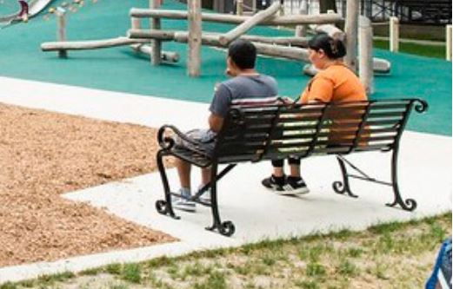
The proposed benched for Voigt Park will be fabricated by Disenos Ornamental Ironwork in Southwest Detroit. The fabricated bench is the City of Detroit, General Services Department standard for historical parks.

