10/16/23
City of Detroit Historic District Commission
2 Woodward Ave., Suite 800
Detroit, MI 48226

RE: Dr. Ossian Sweet House, 2905 Garland DHDC23-8237 Followup
Dear Historic District Commission and HDC Staff,
BlueGate MI LLC, is writing to the Historic District Commission on behalf of the City of Detroit in relation to the rehabilitation of the Dr. Ossian Sweet House located at 2905 Garland Avenue. We are providing updates to COA DHDC22-8036 and DHDC23-8237 as previously requested. This update addresses:
- Rear porch upper and lower portion design
Rear Porch upper and lower Guard / Hand Rail design
We are proposing a deck rail system frequently used in East and West Village:
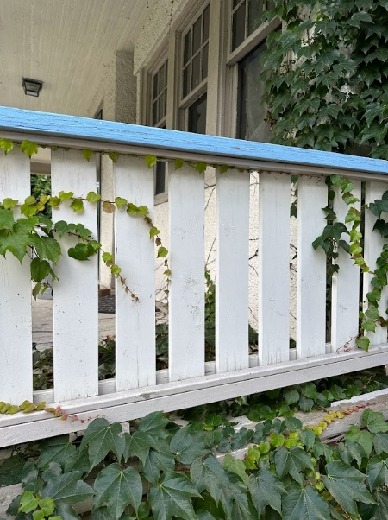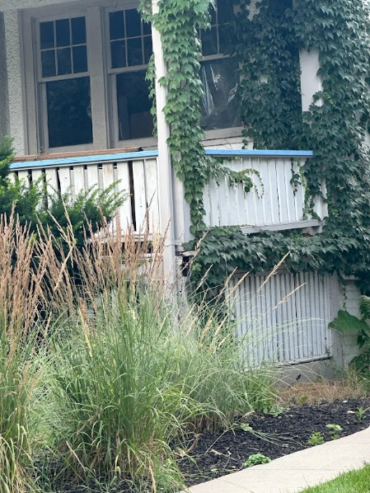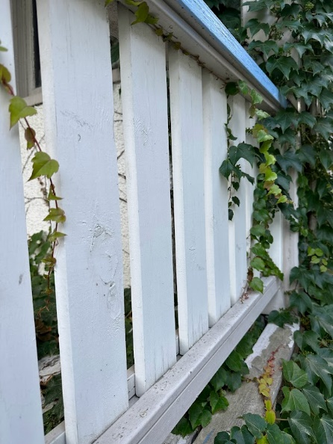

The system features 1x4 balusters in a channel of 1x2 mounted on both sides of a 2x6 top and bottom rail. The system will be supported by 4x4 posts. On the upper porch the railing will be attached to the house at the door fascia per the original condition. The railing will be constructed from cedar and painted to match the previously approved trim color, Benjamin Moore HC-126 Monroe Bisque.
Shadow lines suggest a 4” railing cap was attached to the home with the low point of the upper railing system mounted at a heigh of 23” from the upper porch and 36” from the lower porch. In keeping with the original first floor porch design, we are proposing both the upper and lower railing systems terminate at a height of 40” from the floors. This will preserve symetry and appropriate safety on the upper level.

Upper Porch Historic Hand Rail Height (23”- 27” from the porch)
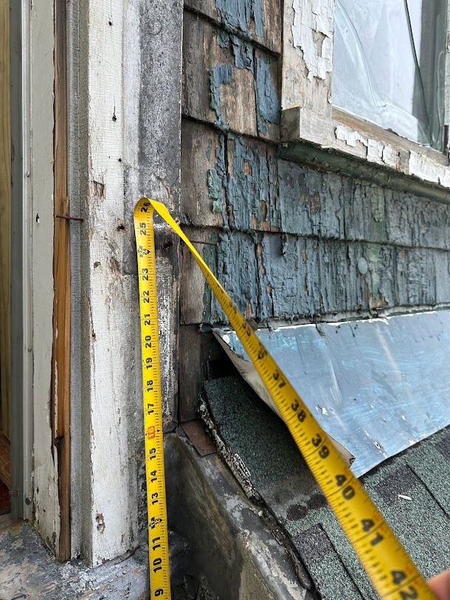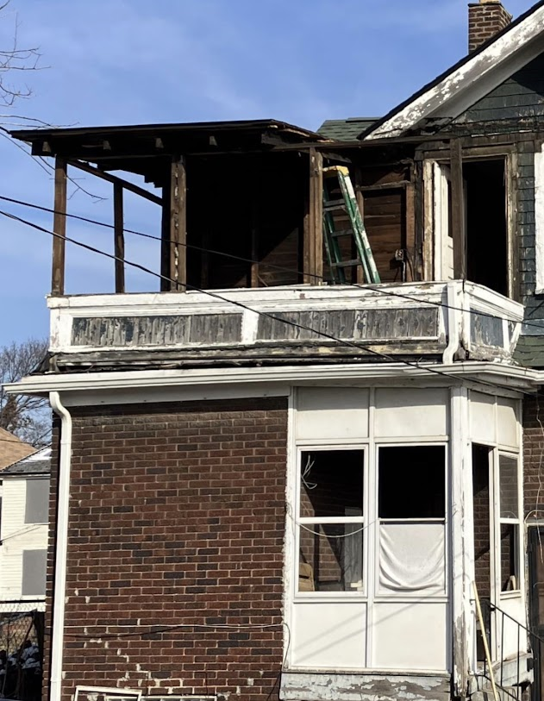
.
Lower Portion Railing Height (37”-41” from the deck joists. Floorboards to be added)
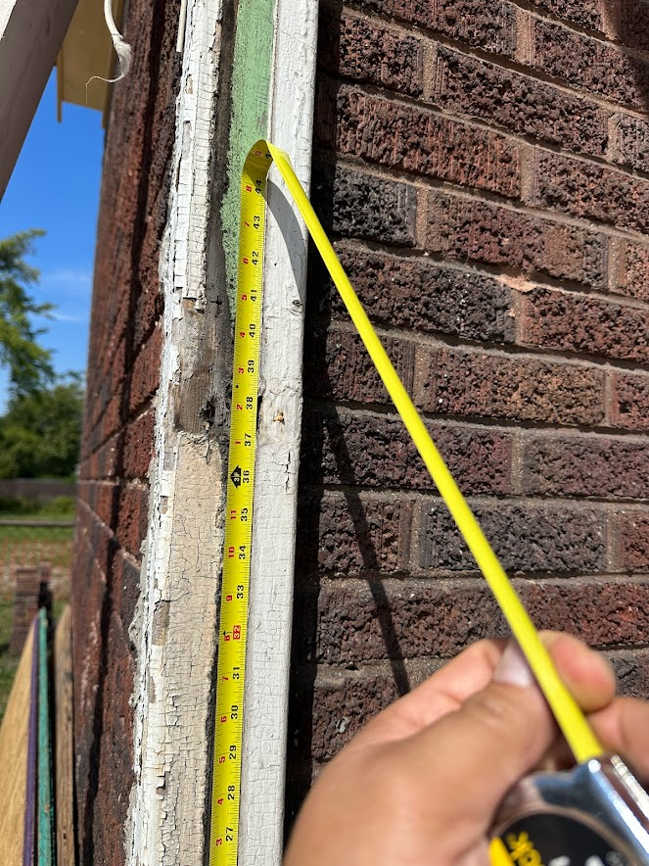

Upper Railing Proposed Height (Between Blue Arrows)
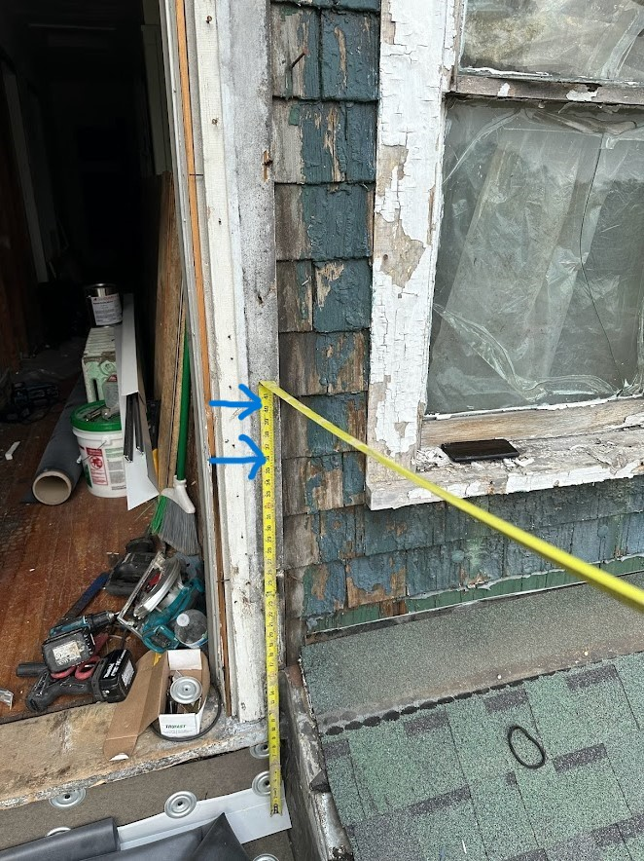

For the lower portion of the rear porch we are proposing:
- Lower Porch Floors- Tongue and grove floors mirroring the size, dimension and material of that on the front of the home
- Stairs and Handrail- Newly constructed wooden stairs 36” wide with 36” handrails on both sides in the design of the guard rails to replace the previous non-historic masonry steps. (Note the exterior door to the basement is an inswing door and appropriate clearance exists to allow entry)
- Skirting Below the Porch- Tongue and groove 1x6 skirting of similar style and material to that used in multiple locations with a 1x4 cap under the floor boards and at the ground

Hand drawn plans have also been attached.

