ATTN: Historic Review Committee:

4770 Leslie St.
Detroit MI 48238

SCOPE OF PRACTICE:
Front Door: Storm door and wooden front door will be replaced.
Side Door: Storm door and standard inside door will be replaced.
Windows: all windows will be replaced on home, besides historic windows on the upper part of the arch of the home.
Gutter guards, Fascias and soffits will be replaced.
Front porch: Resurfacing of front porch, and new railing added.
Rear Balcony: Balcony door
Balcony railing: Railing will be added to balcony.

INFORMATION ON PROSED MATERIALS:
Front Door: black steel front door, and interior door replacement (wood “natural color”)
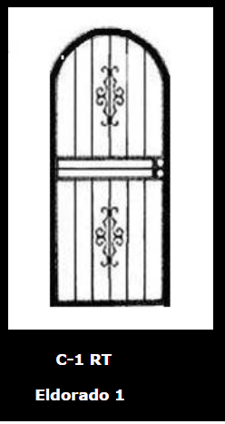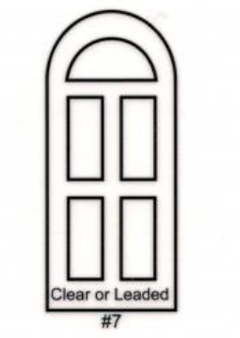

Side Door:
Storm door: Black and aluminum interior white door
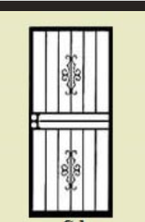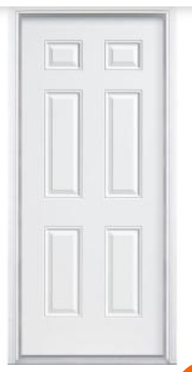

Windows:
Lower front windows: aluminum clad wood windows black/bronze
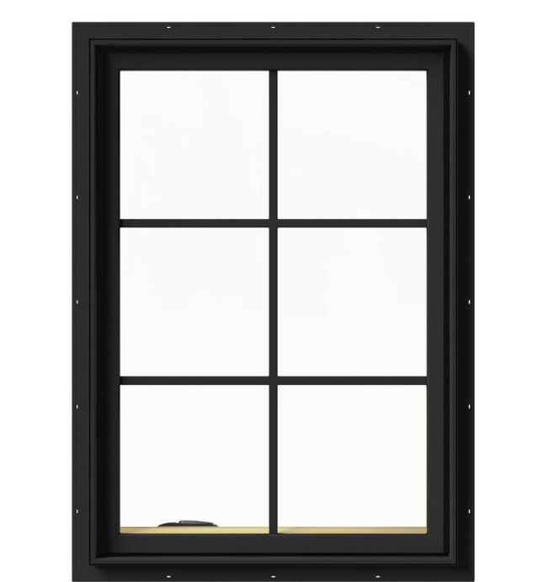
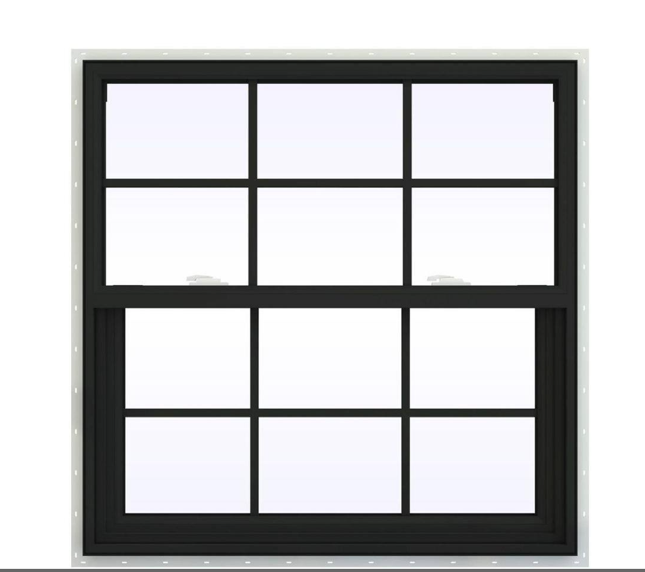

Remaining windows in the home will be replaced with Double hung aluminum clad wood windows style windows
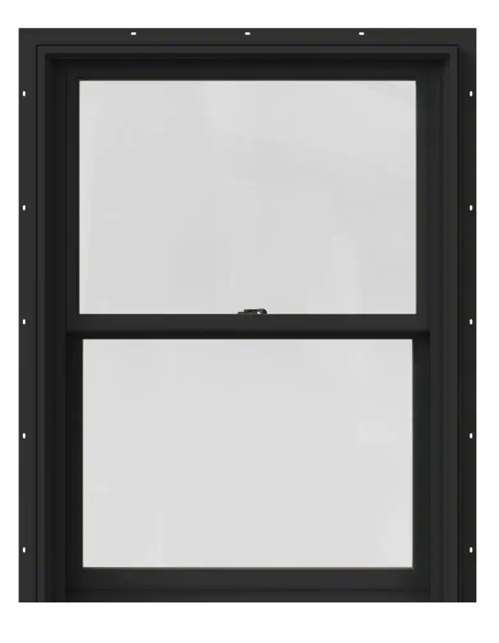

Gutter guards, Fascias and soffits: Black or brown

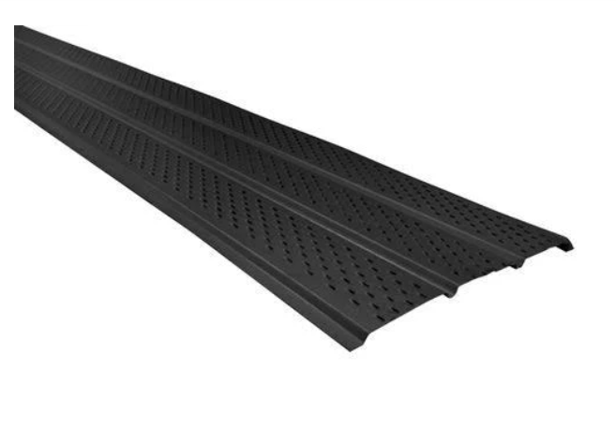

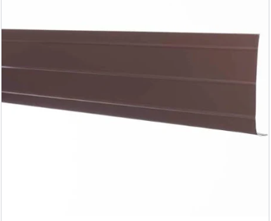

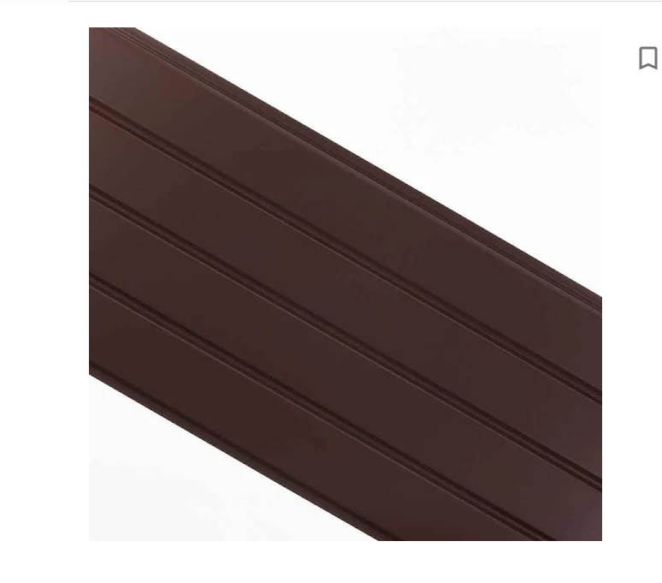

Front porch:
The front porch’s top layer will be resurfaced with cement for smoothing purposes
Railing: Black aluminum railing replaced on front porch
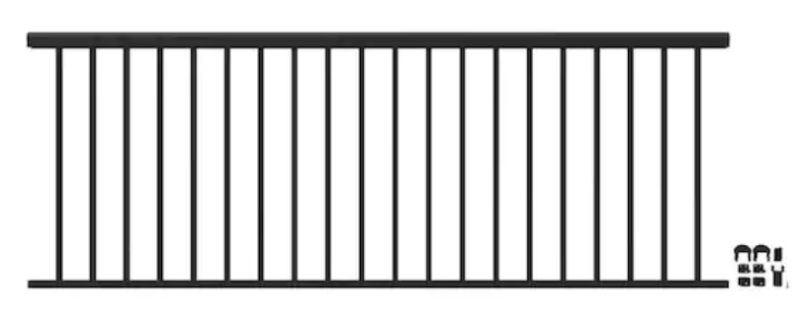

Rear Balcony:
Balcony Door: White
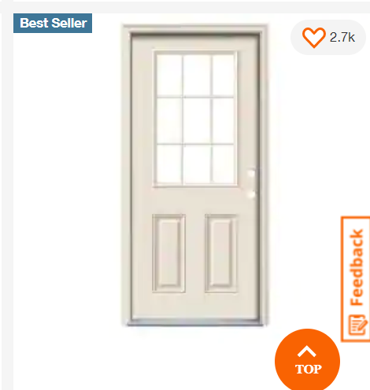
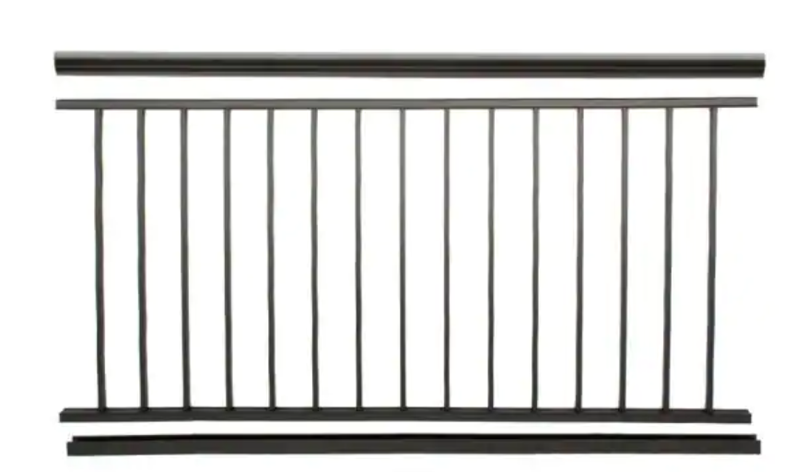Balcony railing

