6/30/2022

Kraemer Design Group Name: 7600 Jefferson Ave.
Attn: Brian Rebain AIA Job Location: Detroit, MI
1457 Griswold St.
Detroit, MI 48226

HISTORIC WINDOW SITE REVIEW:

The following is the Historic Window Site Review as requested for the property at 7600 E. Jefferson in downtown Detroit, MI. This includes a review of all window openings on the 1st and 2nd floors, on all elevations for this 2-story building. This review is based on a site visit by Mike Shields of BlackBerry, and discussions with Brian Rebain, the architect with KDG. It is our understanding this property is in the historic district and must have HDC approval. Our review considers the National Park Service guidelines for restoration and replication as provided in the Steel Window Preservation NPS Brief #13. Likewise, in providing our recommendation for the restoration or replacement we are adhering to the guidelines that meet NPS and SHPO standards. Please note this review is our opinion based on over 30 years of historic window restoration and replication experience; however, you must have written approval from the local HDC prior to proceeding with construction.

Existing Conditions: (65) Hot Rolled Steel Frame Openings @ 2350 Sq. Ft. of window area.

Our site review included viewing all elevations from the street view, as well as a sample survey of windows from the interior. Windows were inspected for operation, condition of the exterior sill, sashes, hardware, glazing, master frame, and perimeter caulking.

The window have not been painted for decades and have light to medium corrosion on both the interior and exterior surfaces. All windows are set in a limestone masonry surround with a steel lintel at the heads of all openings. The frames are recessed into the limestone at the jambs and sills and welded at the heads to the steel lintels. The typical window is fixed with operating projecting sashes staggered in the design at intervals, based on the specific opening configuration. There are various openings that some of the framing members have been broken or cut out by vandals, but despite the corrosion the majority of openings the steel frames are still structurally sound. The joinery is intact including the operating sashes. The hardware is in poor condition or has been removed from the sashes. All the glazing compound is failing and disintegrating and falling out. The perimeter caulking is likewise missing or failing. The buildings roof area is leaking throughout the building which is also causing water damage to the windows on the interior. Obviously with all the broken and missing glazing the weather is penetrating the building on a constant basis. This is allowing excessive water penetration at the sills that is allowing water to enter and get into the interior wall cavities. The overall condition is “poor”, but because of the narrow opening widths the windows are still relatively structurally sound. The windows will require Lead and Asbestos Abatement whether they are restored or replaced. The window glazing compound and the perimeter caulking most likely contain ACM, as well as the remaining surface paint is lead based. The need to be verified in the Environmental Report.

The following are the dimensions for the key window components. Sash thickness is
1 ¾”, Fixed Side stiles 1 ¾”, Fixed Top rail 1 ¾”, Fixed Bottom rail 1 ¾”, Muntins 7/8”, Operator Side stile 2 ½”, Operator Top rail 2 ½”, and Operator Bottom rail 2 ¾”.
The glazing is all ¼” annealed glass, over 50% of the glass is broken and/or missing.

Recommendation:

In our opinion there are two options: that being restoration and full replacement. But our review does provide the determination the restoration can be done even though the window condition is “poor to fair” because the structural integrity is still intact. There would be portions of the work where components have been damaged that would require replacement with a steel custom component, but these are limited.

Restoration would be mostly conducted in the field, the majority of the window areas are fixed and fully recessed in the surrounding substrate which does not allow for removal without excessive damage. Venting sashes can be removed, and shop restored. The following is a brief summary of the process.

- Remove and dispose of all glazing.
- Abate all glazing compound, perimeter caulking and lead paint.
- Field strip all frames.
- Epoxy patch as needed.
- Replace steel components as needed.
- Fix all sashes shut, remove operators.
- Prime all components
- Two coat finish painting.
- Install new double strength glass, and tempered glass where code requires, including new glazing compound or structural silicone sealant.
- New perimeter caulking both on the interior and exterior.
- Clean all glass.
- Note shop restore all sashes prior to fixing in place.

We would suggest adding a storm window to improve the energy efficiency and the comfort level of the interior space. We would recommend fixing all window operators, since the hardware repair or replacement, as well as weather-stripping of the windows present the greatest difficulty and Fixed windows will be the most energy efficient restoration option in lieu of full replacement. We would suggest an exterior or interior storm that is removable for cleaning and maintenance.

Replication would use a thermally broken aluminum steel replica product such as the Quaker H450 Series Fixed and Projected window. We would suggest all fixed since the operator location in the opening would be difficult to access if the original configuration is duplicated. The window would include 1” insulated glass with low-e/argon, AAMA 2605 or 2604 painted finish, interior snap trim, and direct set in the masonry opening. The window site lines would comply with NPS standards for Federal Tax Credit Guidelines. The following is a brief summary of the process.

- Full removal of all steel windows including glazing and hardware.
- Abatement of all ACM and Lead paint.
- Install new window system including interior snap trim, backer rod and interior and exterior structural silicone sealant.
- Clean

So, in summary, the existing windows are restorable and can function well all operators are fixed in place We would strongly suggest a storm window over the vacuum glass since the frames would also be isolated from the interior and not likely to develop condensation during the winter heating season. There are advantages to full replacement over restoration 1. Better energy efficiency and performance. 2. Longer durability and less maintenance. The steel window restoration will require painting every 8-10 years, and re-glazing or glazing compound repair in 15 to 20 years. New thermally broken aluminum replica windows have a 30 + year paint finish and non-corrosive frames. 3. Lower overall cost.

Budget pricing includes material, tax on material, labor, employment cost, insurance, staging, abatement, disposal, board up, and supervision. This pricing is based on a square foot estimate. For a firmer budget BlackBerry can provide an actual estimate upon your request.
Window Restoration Budget Price $365,000.00
Fixed Storm Window Budget Price $118,000.00
Window Replication Budget Price $296,000.00

Budget Pricing does not include permits, lintel or masonry repair, bonding, prevailing or union wages.

Please note that restoration work is dependent on having temperatures above 45 degrees for daytime and nighttime lows. Typically work can be performed between April 1st thru October 31^{st.}

Please contact us with any questions.

Sincerely,

Michael K Shields
President

See Photos Below

Supporting Photos

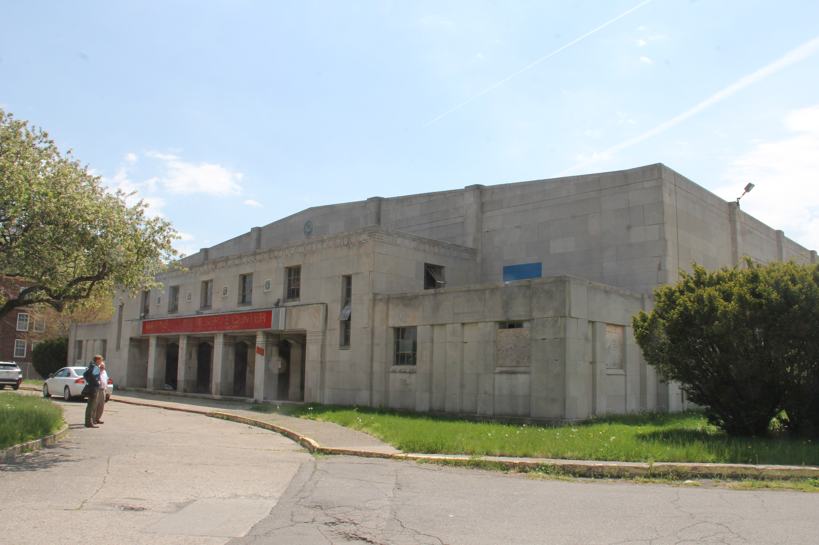

fRONT ELEVATION

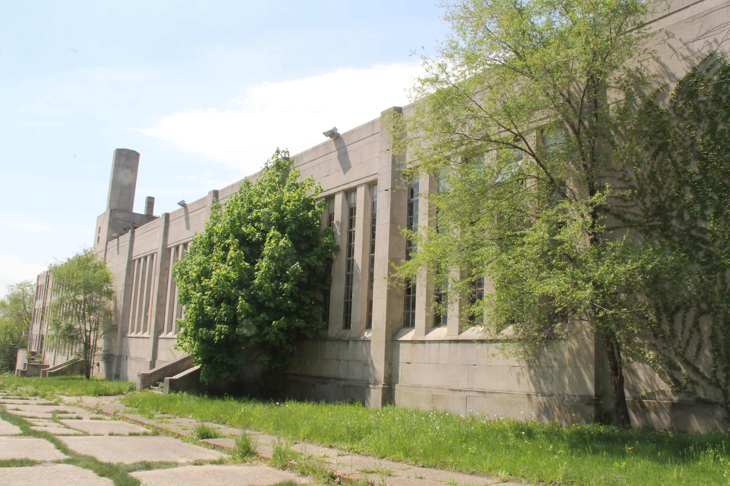

EAST ELEVATION

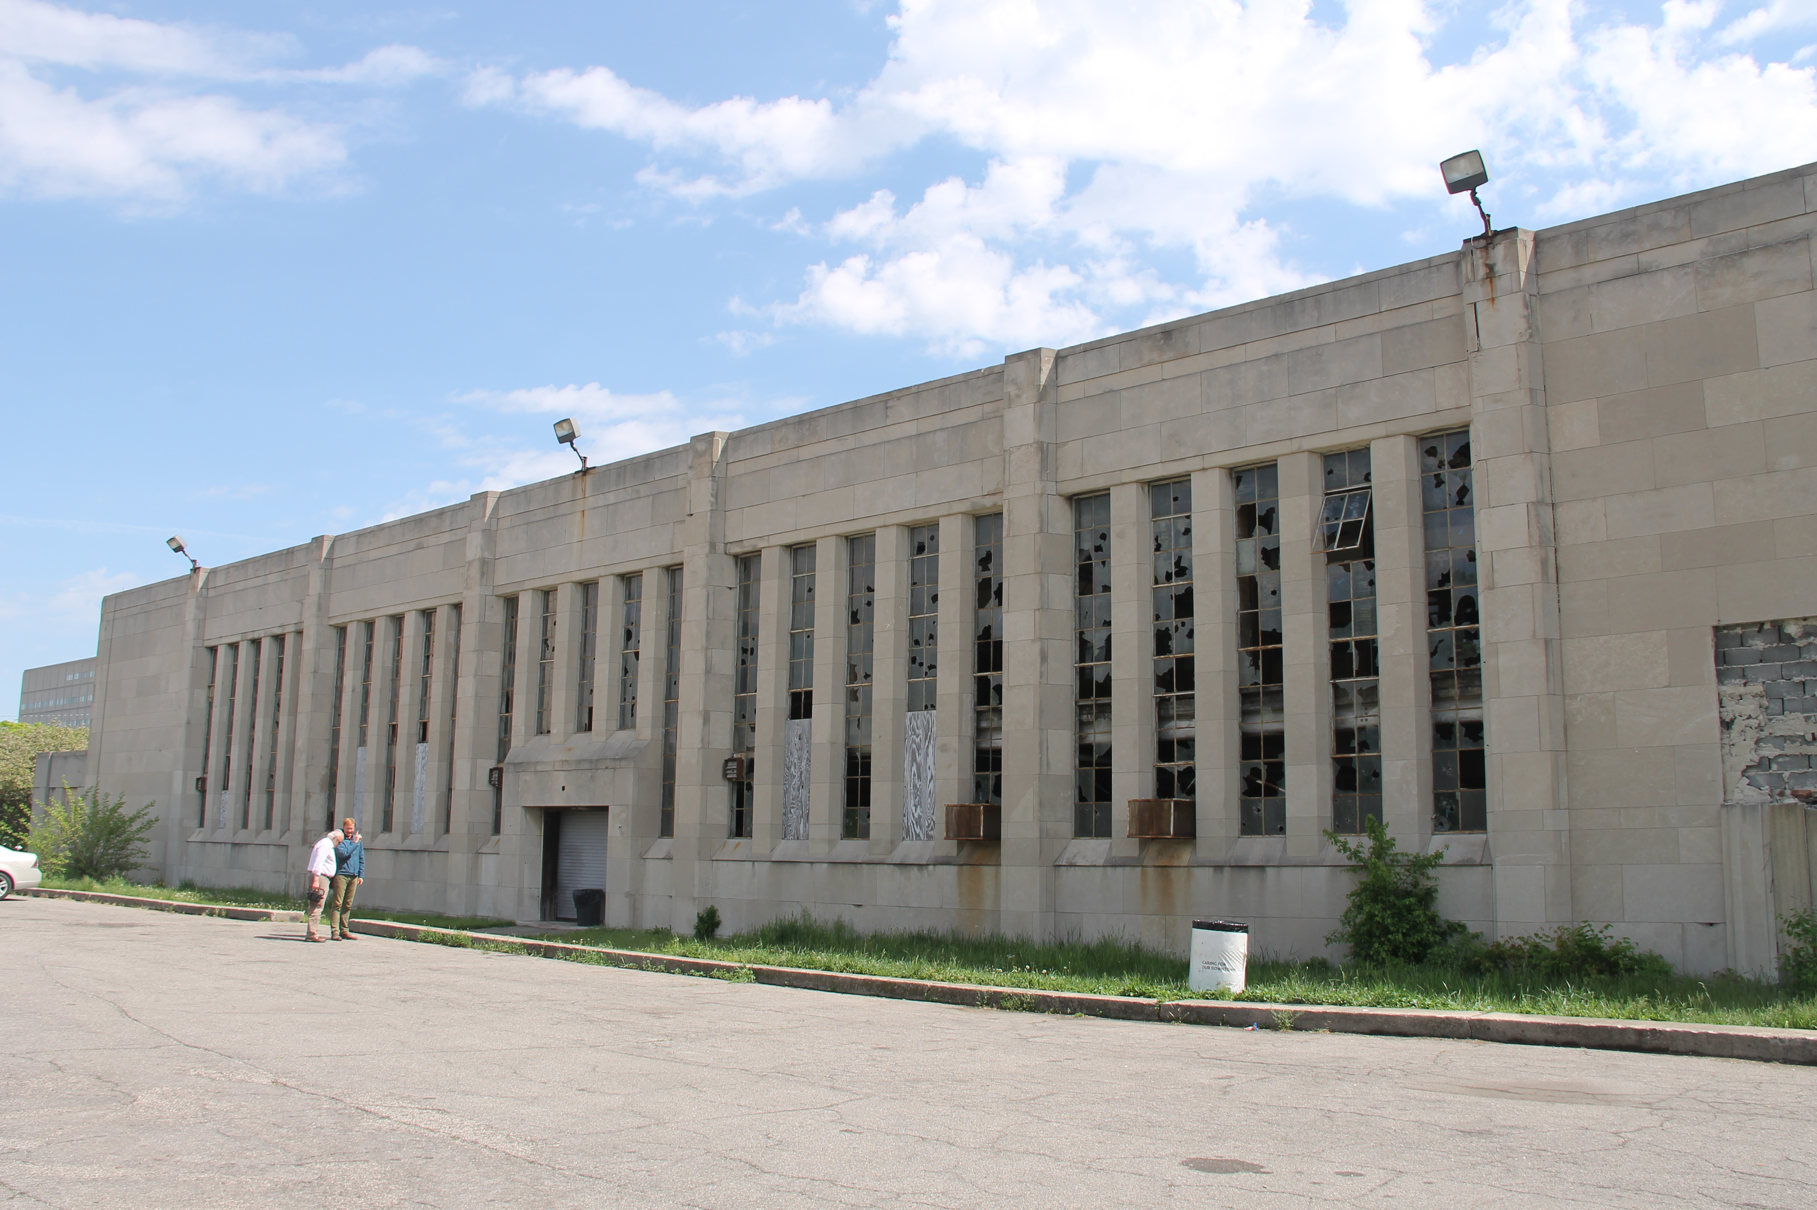

wEST ELEVATION

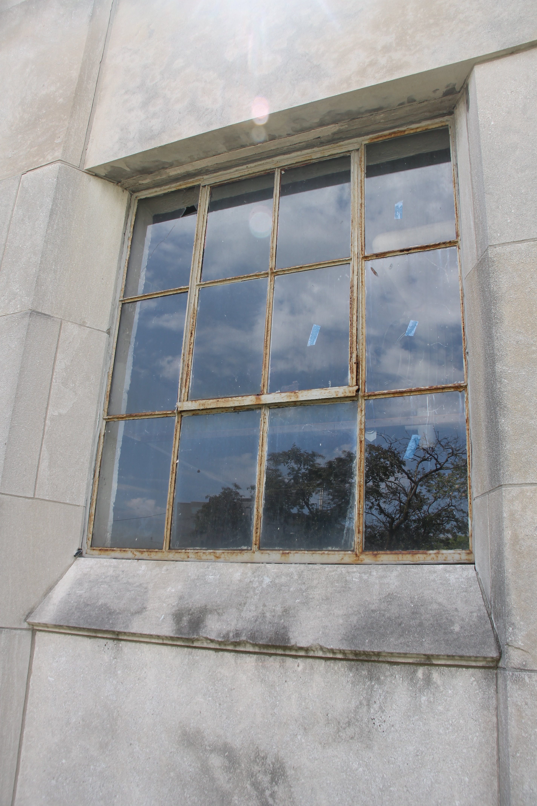

tYPICAL TYPE A WINDOW

tYPICAL TYPE B WINDOW
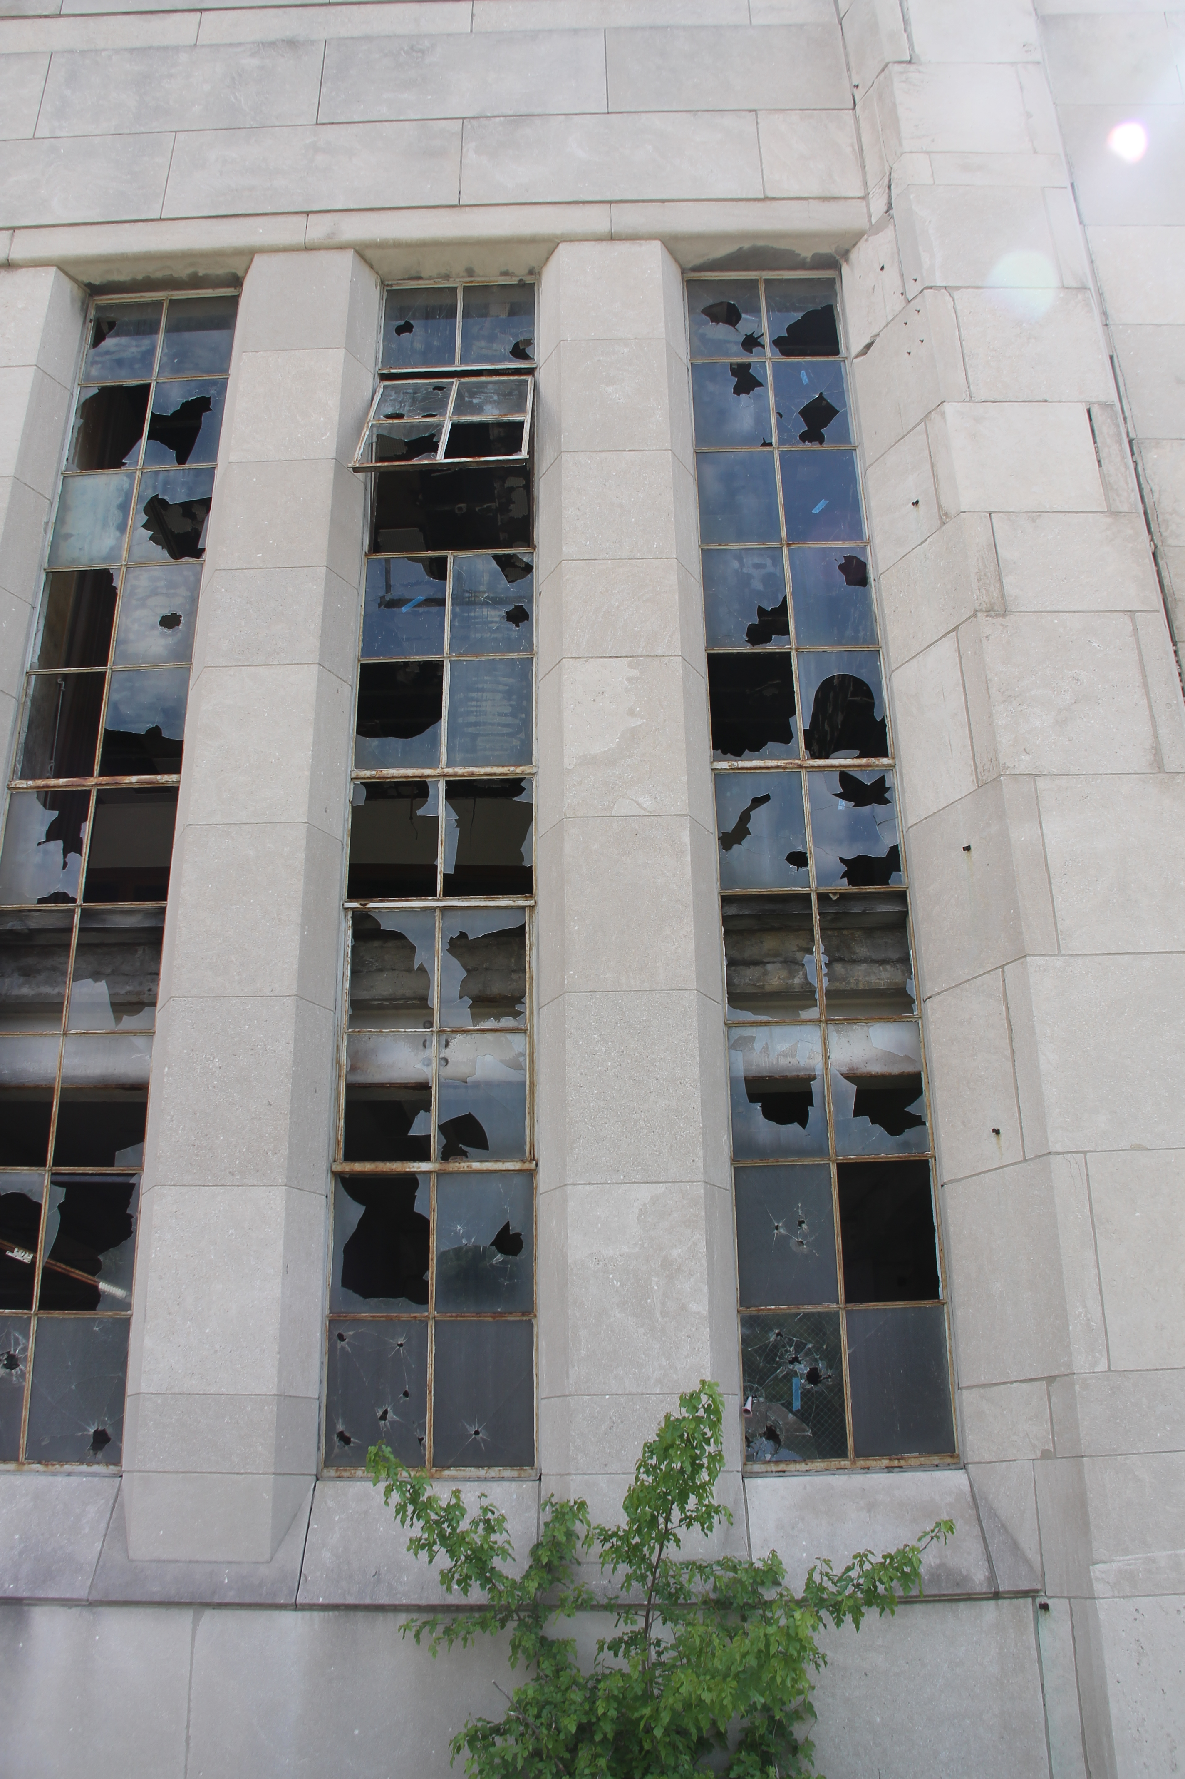

tYPICAL TYPE C WINDOWS

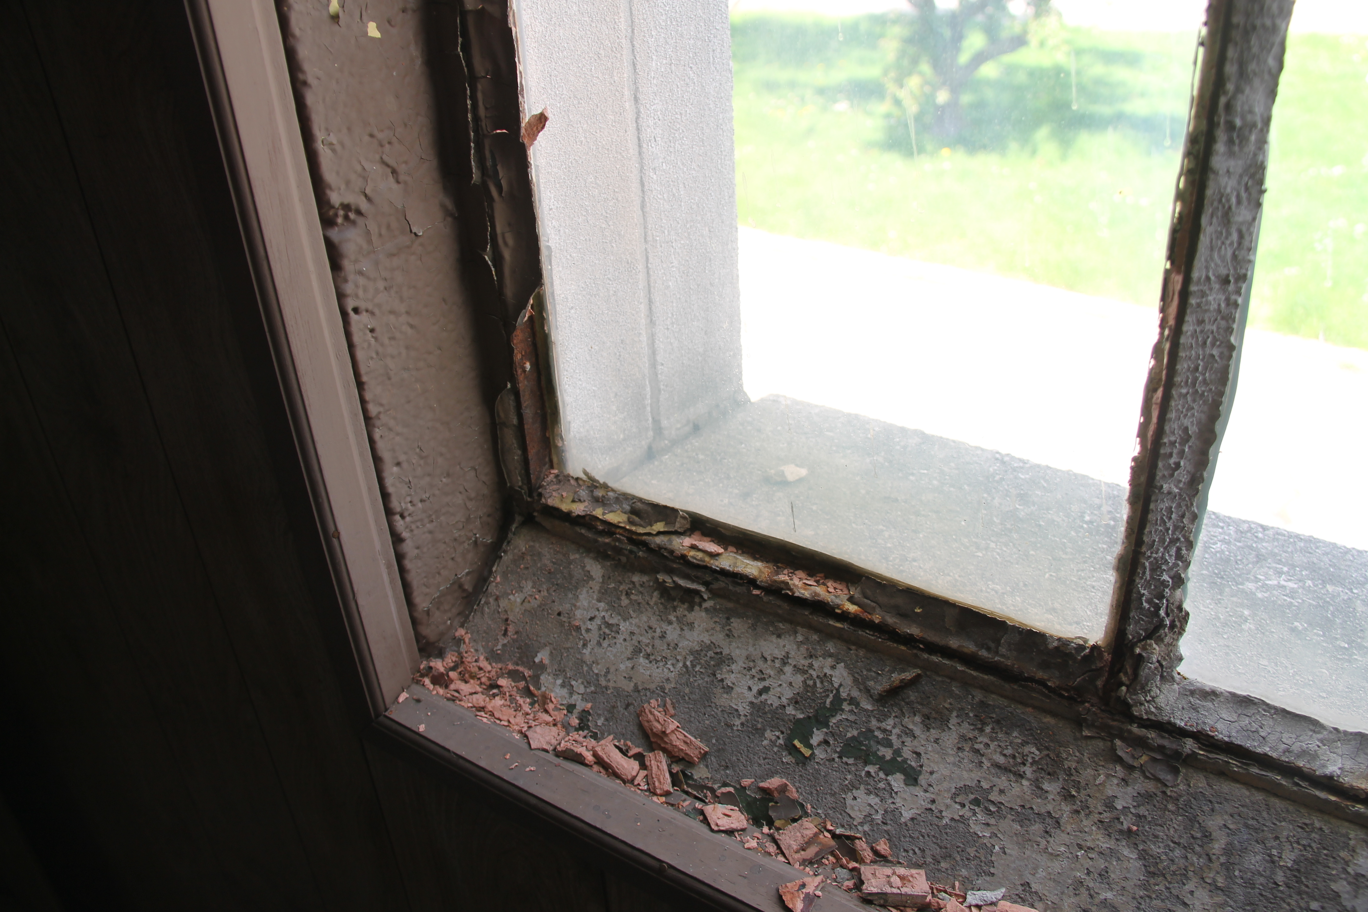

TYPICAL WINDOW SILL CONDITION FROM INTERIOR
NOTE: FAILED GLAZING COMPOUND W/ ACM AND BURIED STEEL FRAME

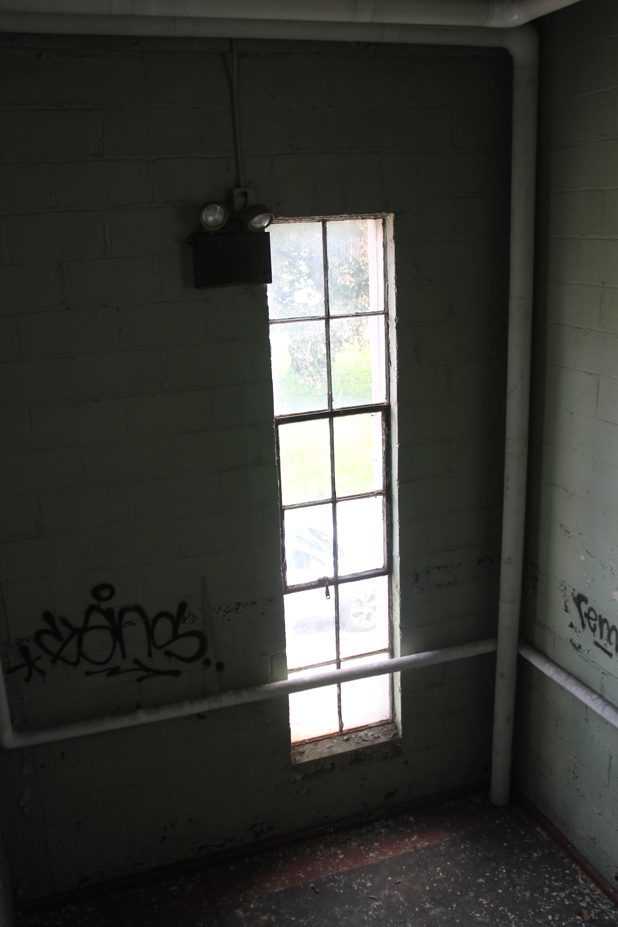

INTERIOR VIEW OF TYPE B WINDOW

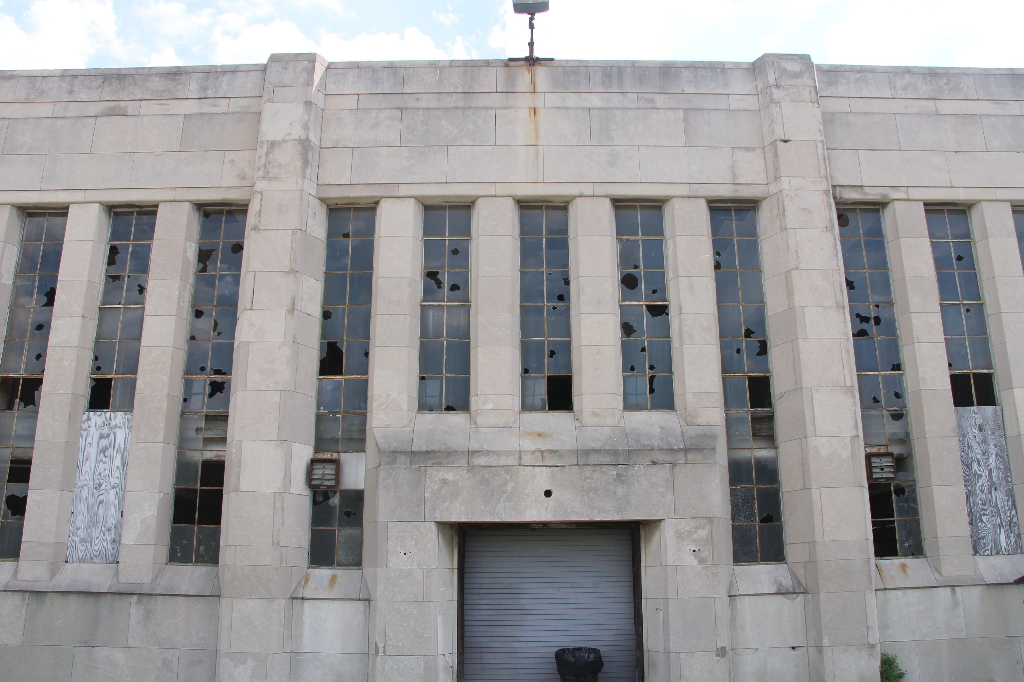

WEST ELEVATION WINDOW TYPE B AND C

