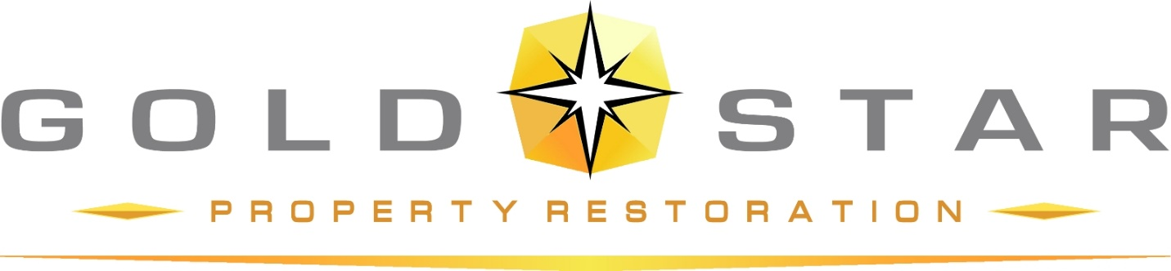

264 Executive Dr. Troy, MI 48083

Current conditions for 731 Covington:
- Steel single pane push out window with fixed transum painted brown to the exterior

Proposed Replacement Scope 731 Covington:
- Wood Aluminum clad case window with brown metal exterior, casement window and fixed transum. Grid pattern to match existing.
- See the attached quote for the photo of replacement widow

