**Written info / Narrative for Commission -Project Review Request Attachments**

**Property Location: 1402 Vinewood**

**Completed Building Permit Application-**

See attached building permit application. I will be doing the work myself

**ePLANS Permit Number** –

See attached building permit application. I do not have a ePlan number yet.

**Current Photographs, Description of Project and Detailed Scope of Work**

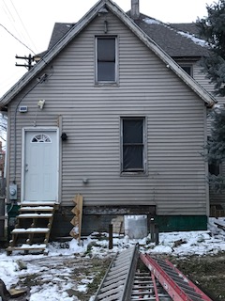

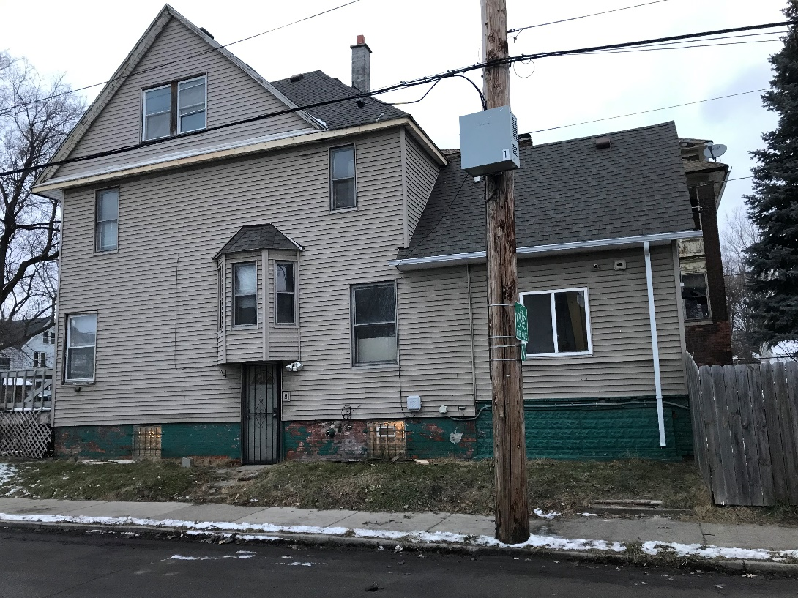

South side of house west side of house – Back yard

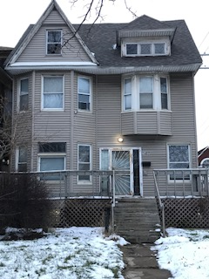



East Side- Front North of side of house. Cannot be photographed because the neighbor’s house is so close

WINDOW

1. Current Condition: The matieral of the window is vertical sliding window that is vinyl. It is not historic wood double hung. This was install before I purchased the house. The size of the window is 48” x 48”

2.  **Description of project**  I want to remove the window and cover the opening with matching beige siding of the existing house

3. **Detailed scope of proposed work for approval**: The location of the window is the south side of the house facing Porter street. The quanity is 1 window removal. I will be buying the siding from Eastern Michigan Distributors. The cut sheet of the siding is below with the color of harbor stone

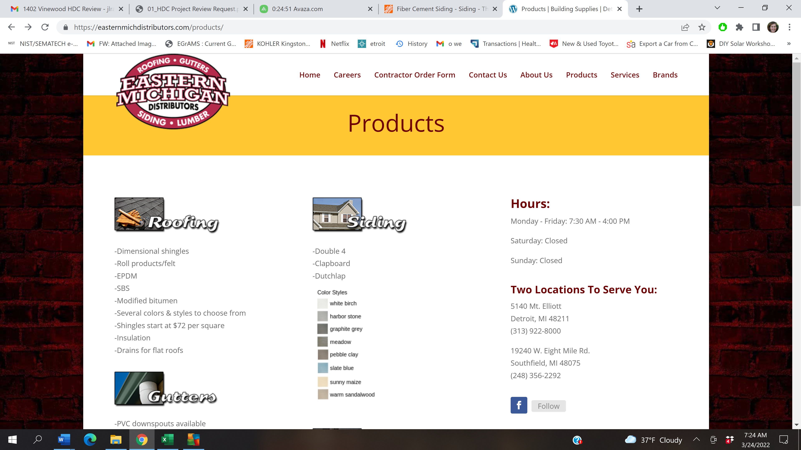

Cut Sheet the siding- Same at the current housing siding.

Window on the south side of house facing Porter street. The scope is to remove this non historic window and cover the opening with siding that matches the current color of siding of the house.

