**Replacement Window Project Review Request – Egress and Basement Windows**

1901 Chicago Blvd, Detroit, MI 48206

Contents

Current Window Pictures 1

Exterior Shots to Show Location 1

Well Windows 4

Small Basement Windows 5

Existing conditions 5

Description of Project 6

Scope of Work 6

Brochure/Cut Sheets 6

Egress: 8

# Current Window Pictures

## Exterior Shots to Show Location

**Front of House facing Chicago**

Bathroom Well Window

Front Well Window A

Front Well Window B

Side Well Window A

Side Well Window B

Small Window B

**Side of House facing Rosa Parks**

Side Well Window B

Small Window B

**Side of House facing Rosa Parks**

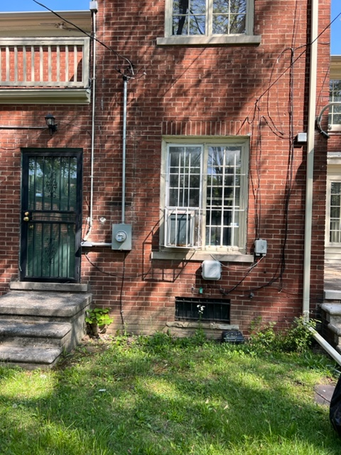

Small Window C

Bathroom Well Window

Small Window A

**Back of House**

**Side of House facing AWAY FROM Rosa Parks**

## A window with blinds Description automatically generated with low confidenceWell Windows

Front Well Window WelWidnWdinwWindow48198w A

Bathroom Well Window

ront Well Window B

Side Well Window A

Side Well Window B

Top of Well Window

## A picture containing wall, indoor, bathroom, window Description automatically generatedA picture containing indoor, building Description automatically generatedSmall Basement Windows

Small Window B

Small Window A

Small Window C

# Existing conditions

All existing basement windows slated to be replaced have the following specifications:

* Glass type: single pane
* Frame type: metal
* Design: 2 x 4 grid; cream colored
* Opening style: N/A; fixed
* Additional info: the 5 large windows slated to replaced are all well windows (sit underground)

The issues seen across most windows are as follows:

* Cracked glass
* Rusted/significantly worn metal frame
* Well filled with debris
* Moisture has seeped in under well area and caused damage to interior plaster

Additional considerations:

* Single pane glass poses concern from safety perspective as it is easily shattered
* With 1700 sq ft in basement and intended use for entertaining, the lack of a true egress window also poses a safety concern

# Description of Project

All existing windows slated to be replaced except for one will be replaced with windows that have the following specifications:

* Company: SPS Glass Block
  + <https://spsglassblock.com/>
* Glass type: glass block
* Frame type: N/A – sealing around existing opening
* Opening style: N/A - fixed
* Exception: one large window at side of house facing Rosa Parks will be converted to a true egress with a door-style window and a code-compliant opening

# Scope of Work

* Removal of debris from window wells
* Inspection of existing drain systems to ensure proper drainage; replacement as required
* Removal of old single pane windows
* Proper disposal of old windows
* Replacement of windows with glass block described in ‘Description of Project’ section above
* Replacement of one window on Rosa Parks side with a true egress door window
* Digging existing well larger to accommodate the true egress door window
* Sealing/insulating around new windows
* Adding shrubbery around the true egress for aesthetics and added privacy

# Brochure/Cut Sheets

Sample photos of SPS glass block windows (from their recent install jobs) and true egress

See images on following pages and visit website above for additional work

Glass Block:

## A picture containing indoor, open, window, dirty Description automatically generatedEgress: