1901 Chicago Windows Project – Additional Information 7.11.22

Age of Windows
- From HDC: In correspondence with our office on June 1, you wrote that the existing windows are principally "Pella replacement windows" installed in "the 70s - 80s". Can you provide any additional information around how you came to this conclusion? This is a post-war house, and may have had Pella installed as the original units.

- Resident/Owner Response: I arrived at this conclusion given the information I had at my disposal (looking at windows for distinguishing information) and the supplementing research I performed.

This house was last owned by a Church and there are not records on original materials, windows, doors, etc. that they provided us. Upon purchase of the house, we asked as many questions as possible and were given contact information for the old church steward as well as the real estate agent. We have reached out to both for additional info, but neither has provided an age for the windows or any other change records for the exterior of the house so we are simply making the best, informed guesses that we can.

In this case, I looked at some key specs of the windows including the product line stamped on the inside of a few windows, the fact that they are double pane glass, the roll screen present in most, etc. and compared against what I could find online for the history of Pella’s product lines and technologies/materials employed. Although it is possible that these are original to 1951, the product line, roll screen, and double pane (all in conjunction) appeared to be more prevalent in the 1970s so it was my educated guess that they wouldn’t have been readily available in 1951.

Previous Review (2000) vs. Current State:
- From HDC: Per our records, attached, these same wood windows were reviewed for replacement by the Commission and denied at the March 2000 meeting. Per staff's analysis at that time, these were the original wooden windows of the home. The presence of the ornamental "strap" hinges and true divided lights suggests that these are not replacement windows. Since 2000, based on our archive photos, the windows (at least on the outside) appear to have been cleaned up, reglazed, and repainted. There are no additional applications or reviews in our files for this property.

- Resident/Owner Response: thank you for that information and for the previous images submitted. I do believe that the windows were cleaned up on the outside in 2000 or shortly thereafter. This unfortunately does not translate to the interior or sealing of the windows. As I’ve stated in previous communications, the appearance of the windows – while important – is not the biggest factor for us wanting to replace. When we initially put in the application, the biggest concern was around safety and that remains at the top. Another factor that has become much more pressing since the initial application is the impact to the house’s structure and integrity. I’ve outlined both issues in a bit more detail below:
  - Safety: The majority of the windows in the house are casements that have no cranks and many are missing the shaft that you could even attach a crank to. Additionally, the interior of the windows have been painted over so extensively that many are completely painted shut. These issues all prevent us from opening the windows to allow for ventilation and/or an exit out in the case of a fire or other disaster.

After talking to our inspector and some contractor specialists, they are hesitant to commit to a solution (other than full window replacement) that they know would function and that would provide us with the safety and egress that we require.

There are some specific windows with larger problems related to safety as highlighted below:

    - The bay window consists partially of plexiglass (appears to have been broken and partially replaced)
    - The breakfast nook window does not cover the full window opening as it is built only for a window AC unit (which we would like to remove). It is also a vinyl replacement window that has a blown seal.

  - Structural Integrity: though the wood frame of the windows may look fine from the outside, we have noticed after spending more time at the house that we have leaking coming through to the ground floor due to improper sealing around windows upstairs. One of the windows we selected for this project is so poorly sealed and has been holding so much water around it that water enters our dining room (room below it) through the ceiling with every heavy rainfall. This has caused significant damage to the plaster ceiling and threatens to affect the wood floors as well.

By completely removing the old window, replacing, and adding modern spray foam insulation plus new caulk (all in scope for the project), we will mitigate the current water/sealing issues and get added benefits of energy efficiency, which I cover in more detail later.

Fiberglass windows are additionally more structurally sound and easier to maintain than both wood and vinyl as they expand/contract at the same rate as the window glass, which allows them to stay in place with their seals intact. The expansion/contraction of wood (and vinyl) can create leaks/structural issues and reduce longevity – this is what we are seeing now with the wood windows. Additionally, wood windows have an average life span that is shorter than fiberglass (10-20 years for wood and 30+ for fiberglass) due in large part to the moisture they absorb and hold on to. In our home’s inspection moisture and humidity were the most pervasive issues so we want to take every step to mitigate this.

- As I said, safety and structural integrity are the biggest drivers for the decision we made to replace, but energy efficiency and appearance do play a role, so I wanted to take time to provide a bit of context around those items as well.

  - Energy Efficiency: Beyond the above, we are also thinking about energy efficiency and future costs. By replacing the existing windows with fiberglass, we will see reduced heating and cooling costs. The material alone is a better insulator than wood or vinyl, which can cause a reduction in heating/cooling costs in and of itself, but the fact that the fiberglass is far less susceptible to air gaps (that result in wood windows from expansion/contraction at a different rate than the glass) increases the energy efficiency as well. Further, the project calls for a complete removal of existing windows and the addition of spray foam insulation and new caulk sealing around the replacement windows, which will contribute more to efficiency.

Based on the comparisons that I have reviewed, I can expect we’ll see at least 15% savings in energy efficiency through this replacement project. I have attached a PDF of the technical specs from the manufacturer’s site, but also have included a screenshot below of the performance data. Some notes:
- The windows we selected are predominantly 2100 series casements with the Cardinal LoWE 366 glass type, which you’ll see has a solar heat gain (SHGC) of only 0.19
- Even if the existing Pella windows were double glazed (re-glazed with a low E coating), they would have a SHGC of ~0.35 at best (as low as 0.35 is expected after the double glaze, which we assume was applied in 2000)
- For context, to be Energy Star rated, windows must have a good SHGC rating of 0.25 or less.

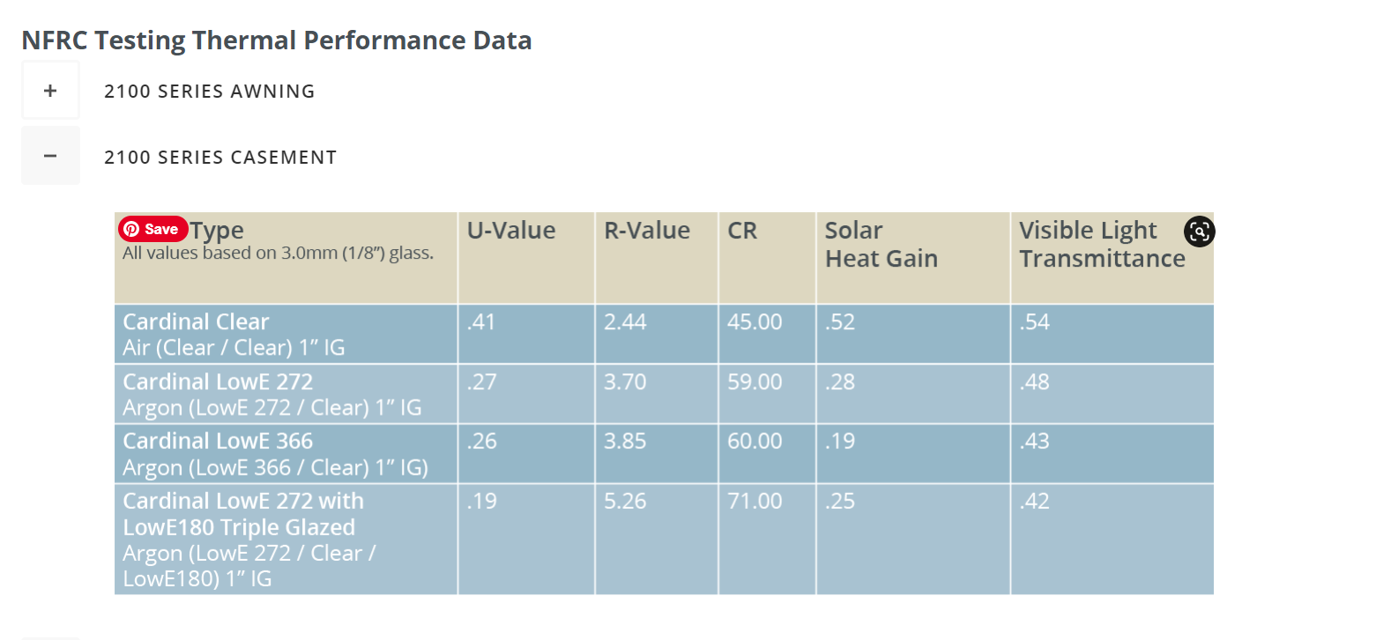

  - Appearance: Once we learned that we would likely need to replace some windows for safety/structural reasons, we wanted to make sure we not only selected the most energy efficient windows, but also ones that really honored the historical time of our house and surrounding houses in the neighborhood. We researched companies that could provide custom fiberglass windows to fit right into the existing places, that could accommodate the same profile, that had a selection of historically accurate colors, and that could provide custom grid patterns to match the existing grid pattern. Although cost savings are important, we chose to set aside the budget for something that did not detract from the look of our house’s era.

