Scope of Exterior Work at 2522 W Boston Blvd.

Issue | Solution
- 70% of windows were not present when home was purchased from seller | - Replace all windows  - Frame exterior of windows with wood the same color as the home previously was painted  Explanation of replacement - New windows are required due to not being able to match remaining windows with current windows present. Replace the remaining windows and add new windows with 8-pane vinyl windows similar to the original windows.
- Water enters basement due to driveway slope. Driveway also cracked throughout.  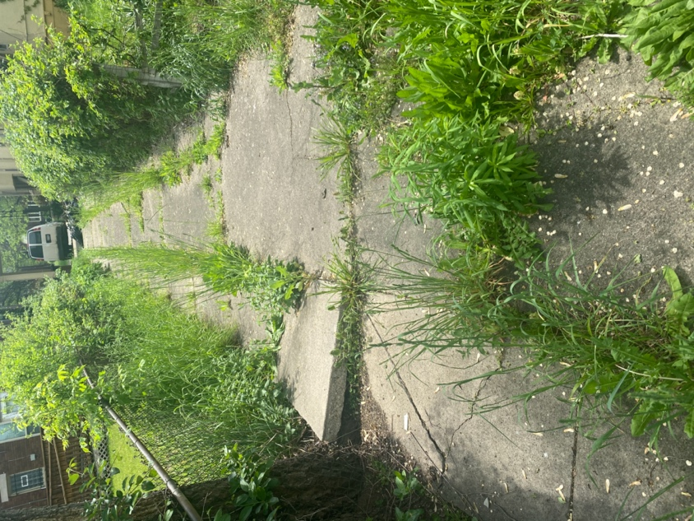 | - Replace driveway and walkway with new concrete  Explanation of replacement – water enters due to the concrete pitch therefore all concrete has to be taken up, dirt pitched away from the house to prevent water build up in the basement then new driveway pou red.
- Stairs into entry of home are worn down (currently made of stone and concrete)  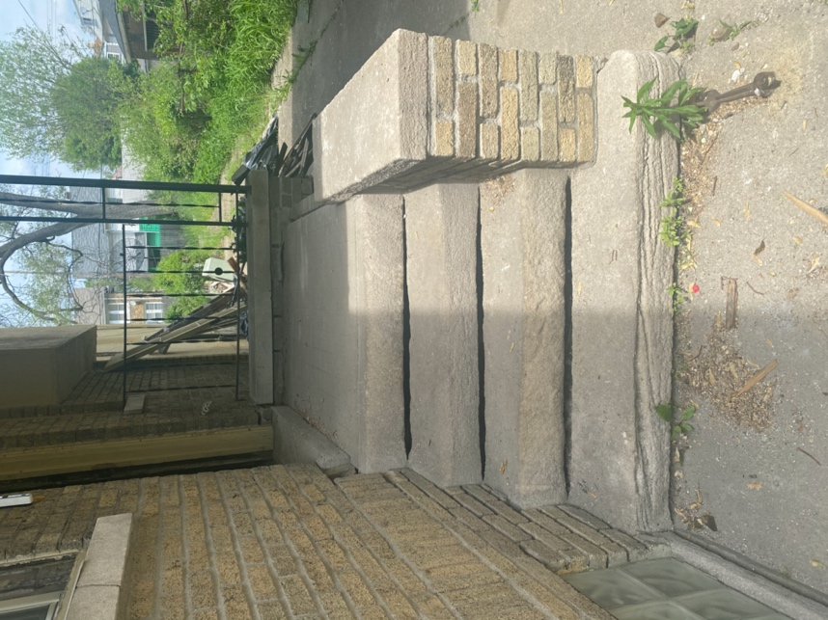 | - Replace current stairs with new concrete stairs  Explanation of replacement – stairs are worn down and are not safe currently therefore they have to be replaced
- No garage  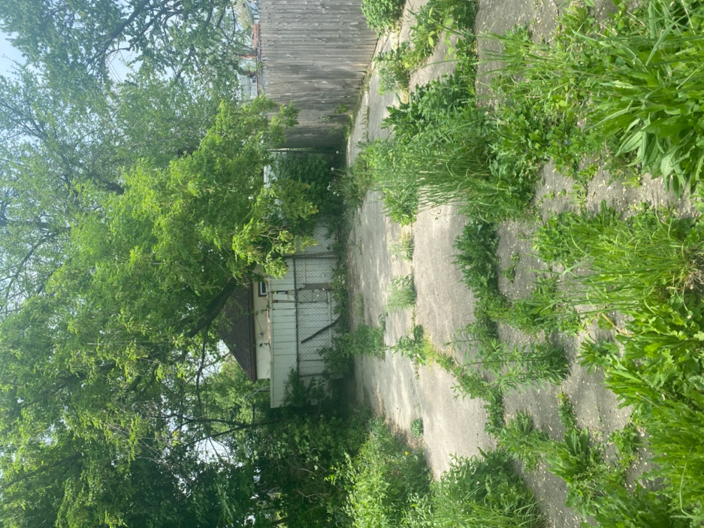 | - Build two-car garage out of material approved by HDC
- Current gate is bent, broken and rusted in several places. Gate also offers no privacy for the back yard | - Replace wire gate with 8-foot wood fence. See image below.  Explanation of replacement - A 3 foot wire, bent, broken and rusted in several places gate exists that offers no privacy into the backyard.  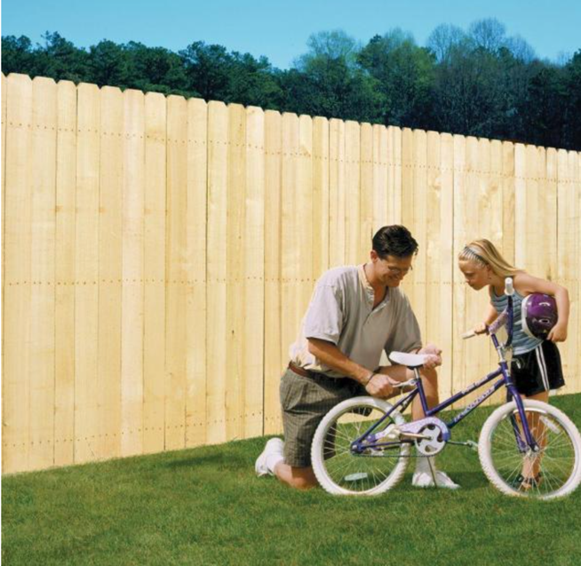

Photos of all sides of the existing building

