2238 Wabash St currently

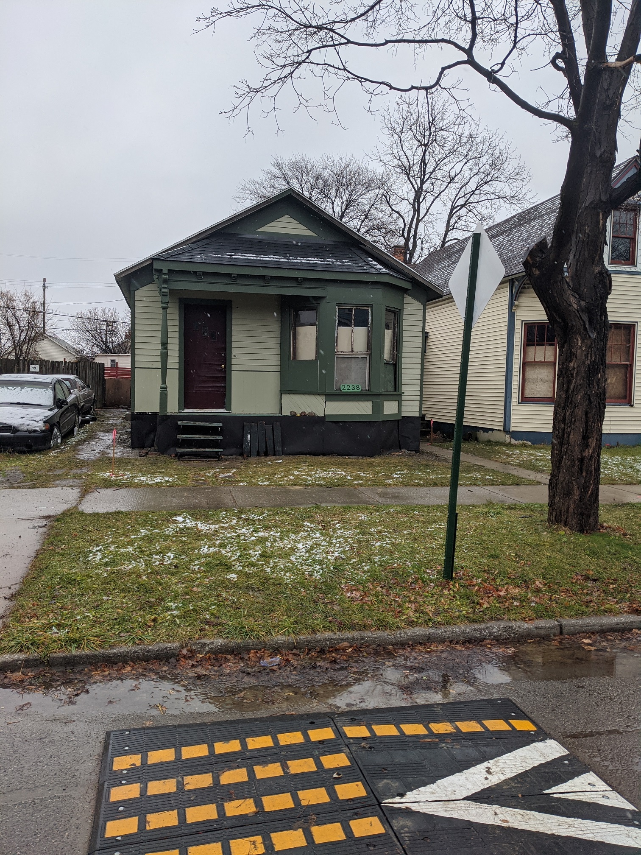

2238 Wabash when I purchased it around 2013
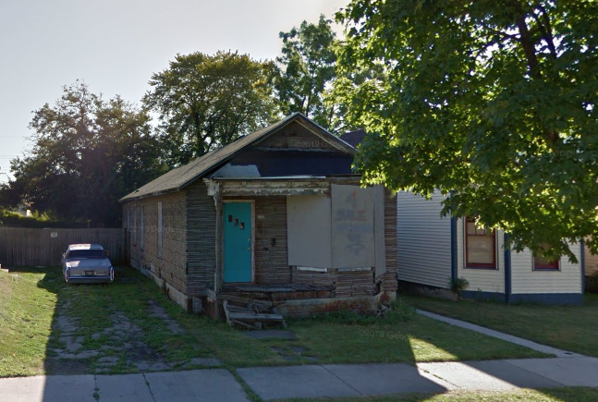

(yes, my neighbor -- a historian of sorts in his own right -- has had the same car parked in the driveway for almost a decade)
About the house

This is whats referred to, as I’m sure anyone reading this well knows, as a workers cottage, almost certainly dating back to the mid 1860s or at the latest the 1870s. The few victorian flourishes (the bay window, the corbels, some moulding), were likely added around the turn of the century at the close of the era to keep up with the fashion of the times.

There’s a fairly colorful and lengthy history of ownership and neglect that I will spare you the novel on at this time, so lets just skip forward until around 2006 or 7, when the house went up for auction by the Detroit Land Bank, I believe.

A man about town bought the house, and had some modest dreams of renovation he was purportedly working on. Some time not long into his stewardship, he got a call from the neighbor -- the one who has had his broken down car parked in the driveway this entire time -- yelling over the blare of the diesel engines that the house was about to be torn down.

In a fittingly dramatic fashion this man immediately went to the premesis and according to him basically heroically stopped the bulldozers. Now, I have no idea how long the city had been prepping this, in fact all I know is that there was a very high, very disputed bill about all of this, and part of the settlement with the city about the partial demolition was contingent on this man selling the house.

ENTER CURRENT OCCUPANT // APPLICANT

So, a spray painted sign that said ’4 sale’, and the previous owner was in business. With me. I will spare you the trials and tribulations of our ‘negotiations’ just that the purchase closed some time in 2013 I believe.

All of this is a very long winded way of saying that when I bought the house, it was on the demolition list.

Which I mention because that is why the windows on the house are missing. And that is why one of the items I would like to cover is the rebuilding of these missing windows. The window sash will be built out of the same exact old-growth long leaf pine as they were at the time. The design and dimensions are identical to within 1/100 of an inch of what the original neighborhood joiner would have specced. I have restored many windows in this neighborhood (and sadly watched many more go), and there is a very specific profile that these windows of this vintage have -- a very slightly elongated ogee -- likely unique to a particular set of moulding planes, but that I have had recreated in various tooling over the years.

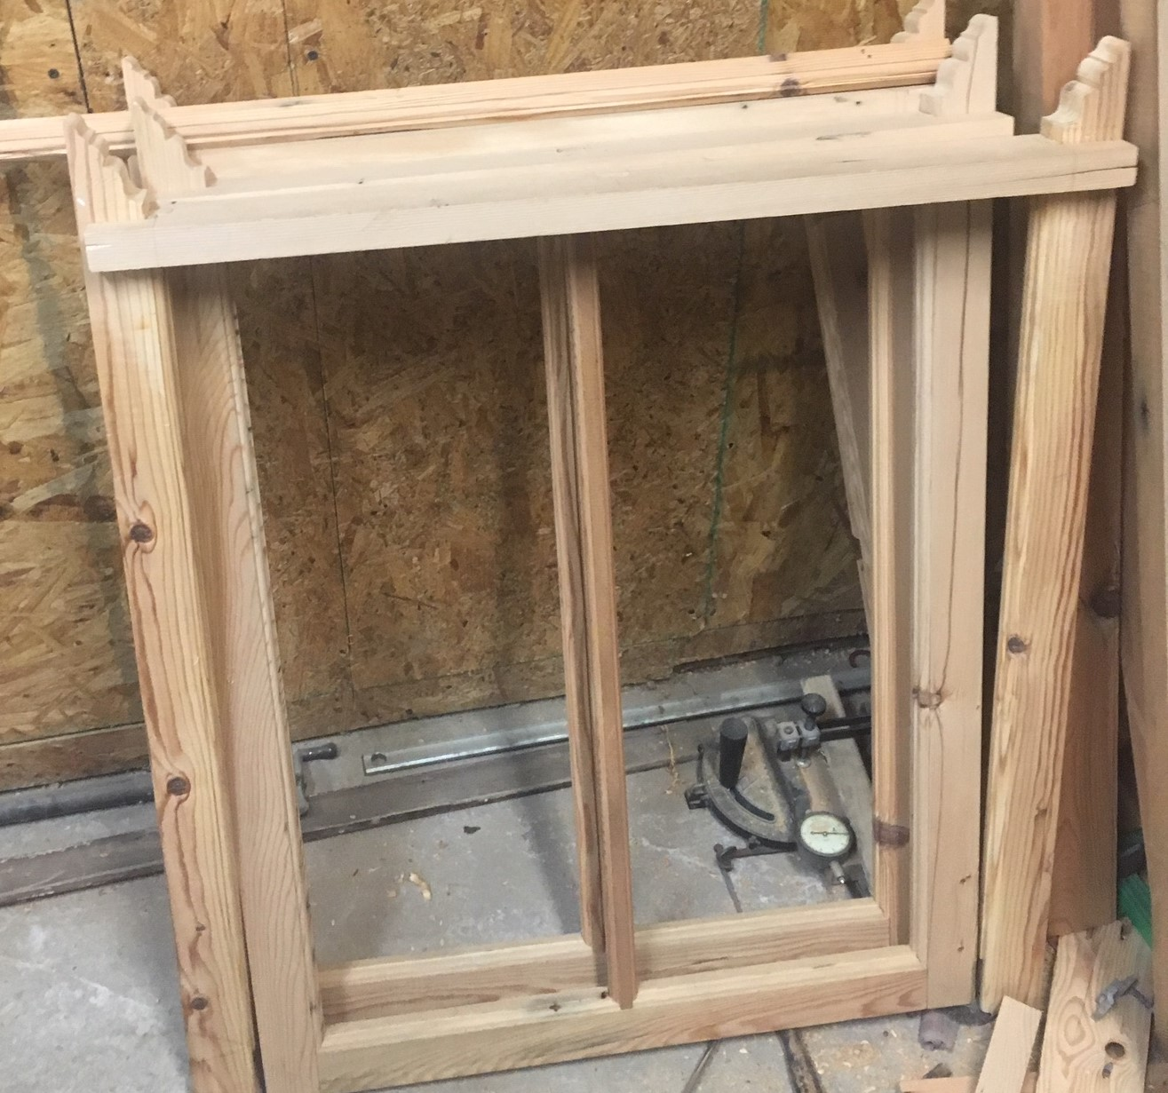

The ‘horns’ at the bottom of the sash are I believe the best design of the local sashmakers. Were I rich enough to afford the luxury of glass back then, this is the sash I would have picked. This design prevents the racking failure at the bridal joint that is so often used as a reason that windows cannot be saved. My goal is to build windows that could be horribly neglected for a few decades and even then the owner would not be able to justify their removal!
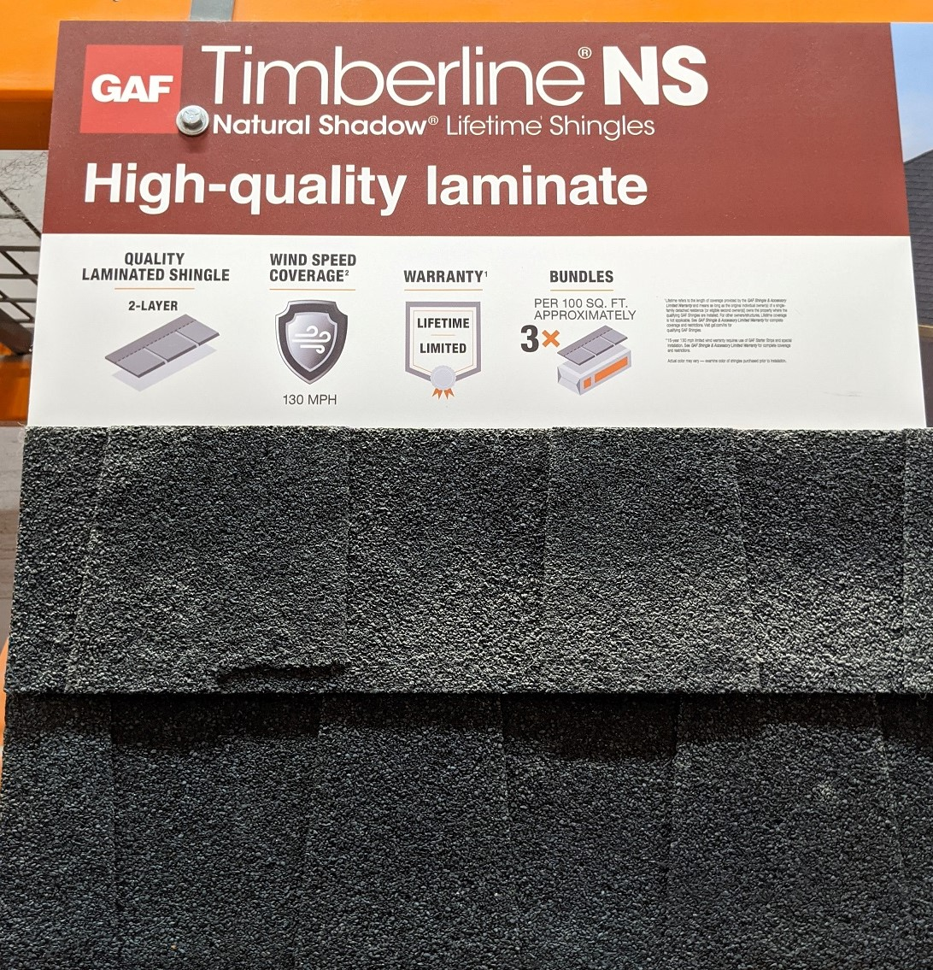
The single piece of information that the previous owner could tell me about the windows the city removed, was that they were 2 over 2. Which is why I went with that particular style.

The good news is everything else around the windows is in good shape all things considered and will be no trouble to restore.

What is not in good shape is the roof. If I let the current roof go any longer I will risk harming the integrity of the building. So I have looked up all the appropriate guidelines and color charts and believe this is the best ‘modern’ roof. I have dreams of someday recreating the exact wood shingled roof the house would have had originally, but I should first ensure the house can get through this winter.

The finest home depot has to offer. For the record, this will be I believe the only material in the entire project that comes from such a place.

Okay, so we have covered the roof and the windows, probably the two most important items. Now there is something of a mea culpa.

In since speaking with some of the staff members, I can see the historic validity to what I had written off as basically, a fake chintzy design. Which would be the asphalt siding, and the tinned metal skirting, both of which I removed.

I will say, truly, that the houses asphalt sweater did a tremendous job protecting the siding underneath, and for that I will be forever greatful.

The metal skirting was not quite as noble in its sacrifice, but I have learned to appreciate it on it’s own terms.

Here is a picture of the skirting that was removed:

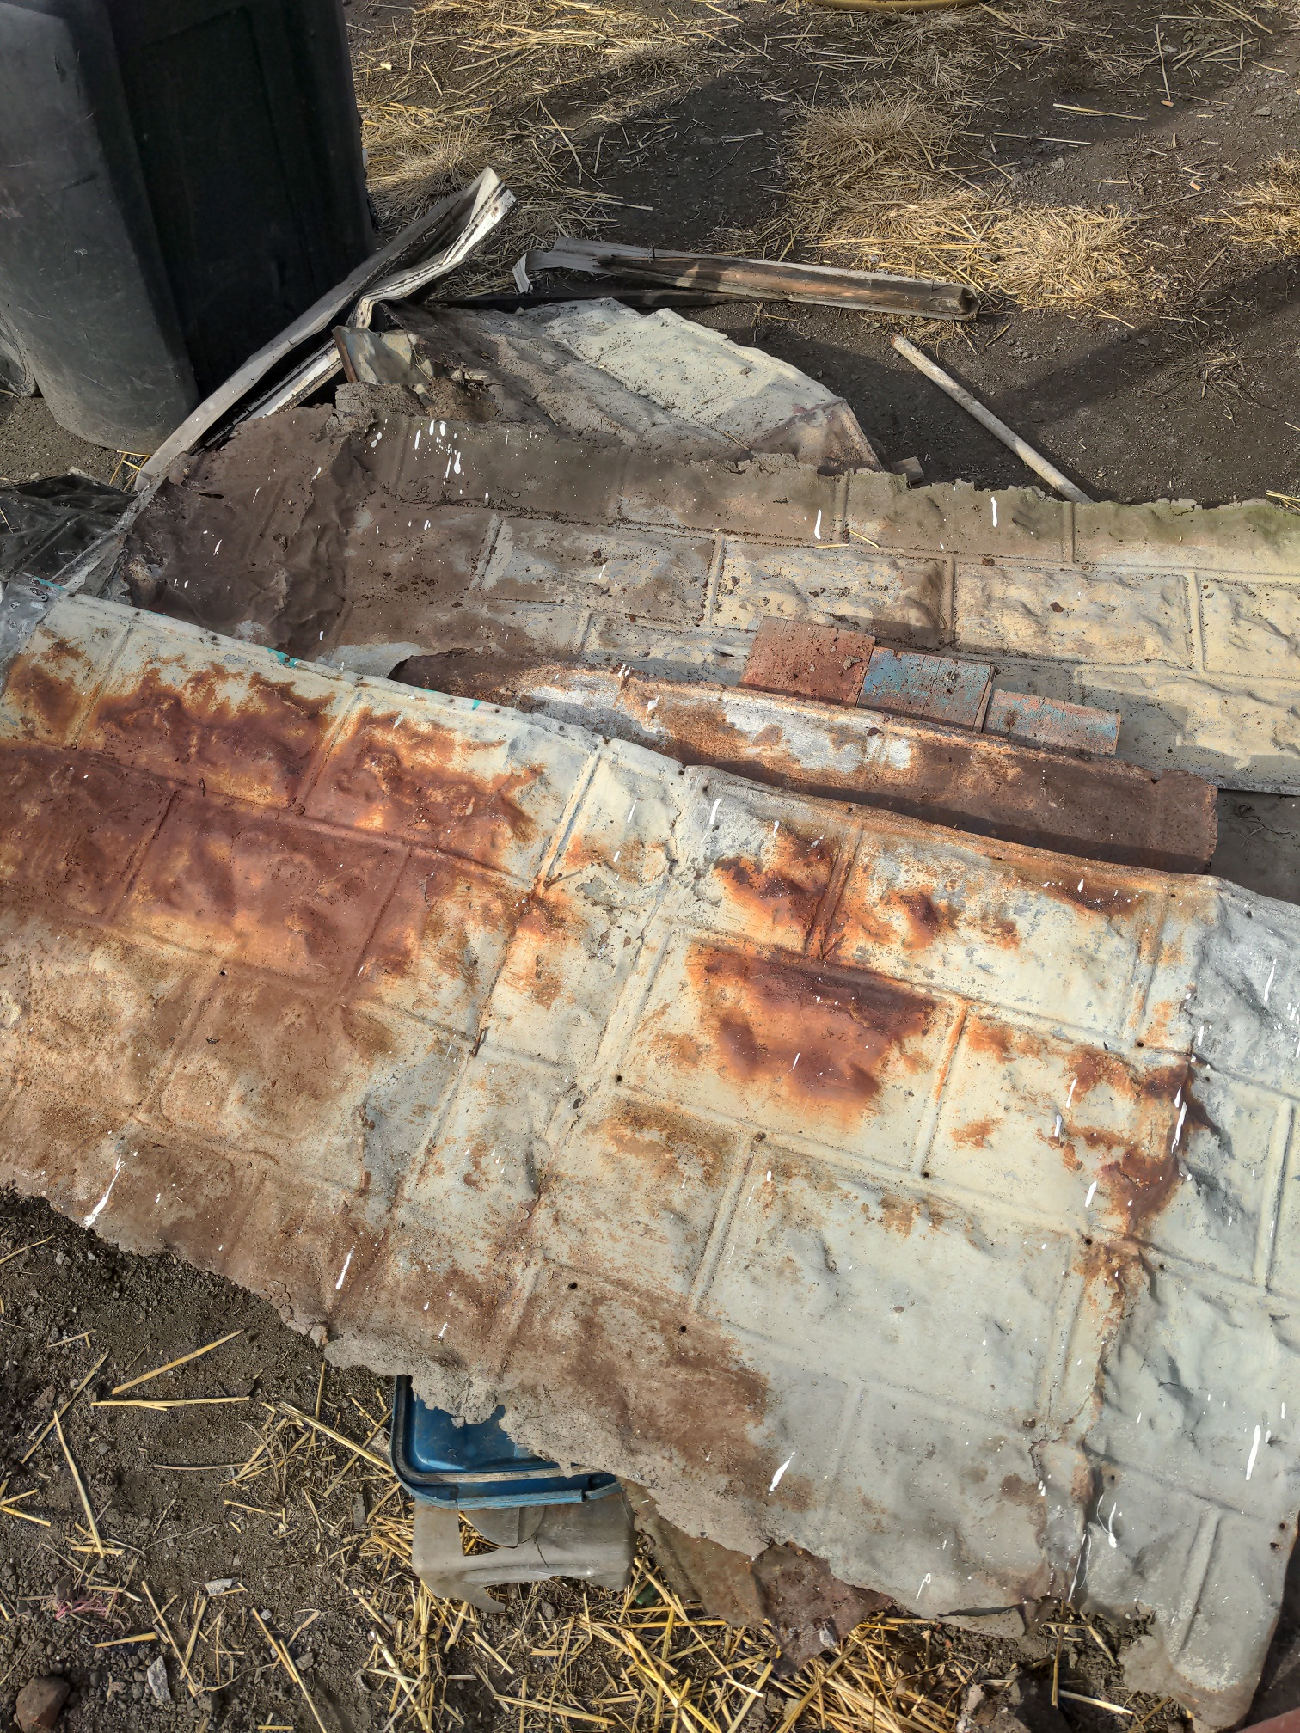

Just so we are all clear on some things. I take the preservation of history extremely seriously. I cannot tell you how many times the language ‘it couldnt be saved’ are used falsely to justify destruction. Actually, of all people, I dont need to tell you because whoever reads this likely knows even better than I. So please believe me when I say that I do not take my responsibilities on this project lightly. The reason I have that picture at all is because I piled the old skirting and found a home for it.

So nothing was thrown away or destroyed. But that metal skirting was removed. It has been rehomed.

What it revealed was undoubtedly the part of the house most in need of attention, so in that sense it was a necessary part of the process.

The skirting was put over the asphalt siding, which laid against the bare, original, wooden skirting.

Where the stacked, beveled, horizontal nature of the siding gives a natural air gap against the asphalt siding ensuring the preservation of both, the original heartwood pine skirting, placed vertically (made of the same exact dimensions as the flooring in these cottages), sits right against it. And so when the water wicks up in the materials over time it has no where to breathe or ‘air out’, which creates the phenomenon called dry rot, which I am pretty sure anyone reading this knows is an erroneous term but, the condition nonetheless is very real.

So what I’m trying to say is that this original wood skirting was in a dire way. It had been trapped for a very long time and being in contact with the ground, subject to the whim of various snows and rodents, it was really trying to survive against the odds. And for these reasons -- and probably because any house still standing after 150 years has had at least one substantial foundation job -- you never see these old workers cottages with this original skirting.

Which is why it is my intention to have the singular house that does.

But first let me share some pictures about what I am referring to. You can see some of this original tongue-and-groove pictured above, but here are some more.

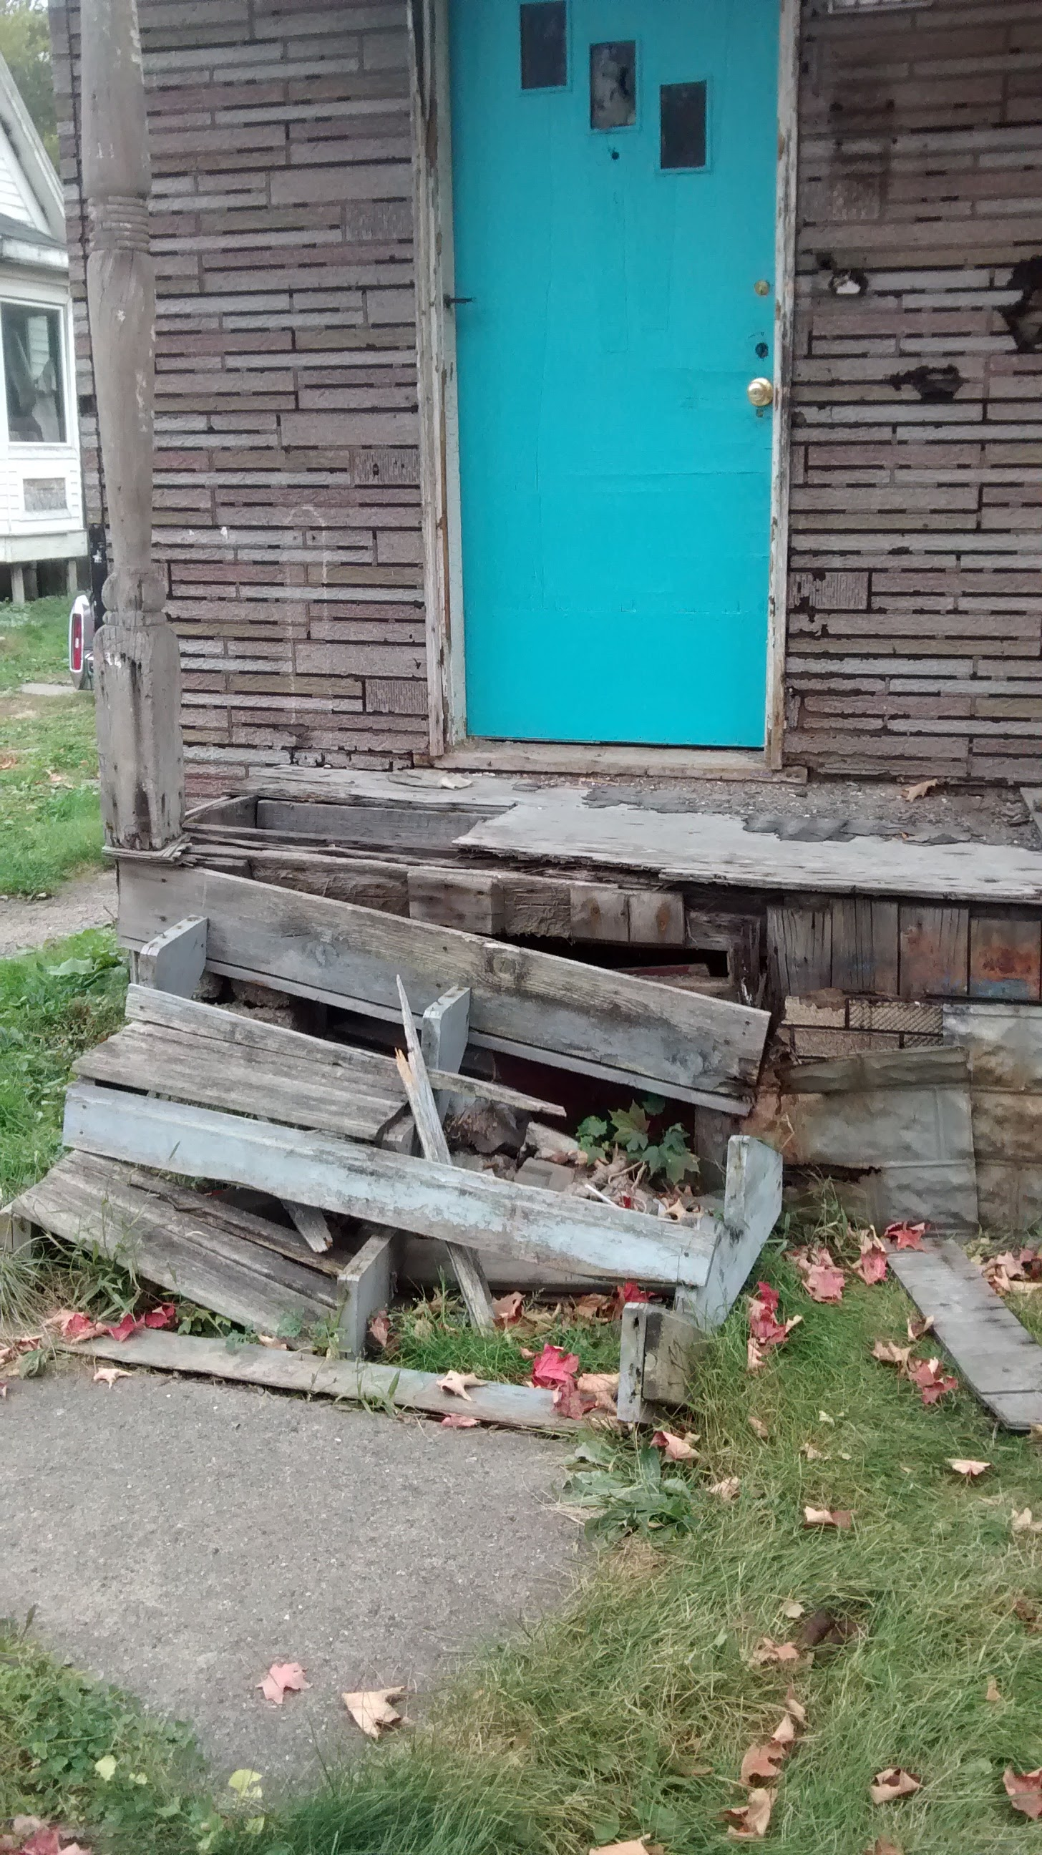

I am also going to attach a photo of the one house left in the entire corktown area that to my knowledge still has the original skirting boards:

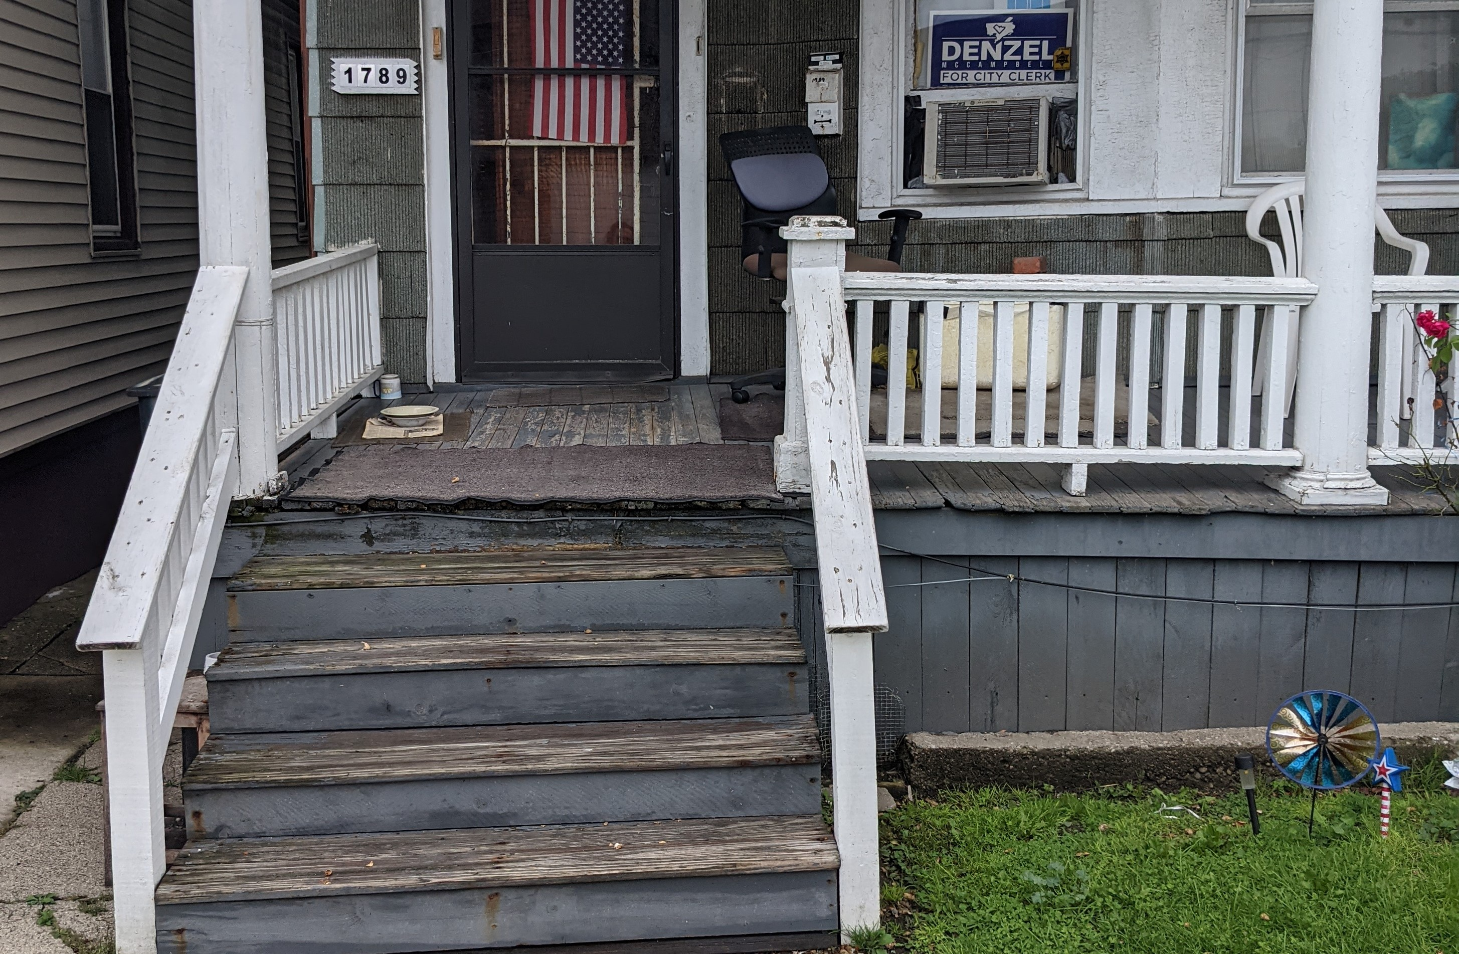

I am doing everything I can to save as many of the boards as I have. They are extremely far gone, and believe me I do not say that lightly. I believe I have enough to do the front half of the house, in the original design and as pictured, going up to the siding, with a board across the top. I will dip the bottoms in epoxy and use a french drain to try to give them the best lifespan possible.

The boards I do not have, I will try to source as much as I can of original materal. My salvaging days (and thankfully the destruction of houses around here), seem to behind me, but I will do my best to source as much as possible.
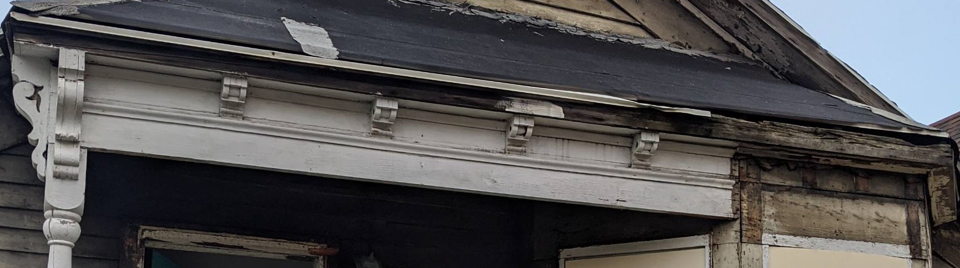
What I cannot make out of the original longleaf tongue-and-groove, I will have sourced by the lumbermaster at Brooks, and I will mill it to the exact dimensions myself.

After the roof, windows and skirting are complete, the remaining details seem relatively minor by comparison. The house has some corbels that were destroyed when the asphalt siding was put on. Fortunatetely the paint lines (that can be seen in person but not in any photograph my camera is capable of taking) are visible and the design is well-known.

Here you can see the existing corbels and the shadow lines over the formost bay window:

I intend to reproduce two of the larger corbells exactly, as well as two of the smaller ones, exactly.

They will be made out of the same longleaf pine from the same vintage as everything house, from lumber sourced from neighboring demolitions and remodels.

Once this work is complete, I can then wrap my head around some of the remaining finer points of the design and I will be happy to contact anyone who reads this when that time comes. But at this time this is the entirety of the scope of work I intent to complete on the house.

If you have actually taken the time to read all of this, thank you. Honestly, I am appreciative of the obligation to document all of this, and many years when I look back on this project, I will be grateful that I had to take all of these pictures, I’m sure.

-- Matt

