June 28, 2021

Detroit Historic Preservation Team
Daniel Rieden, Lead Landscape Architect
Coleman A. Young Municipal Center
2 Woodward Avenue, Suite 808
Detroit, MI 48226

RE: Follow-up on Plan for Painting
2071 Longfellow Street, Detroit, MI 48206

Dear Daniel Rieden:

I hope that this message finds you well. I am following up with you to let you know where I am at in the process of removing the paint on the concrete, and adding the “cream” color that was approved for specific areas. During spring and up until now I was working on making these two changes so here is where I am at today.

I used the entire container of Sure Klean Heavy Duty Paint Stripper. I applied the stripper on May 16th, May 23rd, May 30th, June 5th, June 19th, and June 26th. From my observations, the paint stripper slightly lightened the paint color however no paint was removed. Here are some recent pictures of the areas that I took today for your review.

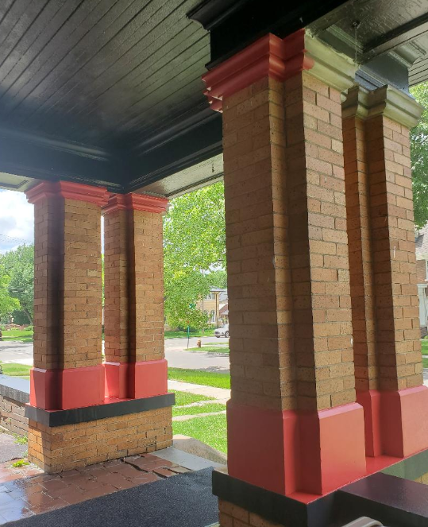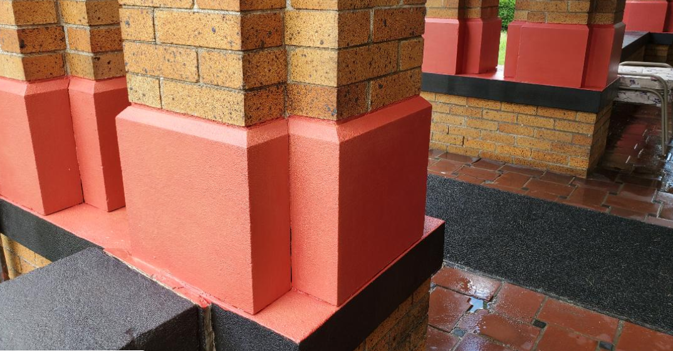

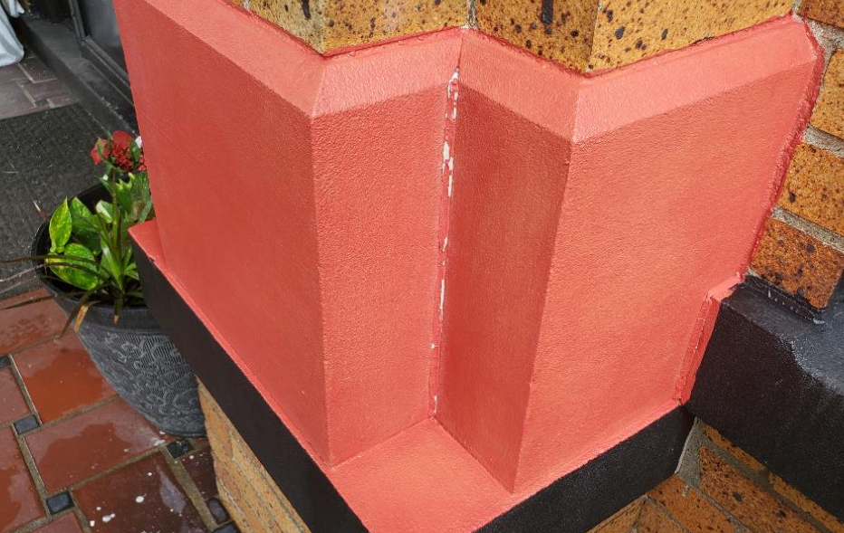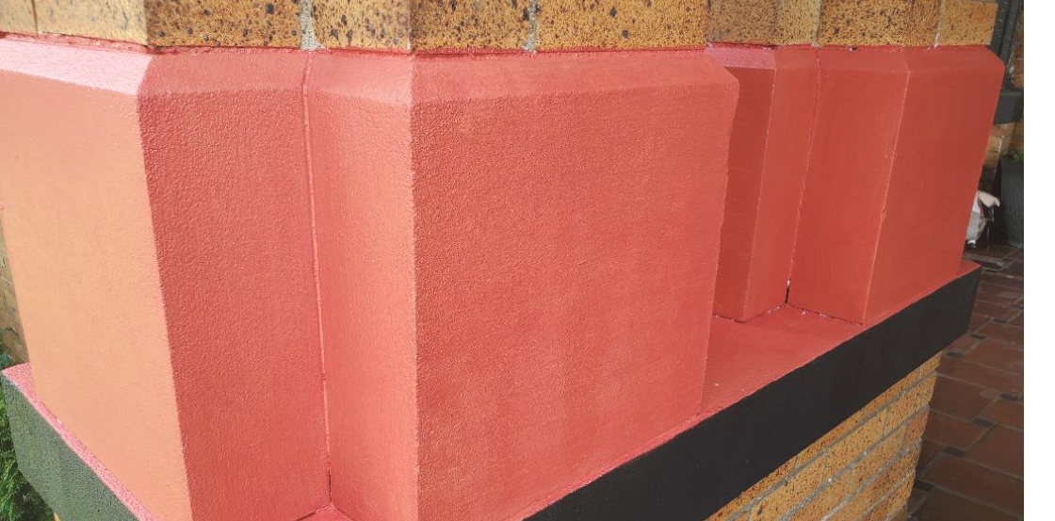

I would like to note that this was a gentle form of attempting to remove the paint however the smell and strength of the stripper made it somewhat dangerous. Some of the stripper fell on my skin when I was rinsing it off of the cement and the stripper literally burnt the skin off of me through my clothes. Here are a few pictures.
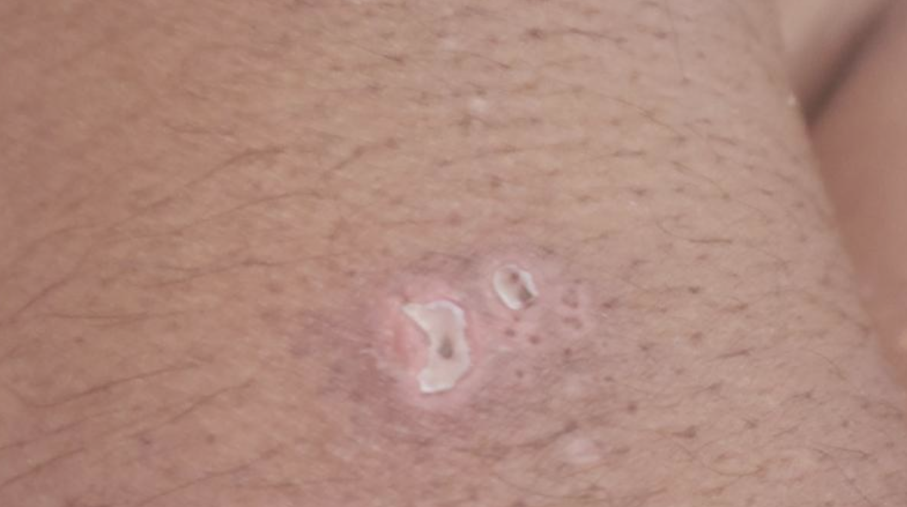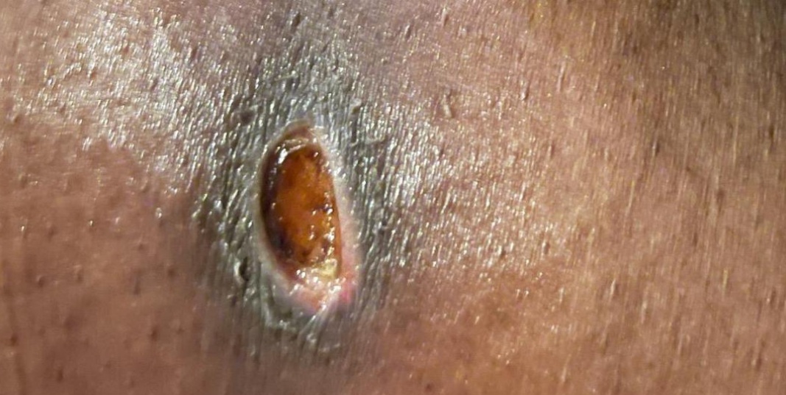
Chest area Right arm Right thigh

I picked the PPG color stone quarry. Here is a link to the PPG website for the color.

https://www.ppgpaints.com/color/color-families/neutrals/stone-quarry

I applied this stone quarry color to the rectangular boxes on the 2nd floor and to the front door. Here are some pictures for your review.
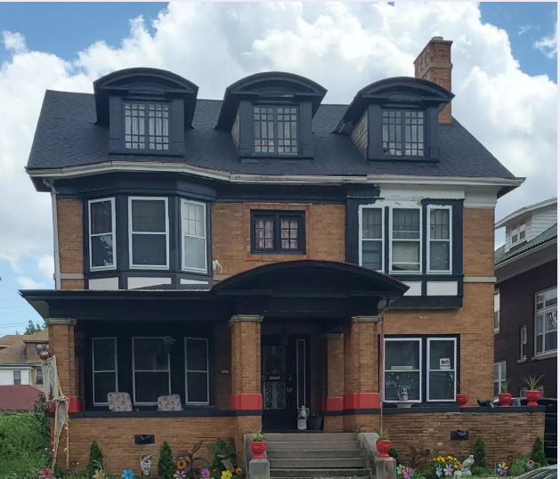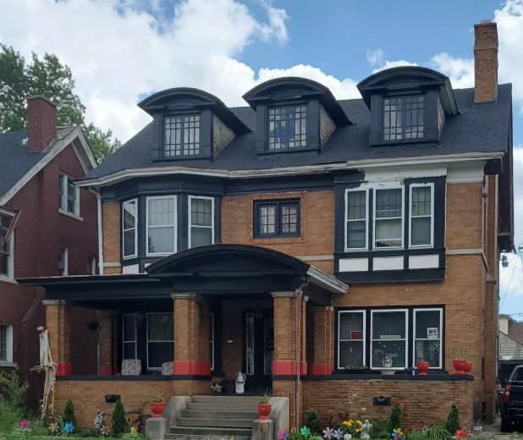

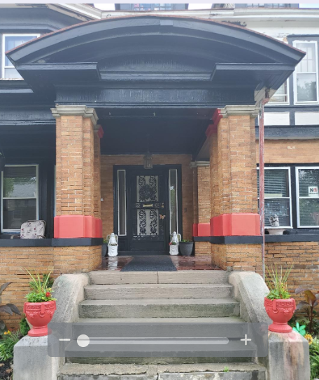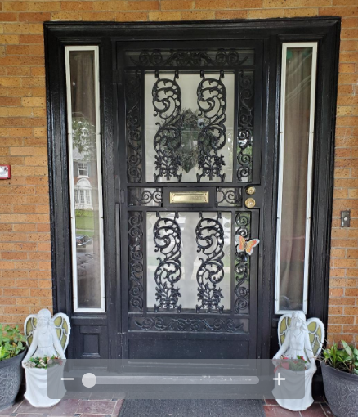

At this point I would like to ask for permission to use the Stone Quarry color to replace the red paint color that is on the cement? I do not think that it is possible to remove the paint from the cement. I think painting the cement the Stone Quarry color will bring some uniformity to the house. I like the color and I think it blends well with the color of the brick.

Thank you for your time and consideration. Please contact me at hightow5@yahoo.com with any questions.

Wells, Delia
2071 Longfellow Street
Detroit, MI 48206

