March 30, 2021

To: The Planning and Development Department for the City of Detroit Historic District
Commission.

From: Estela A. Thompson, Tenant at 1670 Bagley.
Property Owner: Petra Galvan

Attach is a Project Review Request for the house of 1670 Bagley, Detroit, Michigan 48216. Also, included are answers to the questions sent by Brenden Cagney. The only question that I could not answer was question number (7) pertaining to re-vise drawings of the porch I believe. I am not sure.
Historic District: Corktown Detroit

Stella Thompson <sthompson@emich.edu> | Tue, Nov 10, 2020, 2:52 PM
From: Historic District Commission (Staff)
Sent: Friday, August 14, 2020 9:41 AM
To: Carol Johnson <cjsprojectmgt@gmail.com>; Historic District Commission (Staff) <hdc@detroitmi.gov>
Subject: RE: [EXTERNAL] 1670 Bagley Renovation Project

Thanks, feel free to email me if you have any questions…
-Brendan

From: Carol Johnson [mailto:cjsprojectmgt@gmail.com]
Sent: Thursday, August 13, 2020 5:22 PM
To: Historic District Commission (Staff) <hdc@detroitmi.gov>
Subject: Re: [EXTERNAL] 1670 Bagley Renovation Project

Good Afternoon Brendan,
I will get to work on your request. Thank you for the clarification.

On Thu, Aug 13, 2020 at 5:19 PM Historic District Commission (Staff) <hdc@detroitmi.gov> wrote:
Good Afternoon,
I had a hard time understanding the application based on the items submitted.

Please provide / revise the following items to complete your application:
1. Photos of front, rear and sides of home (photos should capture the entire home in one shot, as best as possible… only front elevation provided)
2. Detailed photos of rear / side porch,
3. Detailed photos of front porch, showing decorative elements at top of columns (brackets and trim) bottoms of columns…. deteriorated decking, overhang,
4. Detailed Photos of proposed window to be removed – interior and exterior
5. Better description of all things to be replaced in project- describe columns size and how exactly they will be replaced… for example – replace (4) existing 4”x4” solid wood column with new 4”x4” solid wood column, etc… . you also need to detail what is happening with the brackets and decorative trim, will it be retained It says it will on drawing but needs to be in written description as well... Also, provide detailed info about proposed decking, railing, etc. You will need to better describe the existing window proposed for removal and why it should be replaced. The more detail, the better
6. Spec sheets (pdf or jpeg) for all replacement products, including window, shingles, new fence, decking, columns, octagon window
7. Revise drawings: I am not sure what I am looking at with regard to the drawings, I cannot submit to the commission as they are, please revise them. A 4’ line should not be longer than an 8’ line. Maybe it would be perhaps more effective if you did a before and after drawing instead of showing both existing and proposed. and label the items so we know what we are looking at.

Please note that your application is incomplete until all required information is submitted and cannot be acted upon further. Incomplete applications cannot be heard before the Historic District Commission.

Sincerely,

Brendan Cagney
Historic Preservation Staff
Detroit Planning & Development Dept.
Coleman A. Young Municipal Center
2 Woodward Avenue, Suite 808
Detroit MI, 48226
www.detroitmi.gov/hdc
cagneyb@detroitmi.gov
Michael E. Duggan, Mayor

Photos from front of house.

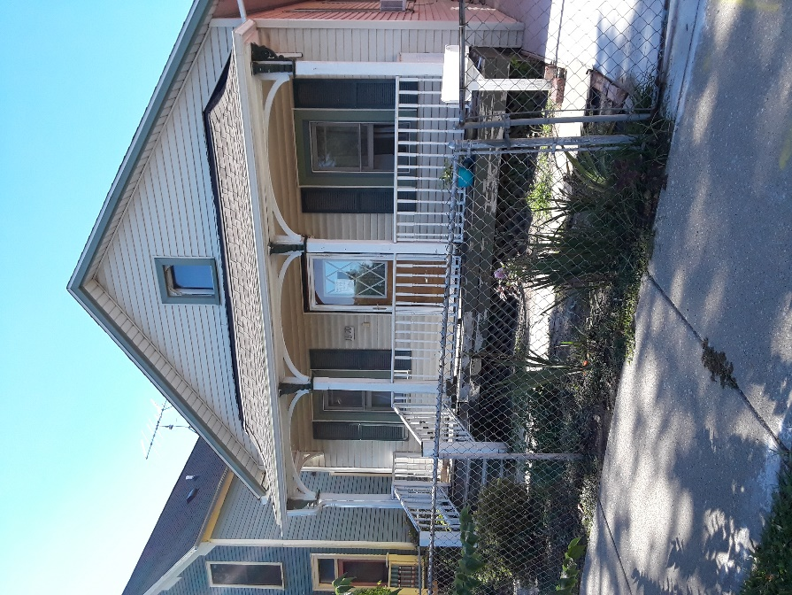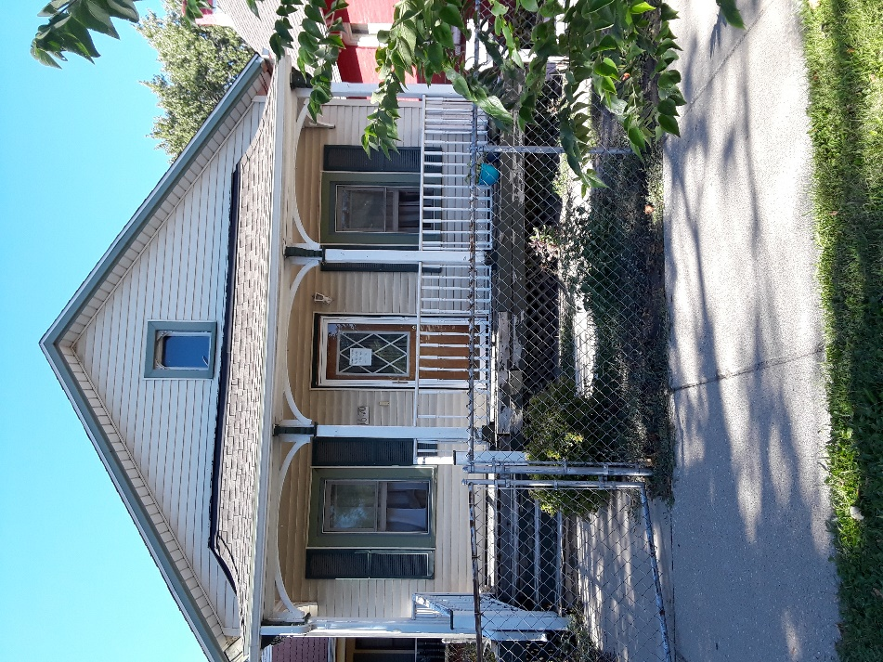
Front top window plus front of house. Picture of front porch.
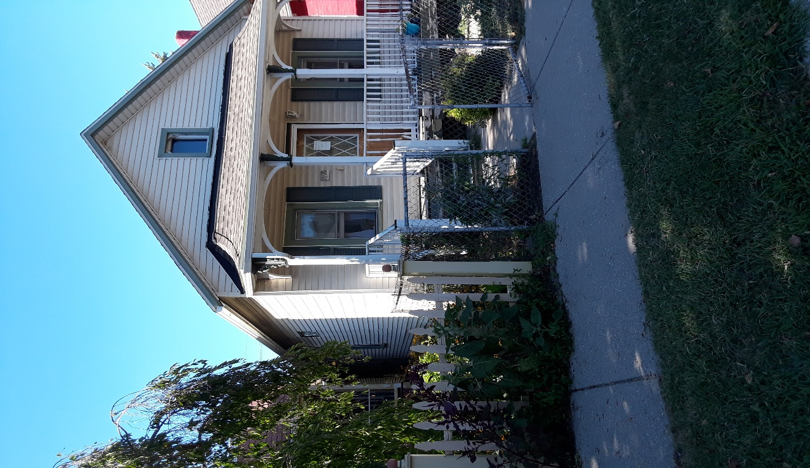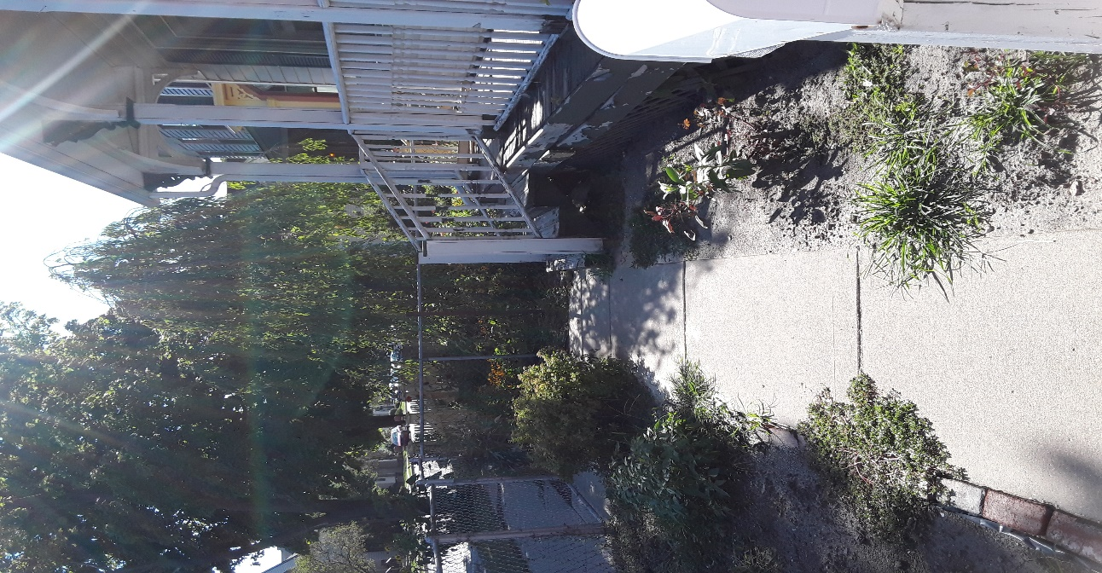
West corner of the front of the house. Metal gate and Paint peeling from front bottom fence will be replanced by painted white wood gate and fence.

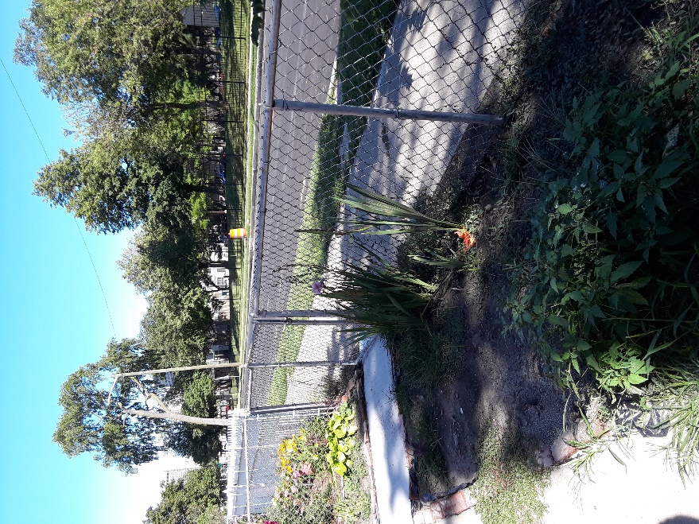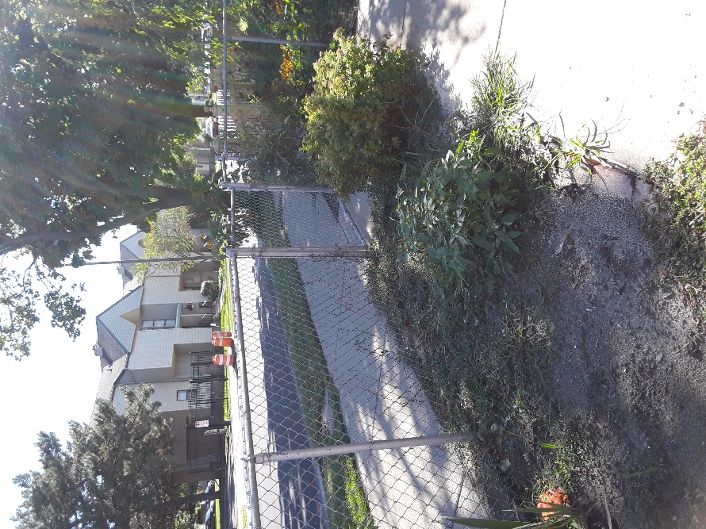
Side gate and fence. Front gate and fence.
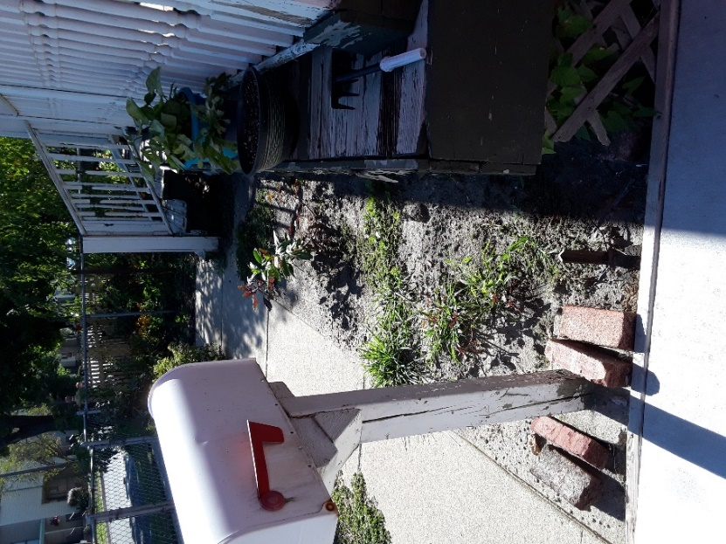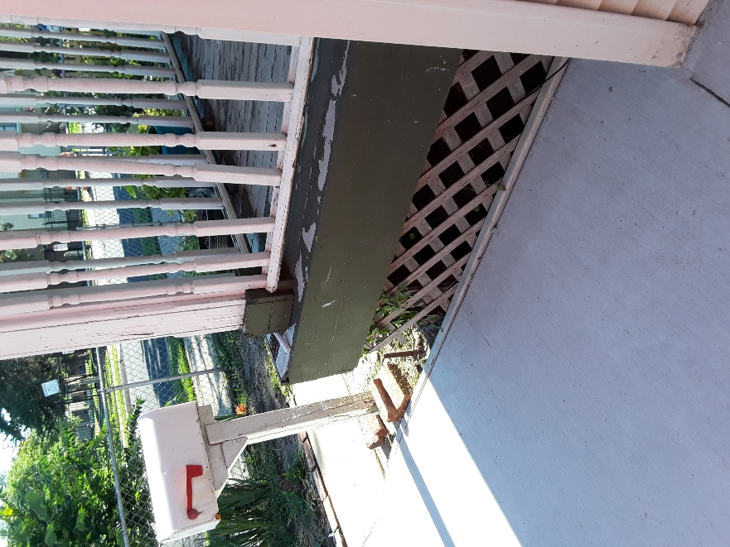
Porch floor is wider than overhang and rail. Porch is falling into the ground.

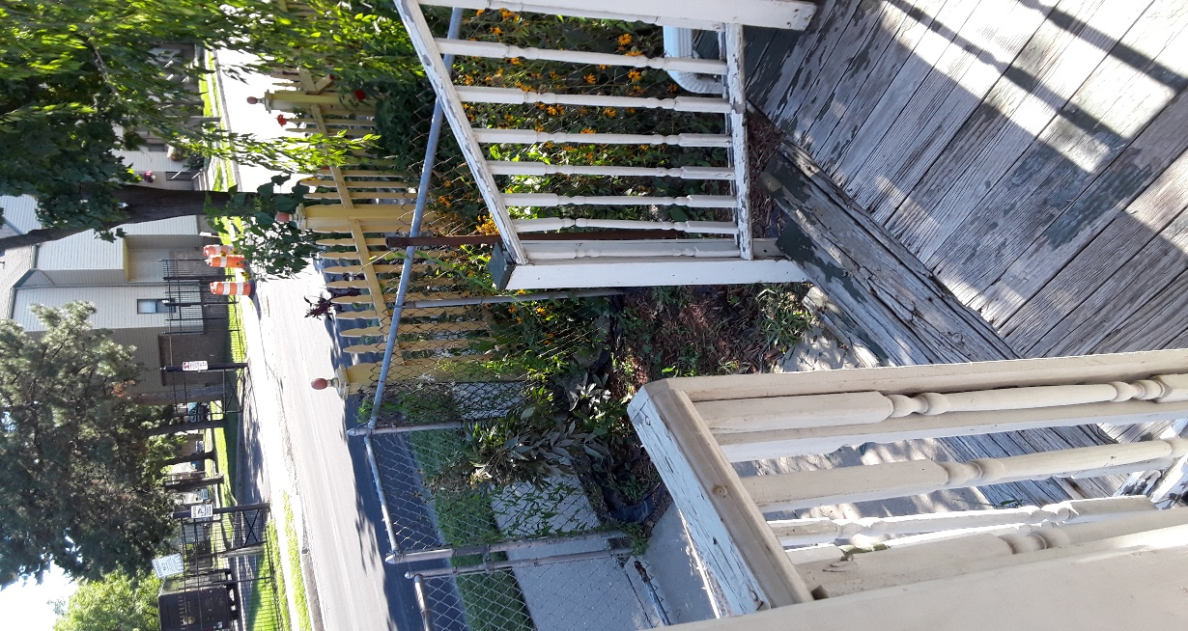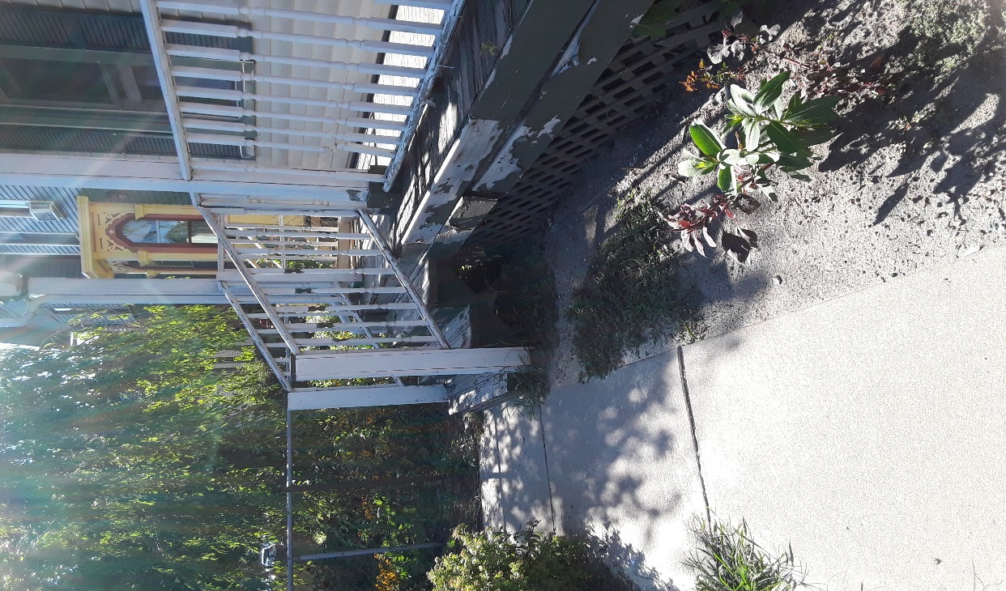
Front steps from front porch.

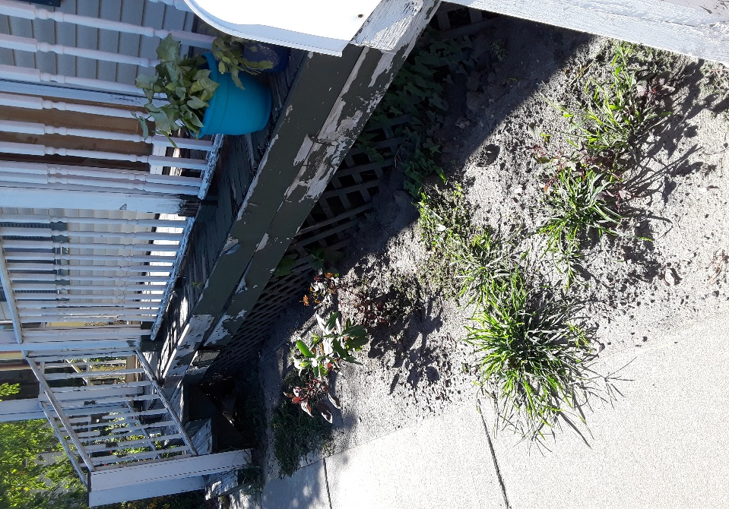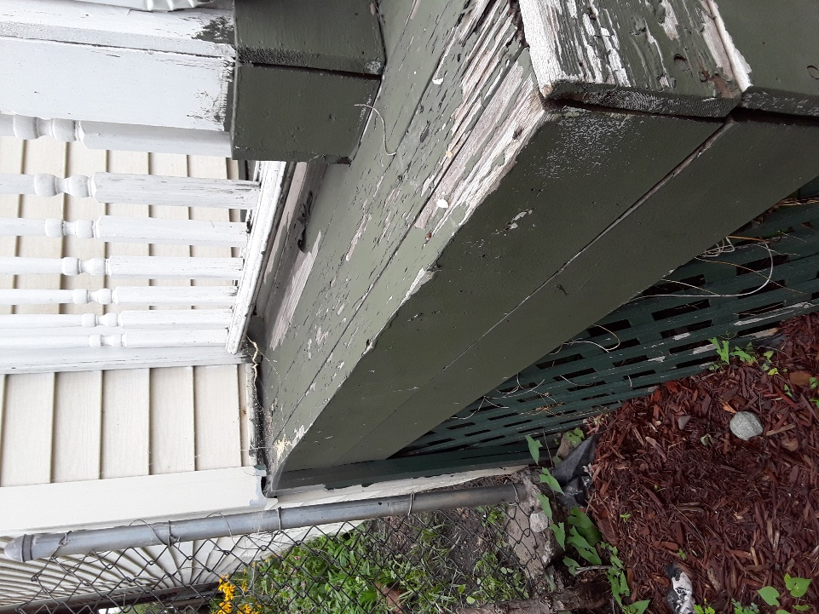
Front porch rail, skirt, and floor siding. West side of porch.

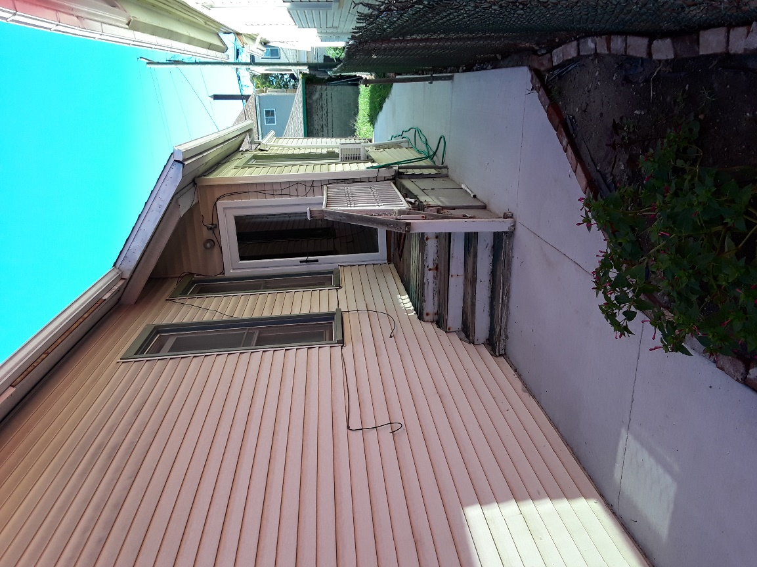
Side porch of house.

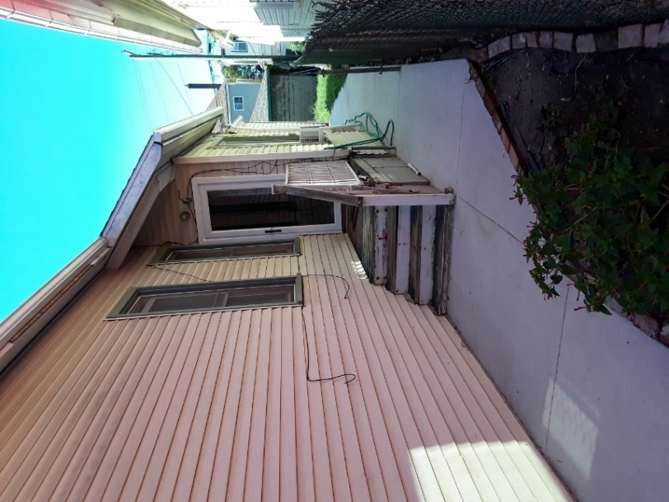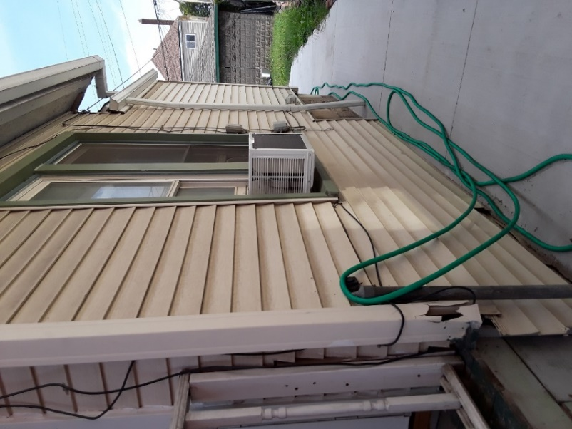
Side of house.
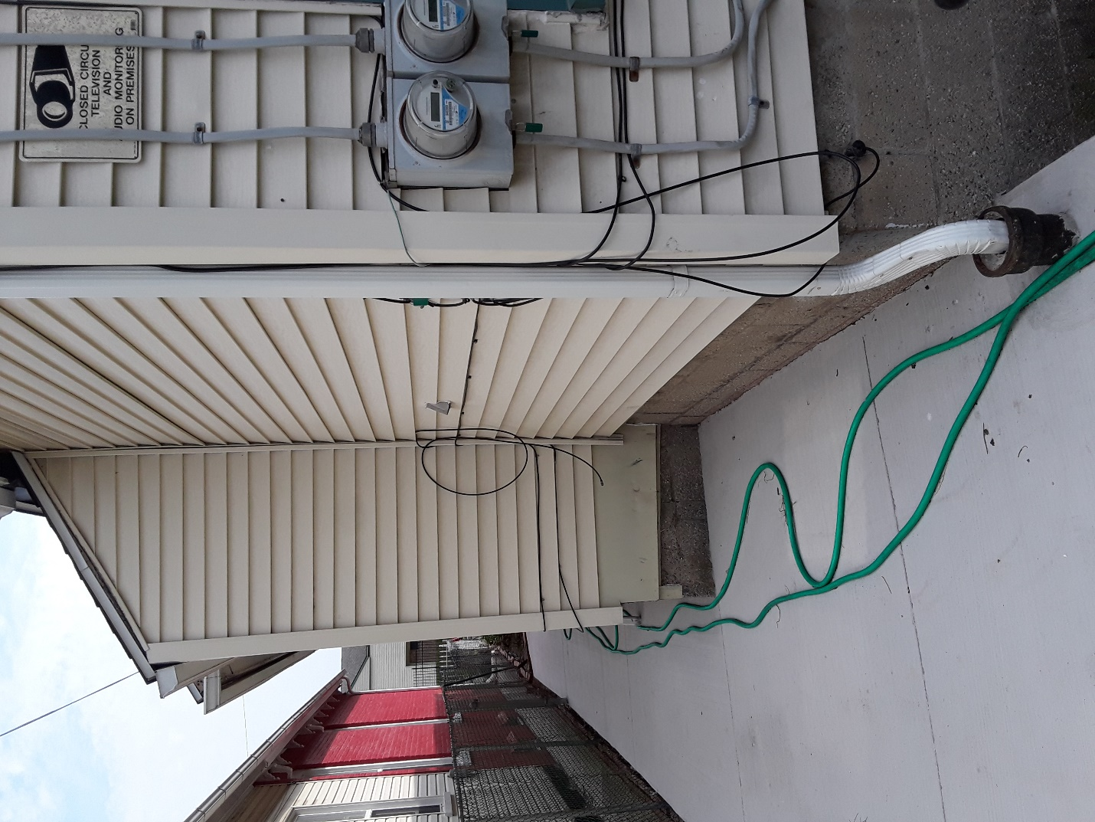
Side of house, heading toward back.

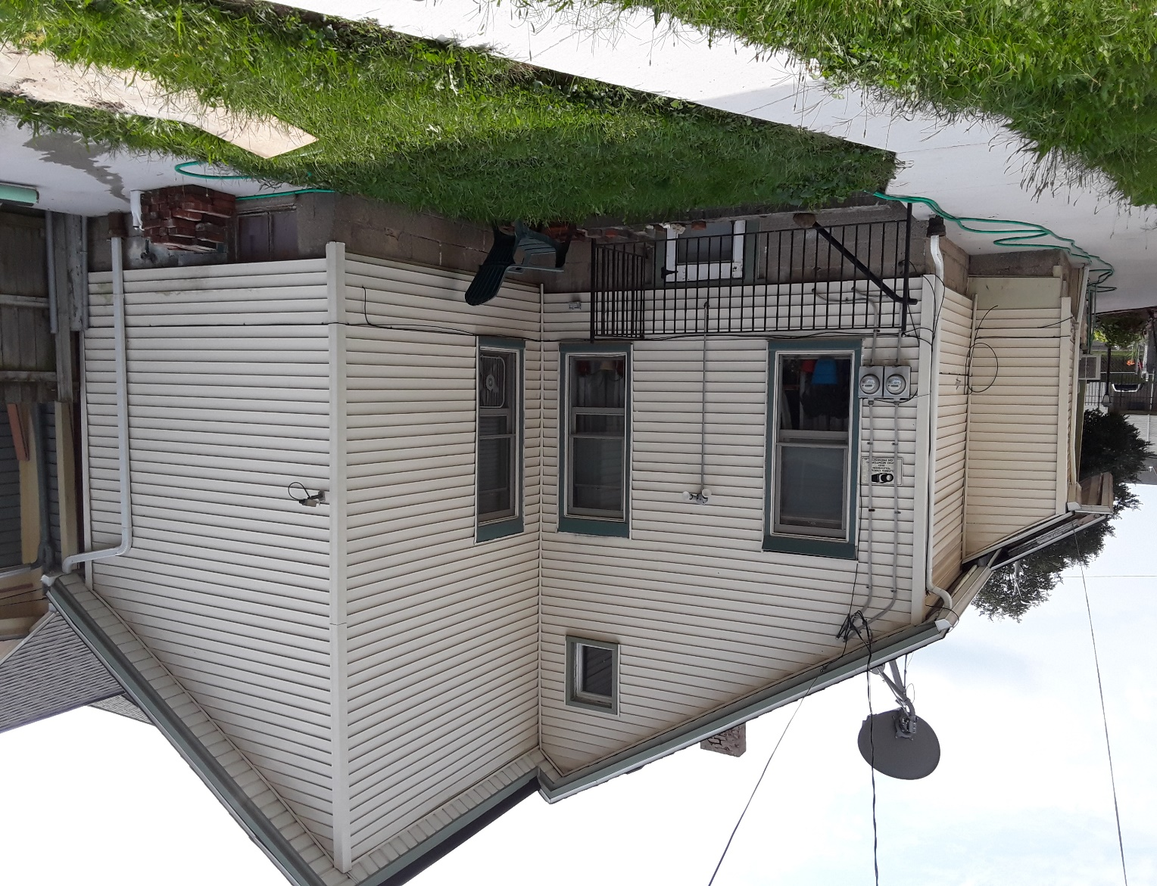

Rear of house.

Side Porch
Most of the work for 1670 Bagley will be the removal of rotted wood floor deck for both side and front porch. The railings, steps and handrails on both front and side porch need to be removed due to hazardous conditions and replaced by sturdy, heavier wood materials for safer traffic.
- Side Porch is in poor condition.
- Requesting removal of wood deck, rails, spindles, handrails, and steps. Requesting Trex composite for side porch deck floor, kick board and top of steps only to prevent wear, tear and wood rot.
- Spindles, rails and front of steps will be wood. I will provide desired spindles further into the report. All spindles and rails to be painted white. Except for Trex composite. Whatever color composite is on sale, I will take.
- Requesting side porch rail to be move over 2 inches from original middle position.

Please see attached photos of side porch:
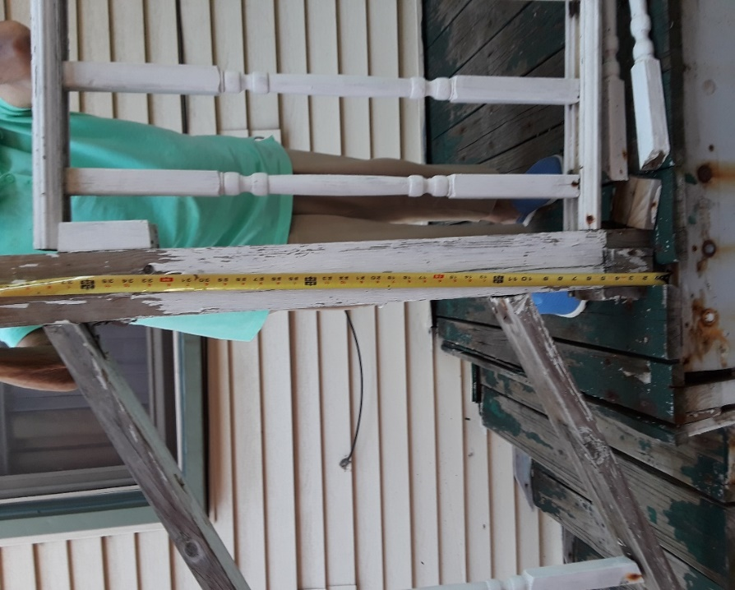

This is my mother helping me take measurements for this project. This is the rail post which will be replaced by a new wood post.
It is 42 inches long inserted into a block wood square which will also be wood.
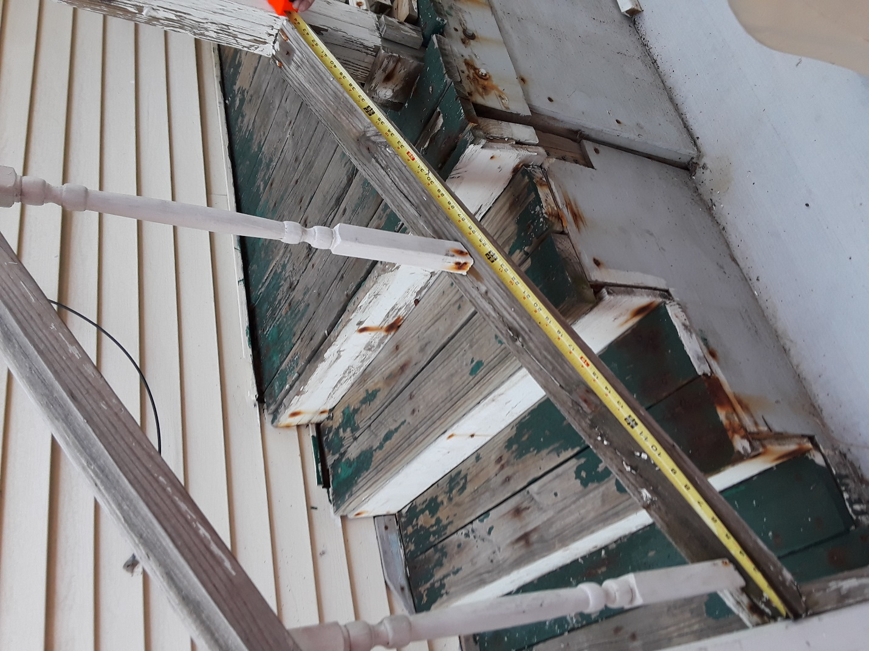
Bottom rail is 45 inches long, being replaced by new wood.

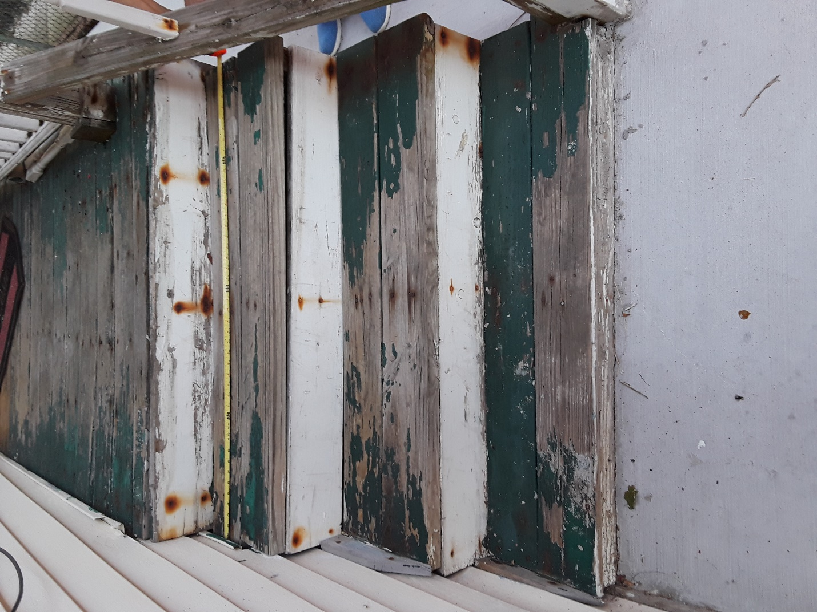

Top of steps are 45 inches wide and top of deck is 46 inches wide. I am requesting to add two more inches in width to the deck of side porch for added space. I am requesting Trex composite for the floor deck and top of steps. I am also requesting Trex composite for the stepping kick board since it has a tendency to fall apart.
Not sure if I should stay with 3 steps or make it 2 steps?

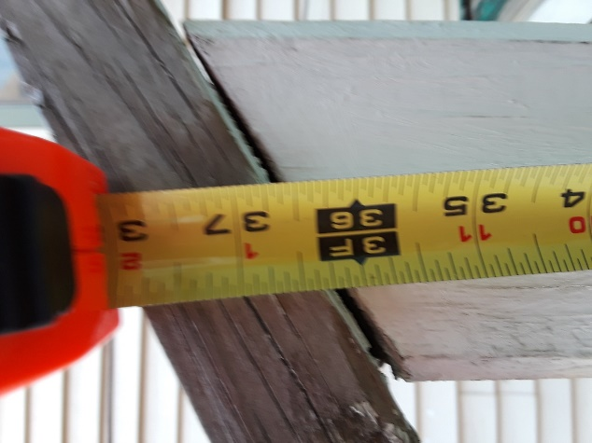

Post for side porch rail is 38 inches. It will be replaced by new wood rail.

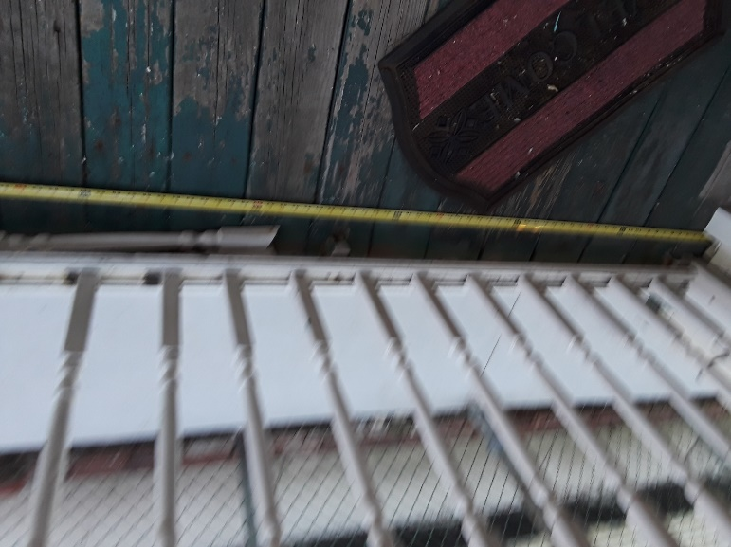
Measuring side porch deck. Kinda blurry. Sorry
Length of side porch is 87 ½ inches long. The length of porch will stay as is preferably with Trex floor composite.

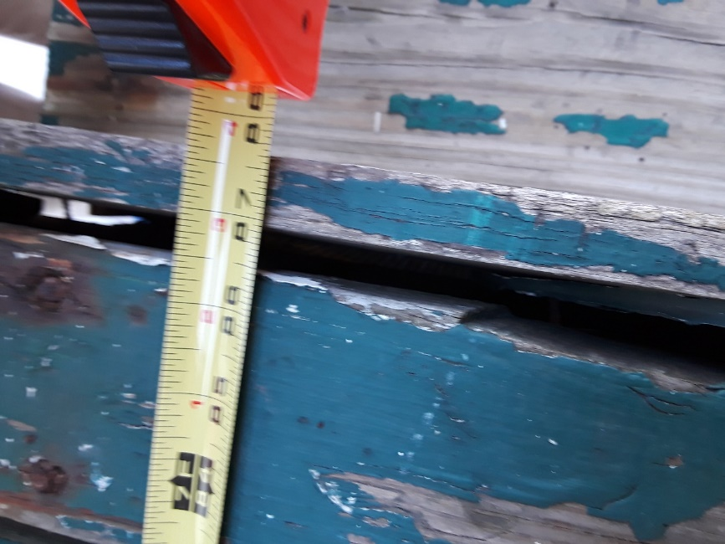
End of porch floor is at 87 ½ inches long.

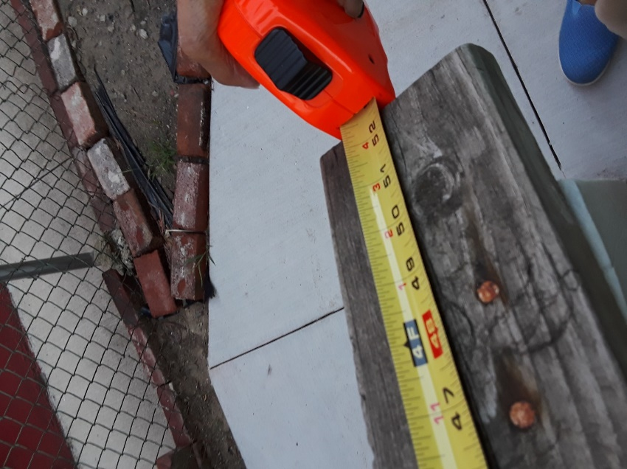
End of top rail for side porch is 52 ½ inches long. It will be replaced by a new wood rail.

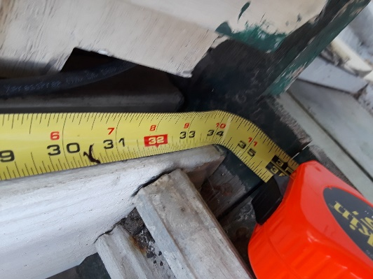

This is the beginning of the rail attach to the house. A wood board attach to the house and rail from top to bottom it is 34 ½ inches long. It will be replaced by a new wood board.

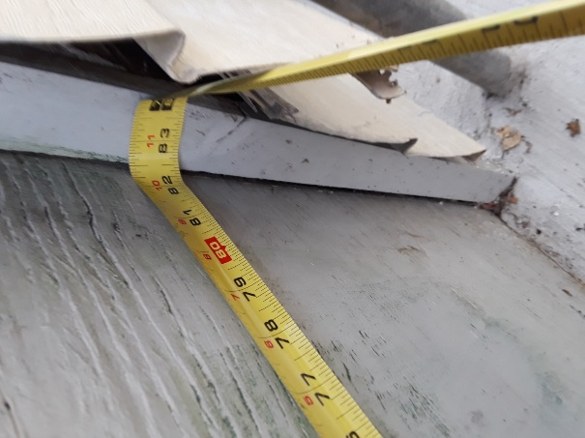
The bottom side porch measures at 82 ½ inches long and 26 inches from top to bottom. It will be replaced with and hopefully with the same kind of design.
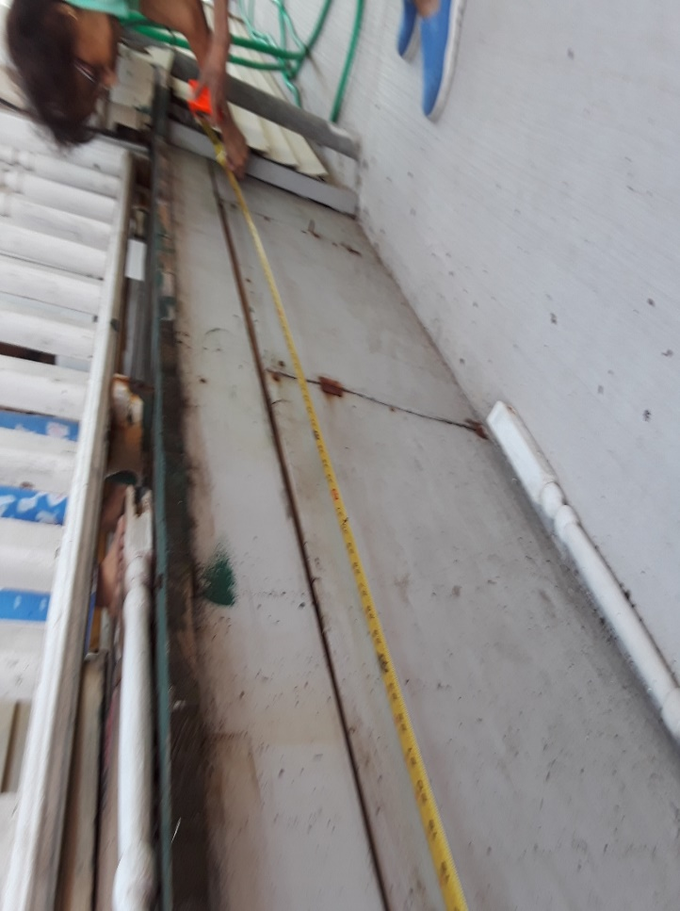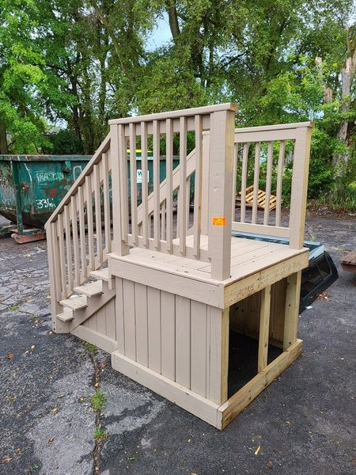
The above photo is sample of how I would like the skirting of the side porch to be. The precious woman helping me measure the porch is my beautiful 92-year-old mother and owner of the house.
I would like to have the skirting covered with Trex material and a small entry door.

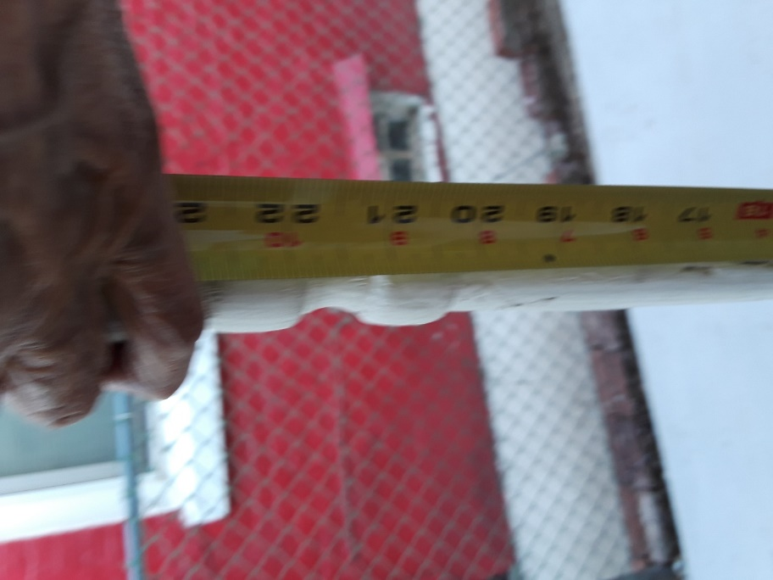
Mother is helping me measure the spindles, but her hand got in the way.

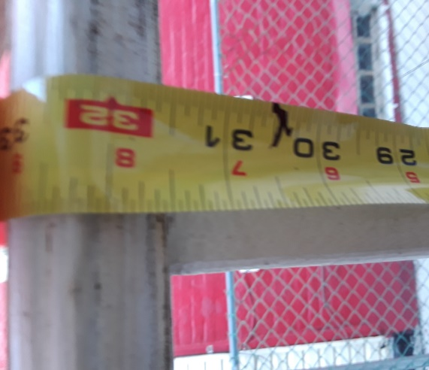
I think the length of the spindles are 31 ½ or 32 inches. There are (13) spindles on the side rail and (5) spindles on the hand/step rail. All spindles will be replaced with new would spindles but the amount of spindles might decrease according to width of new wood spindles.

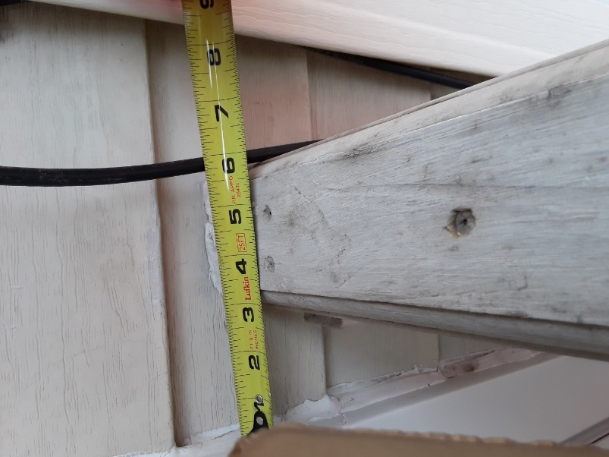

The side porch rail starts in between the side door and the accessory trim of house siding.
I am requesting to move the rail from the middle of door and trim siding, over two inches to the right towards the trim of siding for added space.

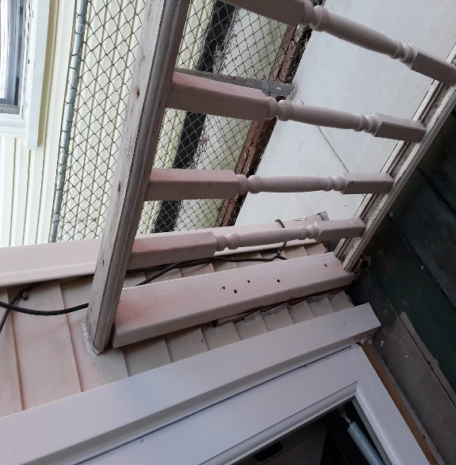
Another picture where side rail begins.
Front Porch
The front porch is what distinguish itself from the other homes. So, it is with great ambition and desire to have it renovated and upheld to its original beauty.

- Current Condition of Front Porch.

- Entire front porch, front side rails, handrails, steps, and missing spindles are all deteriorated and poor condition.
- Porch Overhang is shorter than width of front porch causing wood rot. The overhang is 4 feet wide. The front port is 4 feet 5 inches wide. Porch roof is in an inner slop, making it look slopping and disproportion. I am requesting to widen the front porch from 55 inches (4’.5) wide to 60 inches (5 ft.)
- The front stairs of the porch are currently located to the left of the front entry door.
- The front fence is current a metal fence which I believe is called Hurricane fence and the gates are directly in front of the stairs.
- The small window over the porch currently has a square frame over an arch or octagon window.

- Proposed Modifications

- I am requesting that the front steps be re-located directly in front of the front entry door for easier entry. It has become difficult for my mental disabled 56-year-old sister and 91-year-old mother to maneuver from the sidesteps, then make a right turn, then make a left turn to enter the house when they use their walkers.
- The original frame of the original front window above the porch roof is peeling and need to be framed to the shape of the original window. My 91-year-old mother who remembers the window from back in 1965, says that it was octagon. I believe the top of the original window might be half-moon shape, but I don’t know since there is no second floor and the attic area is a crawl space.
- The front metal or hurricane fence has two gates and will be replaced with a wood picket fence, painted white and one gate. I am requesting the one gate to be moved to the front of the stairs in alignment with the main entry door. The gate to the side porch will be removed and replaced with wood fence
- The current overhang of the front porch will be extended to cover the new extended front porch. From 4 feet wide to 5 feet and 5 inches wide.
- I am requesting the damage frame and window above the front porch roof be replaced by a new window and top frame being arch/half-moon with small shutters.

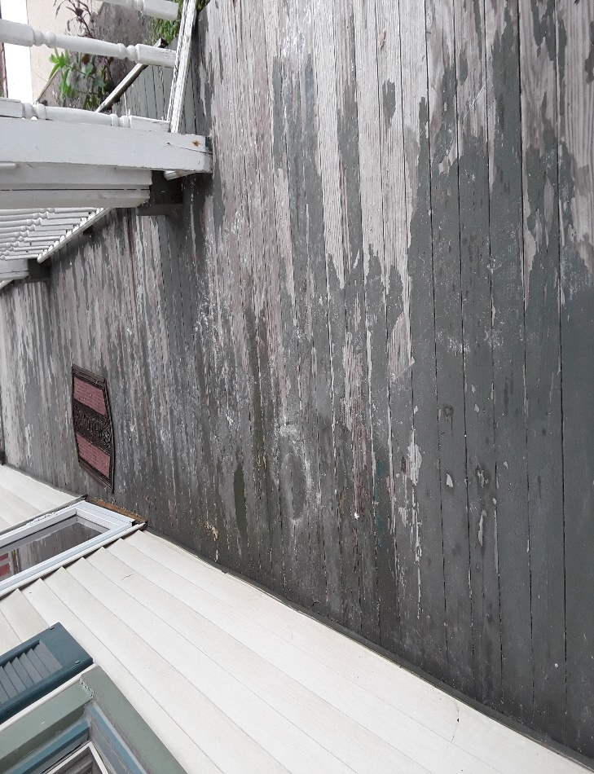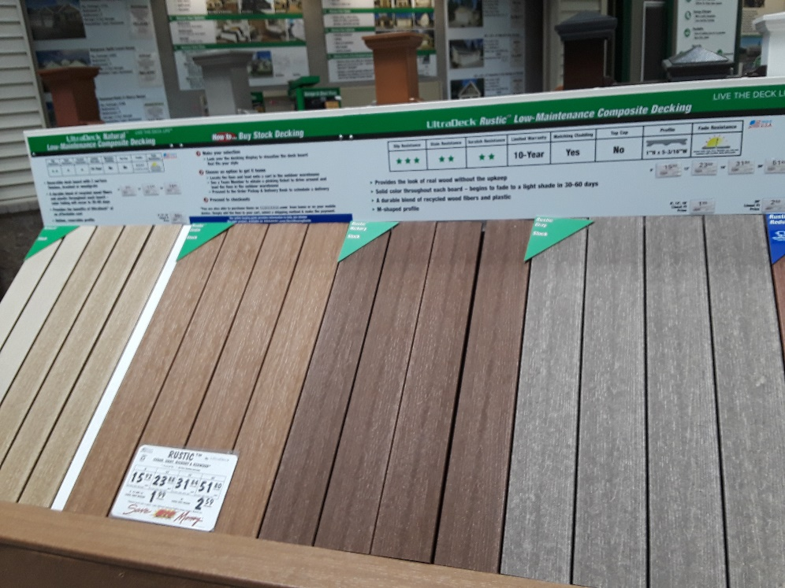
The front porch deck is 22 feet long. I am requesting Trex composite to replace the damage wood deck for both front and side porch in order to keep the deck from deteriorating.

Front steps are 5 feet long and 11 ½ wide. I am requesting Trex composite for the top of the steps for both front and side porch to keep from deteriorating. I am also requesting that the kick of the steps be composite.
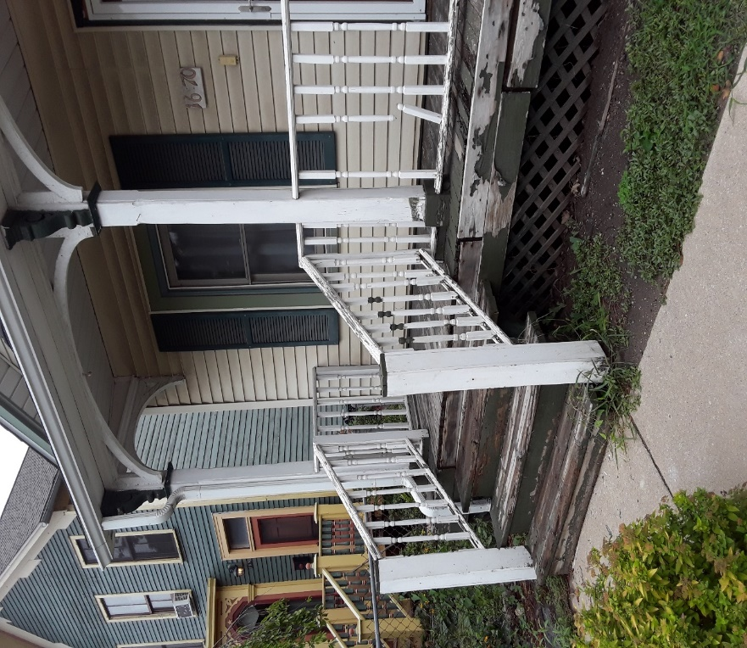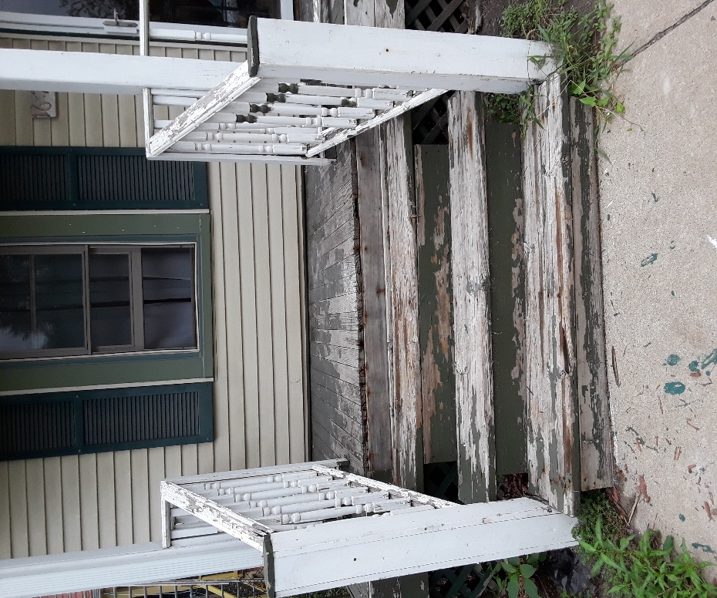
Front porch hand rails are 39 inches long and 3 inches wide. The square Finial at the end of rail is
5 x 5 inches and will be replaced with wood round topper like in picture for both front and side porch. The left Newel post is 46 ½ , right Newel post is 44 ½ inches tall, all to be replaced with wood. The front and side handrail will be wood. The spindles are 4 ½ inches round and will be replaced with wood spindles for both front and side porch.

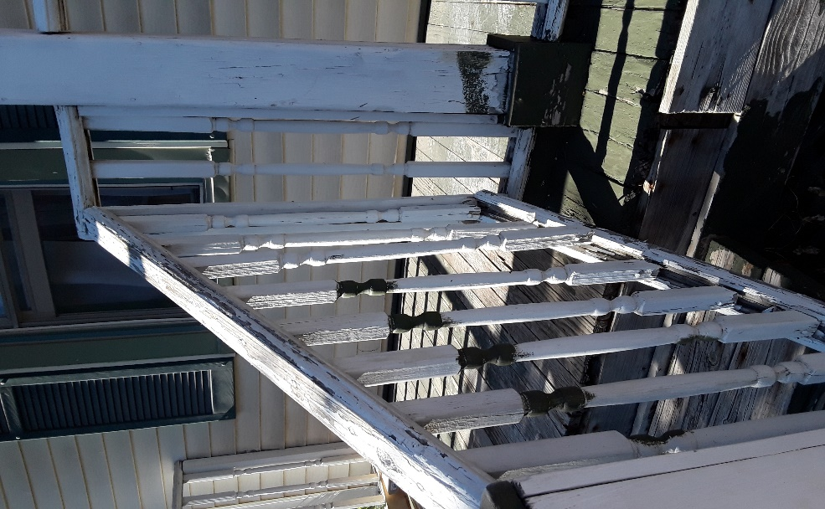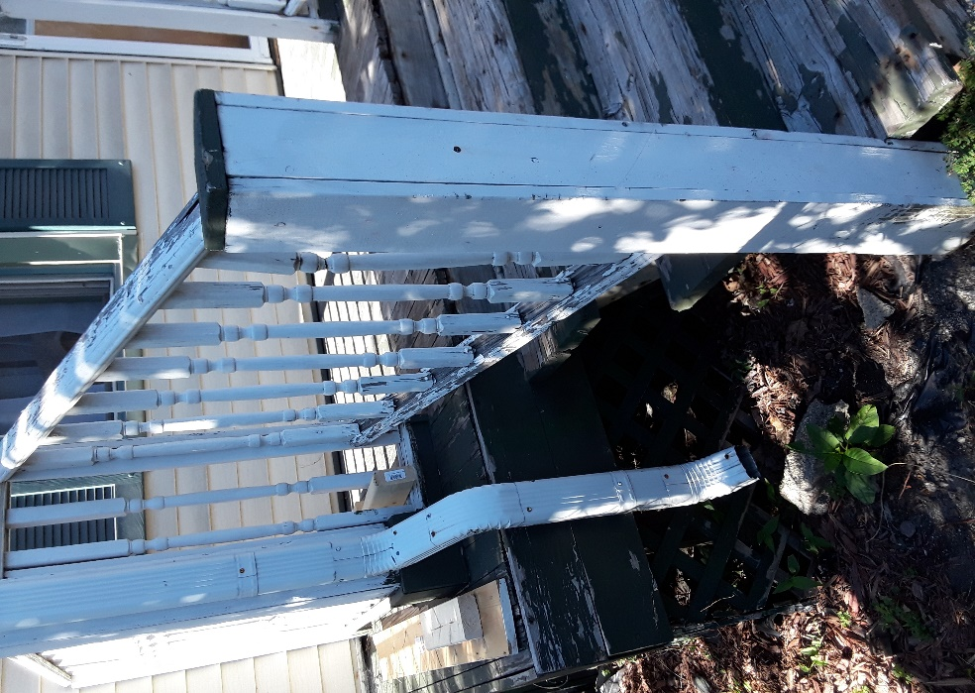

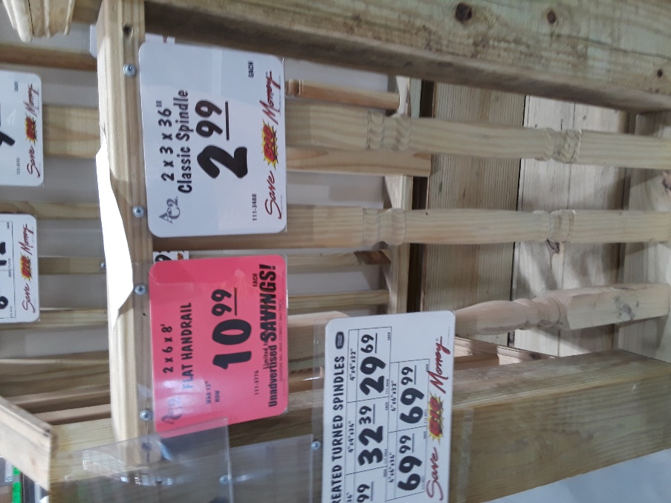
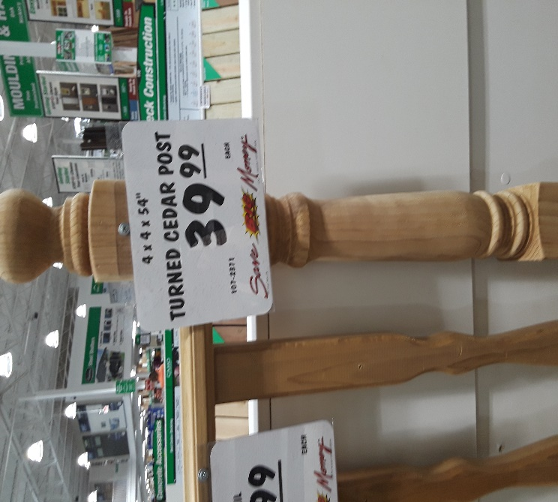

Front and side rails for front porch and side porch will be wood. Side rails for front porch will be moved forward 5 inches. Front porch side rails are 39 inches tall

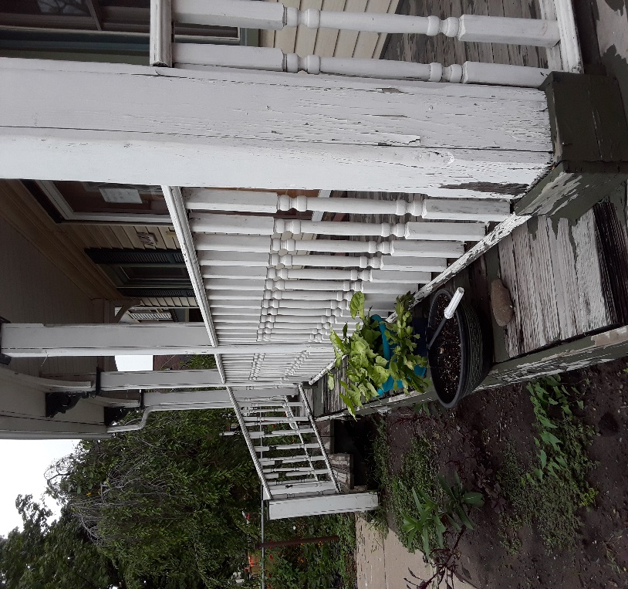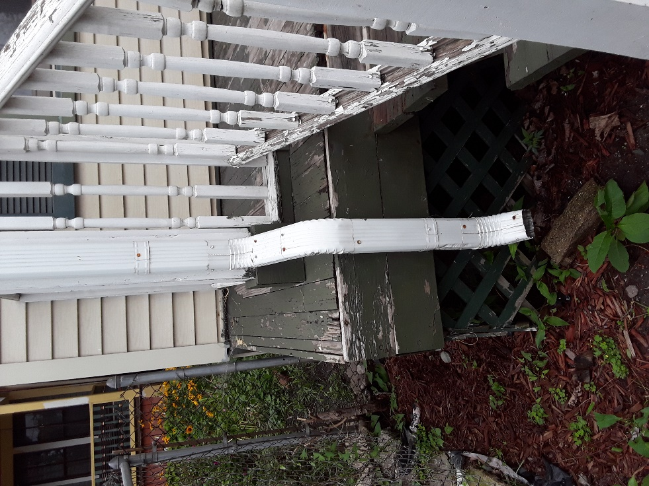
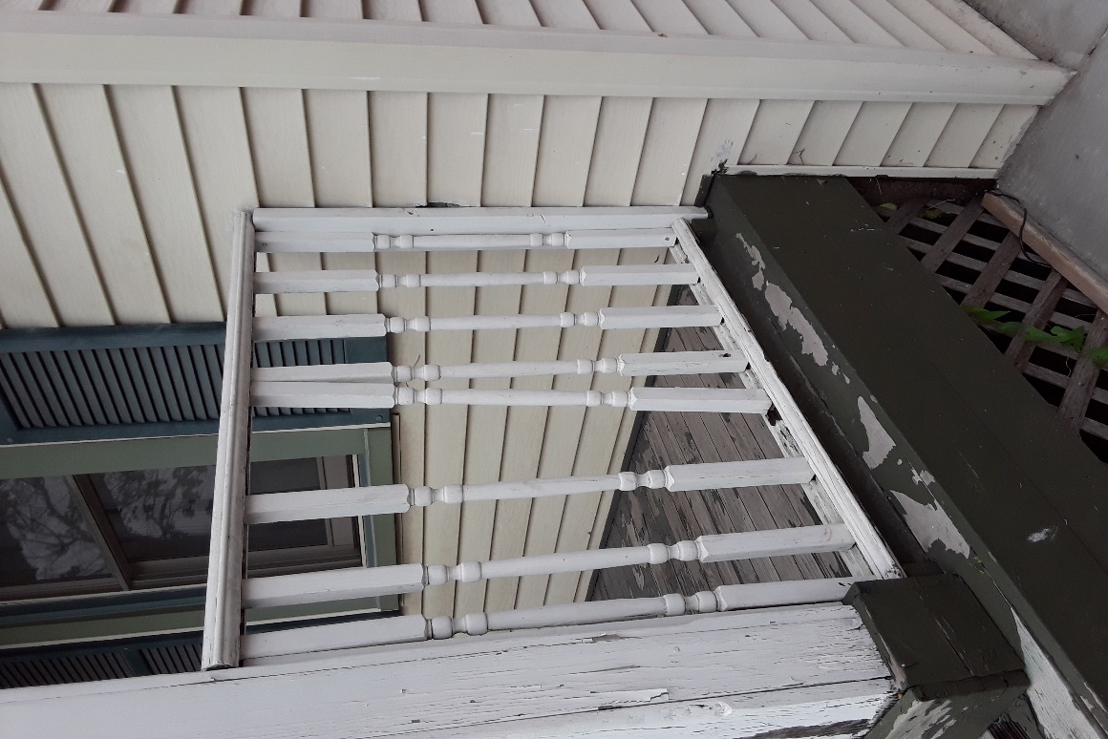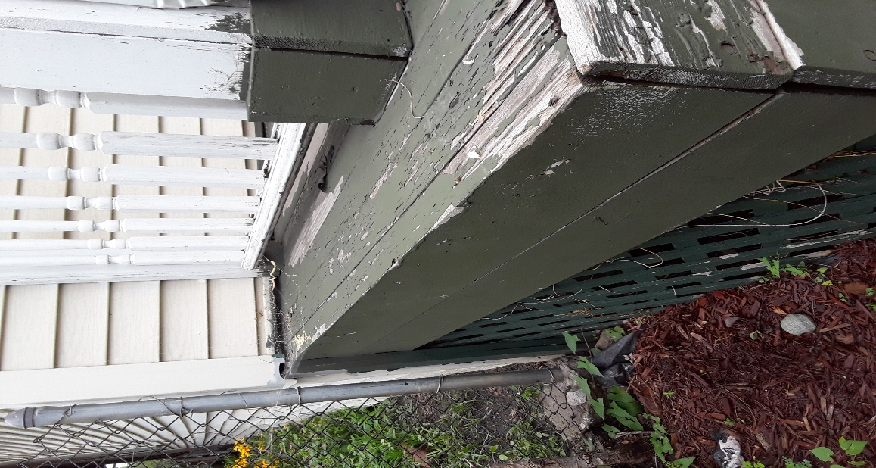
The porch skirting would preferably be small lattice panels. Painted white.
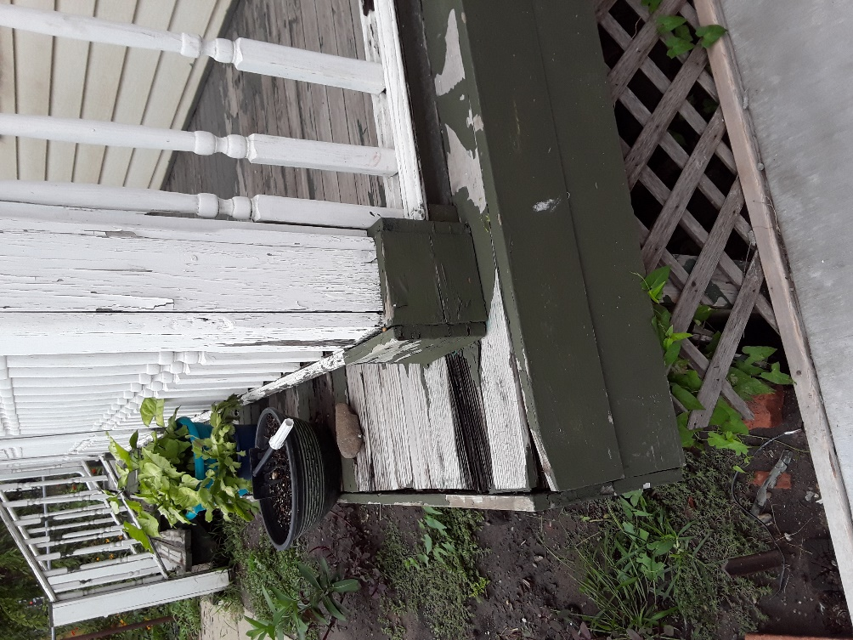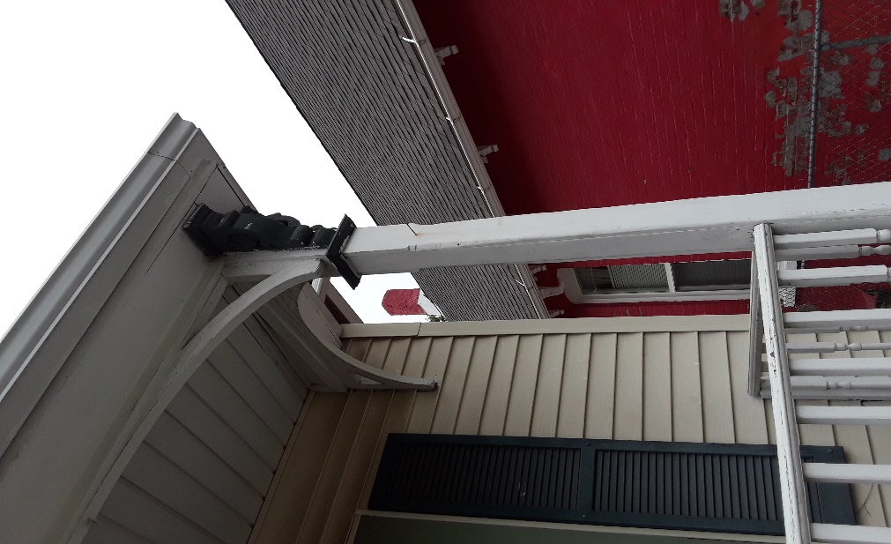
Corner of porch post and rail will go to corner of porch. Corbels will remain.
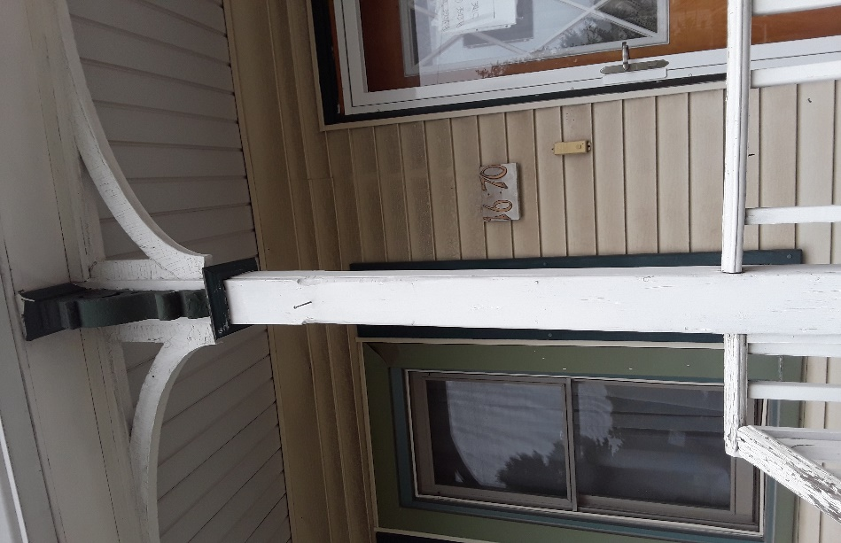
The corner of the porch rail will go to the corner of the porch floor.
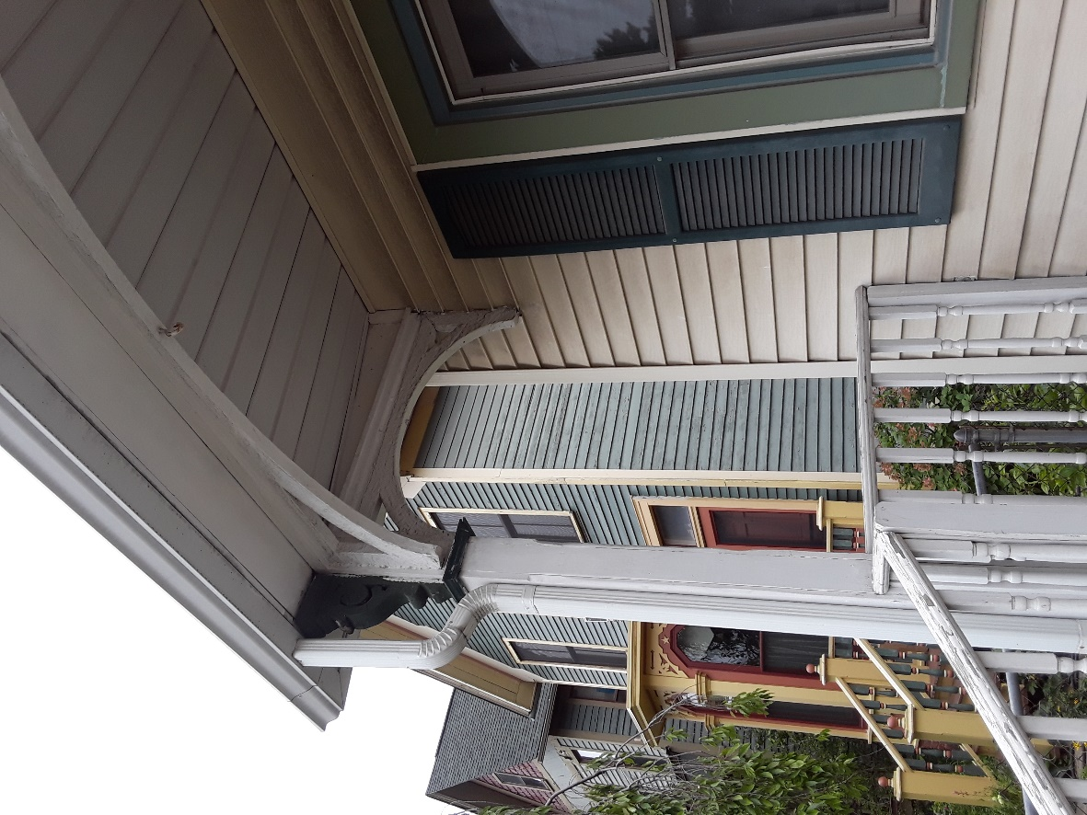
The corbels and arch panel of the porch roof will remain as is.
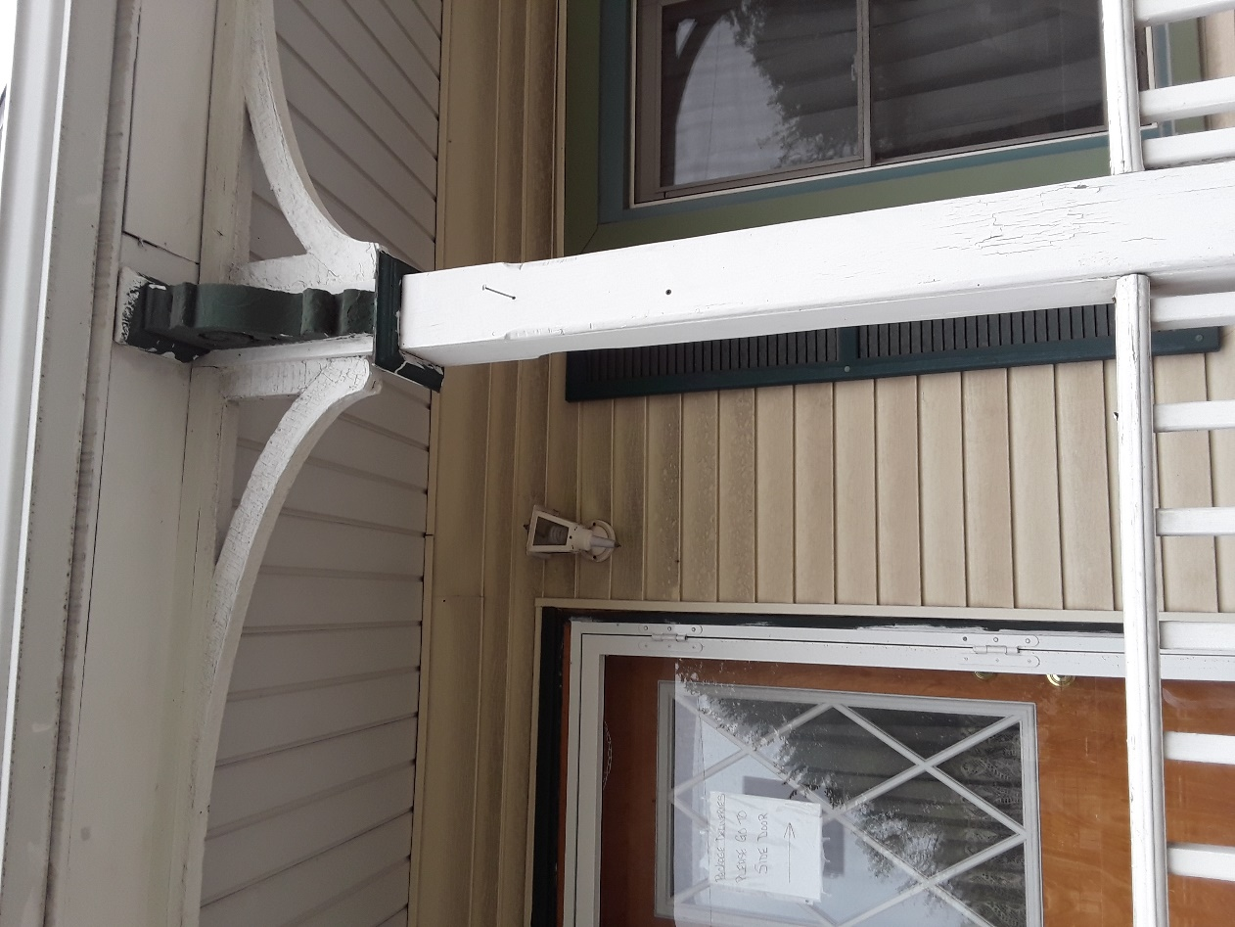
New porch light will be installed on both side of front door.
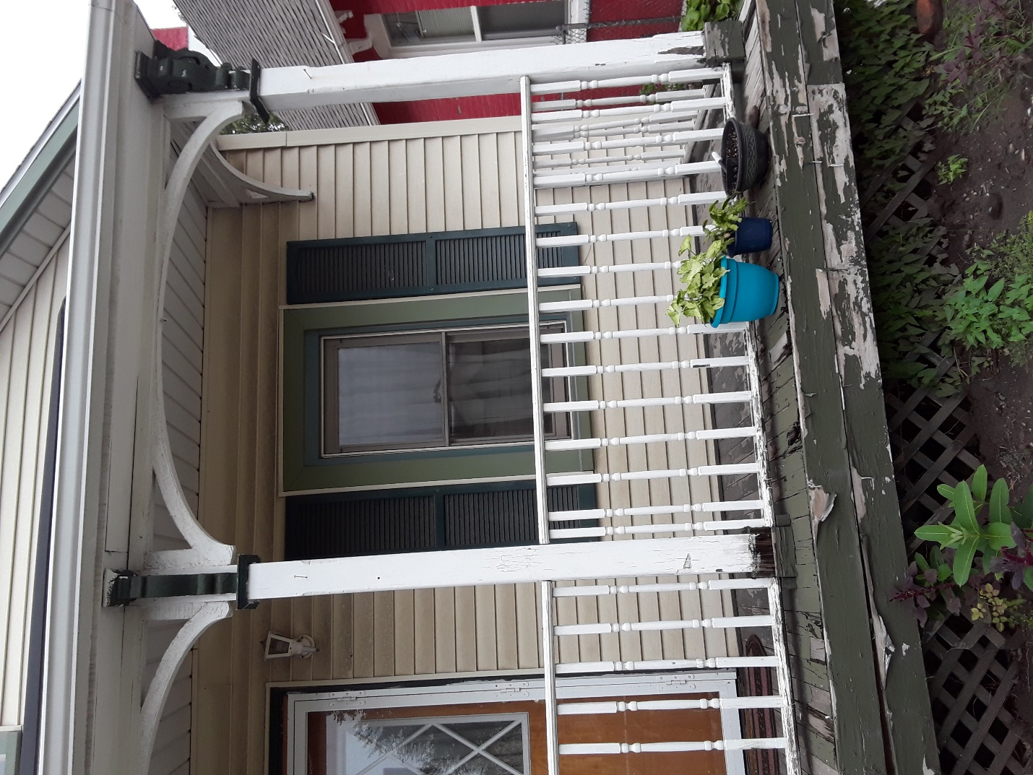
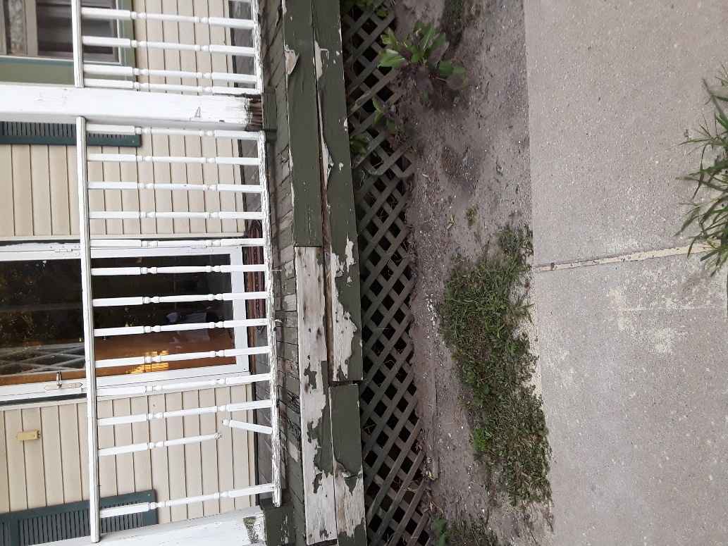
Front porch steps will be moved in front of front door
