115 Erskine – Eliot Wall

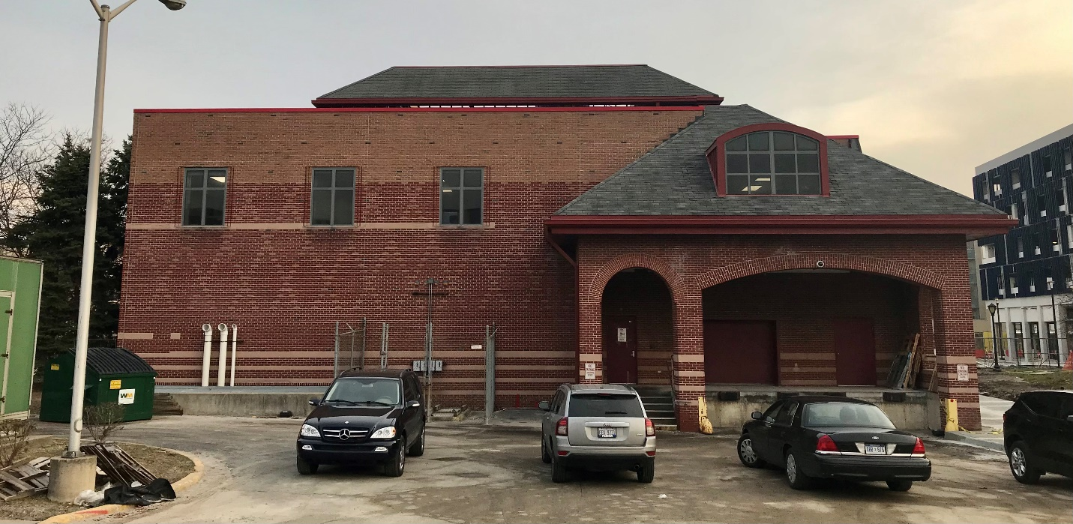

Proposed Mural for 115 Erskine – Eliot Wall

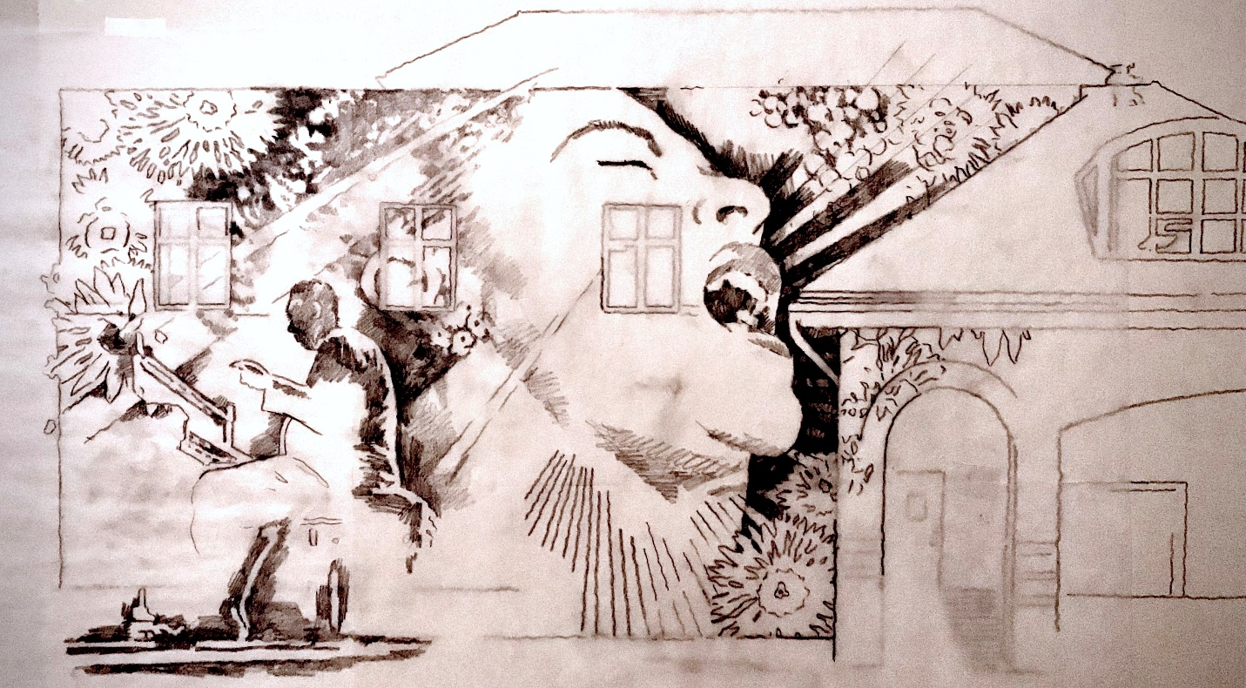

Color Scheme for proposed mural – design depicted above.

