Mark Schlueter (313)475-8977
(4003 west Buena Vista, Detroit MI 48238)
Request for replacing windows from wood- Vinyl) I’ve enclosed 1-23 explaining why windows need to be replaced in (black lettering) each picture is numbered 1-23, Red lettering is Hansons work order breakdown for each window with detailed scope of the project Hanson is looking to fulfill order for replacement for 23 windows with color & dimensions: I have also enclosed the original work order on a separate email with Hanson for breakdown.
-------Interior 1-23
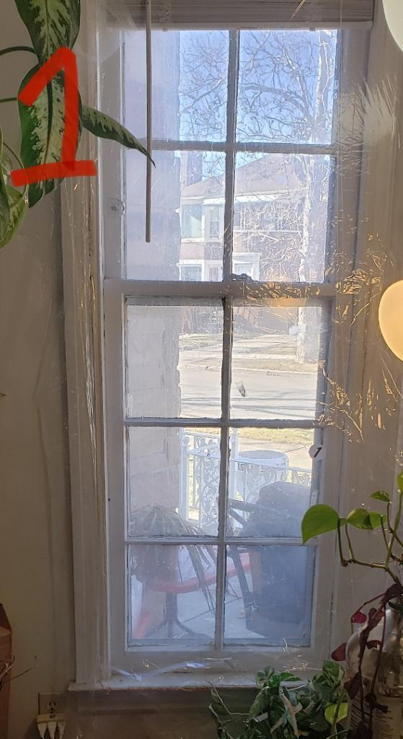
*Reason for REPLACEMENT Window #1: Does not open, Storm does not operate. Crack & Gaps
Detailed window replacement for Hanson: #1 Living Room, Standard, Double Hung, 24"W x 65"H, Exterior Color:White, Interior Color:White, Ext Trim Color:Glacier White, Oriel Style:No,

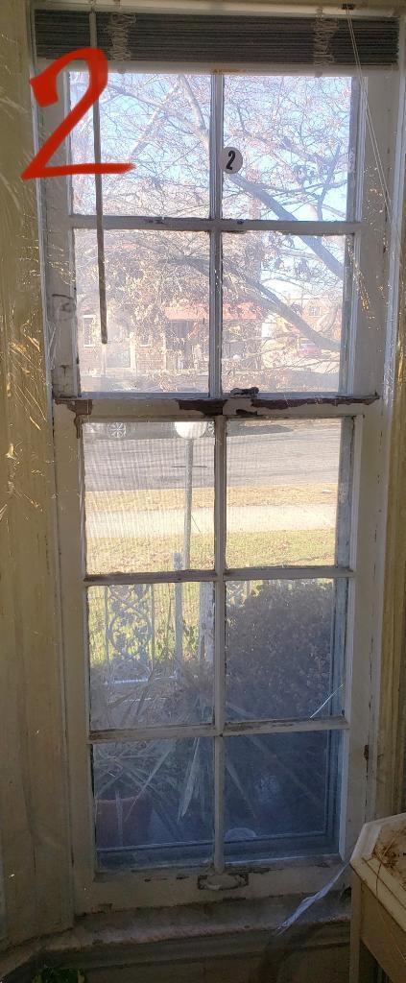
Reason for REPLACEMENT: Window # 2: Does not open, Storm does not operate. Crack & Gaps, Draft from outside come through even when closed (3 pictures of window #2 enclosed)
*Detailed window replacement for Hanson (also refer to Hanson work order enclosed): #2 Living Room, Standard, Fixed, 75"W x 65"H, Exterior Color:White, Interior Color:White, Ext Trim Color:Glacier White, Oriel Style:No, Mulling: Remove Existing Mulls (Quantity:1 , Mull Inches:6)

. 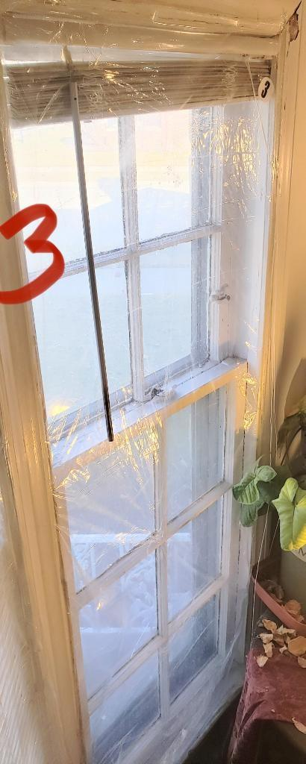
Reason for REPLACEMENT Window #3: Does not open, Storm does not operate. Crack & Gaps
*Detailed window replacement for Hanson (also refer to Hanson work order enclosed): #3 Living Room, Standard, Double Hung, 24"W x 65"H, Exterior Color:White, Interior Color:White, Ext Trim Color:Glacier White, Oriel Style:No,

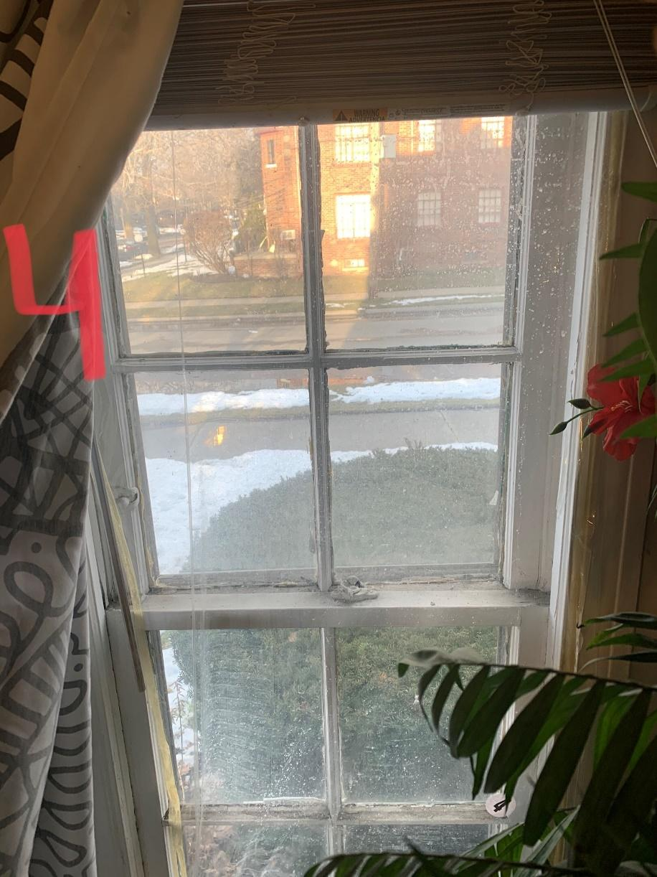
Reason for REPLACEMENT Window #4: Does not open, Storm does not operate. Crack & Gaps, Feel Draft from outside even when windows are closed/ plastic is placed to prevent cold air.
*Detailed window replacement for Hanson (also refer to Hanson work order enclosed): #4 Bedroom, Standard, Double Hung, 28"W x 58"H, Exterior Color:White, Interior Color:White, Ext Trim Color:Glacier White, Oriel Style:No.
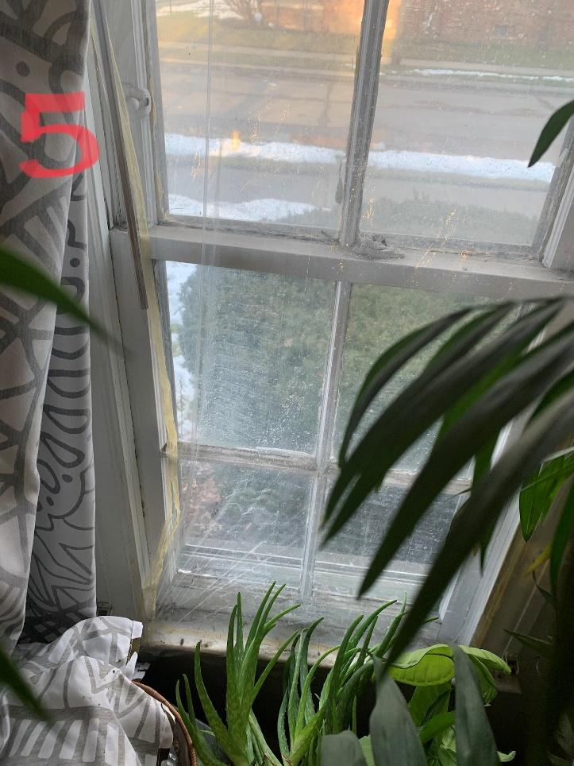
Reason for REPLACEMENT Window #5: Does not open, Storm does not operate. Crack & Gaps, Feel Draft from outside even when windows are closed/ plastic is placed to prevent cold air.
*Detailed window replacement for Hanson (also refer to Hanson work order enclosed) #5 Living Room, Standard, Double Hung, 28"W x 58"H, Exterior Color:White, Interior Color:White, Ext Trim Color:Glacier White, Oriel Style:No

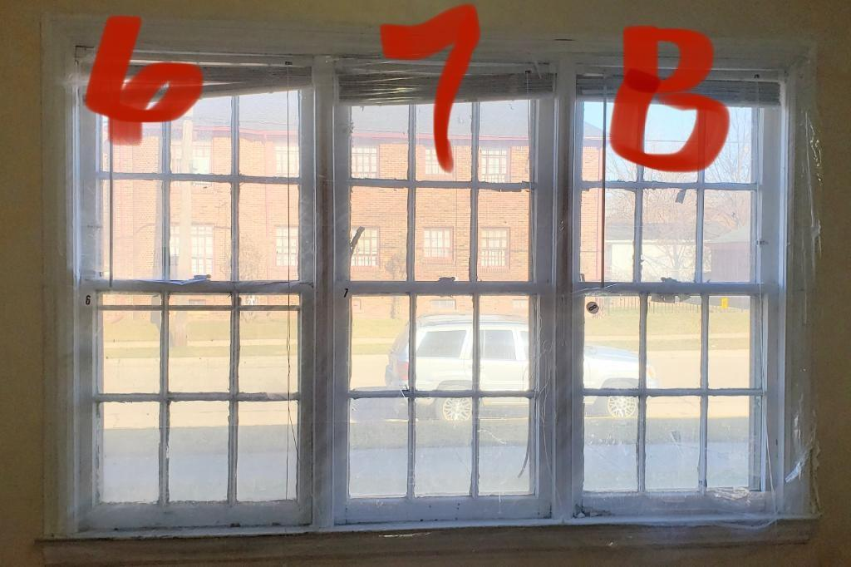
Reason for REPLACEMENT Window #6: Partially opens, Crack & Gaps, Feel Draft from outside even when windows are closed/ plastic is placed to prevent cold air.
Reason for REPLACEMENT Window #7: Does not open, Storm does not operate. Crack & Gaps, Feel Draft from outside even when windows are closed/ plastic is placed to prevent cold air. Hear Noise from outside. Not energy efficient. Broken Glass.
Reason for REPLACEMENT Window #8: Does not open, Storm does not operate. Crack & Gaps, Feel Draft from outside even when windows are closed/ plastic is placed to prevent cold air. Hear Noise from outside. Not energy efficient.
*Detailed window replacement for Hanson (also refer to Hanson work order enclosed) #6 Dining Room, Standard, Double Hung, 28"W x 58"H, Exterior Color:White, Interior Color:White, Ext Trim Color:Glacier White, Oriel Style:No,
*Detailed window replacement for Hanson (also refer to Hanson work order enclosed) #7 Dining Room, Standard, Double Hung, 28"W x 58"H, Exterior Color:White, Interior Color:White, Ext Trim Color:Glacier White, Oriel Style:No,
*Detailed window replacement for Hanson (also refer to Hanson work order enclosed) #8 Dining Room, Standard, Double Hung, 28"W x 58"H, Exterior Color:White, Interior Color:White, Ext Trim Color:Glacier White, Oriel Style:No,

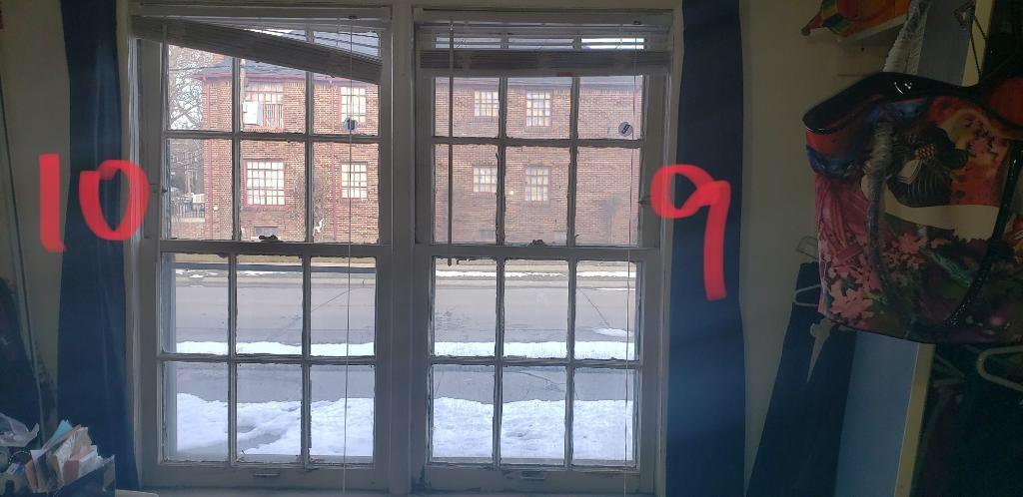

Reason for REPLACEMENT Window #9 & 10: Does not open, Storm does not operate. Crack & Gaps, Feel Draft from outside even when windows are closed. Hear Noise from outside. Not energy efficient. Broken Glass.
*Detailed window replacement for Hanson (also refer to Hanson work order enclosed) #9 Bedroom, Standard, Double Hung, 28"W x 58"H, Exterior Color:White, Interior Color:White, Ext Trim Color:Glacier White, Oriel Style:No,
*Detailed window replacement for Hanson (also refer to Hanson work order enclosed) #10 Bedroom, Standard, Double Hung, 28"W x 58"H, Exterior Color:White, Interior Color:White, Ext Trim Color:Glacier White, Oriel Style:No,

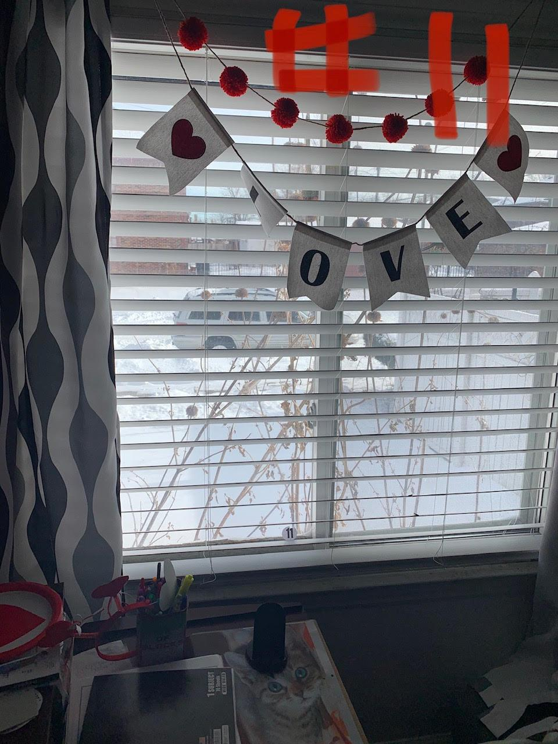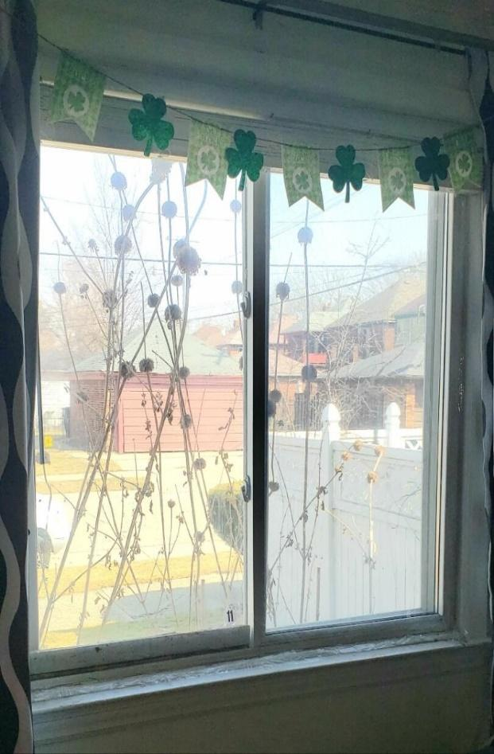
Reason for REPLACEMENT Window #11: Vinyl Window (Not installed properly by previous owners) does not open properly or close all the way/does not lock. Hear Noise from outside.
*Detailed window replacement for Hanson (also refer to Hanson work order enclosed) #11
Bedroom, Standard, Double Slider, 58"W x 54"H, Exterior Color:White, Interior Color:White, Ext Trim Color:Glacier White, Oriel Style:No,

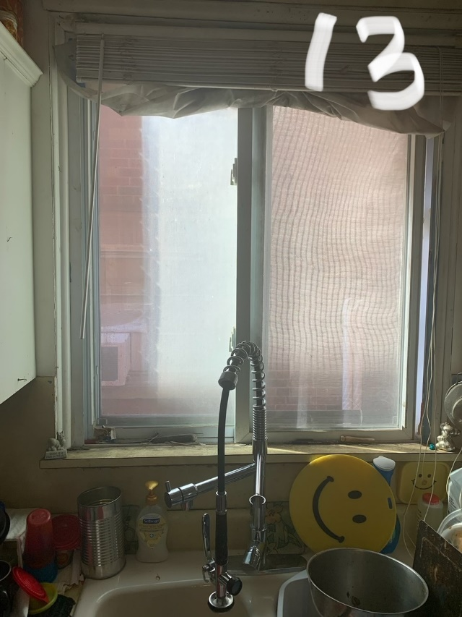
Reason for REPLACEMENT Window #13: Vinyl Window; (Not installed Properly due to previous owners) Feel outside drafts, Hear lots of noise through Windows (Plastic is placed to avoid some of outside draft)
*Detailed window replacement for Hanson (also refer to Hanson work order enclosed) #13 Kitchen, Standard, Double Slider, 42"W x 44"H, Exterior Color:White, Interior Color:White, Ext Trim Color:Glacier White, Oriel Style:No,

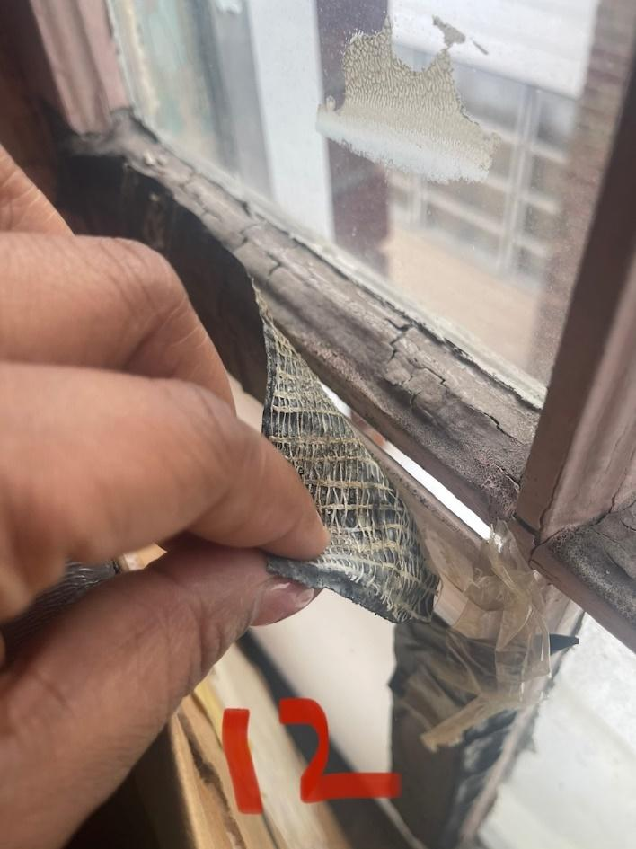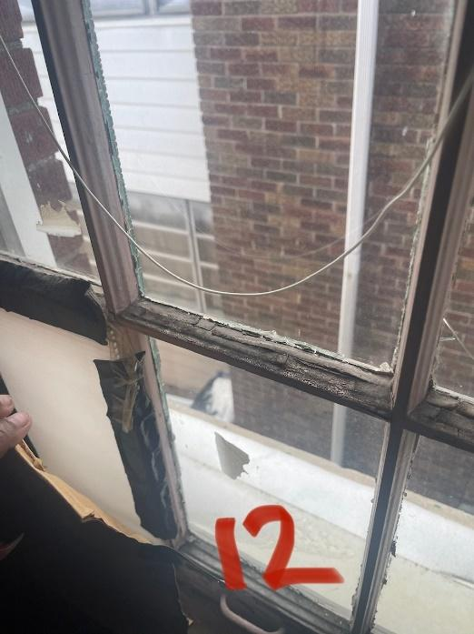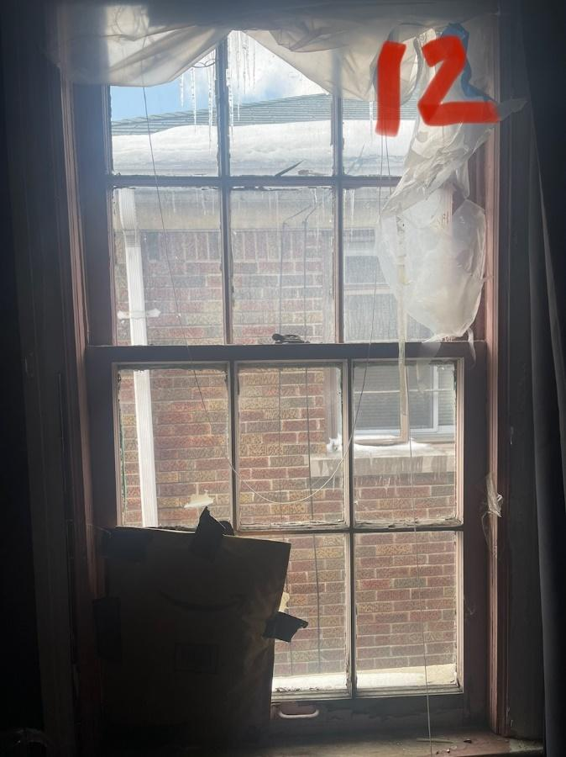
Reason for REPLACEMENT Window #12: Does not open, Storm does not operate. Crack & Gaps, Feel Draft from outside even when windows are closed/ plastic is placed to prevent cold air, as well as stuffing to stop some draft. Hear Noise from outside. Not energy efficient. Water damage, Broken Glass. Missing Panel. Very bad shaped window.
*Detailed window replacement for Hanson (also refer to Hanson work order enclosed) #12 Bedroom, Standard, Double Hung, 28"W x 58"H, Exterior Color:White, Interior Color:White, Ext Trim Color:Glacier White, Oriel Style:No,

(PICTURE)
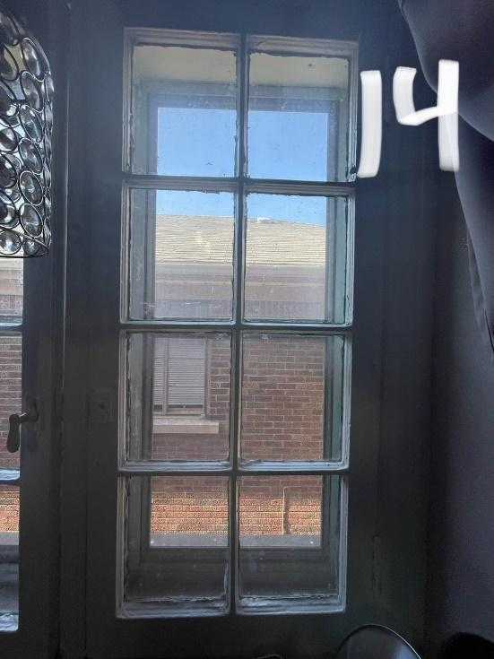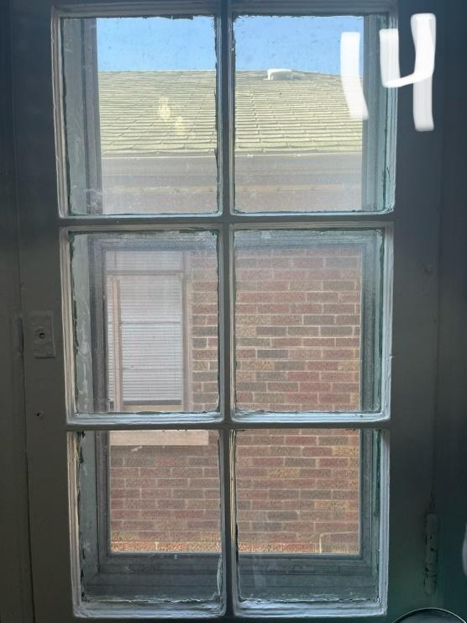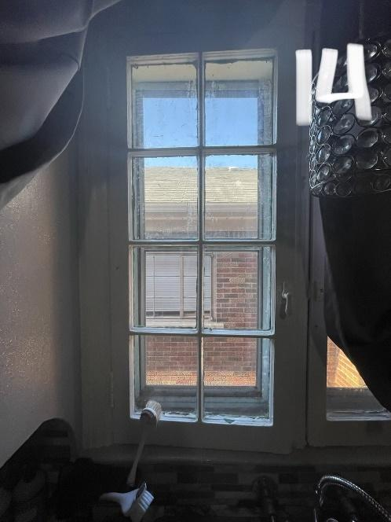
Reason for REPLACEMENT Window #14: Does not open or close properly. Crack & Gaps, Feel Draft from outside even when windows are closed. Hear Noise from outside. Not energy efficient.
*Detailed window replacement for Hanson (also refer to Hanson work order enclosed) #14 Kitchen, Standard, Double Slider, 42"W x 44"H, Exterior Color:White, Interior Color:White, Ext Trim Color:Glacier White, Oriel Style:No,

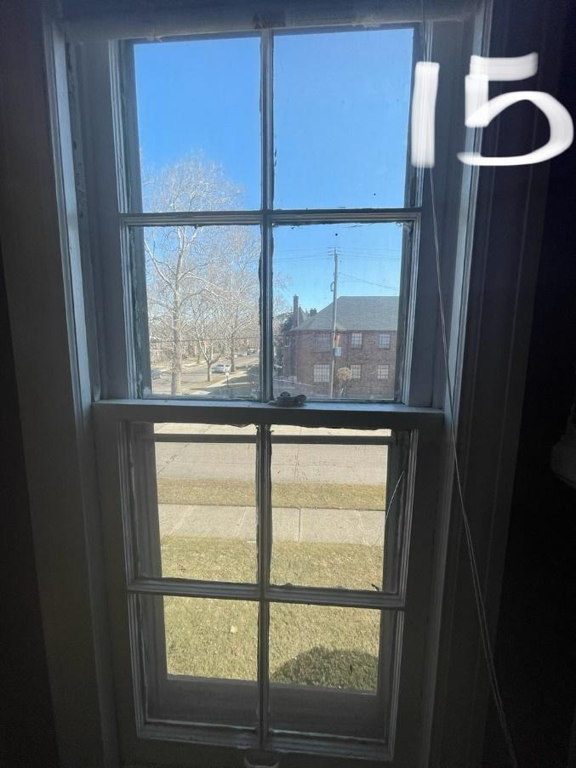
Reason for REPLACEMENT Window #15: Does not open, Storm does not operate. Crack & Gaps, Feel Draft from outside even when windows are closed/ plastic is placed to prevent cold air.
*Detailed window replacement for Hanson (also refer to Hanson work order enclosed) #15 Living Room, Standard, Double Hung, 28"W x 58"H, Exterior Color:White, Interior Color:White, Ext Trim Color:Glacier White, Oriel Style:No,

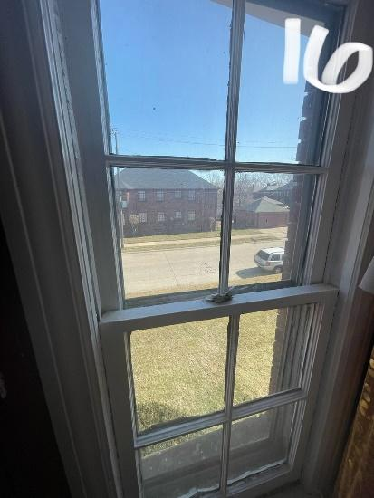
Reason for REPLACEMENT Window #16: Does not open, Storm does not operate. Crack & Gaps, Feel Draft from outside even when windows are closed/ plastic is placed to prevent cold air.
*Detailed window replacement for Hanson (also refer to Hanson work order enclosed) #16 Living Room, Standard, Double Hung, 28"W x 58"H, Exterior Color:White, Interior Color:White, Ext Trim Color:Glacier White, Oriel Style:No,

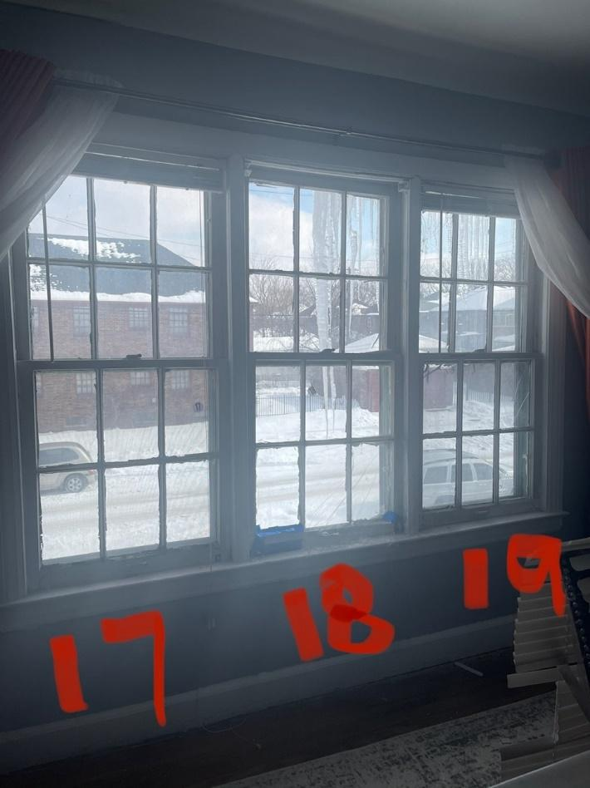

Reason for REPLACEMENT Window #17,18,19: Does not open, severe water damage, Glass is missing from 17-19, Storm are missing. Crack & Gaps, Feel Draft from outside even when windows are closed/ plastic is placed to prevent cold air. Not energy efficient, Panels missing (Plastic and blue tape used to cover up missing panels)

*Detailed window replacement for Hanson (also refer to Hanson work order enclosed) #17 Dining Room, Standard, Double Hung, 28"W x 58"H, Exterior Color:White, Interior Color:White, Ext Trim Color:Glacier White, Oriel Style:No,
*Detailed window replacement for Hanson (also refer to Hanson work order enclosed) #18 Dining Room, Standard, Double Hung, 28"W x 58"H, Exterior Color:White, Interior Color:White, Ext Trim Color:Glacier White, Oriel Style:No,
*Detailed window replacement for Hanson (also refer to Hanson work order enclosed) #19 Dining Room, Standard, Double Hung, 28"W x 58"H, Exterior Color:White, Interior Color:White, Ext Trim Color:Glacier White, Oriel Style:No,

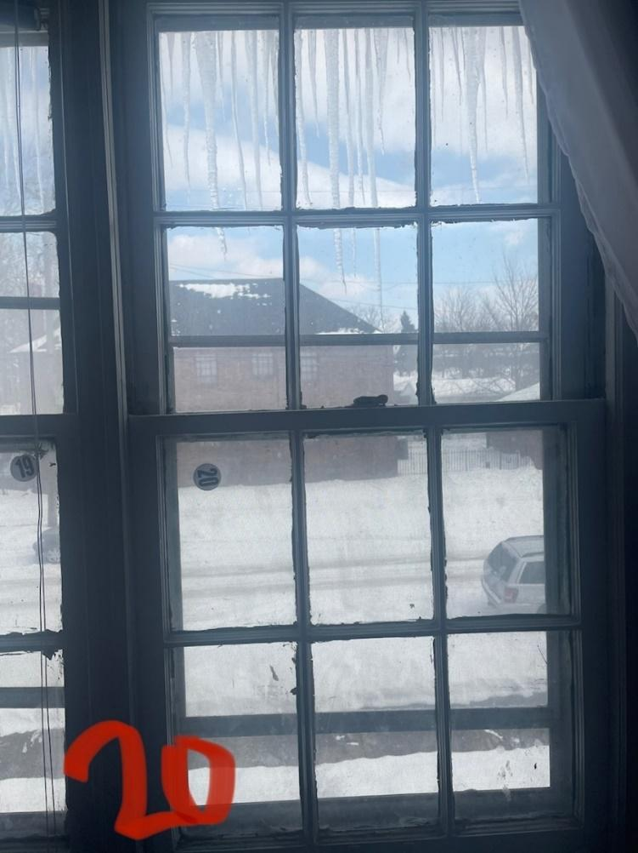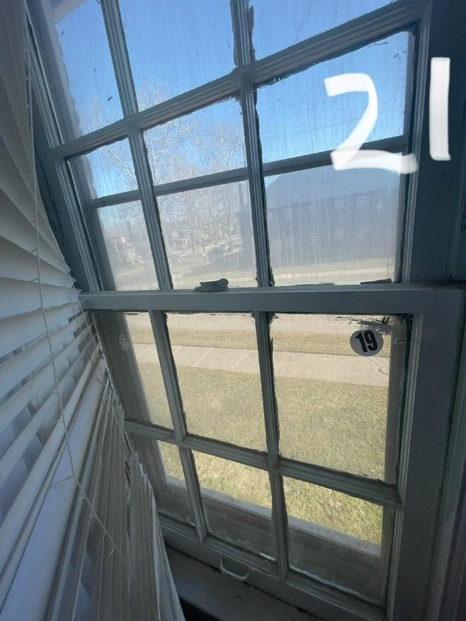
Reason for REPLACEMENT Window #20/21: Does not open, Storm do not operate, Crack & Gaps, Feel Draft from outside even when windows are closed/ plastic is placed to prevent cold air. Not energy efficient.
*Detailed window replacement for Hanson (also refer to Hanson work order enclosed) #20 Bedroom, Standard, Double Hung, 28"W x 58"H, Exterior Color:White, Interior Color:White, Ext Trim Color:Glacier White, Oriel Style:No,
*Detailed window replacement for Hanson (also refer to Hanson work order enclosed) #21 Bedroom, Standard, Double Hung, 28"W x 58"H, Exterior Color:White, Interior Color:White, Ext Trim Color:Glacier White, Oriel Style:No,

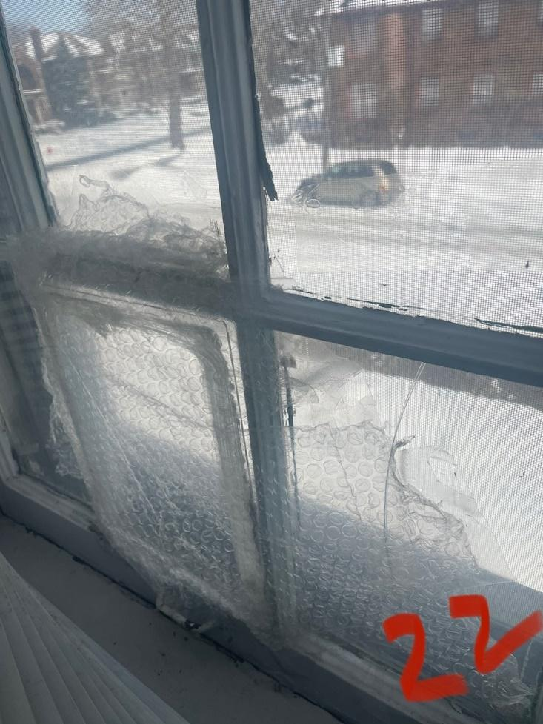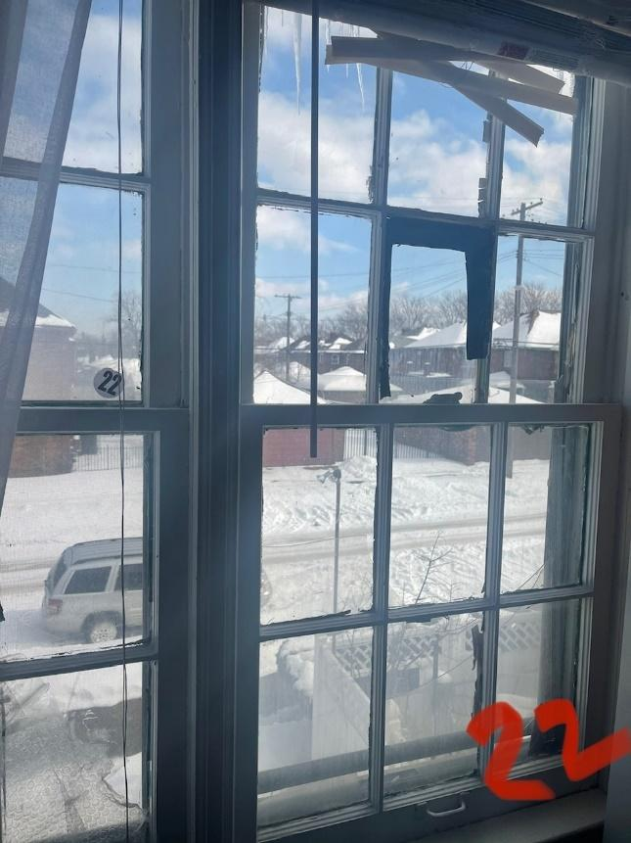
Reason for REPLACEMENT Window #22: partially open, window is rotting, Glass is missing, and Storm do not operate. Crack & Gaps, Feel Draft from outside even when windows are closed/ plastic is placed to prevent cold air. Not energy efficient, Panels missing (Plastic and black tape used to cover up missing panels)
*Detailed window replacement for Hanson (also refer to Hanson work order enclosed) #22 Bedroom, Standard, Double Slider, 58"W x 54"H, Exterior Color:White, Interior Color:White, Ext Trim Color:Glacier White, Oriel Style:No, Mulling: Remove Existing Mulls (Quantity:1 , Mull Inches:3)

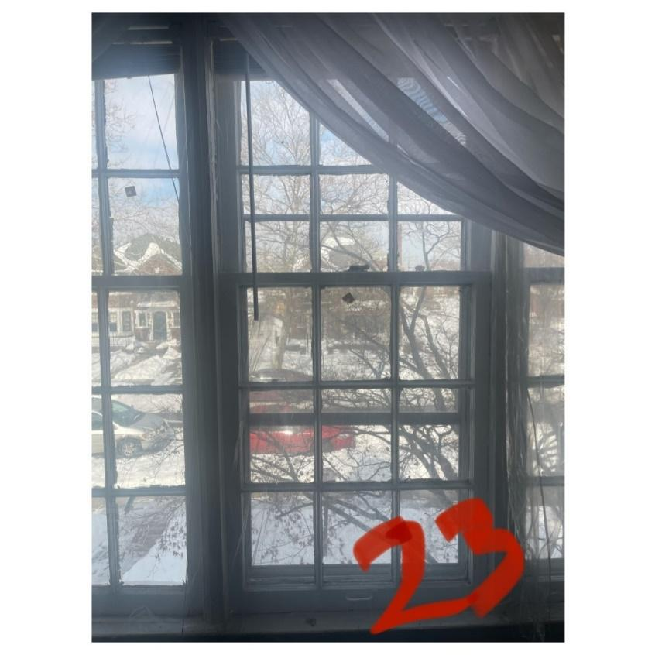
Reason for REPLACEMENT Window #23: does not open, Storm do not operate & missing. Crack & Gaps, Feel Draft from outside even when windows are closed/ plastic is placed to prevent cold air. Water damaged not energy efficient.
*Detailed window replacement for Hanson (also refer to Hanson work order enclosed) #23 Living Room, Standard, Fixed, 87"W x 58"H, Exterior Color:White, Interior Color:White, Ext Trim Color:Glacier White, Oriel Style:No,Mulling: Remove Existing Mulls (Quantity:1 , Mull Inches:6)

