Mark Schlueter (313-475-8977)
4003 West Buena Vista, Detroit MI 48238

What we’re expecting for Hanson to do.
Currently before replacement (23 windows Total)
2 Windows Vinyl (Improperly installed) 21 Windows Wooden
- Outside exterior: White
- Window Interior: White
- Trim Color: Glacier White

Plan to replace windows with all vinyl. (23 windows Total)
- Outside exterior: White
- Window Interior: White
- Trim Color: Glacier White

Example of a Hanson home changed from wooden windows and replaced with Vinyl windows.
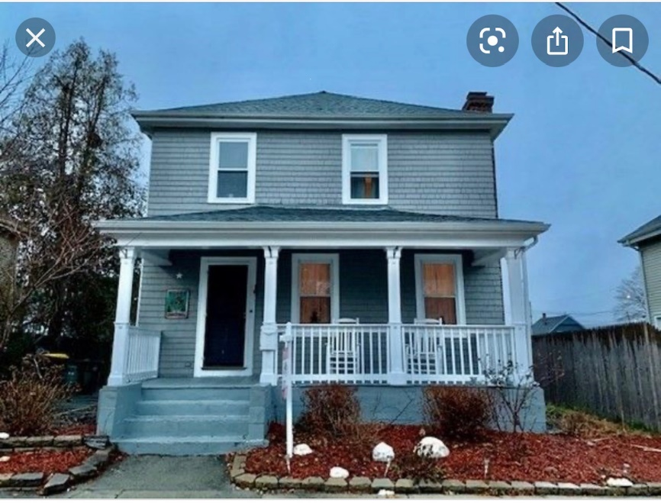

Our home (4003 West Buena Vista, Detroit MI 48238) Front/side view. 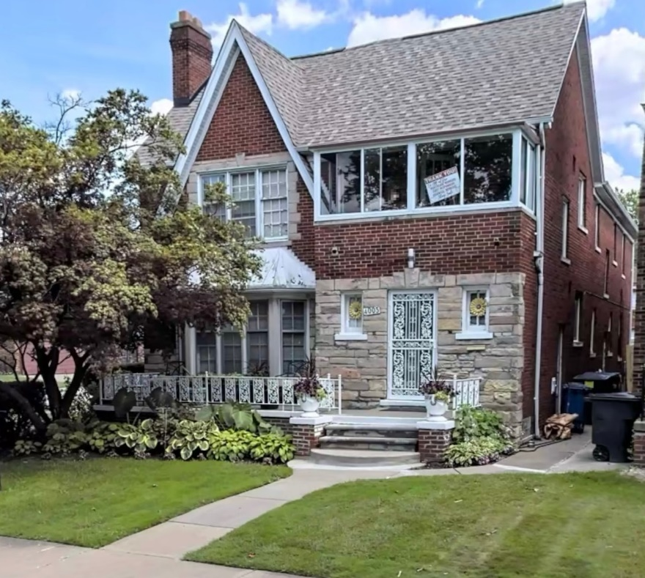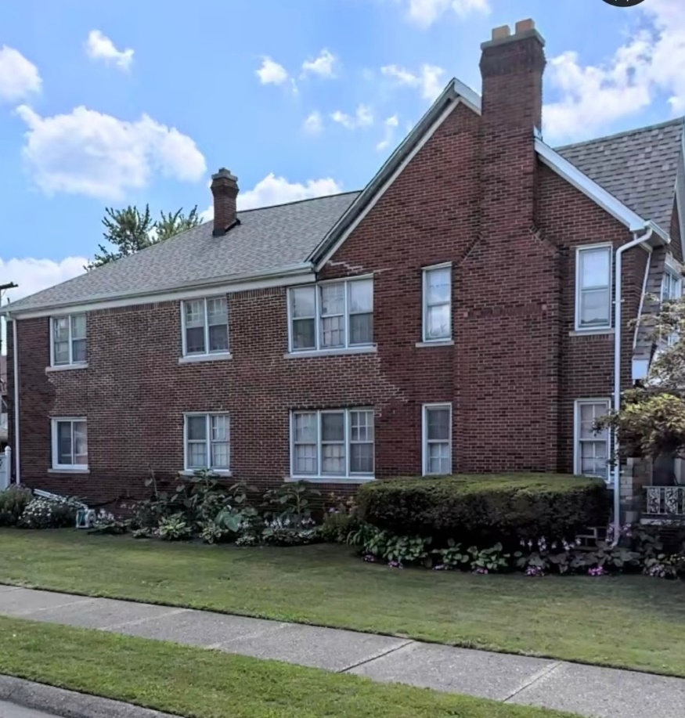

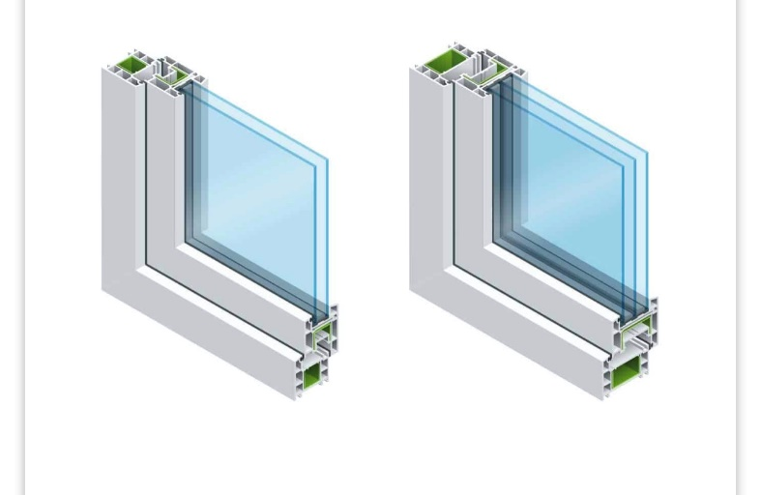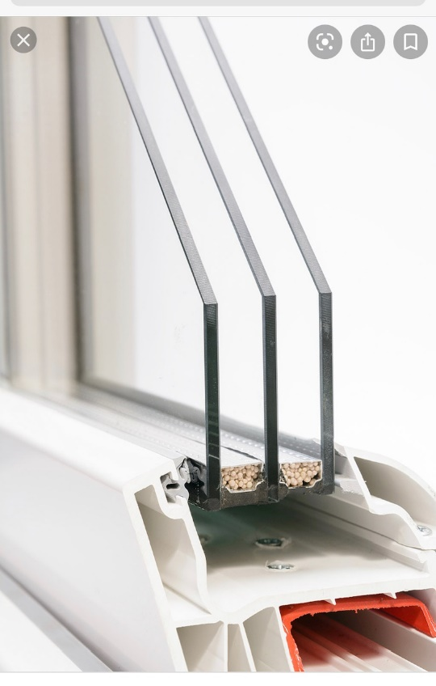
What Hanson is attempting to do: These are Hybrid 0.23 Triple Low E Argon Glass, Welded Corners, Dual Operable, Foam enhanced frame, Fiberglass Reinforced vinyl frame and sash (on most styles), Free Glass Breakage and screen repair.

Why would we prefer these over wooden windows?
One reason is because we simply again cannot afford the wooden replacement or repair cost/ this is a more suitable and cost sufficient route we’re asking for these particular windows are due to the great option ; they provide a high return on investment. Triple pane windows are perfect for those living in a harsh, cold climate and will provide a level of sound insulation. You can expect increased home comfort and consistent savings on utilities ahead. Also increased safety. It is much harder to break through three panes of glass, triple pane windows are much stronger in case of an attempted break-in- also highly energy-efficient, meaning that they keep the heat out during hot summer days and keep the heat in during the winter, These windows are naturally more soundproof, thanks to the extra pane of glass. Also, the use of Insulating Glass Unit (or IG Unit) between glazing’s is another factor that contributes to reduced sound transmission. Triple pane windows stand a better chance at reducing condensation. Condensation will occur when the surface temperature of the interior glass pane is below the dew point.

