Description of existing conditions
Current 18’ x 20’ shed has no vehicle entry point anymore but a concrete ramp on the north side (Lafayette) exists from a time in the past when the shed previously had a garage door. Current materials are wood panel siding with some damage and rotten in areas near the base of the north side from water damage due to poor drainage. Roof has asphalt shingles that were installed in 2010. Interior of shed currently has functioning 120V electric wiring and concrete foundation in good condition.

- Dimensions of exterior north side wall: 220” (over 18 feet) wide and 96” tall (8 feet) from base to trim.

Description of project
Remove Lafayette (north) side garage wall. Frame north side wall for garage door opening. Install new 16’ x 7’ garage door. Remove existing east side shed door and install new wood siding that matches existing. New garage door will be insulated (double-layer with steel and insulation for security purposes), ribbed panel, dark brown to match existing exterior (link and screenshot below): https://www.amarr.com/residential/collection_options/stratford

Project Scope of Work
• Remove Lafayette (north side) garage wall.
• Remove existing (east side) shed door
• Install new wood siding on east side to match existing.
• Fix any damaged or rotten wood siding.
• Frame and trim north side wall for new garage door.
• Install new 16’ x 7’ garage door.
• Prime and paint exterior of garage to match existing dark brown color.

Pictures

- Front of house (east facing):
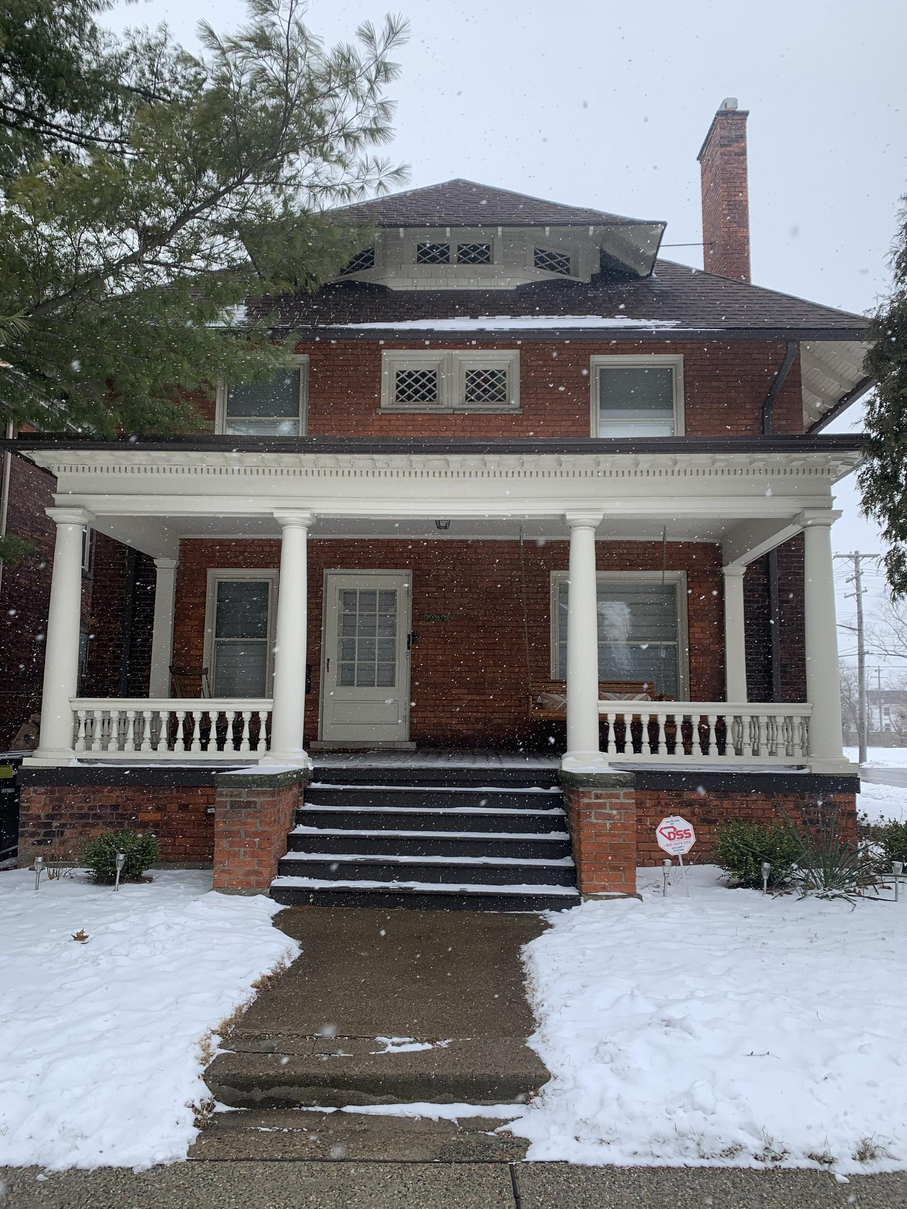

- Back of house (west side):
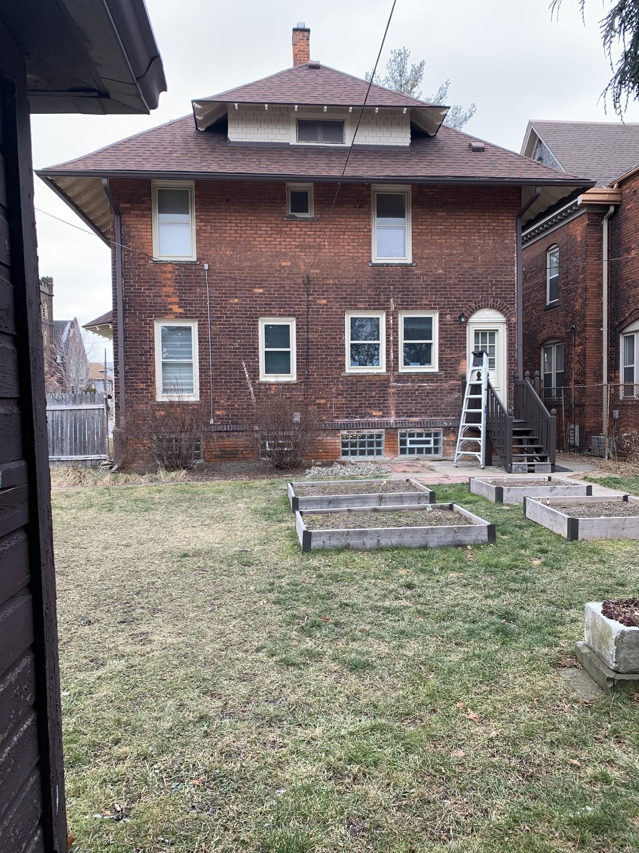

- View from back yard (east side):
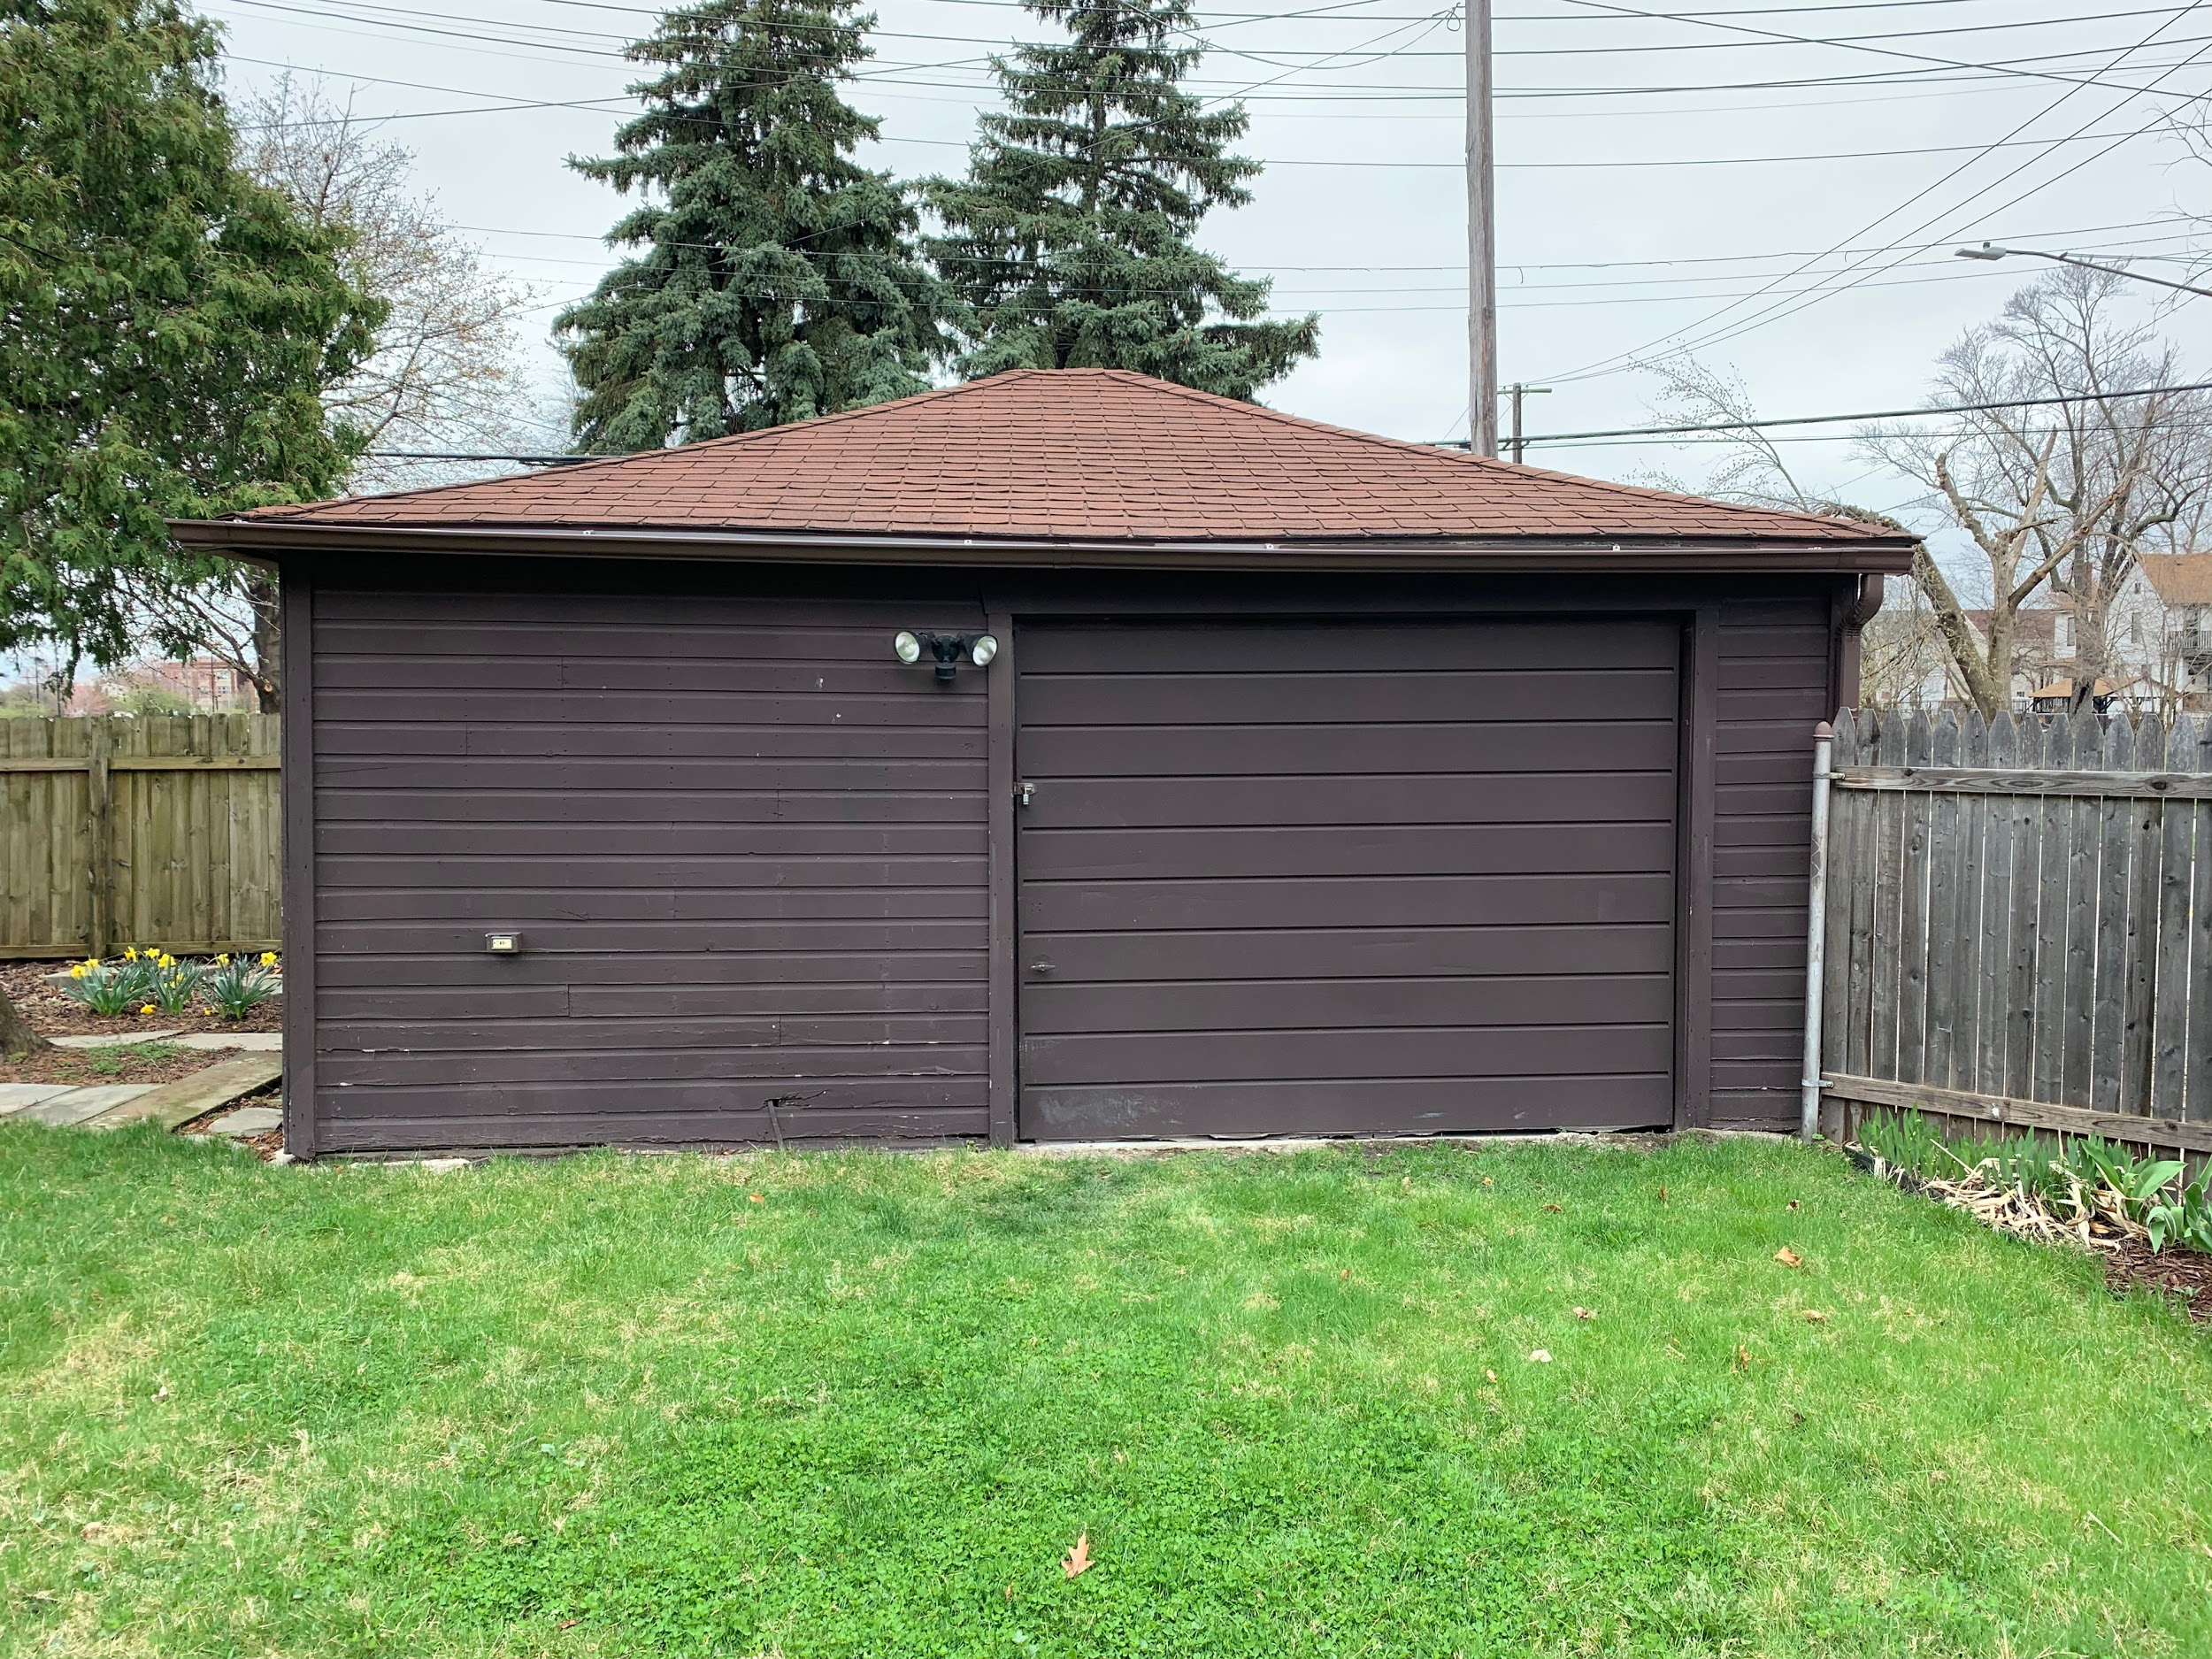

- View from back alley (west side):
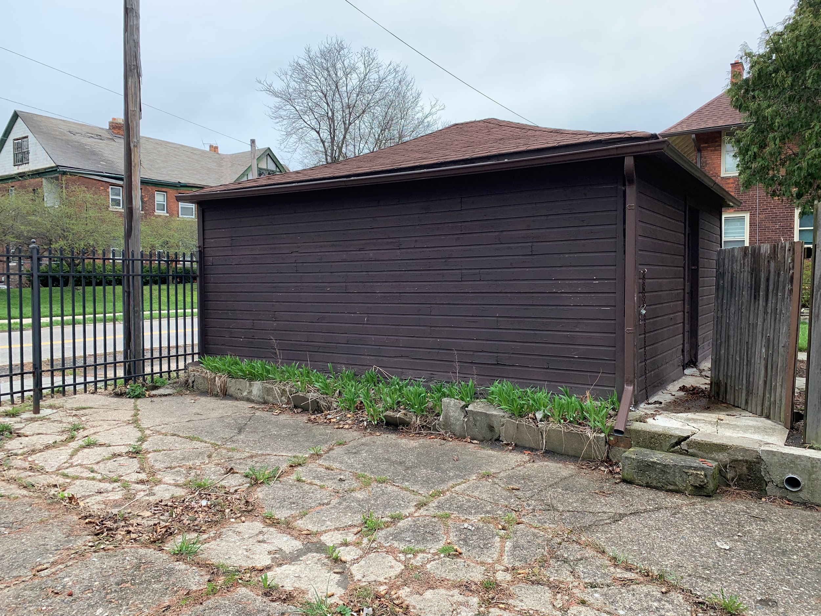

- View from back yard (south side):
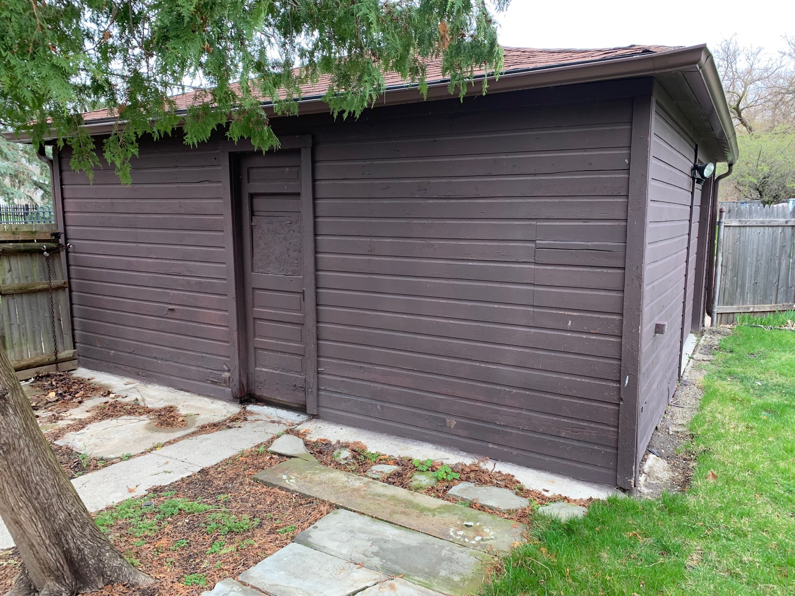

- View from Lafayette (north side) for garage door entry (shows existing concrete ramp):
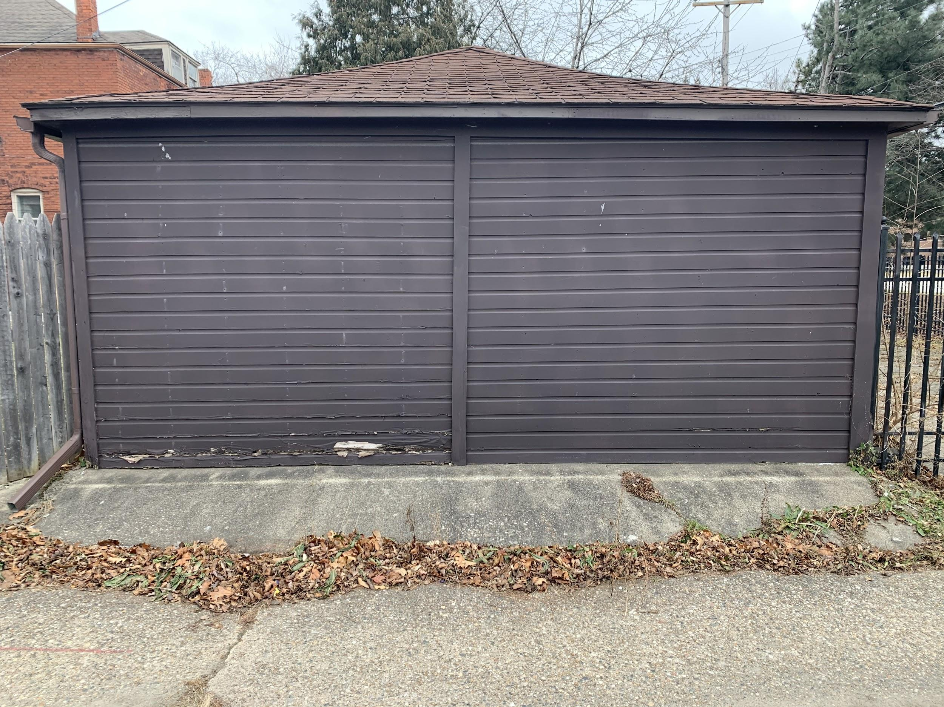

- Garage interior view of Lafayette (north side) wall including old header:
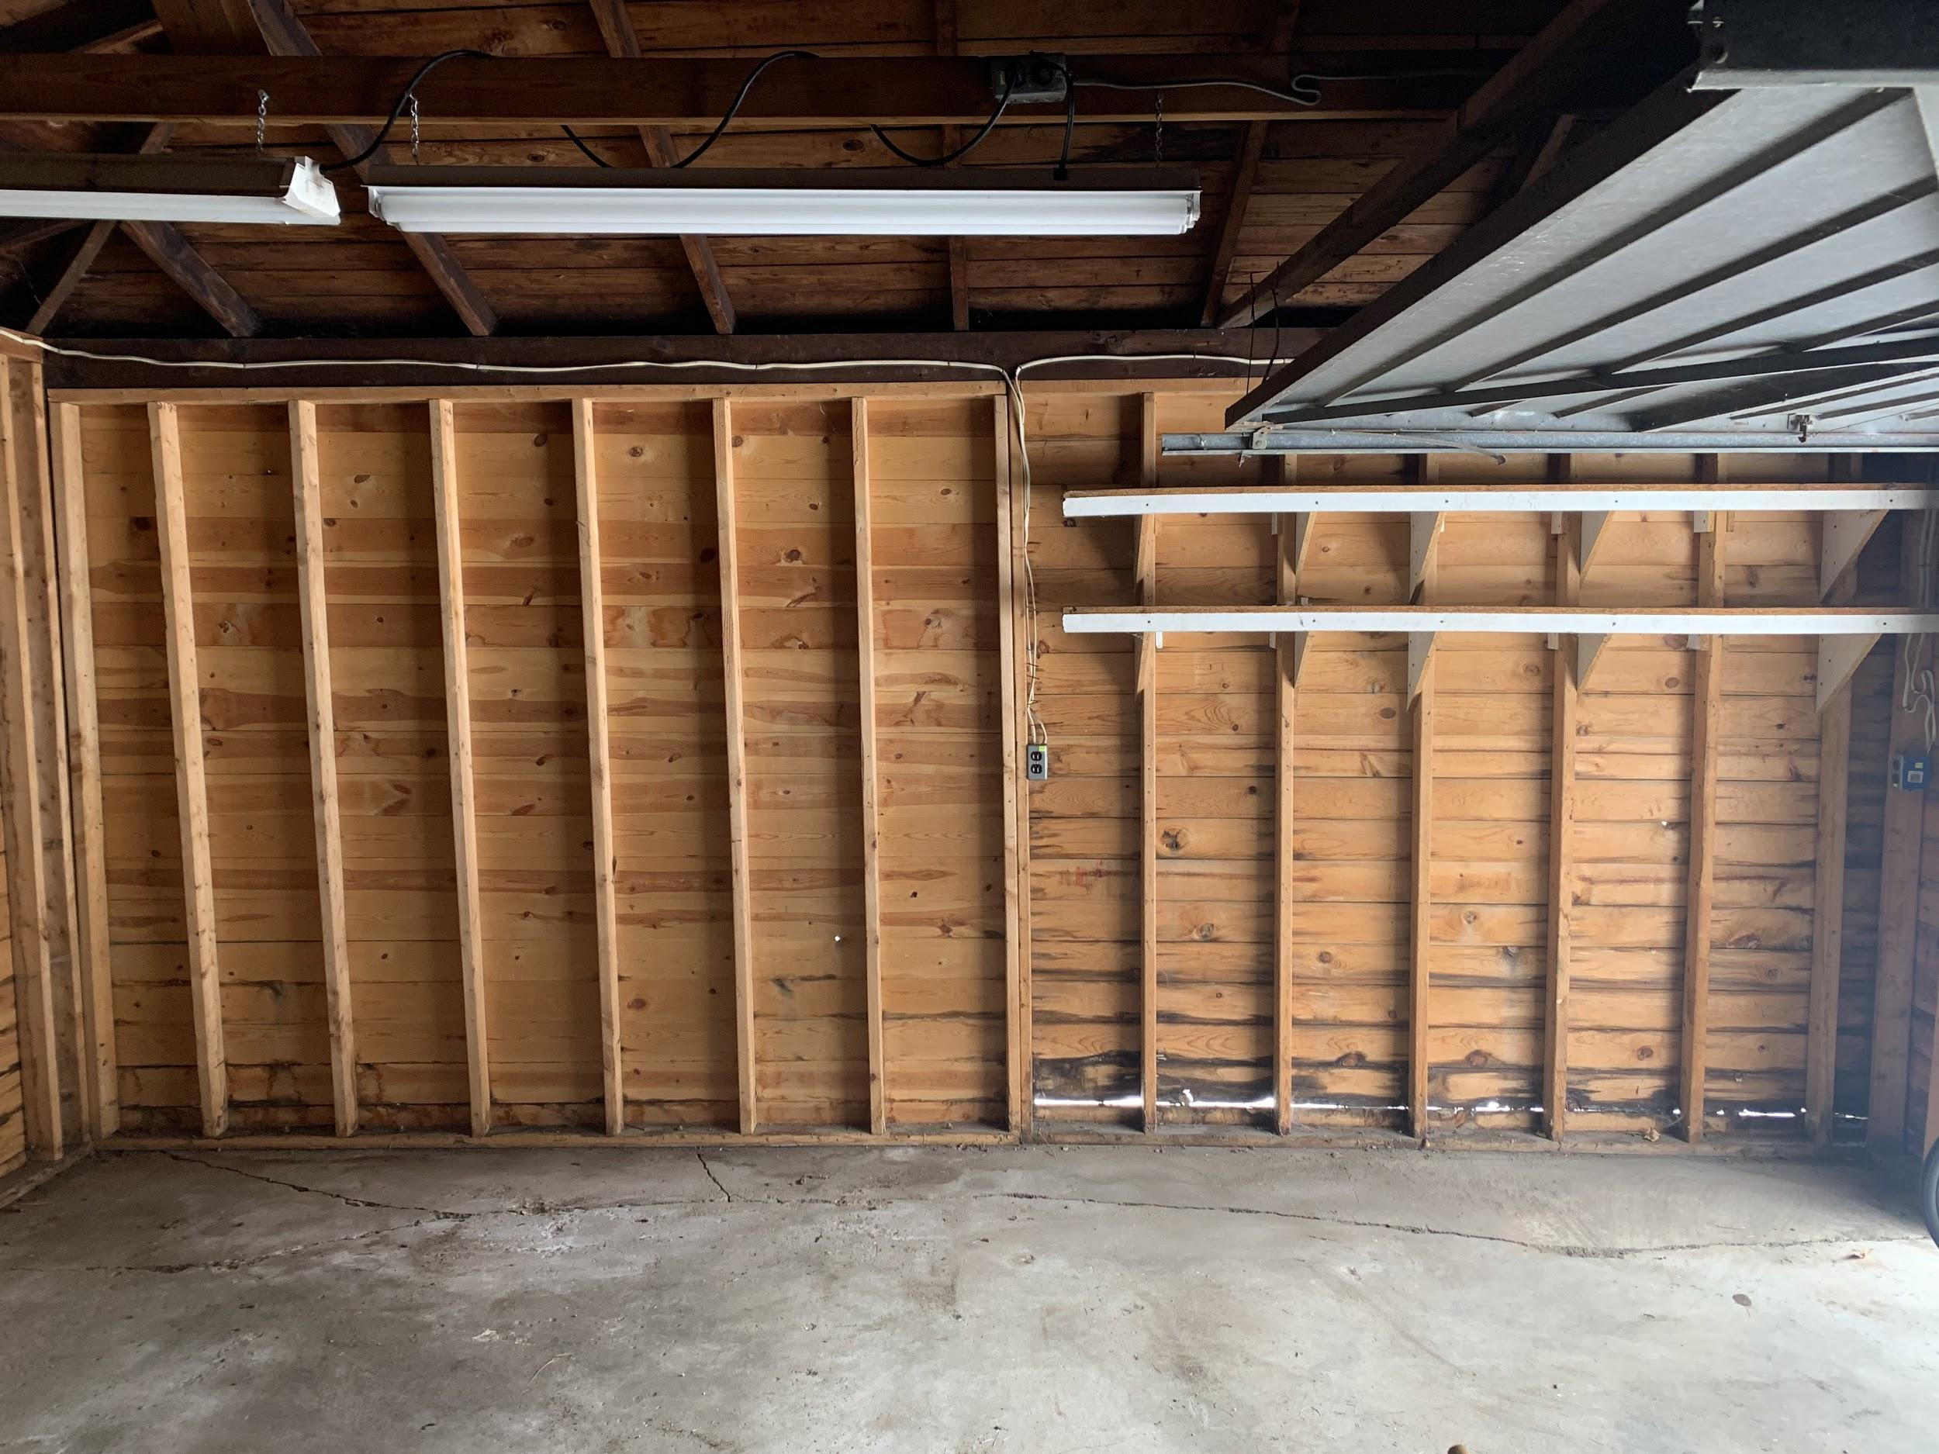

Construction contractor:
Kuper & Co.
Matt Kuper
5568 Saint Aubin Street
Detroit, MI 48211-2639
cell phone 313-801-3047
smckuper@yahoo.com

