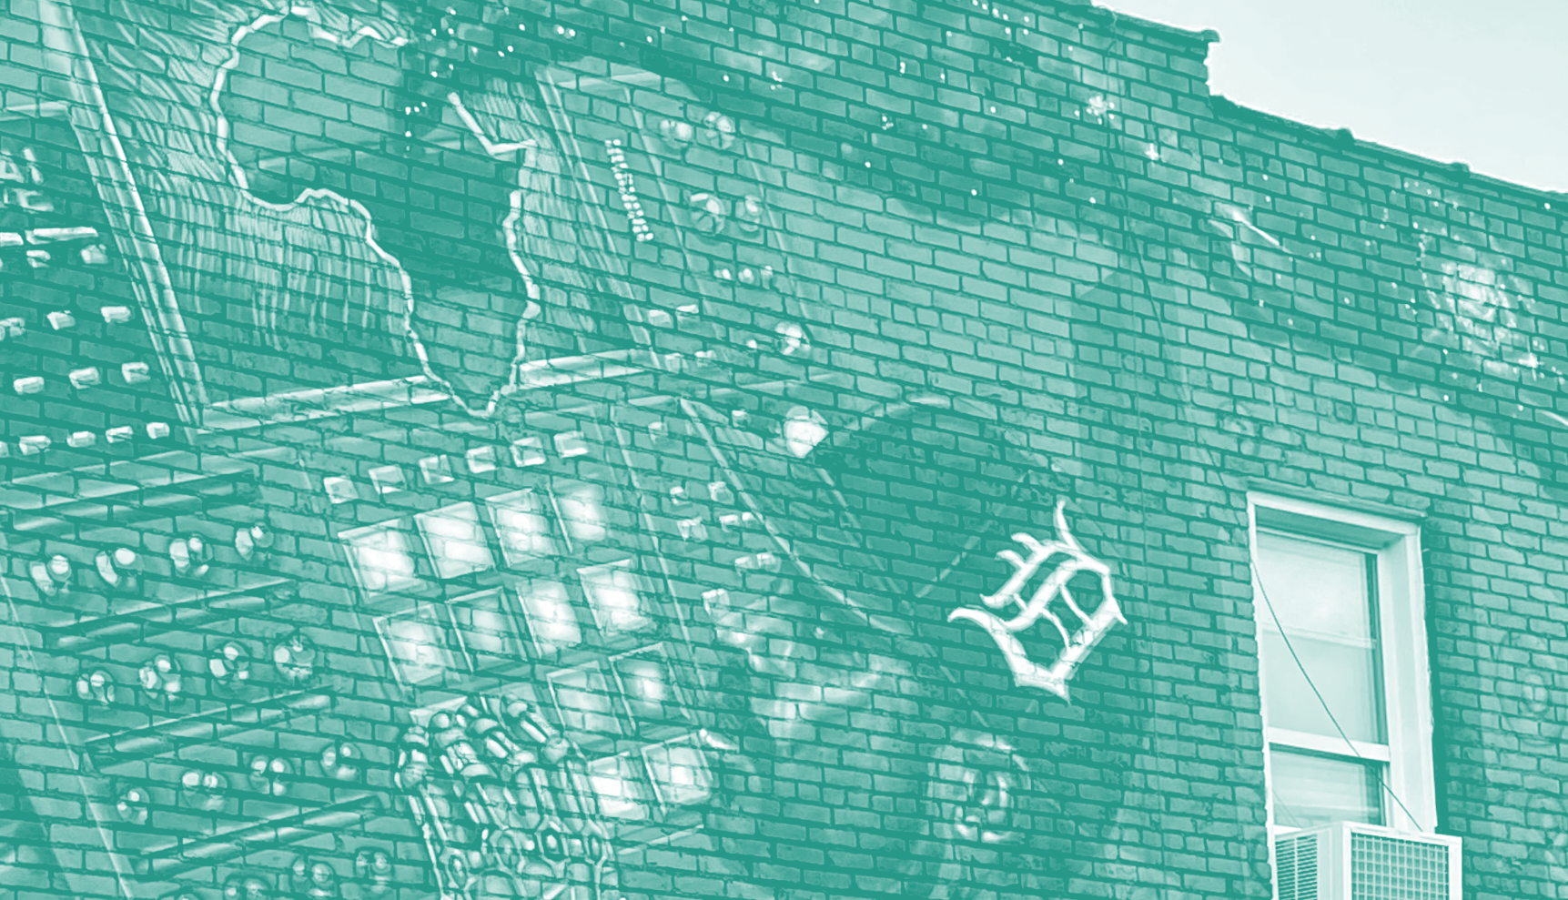
Monthly Newsletter January 2023

North End Neighborhood Framework Plan

Hello North Enders!

The City of Detroit has launched the North End Neighborhood Framework Plan to be a guiding document to support the equitable and inclusive growth and stability of the North End neighborhood. It will be created through a participatory planning process that involves residents and community members of the neighborhood over the course of 12-16 months. The Planning and Development Department’s goal is to create a healthy and beautiful Detroit built on an atmosphere of trust with inclusive growth and economic opportunity that builds off of previous planning studies.

Read on to see how you can be involved!

Get involved!
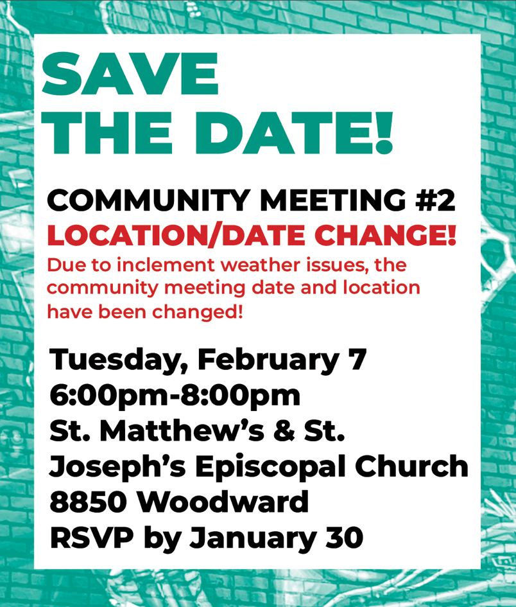
This will be a hybrid meeting, so you can join either in person or virtually! For the in-person meeting, masks are required.

Meeting agenda:
- Welcome
- Project Overview
- Engagement Overview and Update
- Technical Team Presentation
- Breakout Room Discussion
- Breakout Room Share Out
- Close + Next Steps

Please RSVP for either:
In-person: https://NorthEndCommMtgInPerson.eventbrite.com
Virtual: https://NorthEndCommMtgVirtual.eventbrite.com

- Take the survey + be entered into a raffle!
- WE’D LOVE TO ATTEND YOUR BLOCK CLUB MEETING! Email calvin.johnson@detroitmi.gov if you would like us to attend an upcoming meeting!

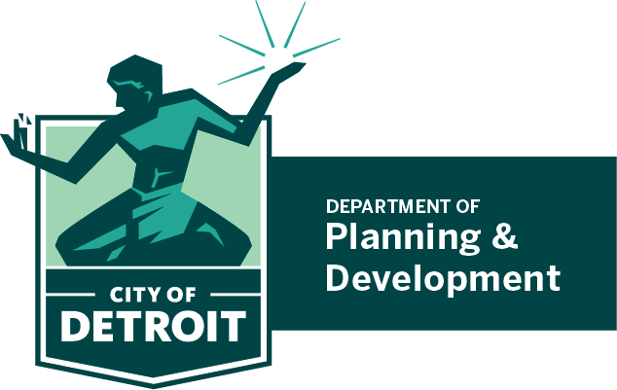
Questions or thoughts?
Calvin Eugene Johnson II, Planner IV
calvin.johnson@detroitmi.gov
Main Office: (313) 224-1339
www.Detroitmi.gov/northend

