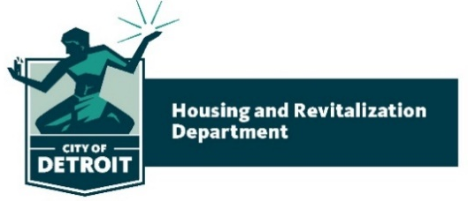

CDBG / NOF Training & Technical Assistance Agenda
“Fund Development for Organizational Sustainability”
April 27th, 2022 – 9:00 AM – 1:00 PM

Objectives:
- Participants will understand how fundraising impacts the organization’s sustainability and help maintain the financial health of the organization.
- Participants will learn to implement special events fundraising best practices as a part of their fund development strategy.
- Participants will know what steps to take to be capital campaign ready.
- Participants will share fundraising best practices.

Agenda
- Introduction – Tamra Hardy
- Attendance – Mandy Valentine
- Icebreaker – Mandy Valentine
- Best Practices for Special Events – Fundraising & Friendraising – Maggie Katz
- Break – 5 minutes
- How to Be Ready for a Capital Campaign – Scott Trudell
- Subrecipient Panel – Fundraising Successes & Challenges
  - Kerrie Mitchell – Matrix Human Services
  - Tara Franey - Luella Hannan Memorial Foundation
  - Jeff Griffith – The Youth Connection
  - Q & A
- Closing – Kerry Baitinger

