West Warren Streetscape Community Meeting
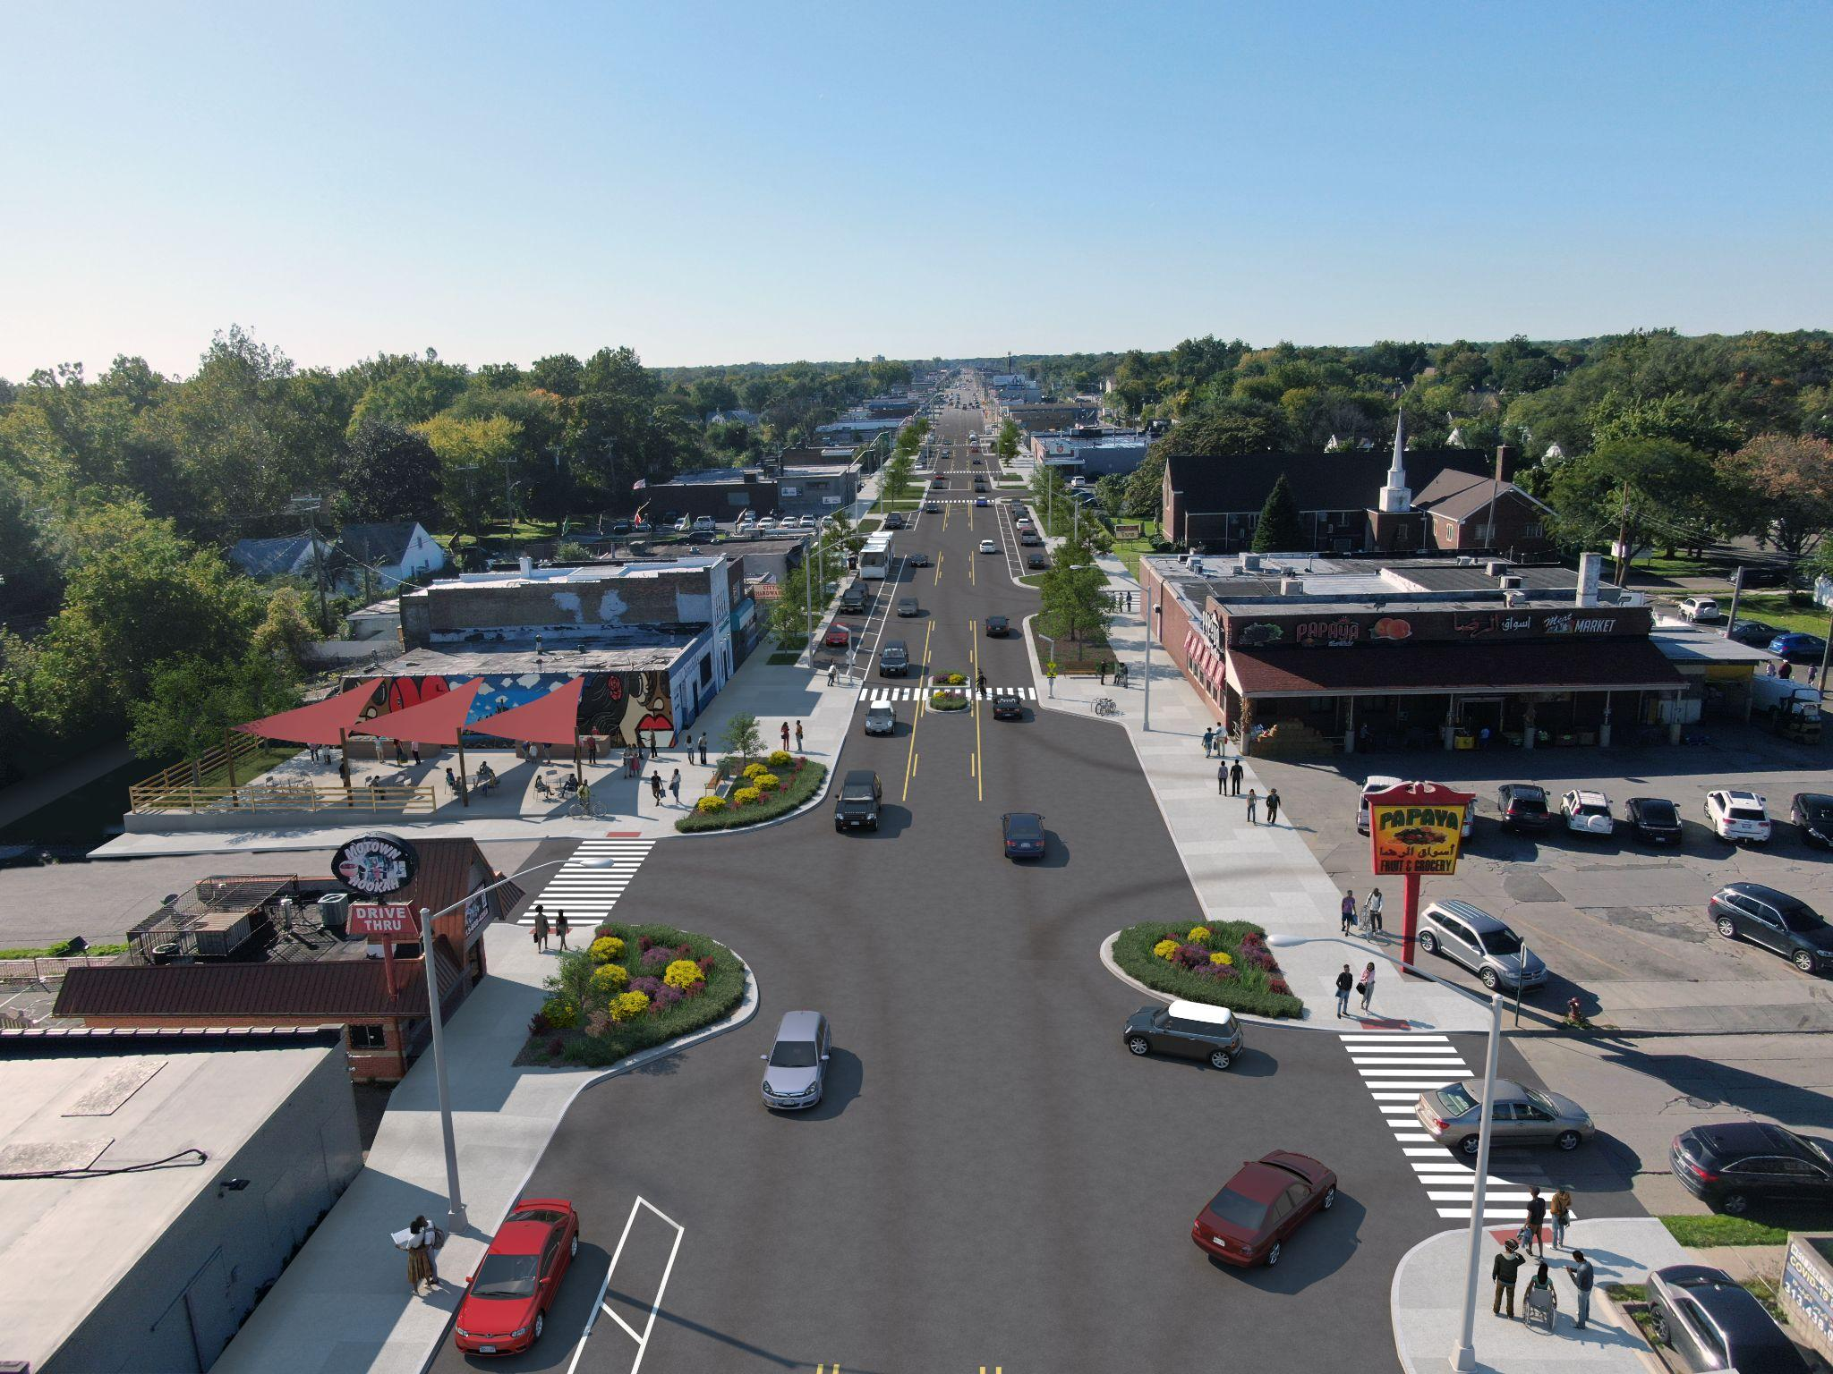
Tuesday, February 22nd, 2022; 6-7:30pm
Join Us Virtually!
Come see the final layout that was designed by the community!

Meeting link:
https://cityofdetroit.zoom.us/j/86883326604
or Call in 12678310333
Phone Conference ID: 868 8332 6604#
_______________________________________________
With advance notice of seven days, the City of Detroit will provide interpreter services at public meetings, including language translation and signage for the hearing impaired. Please contact 313-628-0135 to schedule these services.
For questions or concerns, please contact: Gustavo Serratos,
Project Manager - Complete Streets
313-236-9522 / serratosg@detroitmi.gov
www.detroitmi.gov/streetscapes

