INTERNAL OPERATIONS STANDING COMMITTEE AGENDA

THIS MEETING WILL BE A VIRTUAL COMMITTEE MEETING To attend by phone only, call one of these numbers: +1 929 436 2866, +1 312 626 6799, +1 669 900 6833, +1 253 215 8782, +1 301 715 8592, +1 346 248 7799 - Enter Meeting ID: 330332554##

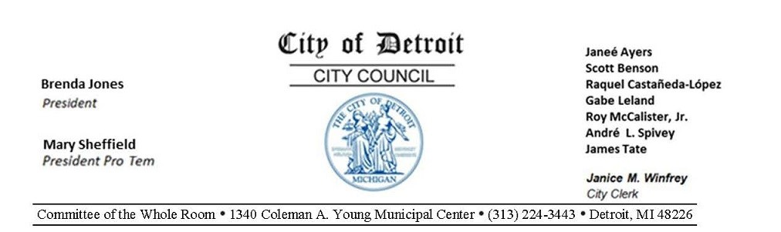
COUNCIL MEMBER ROY MCCALISTER, CHAIRPERSON COUNCIL MEMBER RAQUEL CASTANEDA-LOPEZ, VICE CHAIRPERSON COUNCIL MEMBER JAMES TATE, MEMBER COUNCIL PRESIDENT BRENDA JONES, EX-OFFICIO

Wednesday, September 23, 2020, 10:00 A.M.
Committee of the Whole Room 1340 Coleman A. Young Municipal Center (313) 224-3443 Detroit, MI 48226

- MS. CHRISTIAN HICKS
Asst. City Council Committee Clerk
- ROLL CALL
- CHAIR REMARKS
- APPROVAL OF MINUTES
- 10:05 A.M. INTERVIEW - RE:
Re-appointment of Peter Rhoades to the Detroit Brownfield Redevelopment Board -Community Advisory Committee (Peter Rhoades)
- 10:20 A.M. INTERVIEW - RE:
Re-appointment of Kamal Cheeks to the Detroit Brownfield Redevelopment Board -Community Advisory Committee (Kamal Cheeks)
- UNFINISHED BUSINESS
  - Status of Council President Brenda Jones submitting memorandum relative to
the August Election Concerns. (BROUGHT BACK AS DIRECTED ON 9-16-20)
  - Status of Law Department Submitting reso. autho. Legal Representation and Indemnification
in lawsuit of Javon Dabney v City of Detroit, et al. Civil Action Case No.: 20-10329; for P.O. Derrick King. (BROUGHT BACK AS DIRECTED ON 9-16-20)
  - Status of Council Member Raquel Castañeda-López submitting resolution
Urging Improvements to Citywide Wi-Fi Access by petitioning Comcast to take several actions to close the Digital Divide in Detroit. (BROUGHT BACK AS DIRECTED ON 9-920)
  - Status of Mayor's Office submitting correspondence relative to
Joint Appointment Vacancy on the Board of Ethics. (As it is stated in the Detroit City Charter Sec. 2-106.8, this appointee must be jointly appointed by the Mayor and City Council, which
means the Administration and City Council must agree upon a candidate prior to confirmation and appointment.) (BROUGHT BACK AS DIRECTED ON 9-9-20)
- NEW BUSINESS
  - OFFICE OF CONTRACTING AND PROCUREMENT
  - Submitting reso. autho. Contract No. 6001758
100% City Funding – AMEND 1 – To Provide an Extension of Time and an
Increase of Funds for Advertising Services. – Contractor: Detroit Legal News Company – Location: 2001 West Lafayette Avenue, Detroit, MI 48216 – Contract Period: January 1, 2022 through December 30, 2023 – Contract Increase Amount:
$1,800,000.00 – Total Contract Amount: $3,084,821.50. CITY CLERK (Original
Contract Period: December 31, 2018 through December 31, 2021) (REFERRED TO
THE INTERNAL OPERATIONS STANDING COMMITTEE ON 9-23-20)
  - DETROIT BROWNFIELD REDEVELOPMENT AUTHORITY
1. Submitting report relative to Reappointment of DBRA-CAC member reappointment.
Please be informed that the term of office for Mr. Kamal Cheeks, Mr. Bradley Lutz and Mr. Peter Rhodes, all Community Advisory Committee (CAC) members for the Detroit Brownfield Redevelopment Authority (DBRA) expired on June 30, 2020. Consequently, please take action in reappointing the three current members or appointing three new members to serve a term expiring June 30, 2021.
(REFERRED TO THE INTERNAL OPERATIONS STANDING COMMITTEE
ON 9-23-20)
3. HUMAN RESOURCES DEPARTMENT / LABOR RELATIONS DIVISION
- Submitting reso. autho. Implementation of Rescission of Wage Step Increases and/or Bonus Payments Scheduled for July 1, 2020 through June 30, 2021
for the International Brotherhood of Teamsters, Local 214 *Teamsters, Local 214). (The City's revenue collections have suffered due to COVID-19. Specifically, the City is facing a projected $154 Million revenue shortfall for this fiscal year and a projected $194 Million revenue shortfall for fiscal year 2021. The City recognizes the sacrifices of its employees who have taken reductions in hours and layoffs. The parties recognize the need for additional savings from its full time employees to balance the budget and to avoid State of Michigan oversight. Labor Relations presented a written proposal to the Teamsters, Local 214 for the elimination of economic increases negotiated beginning July 1, 2020; and based on mutual consideration, the 2019 -2023 Collective Bargaining Agreement (CBA) has been amended.) (REFERRED TO THE INTERNAL OPERATIONS STANDING COMMITTEE ON 9-23-20)
- Submitting reso. autho. Implementation of Rescission of Wage and Step Increases and/or Bonus Payments Scheduled for July 1, 2020 through June 30, 2021
for the American Federation of State and Municipal Employees, Non-supervisory (AFSCME, Non-Supervisory). (The City's revenue collections have suffered due to COVID-19. Specifically, the City is facing a projected $154 Million revenue shortfall for this fiscal year and a projected $194 Million revenue shortfall for fiscal year 2021. The City recognizes the sacrifices of its employees who have taken reductions in hours and layoffs. The parties recognize the need for additional savings from its full time employees to balance the budget and to avoid State of Michigan oversight. Labor Relations presented a written proposal to the (AFSCME,
Non-Supervisory) for the elimination of economic increases negotiated beginning
July 1, 2020; and based on mutual consideration, the 2019 - 2023 Collective
Bargaining Agreement (CBA) has been amended. (REFERRED TO THE
INTERNAL OPERATIONS STANDING COMMITTEE ON 9-23-20)
4. OFFICE OF THE CHIEF FINANCIAL OFFICER / OFFICE OF DEVELOPMENT AND
GRANTS
- Submitting reso. autho. To submit a grant application to the Harvard Business School for the FY 2021 Harvard Business School Leadership Fellows Program.
The Mayor’s Office is hereby requesting authorization from Detroit City Council to submit a grant application to the Harvard Business School for the FY 2021 Harvard Business School Leadership Fellows Program. The amount being sought is $50,000.00. The grantor share is $50,000.00 of the approved amount and there is a required cash match of $89,000.00. The total project cost is $139,000.00.
(REFERRED TO THE INTERNAL OPERATIONS STANDING COMMITTEE
ON 9-23-20)
- Submitting reso. autho. Request to Accept and Appropriate FY 2020 Michigan Indigent Defense Commission - Planning Grant.
The Michigan Indigent Defense Commission has awarded the City of Detroit Law

Department with the FY 2020 Michigan Indigent Defense Commission - Planning Grant for a total of $237,014.62. There is no match requirement for this grant. The
total project cost is $237,014.62. (REFERRED TO THE INTERNAL
OPERATIONS STANDING COMMITTEE ON 9-23-20)
5. MISCELLANEOUS
1. Council President Pro Tem Mary Sheffield submitting memorandum relative to
Request for LPD to draft a Resolution urging Congress to amend the Families the First Coronavirus Response Act (FFCRA) to include workers of companies with
more than 500 employees and extend the expiration date. (REFERRED TO THE INTERNAL OPERATIONS STANDING COMMITTEE ON 9-23-20)
9. PUBLIC COMMENT
- GENERAL PUBLIC
- MEMBER REPORTS

