BUDGET, FINANCE AND AUDIT STANDING COMMITTEE AGENDA

THIS MEETING WILL BE A VIRTUAL COMMITTEE MEETING To attend by phone only, call one of these numbers: +1 929 436 2866, +1 312 626 6799, +1 669 900 6833, +1 253 215 8782, +1 301 715 8592, +1 346 248 7799 - Enter Meeting ID: 330332554##

COUNCIL MEMBER JANEE AYERS, CHAIRPERSON COUNCIL MEMBER ANDRE SPIVEY, VICE CHAIRPERSON COUNCIL PRESIDENT PRO TEM MARY SHEFFIELD, MEMBER COUNCIL PRESIDENT BRENDA JONES, (EX-OFFICIO)

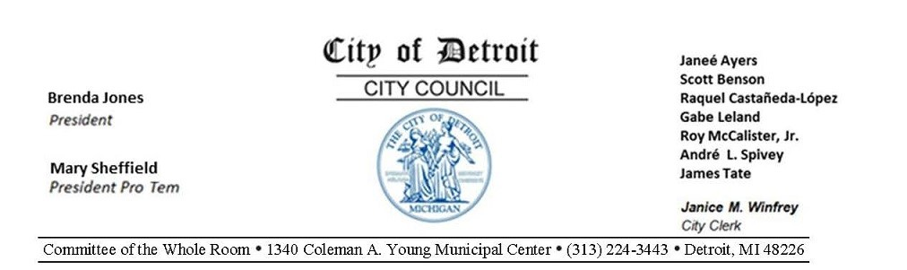
Wednesday, September 23, 2020, 1:00 P.M.
Committee of the Whole Room 1340 Coleman A. Young Municipal Center (313) 224-3443 Detroit, MI 48226

- MILLICENT G. WINFREY
Assistant City Council Committee Clerk
- ROLL CALL
- CHAIR REMARKS
- MEMBER REPORTS
- APPROVAL OF MINUTES
- PUBLIC COMMENT
- 1:05 P.M. DISCUSSION - RE:
Plante Moran Pre-Audit Communication (Plant Moran, Office of the Auditor General)
- UNFINISHED BUSINESS
  - Status of Mayor’s Office submitting reso. autho.
Supporting the Administration's Commitment to the goals of the Neighborhood Improvement
Plan. (The Administration is pleased to present the Neighborhood Improvement Program (NIP) resolution for the Council’s consideration. The resolution outlines a series of governance, procurement and community development policy objectives the administration is committed to implement in the expenditure of the bond funds.) (BROUGHT BACK AS DIRECTED ON 9-16-20)
  - Council Member Raquel Castañeda-López submitting memorandum
requesting an Amendment to the Detroit City Code Section 17-5-91 (f) to ensure that no services are provided by Vendors beyond the expiration date of the relevant contract, through an amendment to Chapter 17 Division 1 of the Detroit City Code.(BROUGHT BACK AS DIRECTED ON 9-9-20)
- NEW BUSINESS
  - OFFICE OF CONTRACTING AND PROCUREMENT
    - Submitting reso. autho. Contract No. 3045164
100% City Funding – To Provide a Cloud Based Database Backup and Storage System for the Retention and Retrieval of Documents Generated by the Office of the Assessor. – Contractor: IT Right, Inc. – Location: 5815 East Clark Road, Bath,
MI 48808 – Contract Period: Upon City Council Approval through September 30,
2023 – Total Contract Amount: $170,000.00. OFFICE OF THE CHIEF
FINANCIAL OFFICER (REFERRED TO THE BUGET, FINANCE AND AUDIT STANDING COMMITTEE ON 09-23-20)
    - Submitting reso. autho. Contract No. 6002861
100% City Funding – To Provide Citywide Insurance Broker Services. –
Contractor: Alliant Insurance Services, Inc. – Location: 1050 Wilshire Drive Suite
210, Troy, MI 48084 – Contract Period: Upon City Council Approval through June
30, 2021 – Total Contract Amount: $1,822,601.78. OFFICE OF THE CHIEF
FINANCIAL OFFICER (REFERRED TO THE BUGET, FINANCE AND AUDIT STANDING COMMITTEE ON 09-23-20)
- OFFICE OF THE ASSESSOR
  - Submitting reso. autho. REC Center Limited Dividend Housing Association
Limited Partnership - Payment in Lieu of Taxes (PILOT)
Full Circle Communities, Inc. has formed REC Center Limited Dividend Housing
Association Limited Partnership in order to develop the Project known as the Ruth Ellis Clairmount Center. The Project is a newly constructed mixed-use building with elevator access and will consist of forty-three (43) units on the second through fourth floors with commercial space for supportive services on the ground floor. The building will be located in an area bounded by Clairmount on the north, Woodward on the east, Hazelwood on the south and Second on the west.
(REFERRED TO THE BUGET, FINANCE AND AUDIT STANDING COMMITTEE ON 09-23-20)
- OFFICE OF THE AUDITOR GENERAL
  - Submitting report relative to Audit of the Department of Public Works
Attached for your review is our report on the Audit of the Department of Public Works. This report contains our audit purpose, scope, objectives, methodology and conclusions; background; our audit findings and recommendations; and the responses from the Department of Public Works and the Office of the Chief
Financial Officer. (REFERRED TO THE BUGET, FINANCE AND AUDIT STANDING COMMITTEE ON 09-23-20)
  - Submitting report relative to Fiscal Year 2019-2020 Fourth Quarter.
Attached for your review is the Office of the Auditor General's (OAG) Fiscal Year 2019-20 Fourth Quarter Report. This report contains an overview of our audit activities, TeamMate Projects, and a review of our Fiscal Year 2020-21 Adopted
Budget. (REFERRED TO THE BUGET, FINANCE AND AUDIT STANDING COMMITTEE ON 09-23-20)
- OFFICE OF THE CITY CLERK/CITY PLANNING COMMISSION
  - Submitting reso. autho. Neighborhood Enterprise Zone Certificate Application
for the rehabilitation of an existing single-family residential structure located at 1321 Labrosse Avenue in the Corktown Neighborhood Enterprise Zone area.
(REFERRED TO THE BUGET, FINANCE AND AUDIT STANDING COMMITTEE ON 09-23-20)
  - Submitting reso. autho. Neighborhood Enterprise Zone Certificate Applications

for the new construction of ten condominiums located at 1454 Townsend Avenue, Units 26 - 35 in the Islandview Neighborhood Enterprise Zone area. (REFERRED
TO THE BUGET, FINANCE AND AUDIT STANDING COMMITTEE ON 09-
23-20)
5. MISCELLANEOUS
1. Council President Pro Tem Mary Sheffield submitting memorandum relative to
Federal CARES Dollars for the Board of Review. (REFERRED TO THE BUGET,
FINANCE AND AUDIT STANDING COMMITTEE ON 09-23-20)

