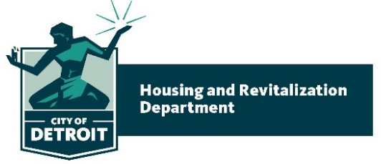 | Coleman A. Young Municipal Center  2 Woodward Avenue. Suite 908  Detroit, Michigan 48226 | Phone: 313.224.6380  Fax: 313.224.1629  www.detroitmi.gov
July 20, 2020

Detroit City Council
1340 Coleman A. Young Municipal Center
Detroit, MI 48226

RE: FY 2020-21 BUDGET AMENDMENT TO CDBG/NOF, ESG, HOME & HOPWA

Honorable City Council:

The Housing & Revitalization Department (HRD) hereby requests to amend the 2020-21 Community Development Block Grant, Neighborhood Opportunity Fund (CDBG/NOF), Emergency Solutions Grant (ESG), HOME Investment Partnerships (HOME) and Housing Opportunities for Persons With Aids (HOPWA) budgets to reflect the actual allocations received from the U.S. Department of Housing and Urban Development (HUD). Please see the attached spreadsheet (Schedule A) for all account information relative to this amendment.

The fiscal year 2020-21 budget for HUD’s final allocations were received after the Departmental budgets were finalized. Therefore, the budgets in these programs needs to be adjusted to reflect HUD’s final allocations. The Department is requesting that the revisions are approved to enable HRD to begin working with the actual allocations and community partners to facilitate the great work planned in the City of Detroit.

We respectfully request that your Honorable Body approve the attached resolution authorizing this amendment to the 2020-21 budget for the stated purpose.

Respectfully submitted,

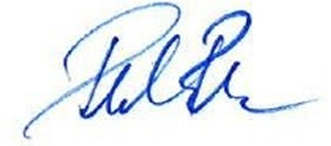

Donald Rencher
Director

Attachment

cc: Avery Peeples, Mayor’s Office
Val Miller, HRD

BY COUNCIL MEMBER _______________________________________________

WHEREAS, the Detroit City Council hereby approved Fiscal Year 2020-21 City’s estimated Budgets for the Community Development Block Grant (CDBG), Emergency Solutions Grant (ESG), HOME Investment Partnerships (HOME) and Housing Opportunities for Persons With Aids (HOPWA); and

WHEREAS, the Mayor of the City of Detroit, Michael E. Duggan, is hereby authorized to amend the revised 2020-21 budget w/appropriation numbers for revenues and expenditures, including all understandings and assurances contained therein to the U.S. Department of Housing and Urban Development (HUD) in accordance with the foregoing communication; and

RESOLVED, that the Budget Director be and is hereby authorized to increase CDBG Appropriation #06102 HRD Letter of Credit revenues by $2,494,939; and

RESOLVED, that the Budget Director be and is hereby, authorized to amend the existing budget with appropriation numbers for revenues and expenditures, to be reflected in the budget allocations for FY 2020-21 CDBG/NOF Public Service Section of the Schedule A budgeted activities as outlined in the attached spreadsheet; and

RESOLVED, that the Budget Director be and is hereby, authorized to amend the existing budget with appropriation numbers for revenues and expenditures, to be reflected in the budget allocations for FY 2020-21 CDBG/NOF Homeless Public Service Section of the Schedule A budgeted activities as outlined in the attached spreadsheet; and

RESOLVED, that the Budget Director be and is hereby authorized to setup, appropriate and increase CDBG Appropriation #20830 150 Bagley (Public Facility Historic Preservation) by $1,322,699; and

RESOLVED, that the Budget Director be and is hereby authorized to increase ESG expenditures and revenues Appropriation #13340 by $261,560; and

RESOLVED, that the Budget Director be and is hereby authorized to decrease HOME expenditures and revenues Appropriation #13171 HOME Admin by $238,141; and

RESOLVED, that the Budget Director be and is hereby authorized to decrease HOME expenditures and revenues Appropriation #10821 HOME Projects by $2,143,256; and

RESOLVED, that the Budget Director be and is hereby authorized to decrease HOPWA (Health Department) expenditures and revenues Appropriation #20722 by $296,865; and

BE IT FINALLY RESOLVED, that the Finance Director be and is hereby authorized to accept and process all documents reflecting these changes.

