COLEMAN A. YOUNG MUNICIPAL CENTER
2 WOODWARD AVENUE, SUITE 1026
DETROIT, MICHIGAN 48226
CITY OF DETROIT PHONE: 313 • 628-2158
OFFICE OF THE CHIEF FINANCIAL OFFICER FAX: 313 • 224 • 0542
OFFICE OF DEVELOPMENT AND GRANTS WWW._{DETROITMI}._{GOV} #16
_____________________________________________________________________________________________
__

April 22, 2020

The Honorable Detroit City Council

ATTN: City Clerk Office
200 Coleman A. Young Municipal Center
Detroit MI 48226

RE: Authorization to submit a grant application to the U.S. Department of Homeland Security for the Homeland Security Grant Program

The Detroit Department of Transportation (DDOT) is hereby requesting authorization from Detroit City Council to submit a grant application to the U.S. Department of Homeland Security for the FY 2020 Homeland Security Grant Program. The amount being sought is $1,654,157.00. There is no local match requirement.

The FY 2020 Homeland Security Grant Program will enable the department to:

• Purchase and install security camera equipment and back-office hardware and software for 288 DDOT buses

We respectfully request your approval to submit the grant application by adopting the attached resolution.

Sincerely,
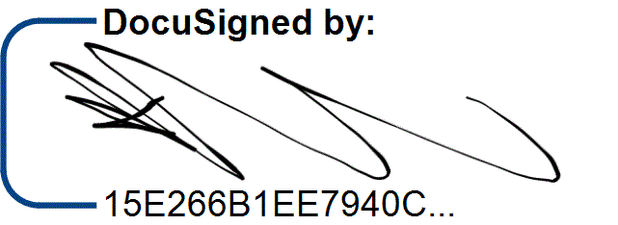

/9/

/13/

Katerli Bounds
Director, Office of Development and Grants CC:
Sirene Abou-Chakra, Chief Development Officer
Sajjiah Parker, Assistant Director, Grants

Office of
Development and Grants

RESOLUTION

Council Member_______________________________

WHEREAS, the Detroit Department of Transportation (DDOT) has requested authorization from City Council to submit a grant application to the U.S. Department of Homeland Security, for the FY 2020 Homeland Security Grant Program, in the amount of $1,654,157.00, to purchase and install security camera equipment and back-office hardware and software for 288 DDOT buses; now

THEREFORE, BE IT RESOLVED, the Detroit Department of Transportation is hereby authorized to submit a grant application to the U.S. Department of Homeland Security for the FY 2020 Homeland Security Grant Program.
Page 1 of 1
/1/ /2/ /7/ /8/ /11/ /3/ /4/ /12/ /14/
/10/ /5/

C
ITY OF
D
ETROIT
OFFICE OF THE CHIEF FINANCIAL OFFICER
O
FFICE OF
D
EVELOPMENT AND
G
RANTS
2
W
OODWARD
A
VENUE
,
SUITE
1026

D
ETROIT
, M
ICHIGAN

48226
P
HONE
313
:

628-2158
F
AX
:
313
224

0542

WWW
.
DETROITMI
.
GOV
Grant Application Request Form (GARF)
In order to secure the Office of Development and Grants (ODG) approval required under Section 18-4-2 of the Detroit City Charter, this form is to be filled out by City Departments as soon as possible upon learning of an opportunity that the Department would like to pursue. This form must be signed and submitted not later than 20 business days prior to the application deadline.
Please submit this form to the following ODG staff: Sajjiah Parker, Assistant Director,
