DocuSign Envelope ID: 56B09676-6E1B-4F2F-9C3F-1DE7DCD9A2E9
COLEMAN A. YOUNG MUNICIPAL CENTER
2 WOODWARD AVENUE, SUITE 1026
DETROIT, MICHIGAN 48226
CITY OF DETROIT PHONE: 313 • 628-2158

OFFICE OF THE CHIEF FINANCIAL OFFICER FAX: 313 • 224 • 0542
OFFICE OF DEVELOPMENT AND GRANTS WWW._{DETROITMI}._{GOV} #14
_____________________________________________________________________________________________
__

April 15, 2020

The Honorable Detroit City Council

ATTN: City Clerk Office
200 Coleman A. Young Municipal Center
Detroit MI 48226

RE: Request to Accept and Appropriate the COVID-19 Testing Sites Grant

The Community Foundation for Southeastern Michigan has awarded the City of Detroit Office of Mobility with the COVID-19 Testing Sites Grant for a total of $100,000.00. There is no match requirement. This grant was made possible by the generous individual donation from Mr. Gary H. Torgow. The total project cost is $100,000.00.

The objective of the grant is to support transportation to COVID-19 testing sites for residents. The funding allotted to the department will be utilized to provide safe transportation for Detroit residents to and from testing sites at no cost, in order test individuals who show symptoms of the coronavirus accordingly.

If approval is granted to accept and appropriate this funding, the appropriation number is 20801.

I respectfully ask your approval to accept and appropriate funding in accordance with the attached resolution.

Sincerely,
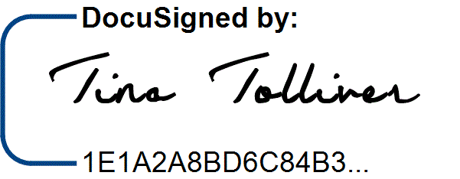
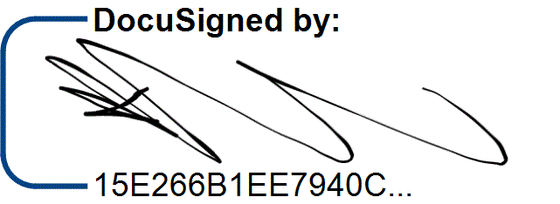
/9/

/13/
___________________
Katerli Bounds Office of Budget
Director, Office of Development and Grants
CC: /6/
Sirene Abou-Chakra, Chief Development Officer
Sajjiah Parker, Assistant Director, Grants

Office of Development and Grants

DocuSign Envelope ID: 56B09676-6E1B-4F2F-9C3F-1DE7DCD9A2E9

RESOLUTION

Council Member_______________________________

WHEREAS, the Office of Mobility is requesting authorization to accept a grant from the Community Foundation for Southeastern Michigan, in the amount of $100,000.00, to support transportation to COVID-19 testing sites for residents; and

WHEREAS, this request has been approved by the Office of Budget; now

THEREFORE, BE IT RESOLVED that the Director or Head of the Department is authorized to accept the grant agreement on behalf of the City of Detroit, and

BE IT FURTHER RESOLVED, that the Budget Director is authorized to establish Appropriation number 20801, in the amount of $100,000.00, for the COVID-19 Testing Sites Grant.

/1/ /2/ /7/ /8/ /11/ /3/ /4/ /12/ /14/
/10/ /5/
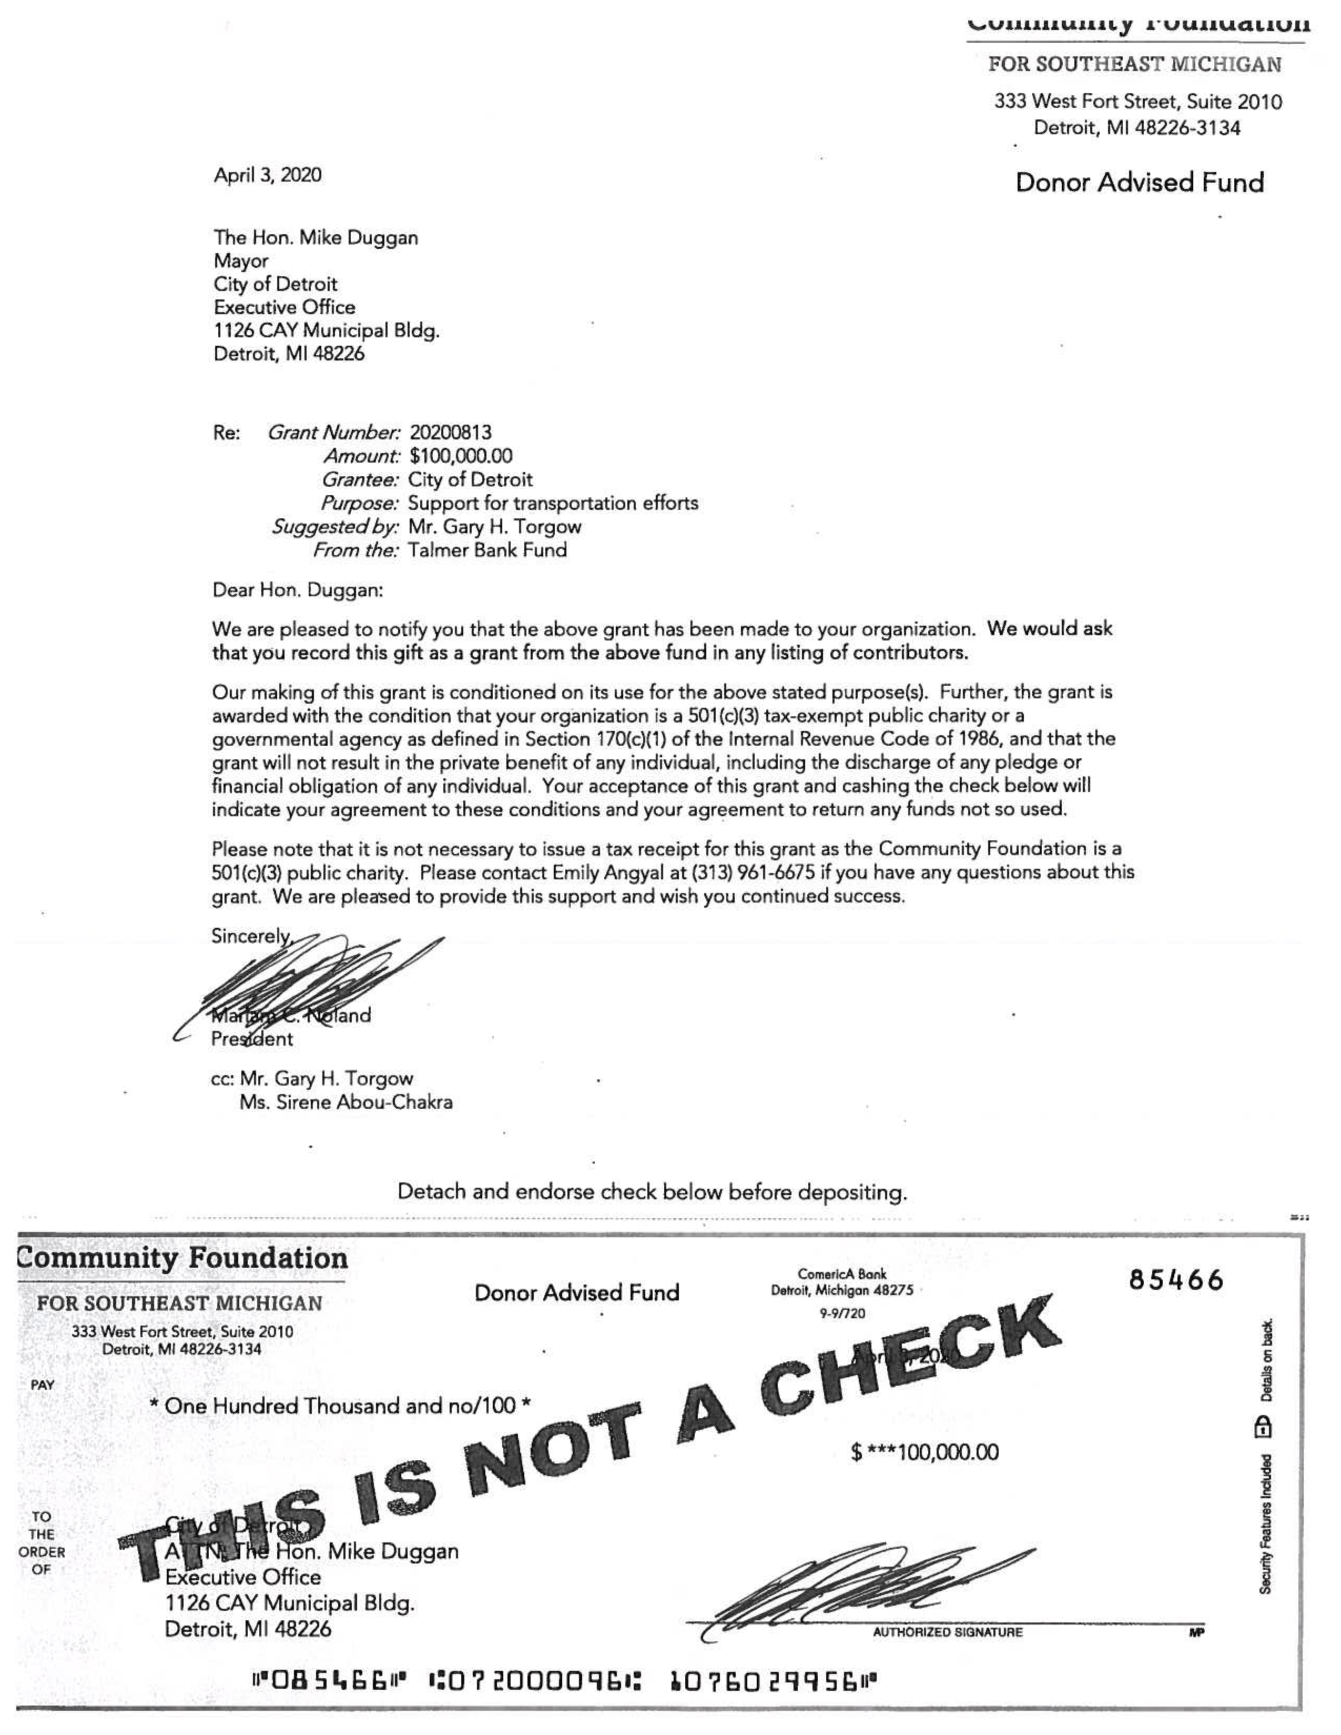
DocuSign Envelope ID: 56B09676-6E1B-4F2F-9C3F-1DE7DCD9A2E9
DocuSign Envelope ID: 56B09676-6E1B-4F2F-9C3F-1DE7DCD9A2E932 CEF4-3FAD-4B9C-B4EB-2BEA 7FBF 26

CITY OF DETROIT INTER-DEPARTMENTAL MEMORANDUM
FROM: |  | Mark de la Verge  Director, Office of Mobility
TO: |  | Katerli Bounds  Director, Office of Development and Grants
DATE: |  | April 9, 2020
RE: |  | COVID-19 Transportation Grant from Community Foundation for Southeastern Michigan

Purpose:

This correspondence is to inform you that the Office of Mobility has been awarded a $100,000 grant from Gary H. Torgow through the Community Foundation for Southeastern Michigan in order to support transportation to COVID-19 testing sites for residents.

The grant is coming via the Community Foundation from a generous private donation by Gary
H. Torgow who asked to specifically support this effort. We ask that you assist in processing Council Approval. On behalf of the Office of Mobility Innovation: thank you for your continued support and partnership.

Sincerely,
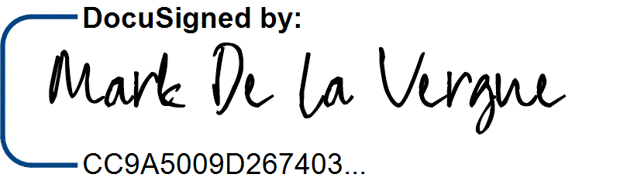
Mark de la Verge

Chief of Mobility Innovation

Attachments:
• Award Letter

