COLEMAN A. YOUNG MUNICIPAL CENTER
2 WOODWARD AVENUE, SUITE 1026
DETROIT, MICHIGAN 48226
CITY OF DETROIT PHONE: 313 • 628-2158
OFFICE OF THE CHIEF FINANCIAL OFFICER FAX: 313 • 224 • 0542
OFFICE OF DEVELOPMENT AND GRANTS WWW._{DETROITMI}._{GOV} #11
_____________________________________________________________________________________________
__

April 17, 2020

The Honorable Detroit City Council

ATTN: City Clerk Office
200 Coleman A. Young Municipal Center
Detroit MI 48226

RE: Request to Accept and Appropriate the FY 2020 COVID-19 Grant from The DMC Foundation

The DMC Foundation has awarded the City of Detroit Health Department with the FY 2020 COVID-19 Grant for a total of $300,000.00. There is no required match. The total project cost is $300,000.00. The grant period is March 24, 2020 through March 23, 2021.

The objective of the grant is to expand access to COVID-19 testing. The funding allotted to the department will be utilized to purchase food, masks and personal protective equipment (PPE), at COVID-19 testing centers.

If approval is granted to accept and appropriate this funding, the appropriation number is 20802.

I respectfully ask your approval to accept and appropriate funding in accordance with the attached resolution.

Sincerely,
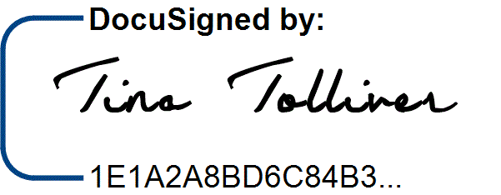
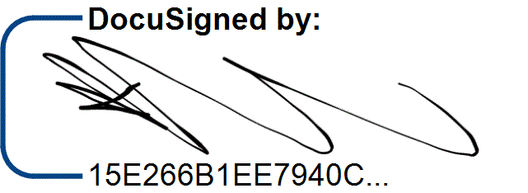

/9/

/13/
___________________
Katerli Bounds Office of Budget
Director, Office of Development and Grants
CC: /6/
Sirene Abou-Chakra, Chief Development Officer
Sajjiah Parker, Assistant Director, Grants

Office of Development and Grants

RESOLUTION

Council Member_______________________________

WHEREAS, the Health Department is requesting authorization to accept a grant from the DMC Foundation in the amount of $300,000.00, to expand access to COVID-19 testing; and

WHEREAS, this request has been approved by the Office of Budget; now

THEREFORE, BE IT RESOLVED that the Director or Head of the Department is authorized to execute the grant agreement on behalf of the City of Detroit, and

BE IT FURTHER RESOLVED, that the Budget Director is authorized to establish Appropriation number 20802, in the amount of $300,000.00, for the FY 2020 COVID-19 grant.

/1/ /2/ /7/ /8/ /11/ /3/ /4/ /12/ /14/
/10/ /5/
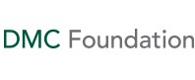
April 7, 2020
Mike Duggan
Mayor
City of Detroit
Executive Office
1126 Cay Municipal Bldg
Detroit, Michigan 48226
Re: #DMC-G--20208690
Dear The Hon. Duggan:
We are pleased to announce that the Board of Directors of the DMC Foundation has adopted the following resolution:
RESOLVED, that a grant of $300,000 to City of Detroit for support for expanded access to COVID-19 testing with priority for first responders and healthcare personnel be approved.
Included are the Terms of Grant Agreement related to this grant. Please make special note of all the provisions and procedures indicated. Please sign and submit the Terms of Grant Agreement to the DMC Foundation as soon as possible indicating your acceptance of the grant award and its terms. Also, please visit our website at cfsem.org/dmc-foundation-grantee-resources/ for guidelines about publicizing your award, and any unique reporting requirements.
While you are welcome to share news of this award internally and encouraged to begin your programming, we are asking that your organization does not publicly announce your grant at this time. The Community Foundation will be issuing a collective press release about all of the grants from this effort in the coming weeks. We will share it with you once it is completed, along with any details of how your organization can publicize the grant moving forward from that point.
After a signed copy of the Terms of Grant Agreement has been received, it is anticipated that payment will be made as follows:
Date: | Amount:
April 2020 | $300,000.00
We wish you every success and look forward to receiving reports on your progress.
Sincerely,
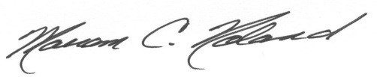
Mariam C. Noland
President

TERMS OF GRANT AGREEMENT
PLEASE READ CAREFULLY!
- Acceptance of Grant
The grant to your organization from the DMC Foundation is for the explicit purposes described in the Grant Resolution and is subject to your acceptance of the terms described therein.
Report: | Due Date:
Final Report | April 23, 2021
To accept the grant and receive the funds, return a signed copy of this "Terms of Grant Agreement" to the DMC Foundation. Please refer to the grant number and title in all communication concerning the grant.
Grantee: | Date Authorized:
City of Detroit | March 23, 2020
Grant Number: | Amount Granted:
DMC-G--20208690 | $300,000
Grant Resolution:
RESOLVED, that a grant of $300,000 to City of Detroit for support for expanded access to COVID-19 testing with priority for first responders and healthcare personnel be approved.
Grant Period:
Begins – | March 24, 2020
Terminates – | March 23, 2021
- Review of Grant Activity
The grantee will furnish the DMC Foundation with written reports according to the following schedule:

TERMS OF GRANT AGREEMENT
City of Detroit
DMC-G--20208690
- Publicity
We strongly encourage the grantee to publicize the receipt of this grant. Please share a copy of any press releases and announcements for approval prior to distributing, as well as copies and links of news coverage that results from press outreach.
Please visit our website at cfsem.org/dmc-foundation-grantee-resources/ for guidelines about publicizing your award.
- Special Provisions
In accepting this grant, the grantee agrees to the following conditions:
  - To use the funds granted solely for the purpose stated.
  - To repay any portion of the amounts granted which is not used for the purpose of the grant.
  - To return any unexpended funds if the grantee loses its exemption from Federal income taxation as provided under Section 501(c)(3) of the Internal Revenue Code of 1986, as amended (the “Code”), or (b) as a governmental entity or political subdivision within Section 170 (c) of the Code.
  - To maintain books and records adequate to verify actions related to this grant should this prove necessary.
  - Pre-approval is needed for any modifications in the approved project budget.
For the Grantee:

Signature of Authorized Representative |  | Date

Name and Title of Authorized Representative

