DocuSign Envelope ID: 20DF0FF9-AB25-439B-ADA4-AC9ADC14D304
Coleman A. Young Municipal Center
2 Woodward Avenue. Suite 908
Detroit, Michigan 48226
Phone: 313.224.6380 Fax: 313.224.1629 www.detroitmi.gov #9
April 28, 2020 Detroit City Council
Coleman A. Young Municipal Center
2 Woodward Ave., Suite 1340
Detroit, MI 48226
Re: Request for Public Hearing to Approve an Obsolete Property Rehabilitation Certificate on behalf of GRAND LASHER , LLC in the area of 22000 GRAND RIVER, Detroit, Michigan, in accordance with Public Act 146 of 2000 (Petition #556).
Honorable City Council:
The Housing and Revitalization Department and Finance Departments have reviewed the application of GRAND LASHER , LLC and find that it satisfies the criteria set forth by P.A. 146 of 2000 and would be consistent with development and economic goals of the Master Plan.
Public Act 146 of 2000 states that the legislative body of the qualified local governmental unit, shall by resolution either approve or disapprove the application for an Obsolete Property Rehabilitation Exemption Certificate in accordance with Section 8 and other provisions of this act. Prior to acting upon a resolution to recommend approval, a public hearing must be held, and the City Clerk must provide written notice of the public hearing to the assessor and to the governing body of each taxing unit that levies an ad valorem tax within the eligible district.
We request that a Public Hearing be scheduled on the issue of approving the application for the Obsolete Property Rehabilitation Certificate. Attached for your consideration, please find a resolution establishing a date and time for the public hearing.

Respectfully submitted,
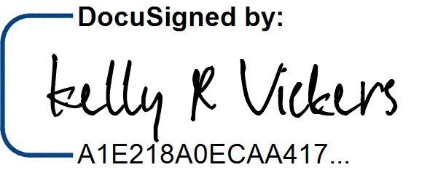

Kelly Vickers
Associate Director of Housing Underwriting
KV/AM
cc: A. Peeples, Mayor's Office
K. Trudeau, P&DD
K. Vickers, HRD
A. McLeod, HRD
DocuSign Envelope ID: 20DF0FF9-AB25-439B-ADA4-AC9ADC14D304

BY COUNCIL MEMBER__________________________________________

WHEREAS, pursuant to Public Act No. 146 of 2000 (“the Act”) this City Council may adopt resolution which approves the application of an Obsolete Property Rehabilitation Certificate within the boundaries of the City of Detroit; and

WHEREAS, GRAND LASHER, LLC has made application for an Obsolete Property
Rehabilitation Certificate whose boundaries are particularly described in the map and legal description attached hereto; and

WHEREAS, prior to such approval, the City Council shall provide an opportunity for a Public Hearing, at which Public Hearing on such adoption of a resolution providing such tax exemption, at which Public Hearing representatives of any taxing authority levying ad valorem taxes within the City, or any other resident or taxpayer of the City of Detroit may appear and be heard on the matter.

NOW THEREFORE BE IT

RESOLVED, that on the ___________________, 2020 in the City Council Committee Room, 13th floor, Coleman A. Young Municipal Center, a Public Hearing be held on the above described application and be it finally

RESOLVED, that the City Clerk shall give notice of the Public Hearing to the general public and shall give written notice of the Public Hearing by certified mail to all taxing authorities levying an ad valorem tax within the City of Detroit.

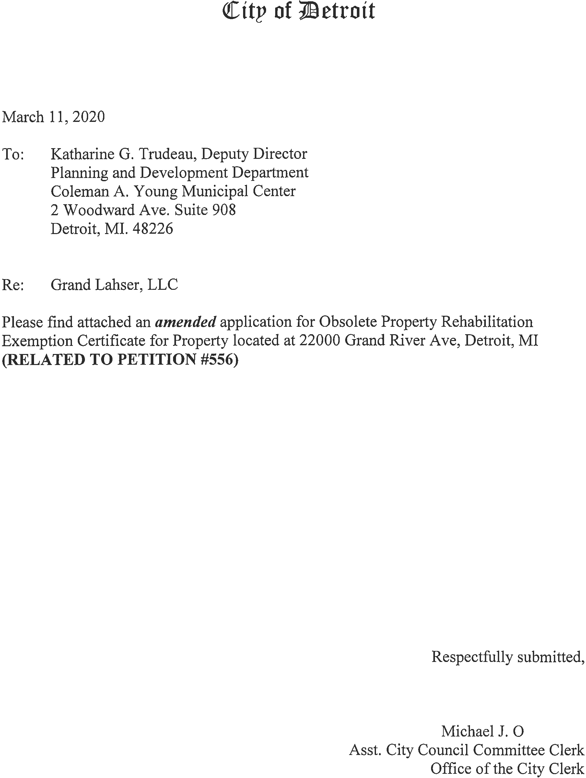
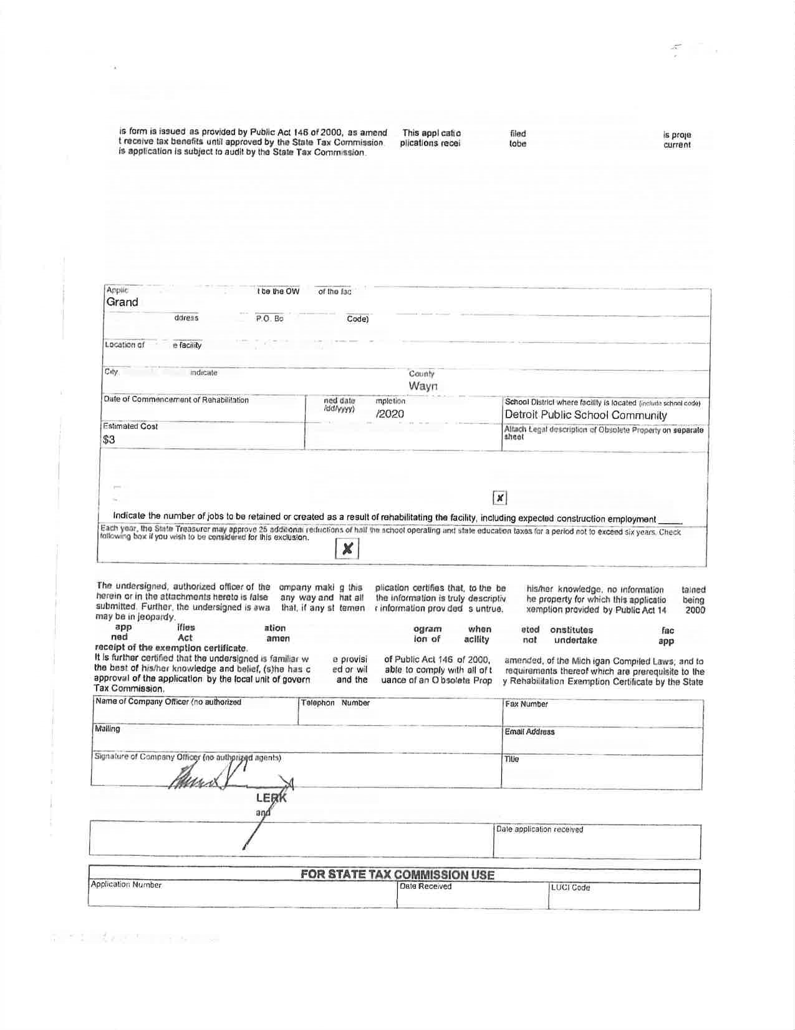
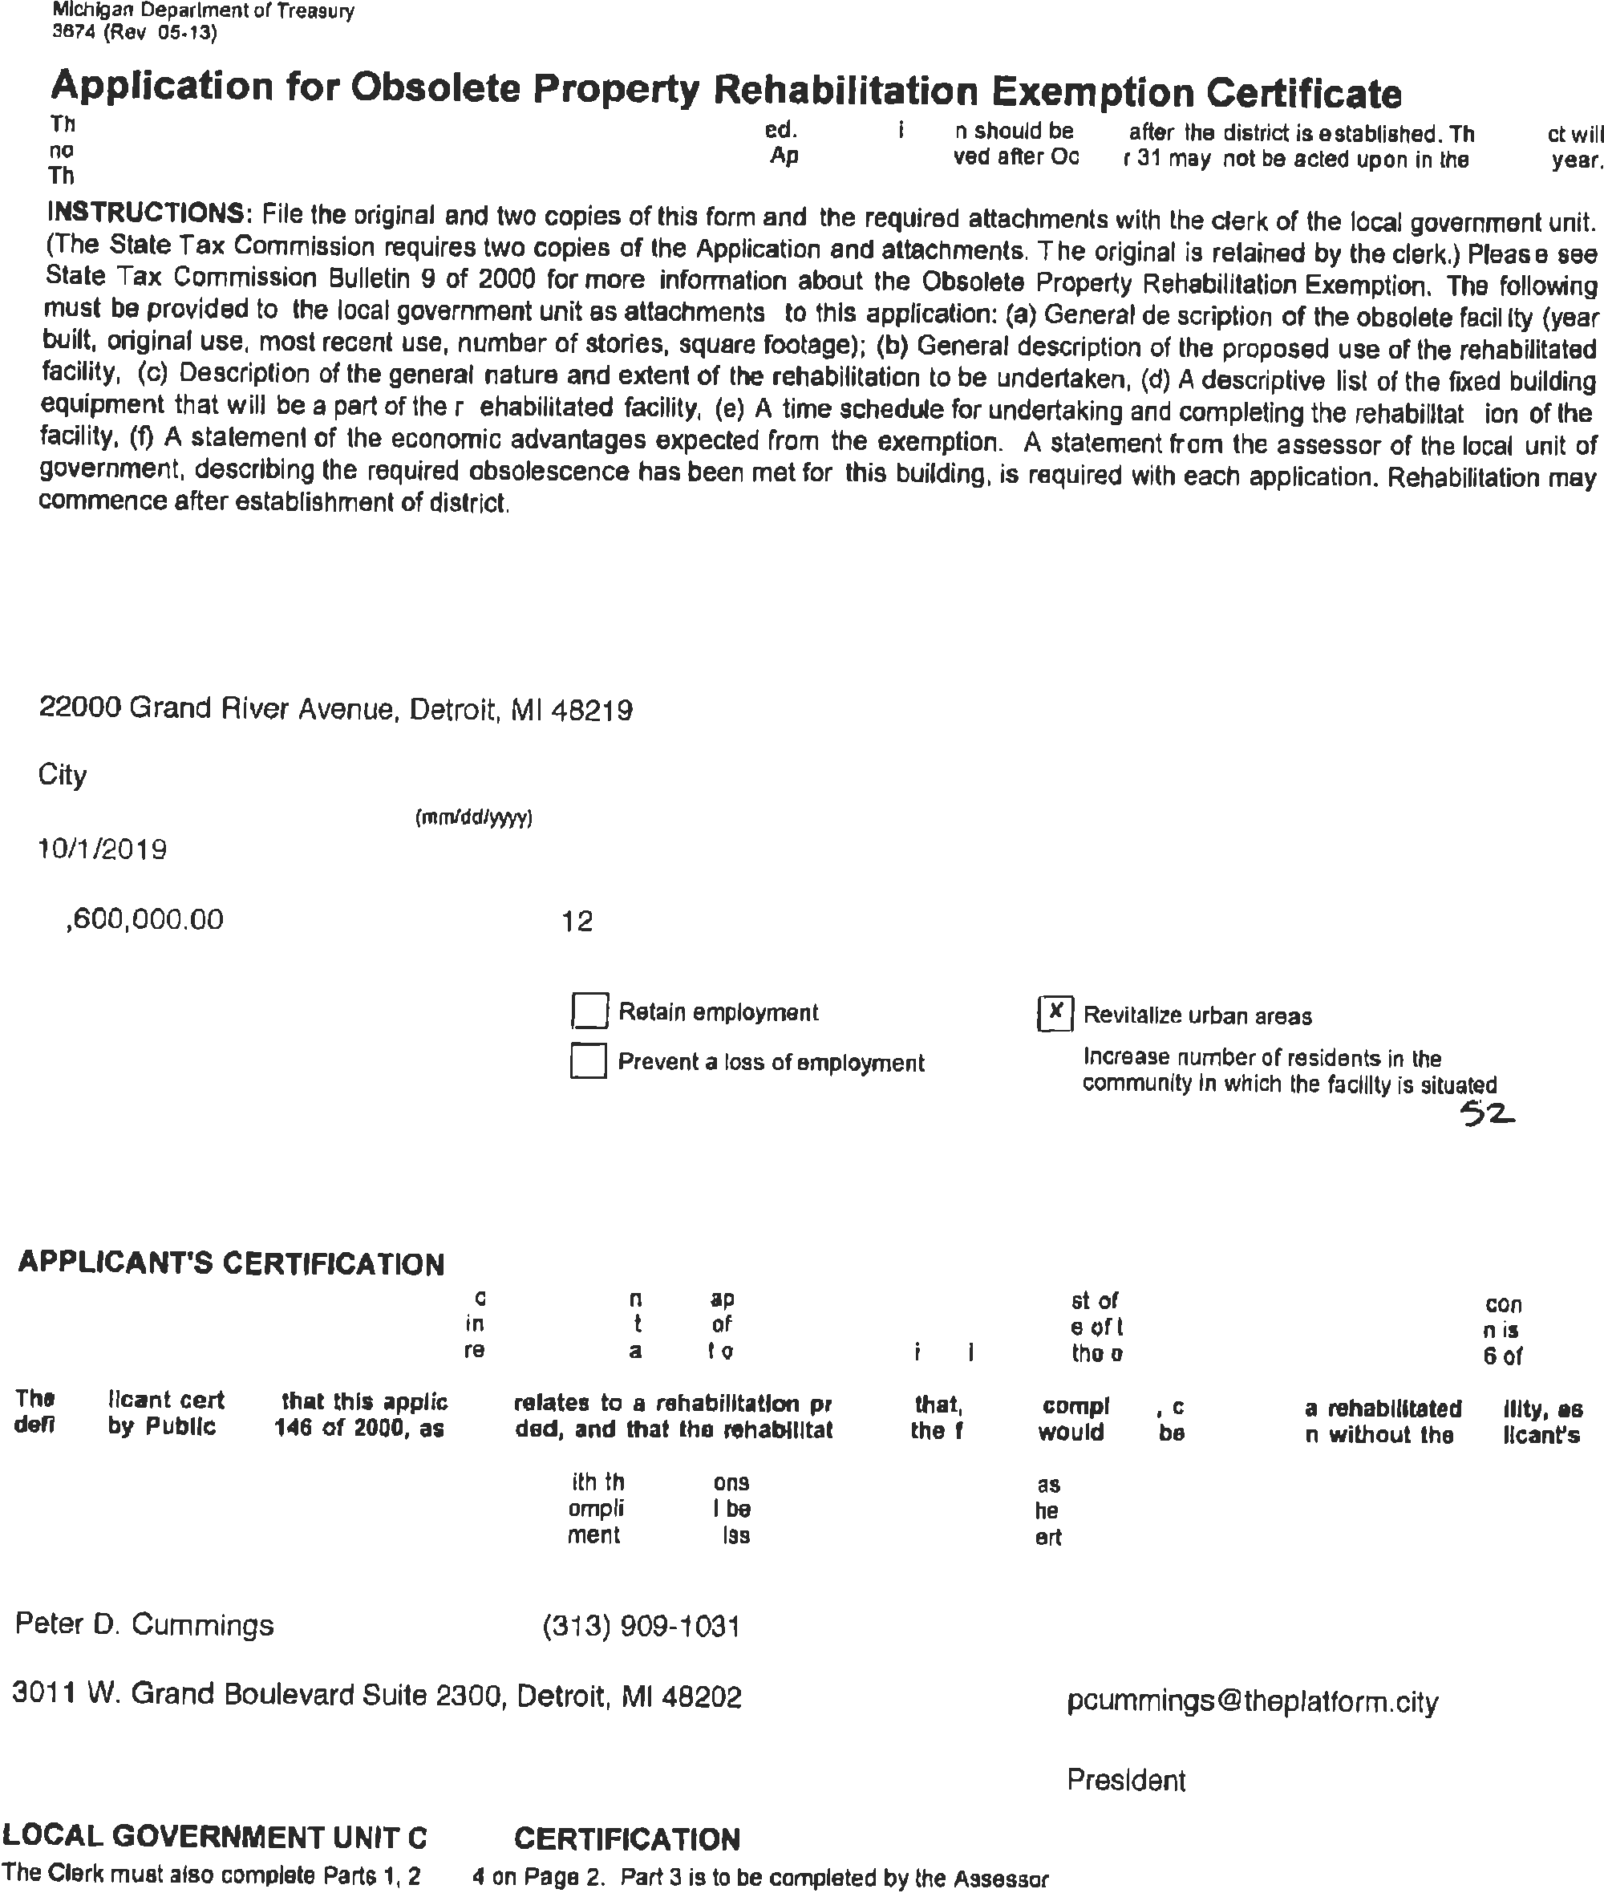
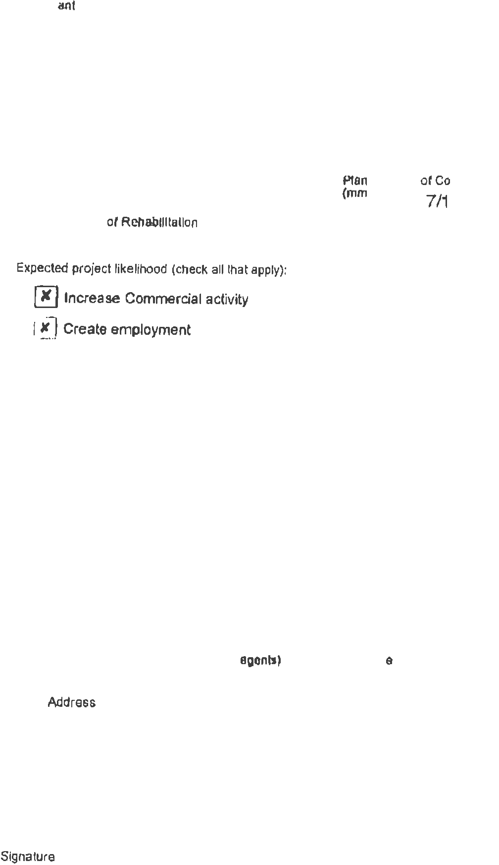
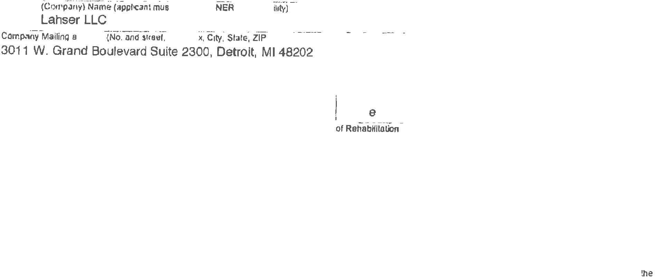
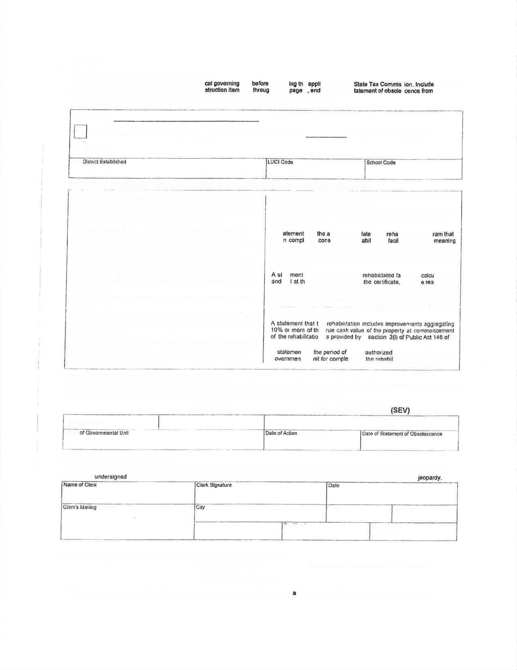
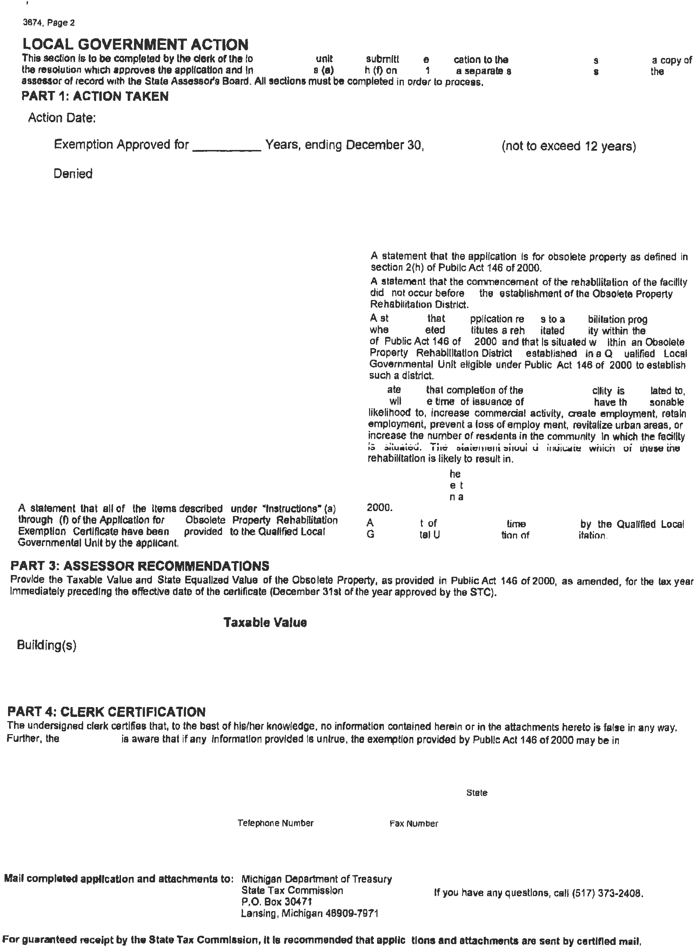
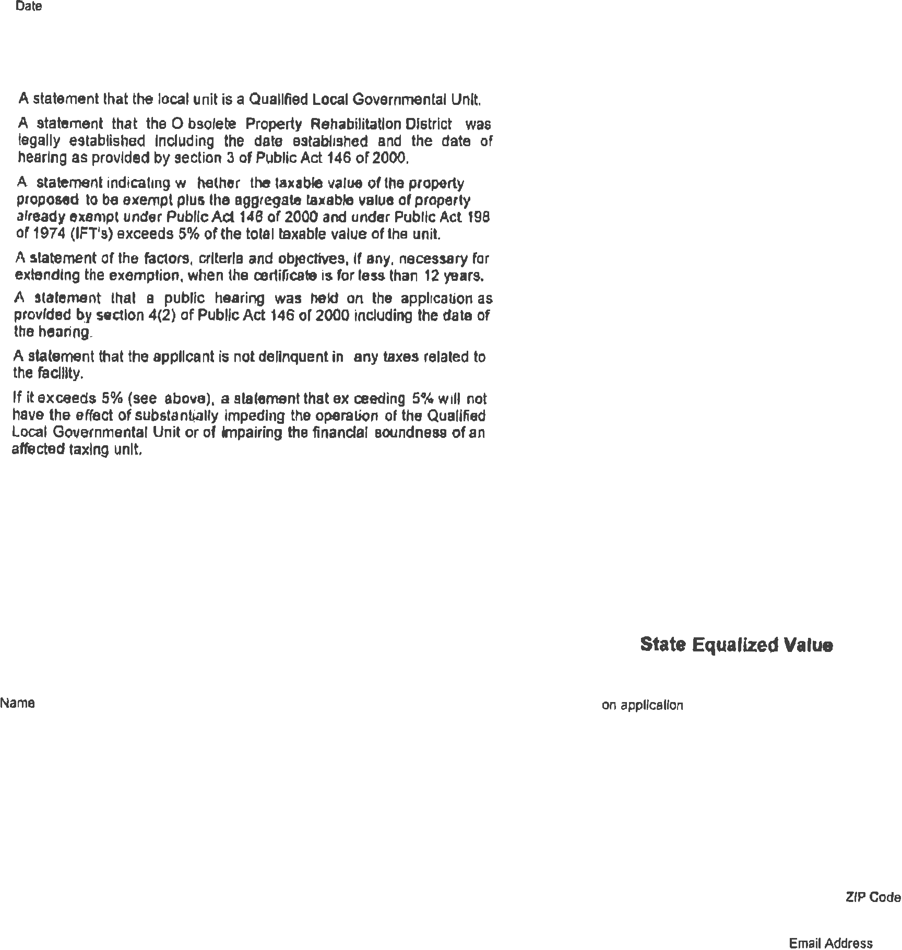
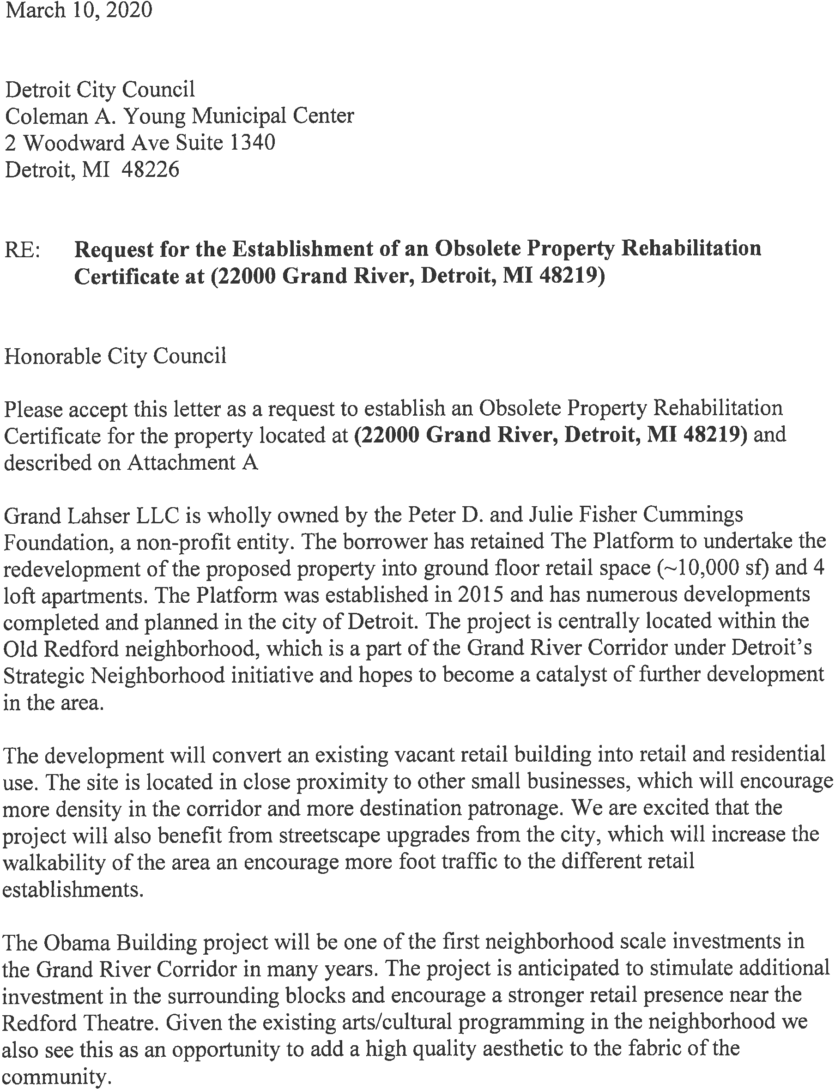
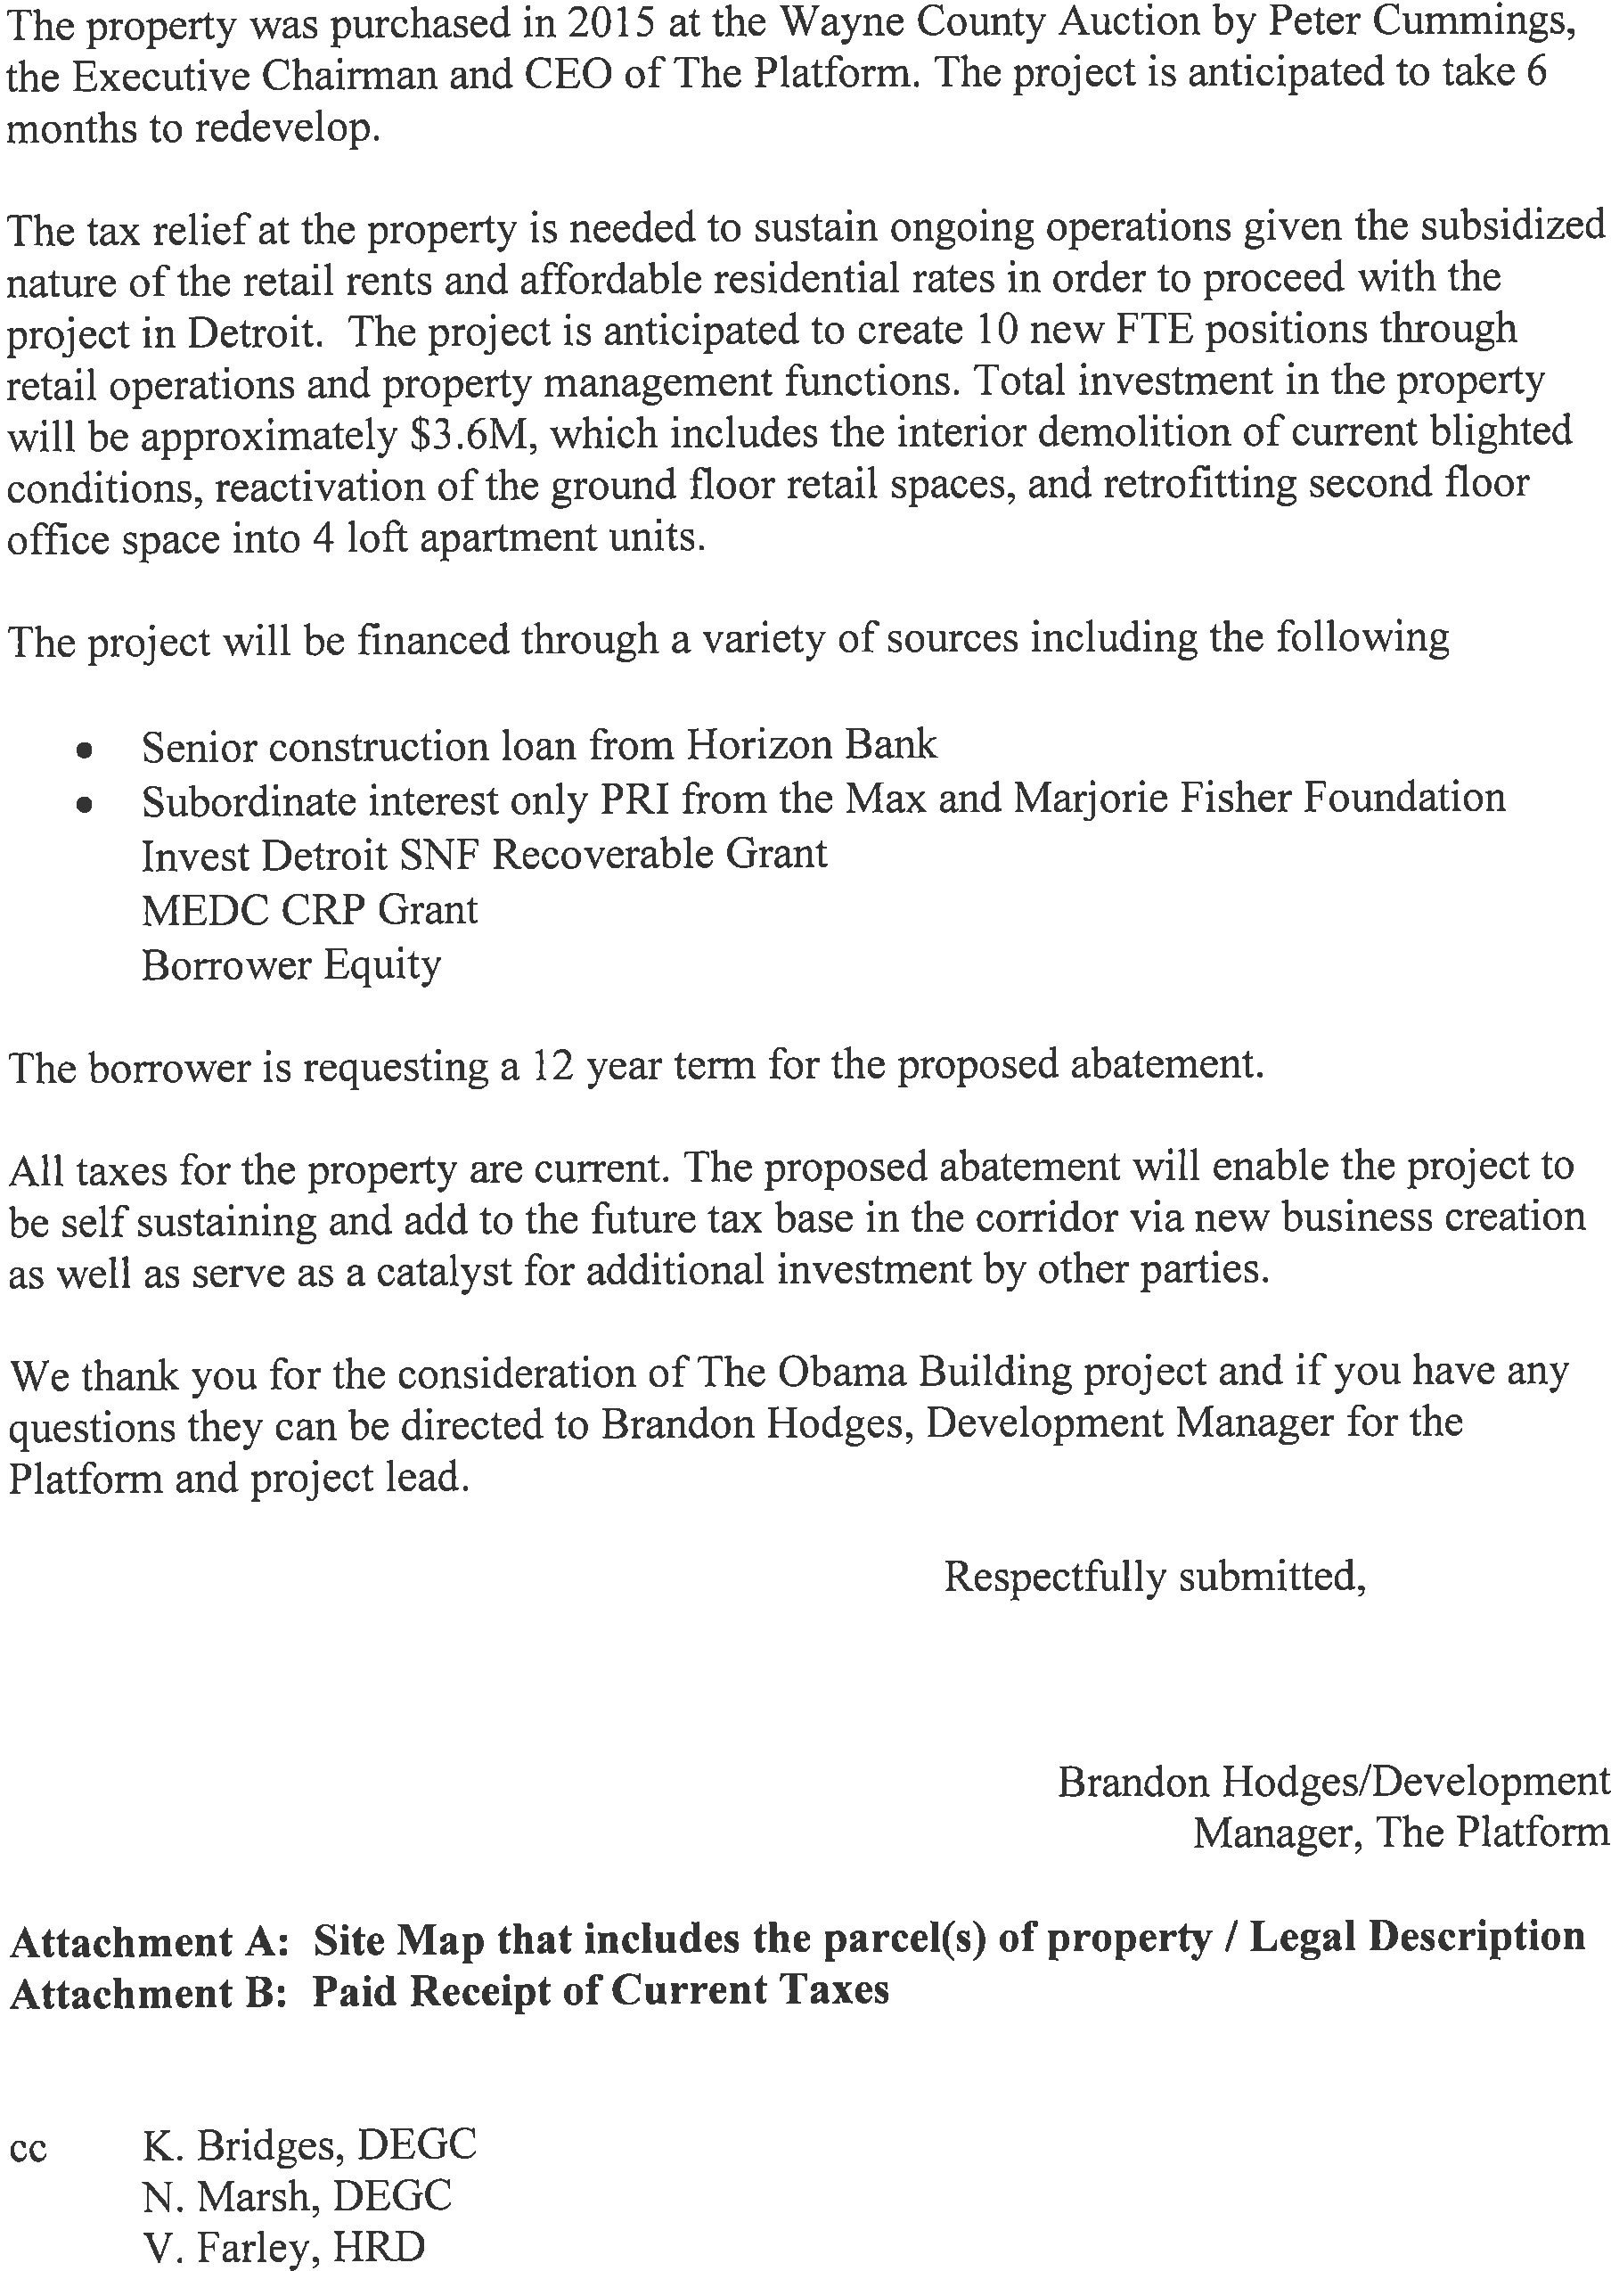
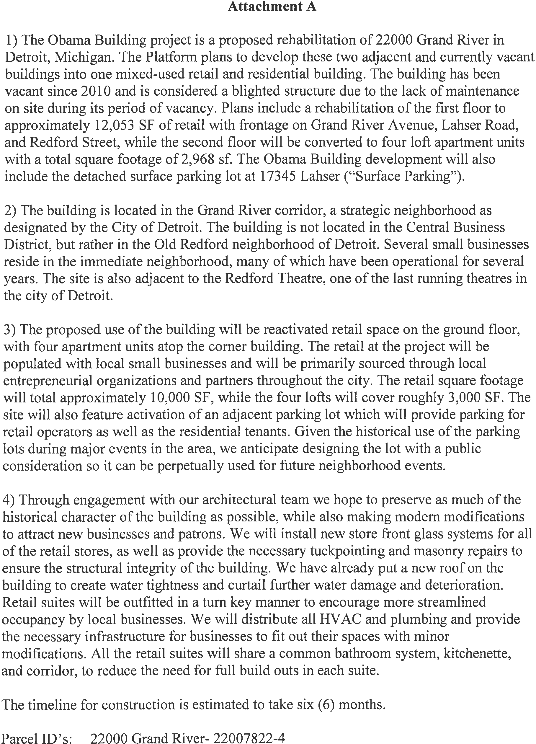
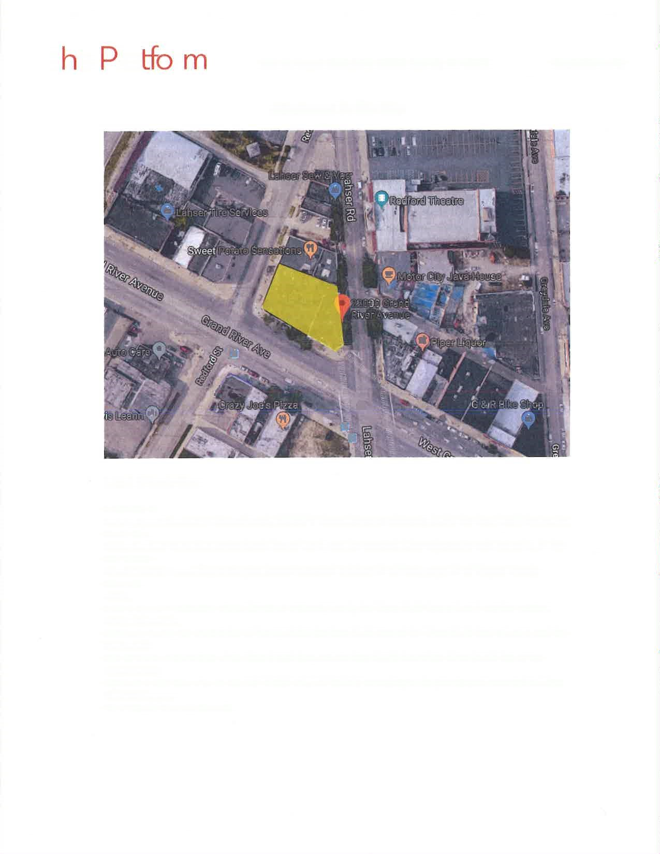
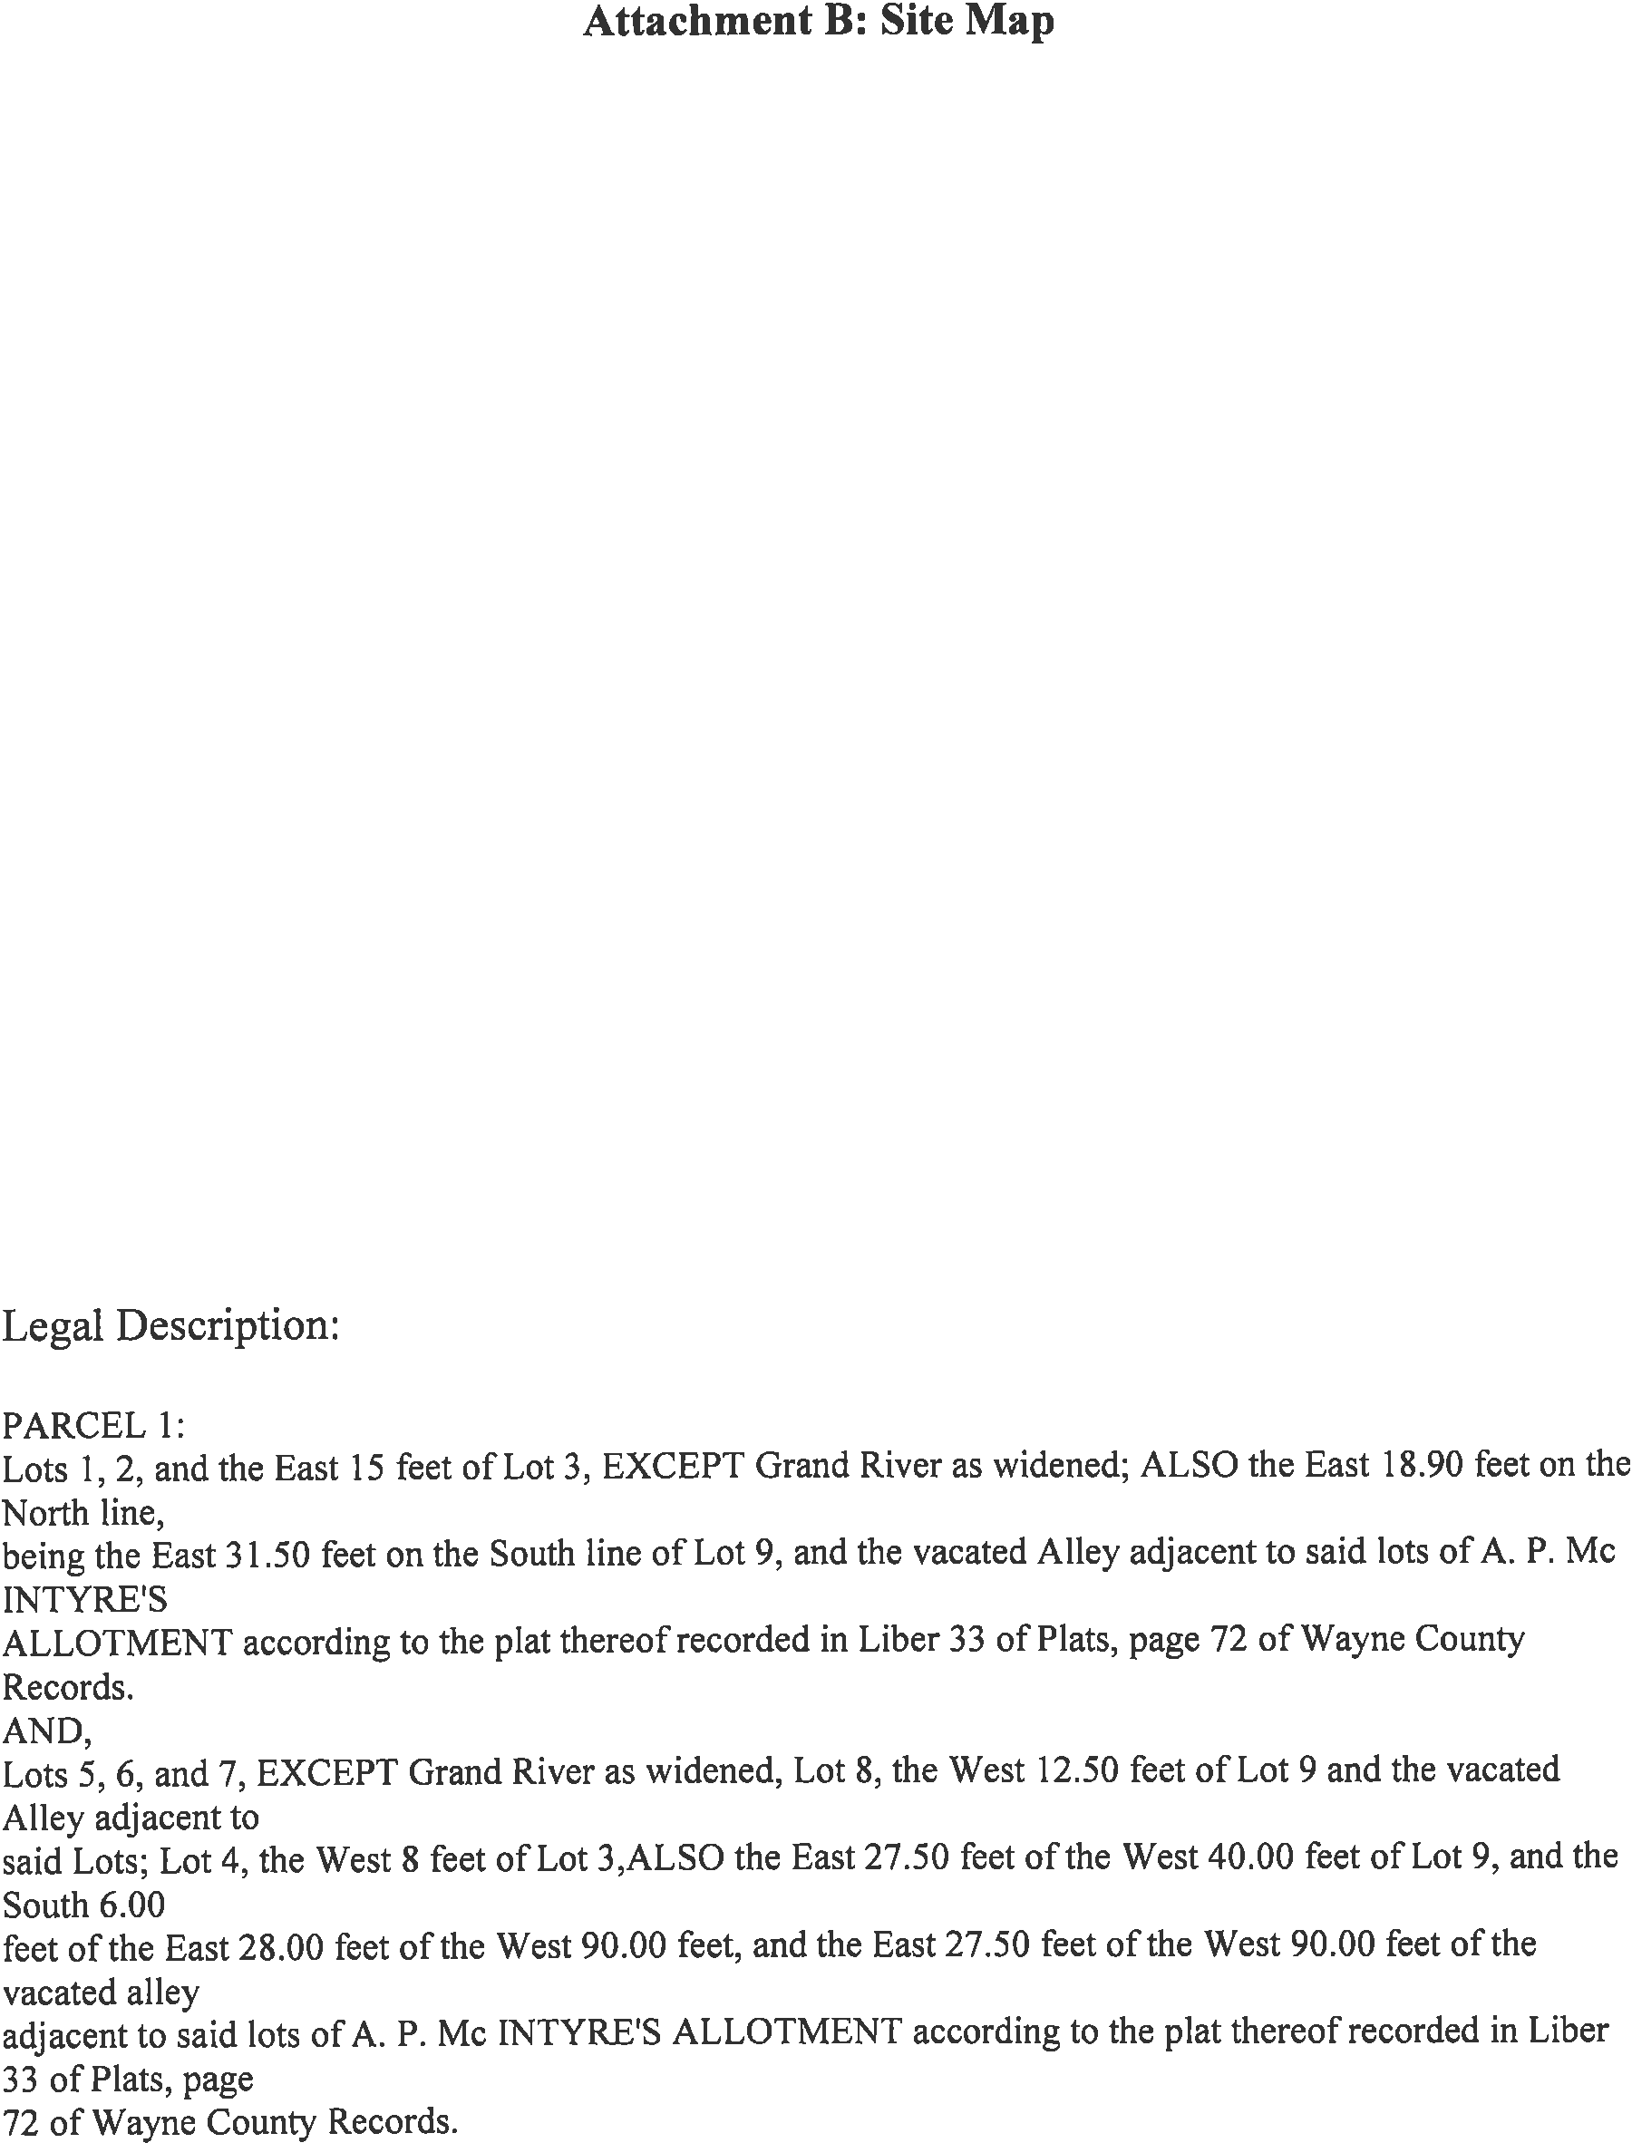
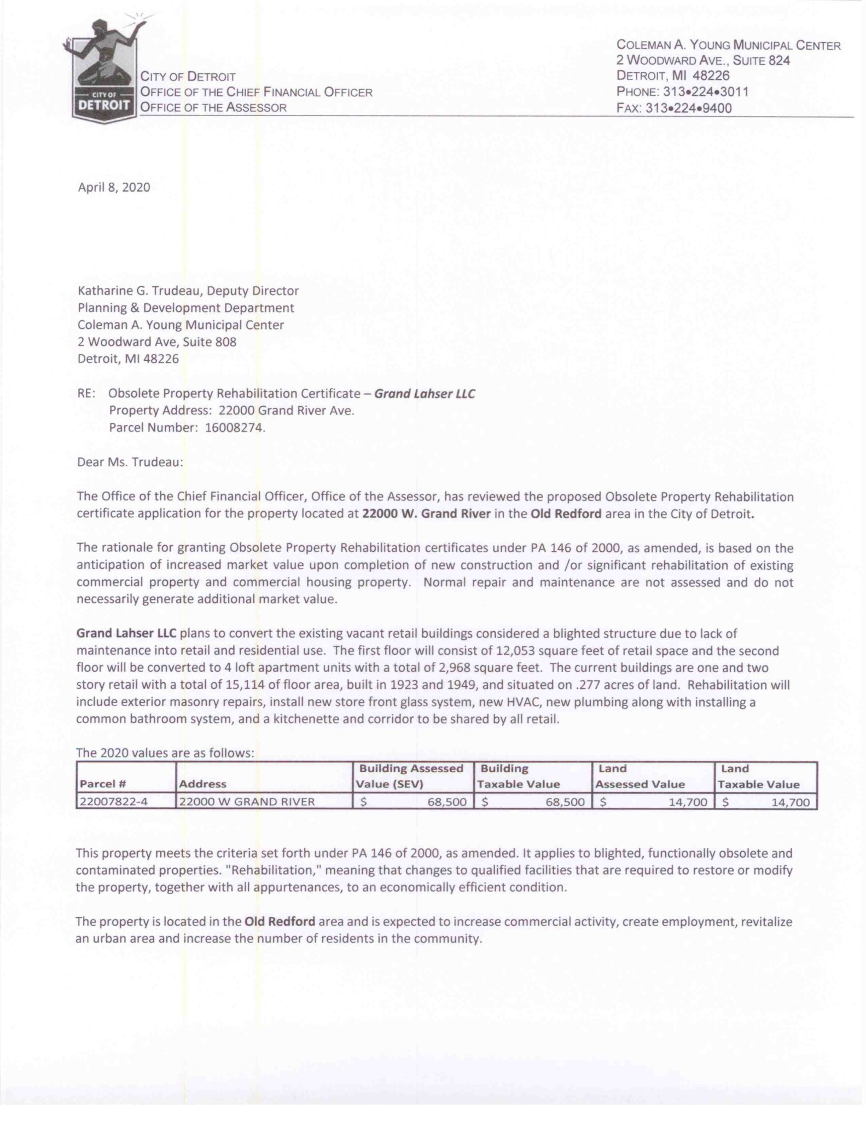
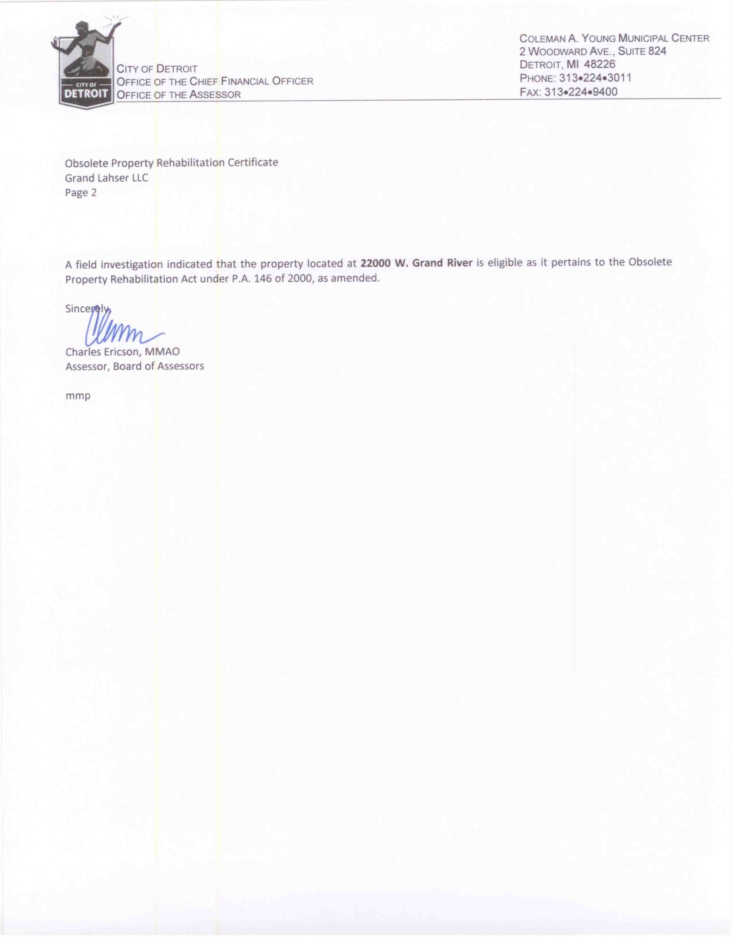
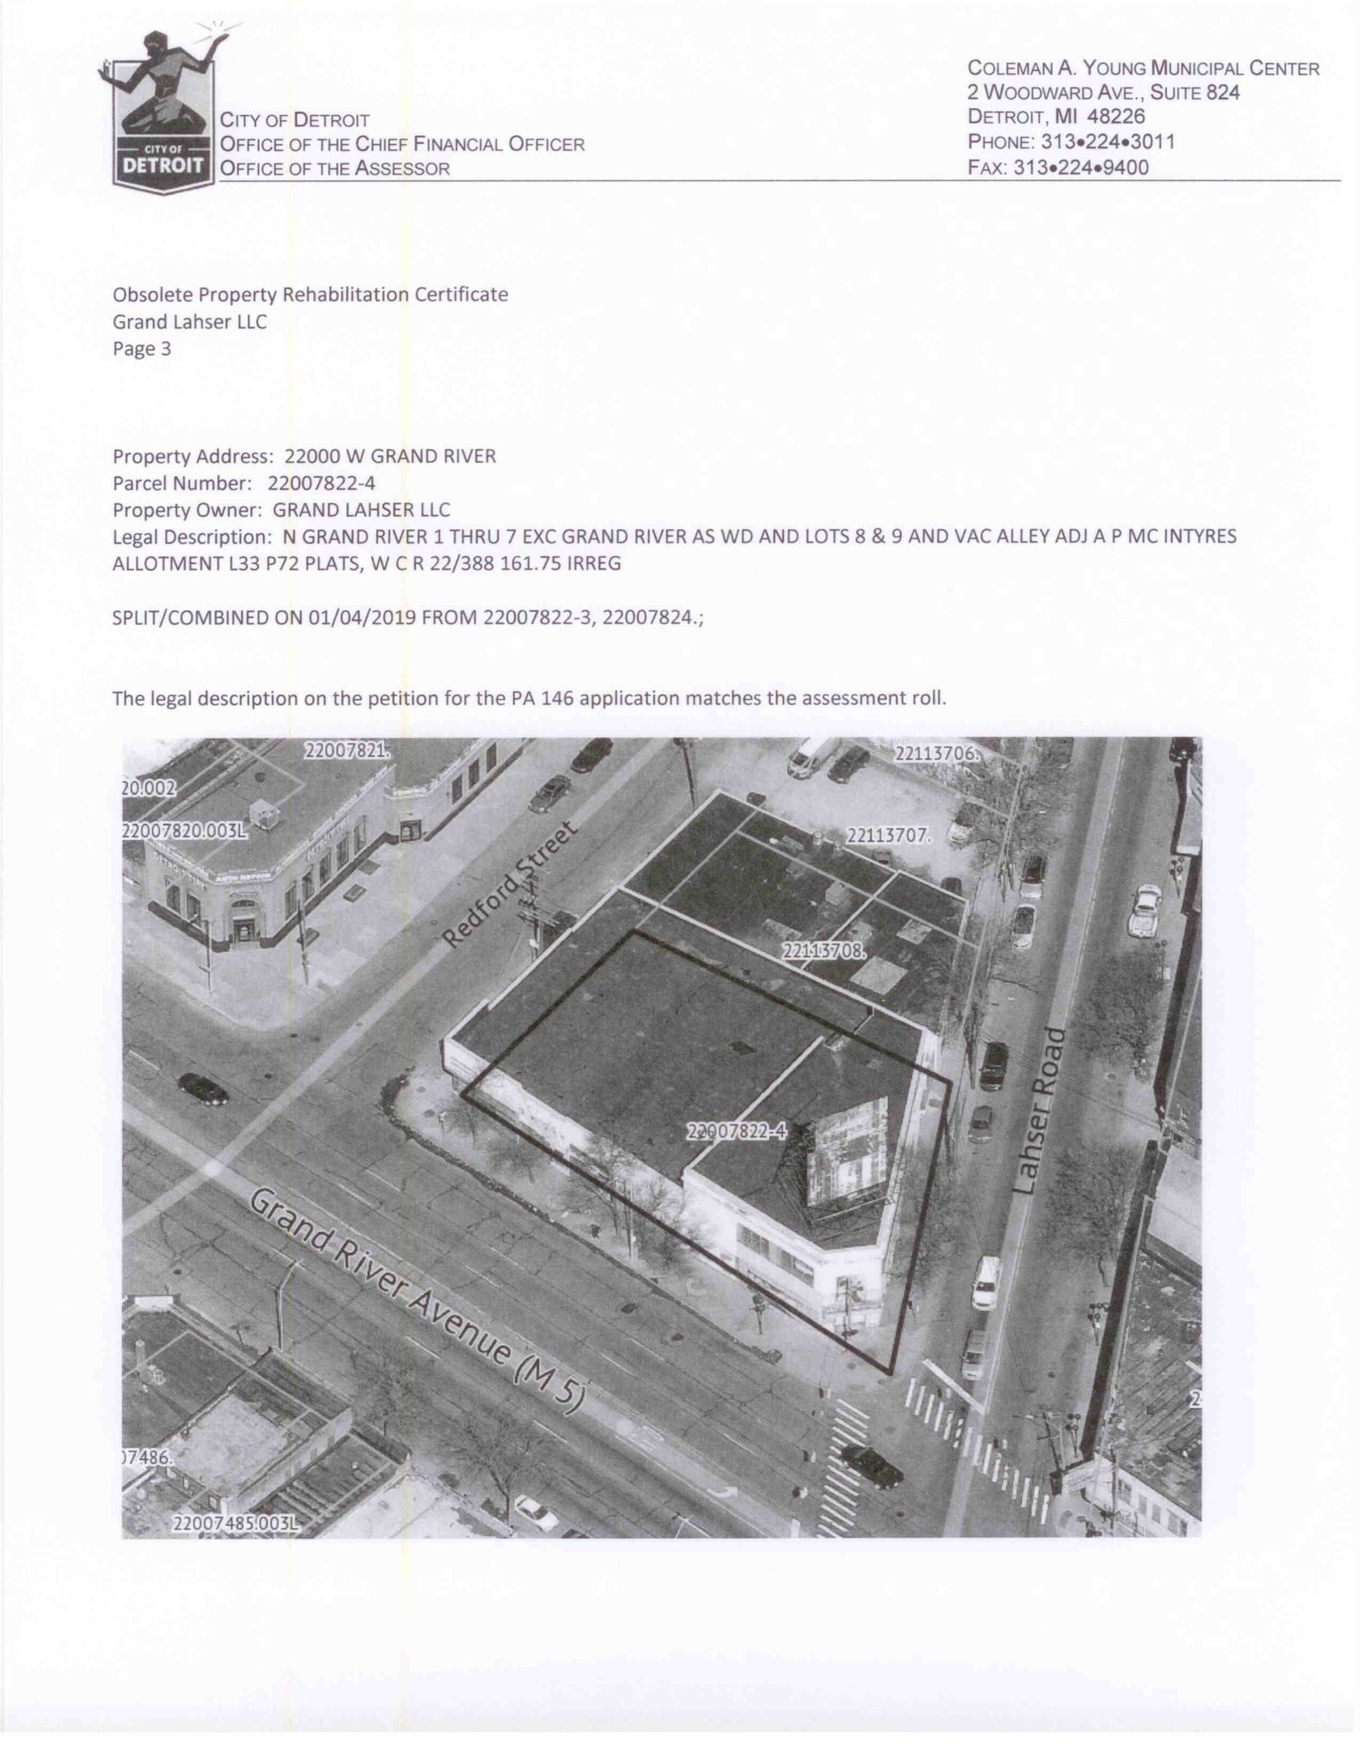

TO: | Ashley McLeod, Housing and Revitalization
FROM: | Esther Yang, Planning and Development
RE: | Master Plan Interpretation for Obsolete Property District (PA 146) at 22000 Grand River (Associated to Petition #556)
DATE: | March 6, 2020
CC: | Katharine Trudeau, Deputy Director, Planning and Development
 | Dave Walker, PDD West, Planning and Development
 | Karen Gage, PDD Zoning, Planning and Development

In order to ensure that the issuance of a certificate for an Obsolete Property District is in conformance with the City’s Master Plan of Policies and will have the reasonable likelihood to increase commercial activity; create, retain or prevent a loss of employment; revitalize an urban area; or increase the number of residents in a community, pursuant to State of Michigan, Public Act 146 of 2000 (section 125.2784), the Planning and Development Department submits the following interpretation. The Petitioner is Grand Lahser, LLC

Location and Project Proposal: 22000 Grand River; Project proposes to develop these two adjacent and currently vacant building into one mixed‐use retail and residential building. The building has been vacant since 2010. Project proposes to rehabilitate the first floor to 12,053 square feet of retail with frontage on Grand River Avenue, Lahser Road, and Redford Street, while the second floor will be converted to four loft apartment units with a total square footage of 2,968 square feet. The "Obama Building" development will also include the detached surface parking lot at 17345 Lahser.

COLEMAN A. YOUNG MUNICIPAL CENTER
2
WOODWARD AVE SUITE 808
DETROIT, MICHIGAN 48226
(313) 224-1339
. TTY: 711
(313) 224-1310

WWW.DETROITMI.GOV
CITY OF DETROIT
PLANNING AND DEVELOPMENT DEPARTMENT

Current Master Plan (MP) & Zoning: MP Classification – Mixed Town Center (MTC); Zoning – B3 (Shopping District)

Master Plan Interpretation
The Master Plan Future General Land Use designation of the site is Mixed Town Center. Mixed ‐ Town Centers (MTC) are activity centers for a Cluster. They are often located at the intersection of two major thoroughfares. Land uses include a commercial, entertainment and / or institutional anchor with a mix of support uses including or in close proximity to residential land uses. Town Centers are distinguished from other activity centers by an emphasis on pedestrian orientation with wide sidewalks, building facades built up to the lot line, street‐front access to buildings and landscaping and street furniture (i.e. benches and planters). Town Centers require strict design guidelines to maintain and enhance their streetscapes, pedestrian orientation and overall character.

The proposed development conforms to the Future General Land Use characteristics of the area.

Attachments
Future General Land Use Map: Neighborhood Cluster 8, Redford; Map #8‐3B

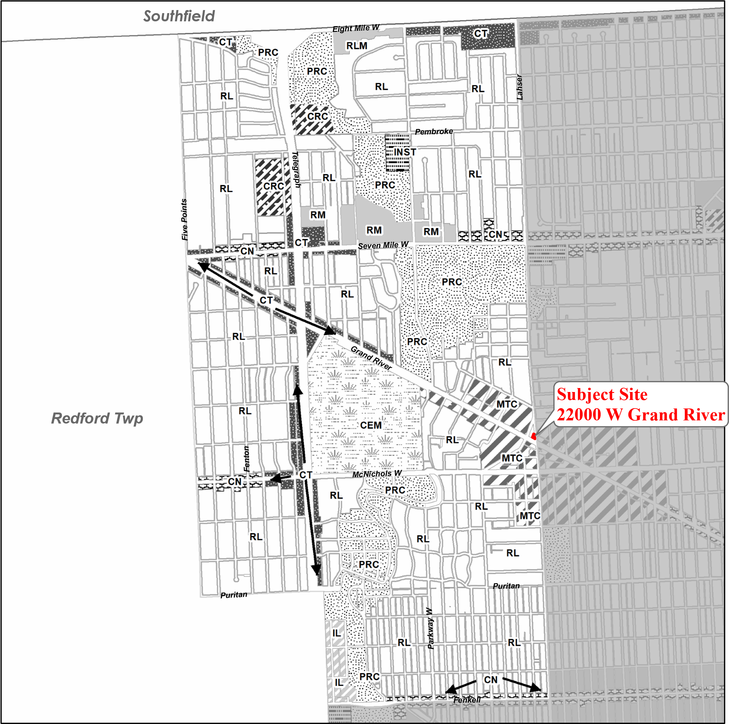
Map 8-3B  City of Detroit  Master Plan of  Policies | Neighborhood Cluster 8 Redford

Future Land Use
Low Density Residential (RL)Thoroughfare Commercial (CT)Mixed - Town Center (MTC)
Low / Medium Density Residential (RLM)Special Commercial (CS)Recreation (PRC)
Medium Density Residential (RM)General Industrial (IG)Regional Park (PR)
High Density Residential (RH)Light Industrial (IL)Private Marina (PRM)
Major Commercial (CM)Distribution / Port Industrial (IDP)Airport (AP)
Retail Center (CRC)Mixed - Residential / Commercial (MRC)Cemetery (CEM)
Neighborhood Commercial (CN)Mixed - Residential / Industrial (MRI)Institutional (INST)

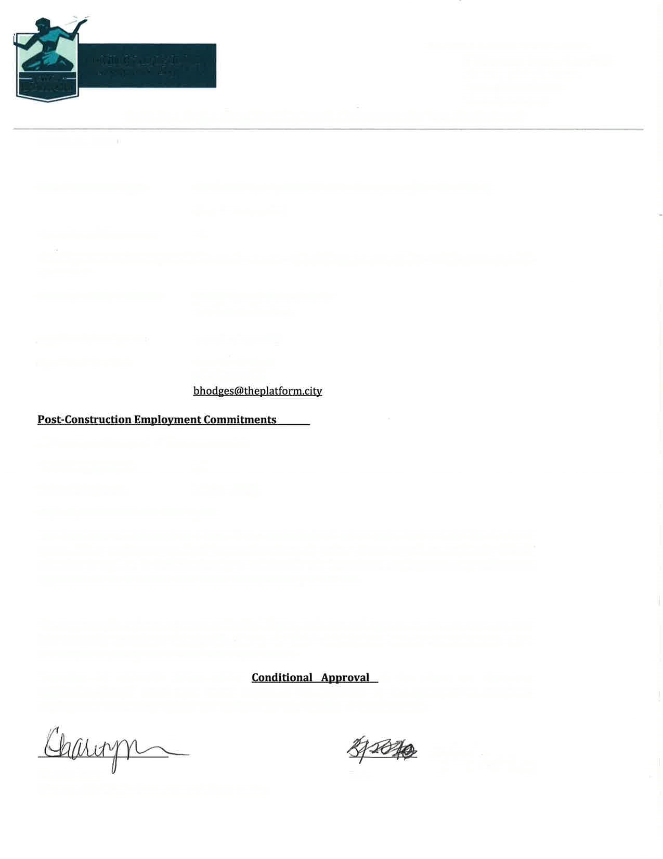
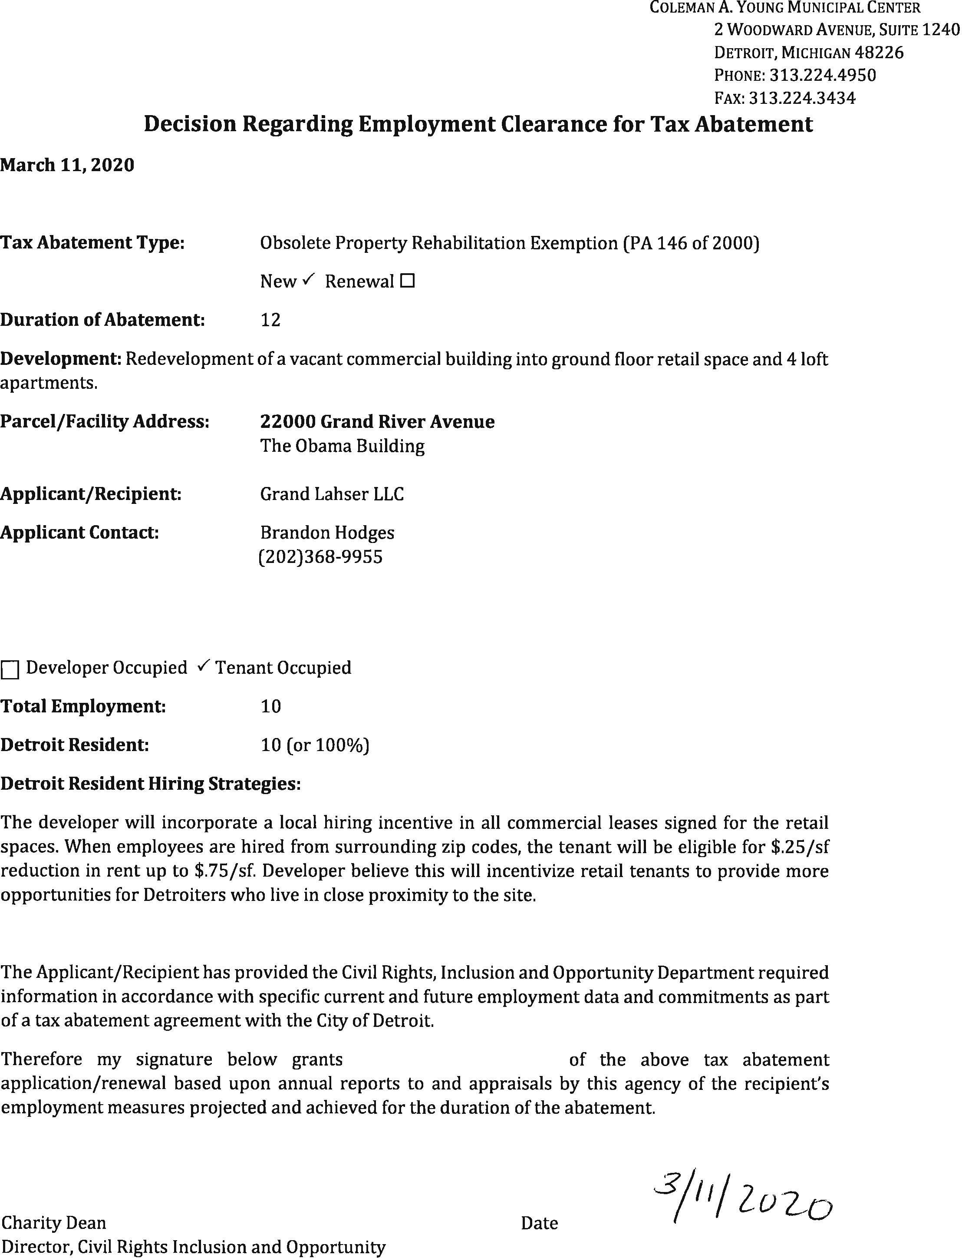
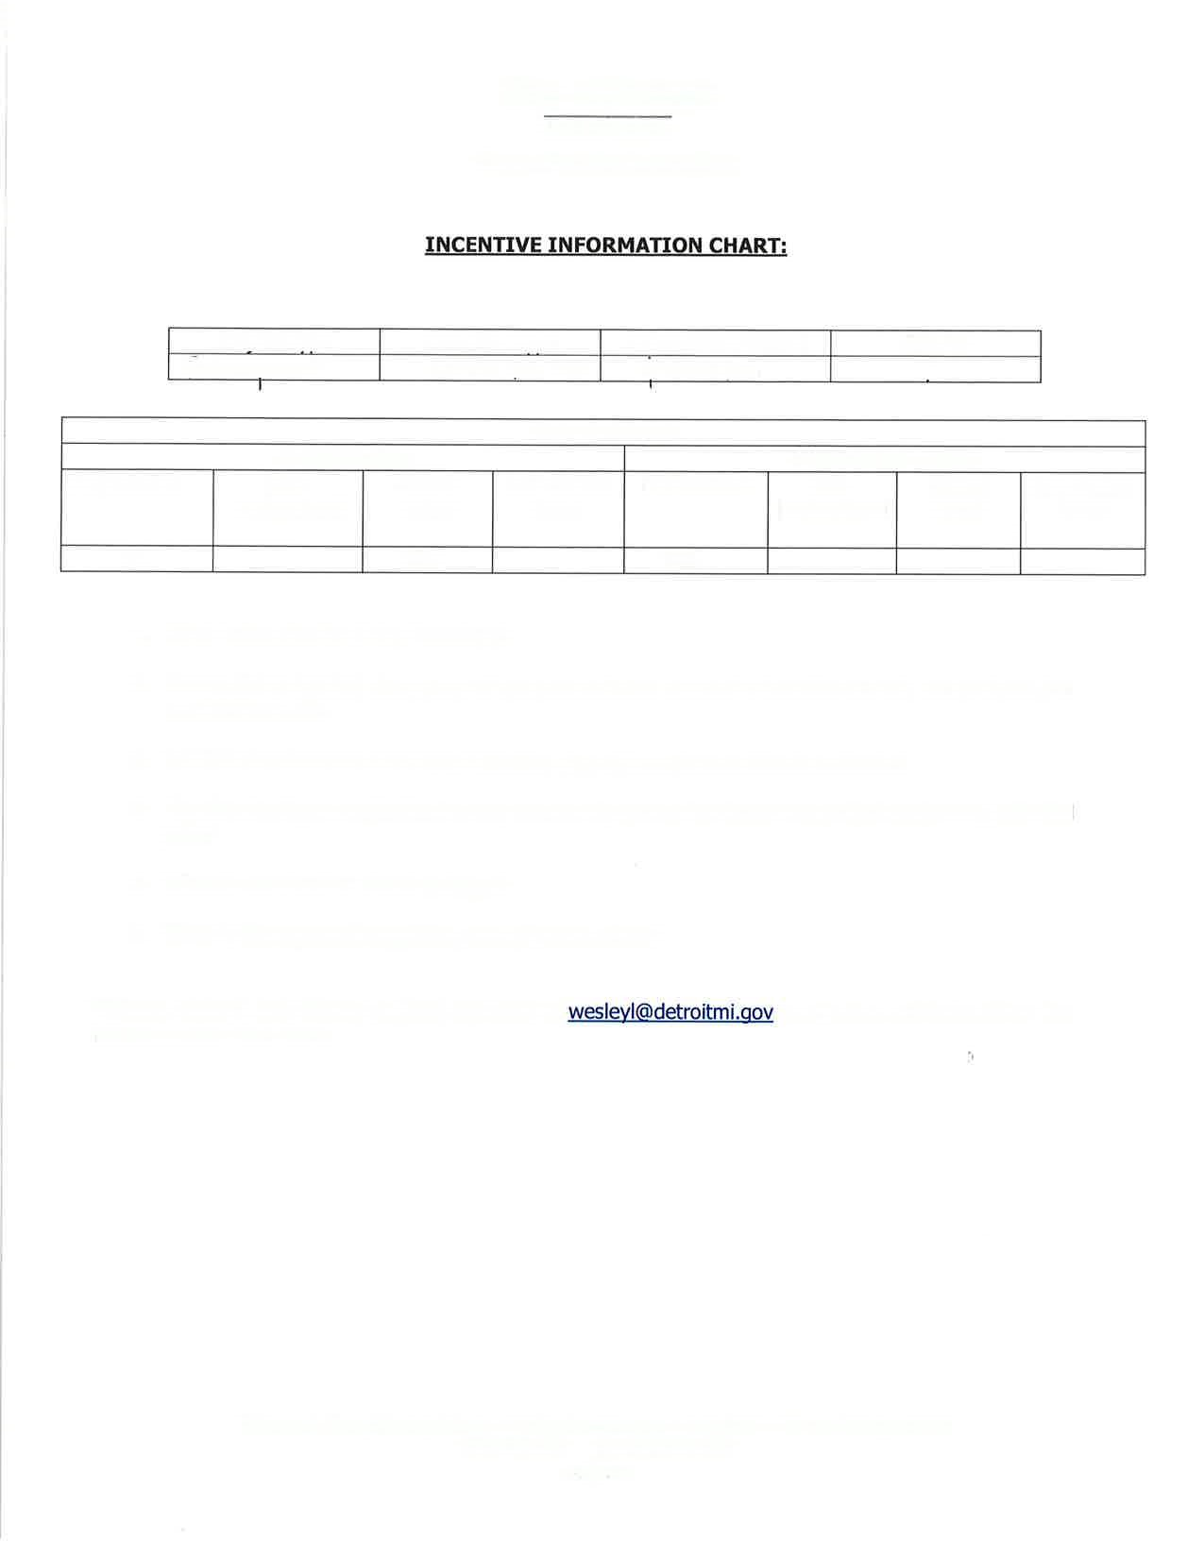
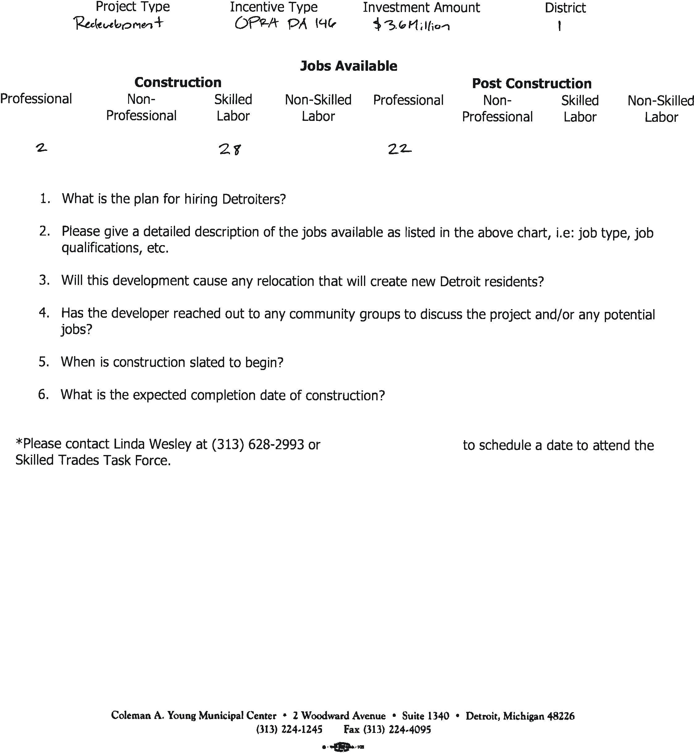

Incentive Information and Hiring Addendum

Project Type: Mixed Use Rehabilitation of Vacant Retail Space
Incentive Type: PA 146 OPRA Tax Abatement
Investment Amount: $3.6 Million Dollars

District: 1

- In order to incentive long term hiring of Detroit residents, the developer will incorporate a local hiring incentive in all commercial leases signed for the retail spaces. When employees are hired from surrounding zip codes, the tenant will be eligible for $.25/sf reduction in rent up to $.75/sf. We believe this will incentivize retail tenants to provide more opportunities for Detroiters who live in close proximity to the site. We will also be providing a landscaping and maintenance contract for Motor City Blight Busters, an area non-profit.

- All of the jobs at the site will be for retail positions and office employees for any nonprofits that take occupancy. We estimate these figures based on our knowledge of other property types in our portfolio and the square footage of the actual spaces in terms of occupancy loads.

- No, this development will reactivate vacant retail space and create 4 new loft apartments to add density to the immediate corridor.

- Yes, the developer has reached out to multiple stakeholder groups including the D1 monthly council meeting, the local Malvern Hill/Greater Sandhill Block Club, and The Old Redford Business Association. The developer also initiated a community based naming exercise for the building, allowing local community members to solicit feedback on and ultimately vote for the name of the building. Pictures included below:

- Construction commenced on the building in late 2019.

- The estimated completion date is July 2020.

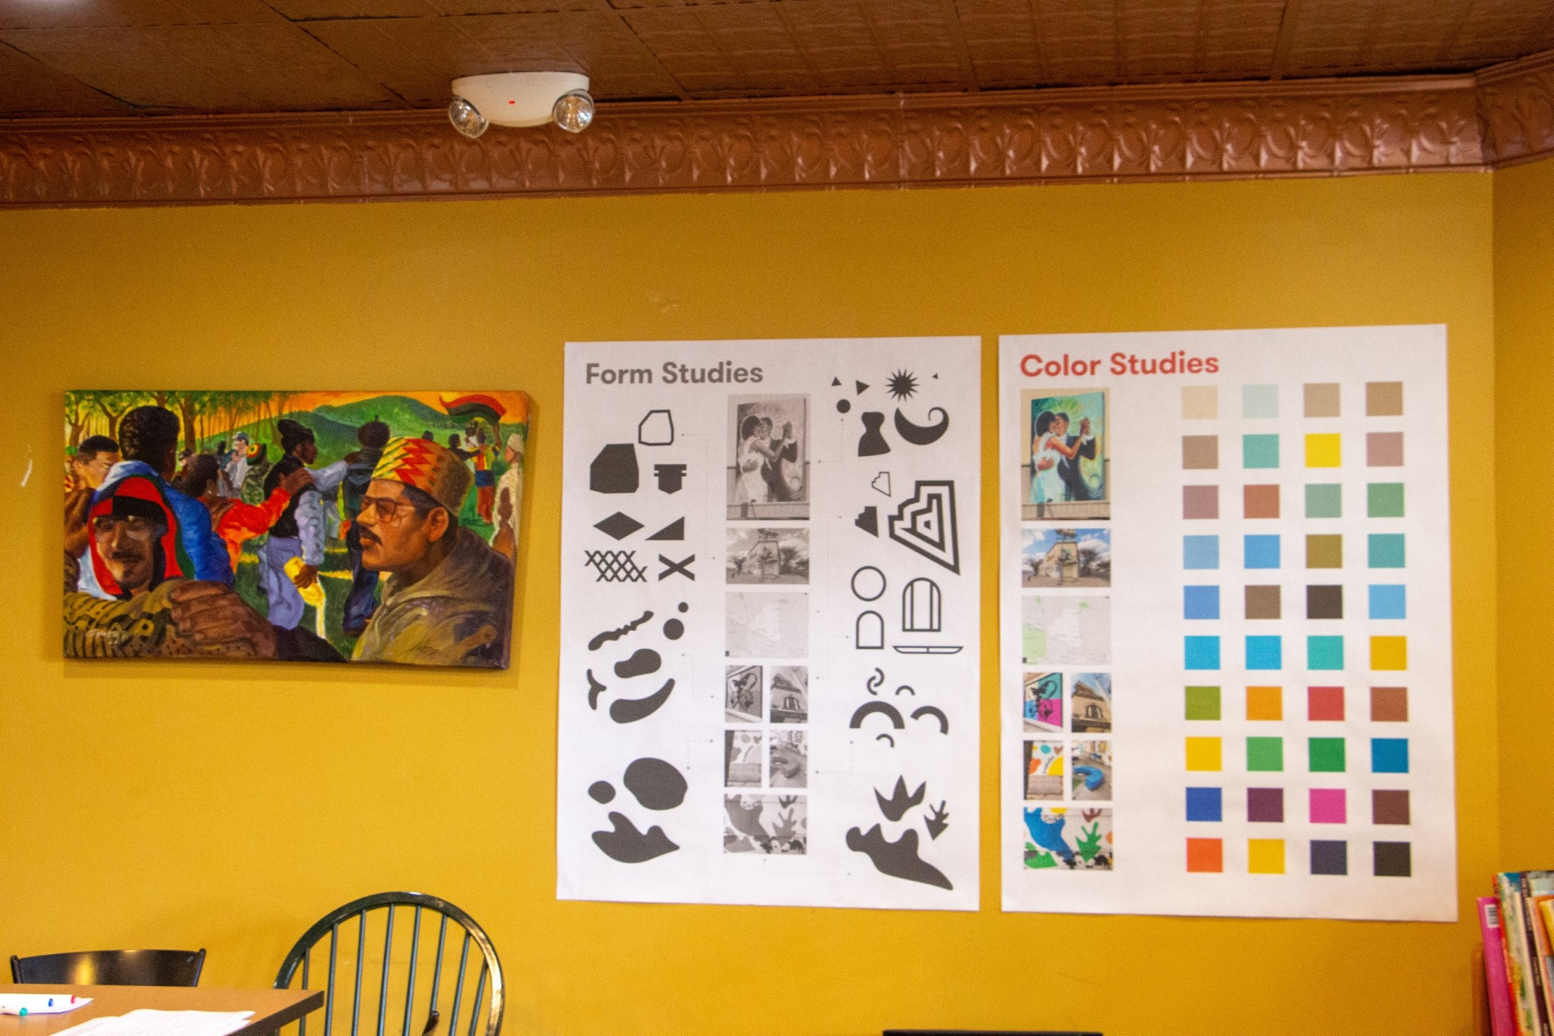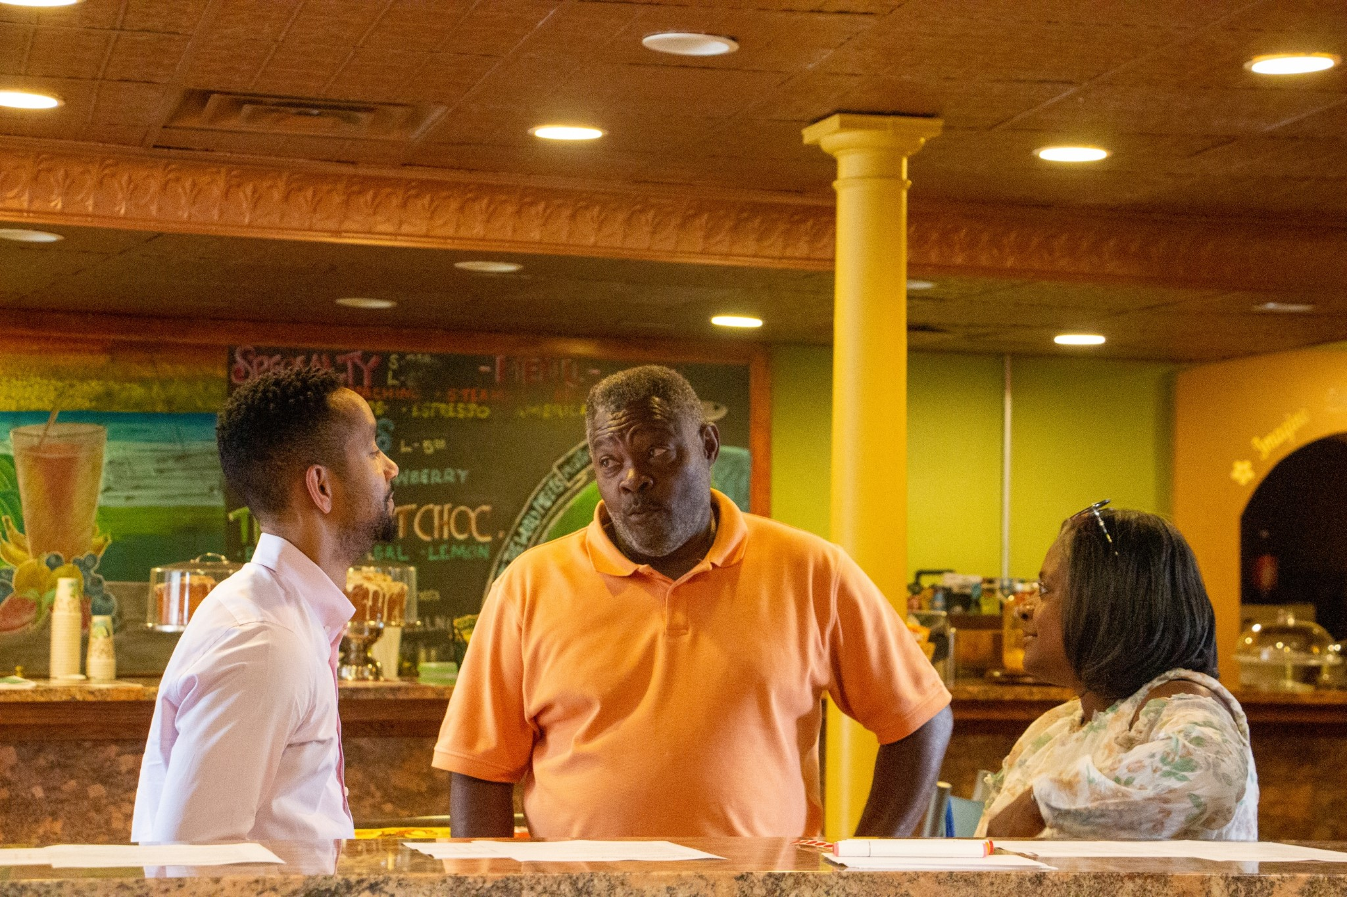
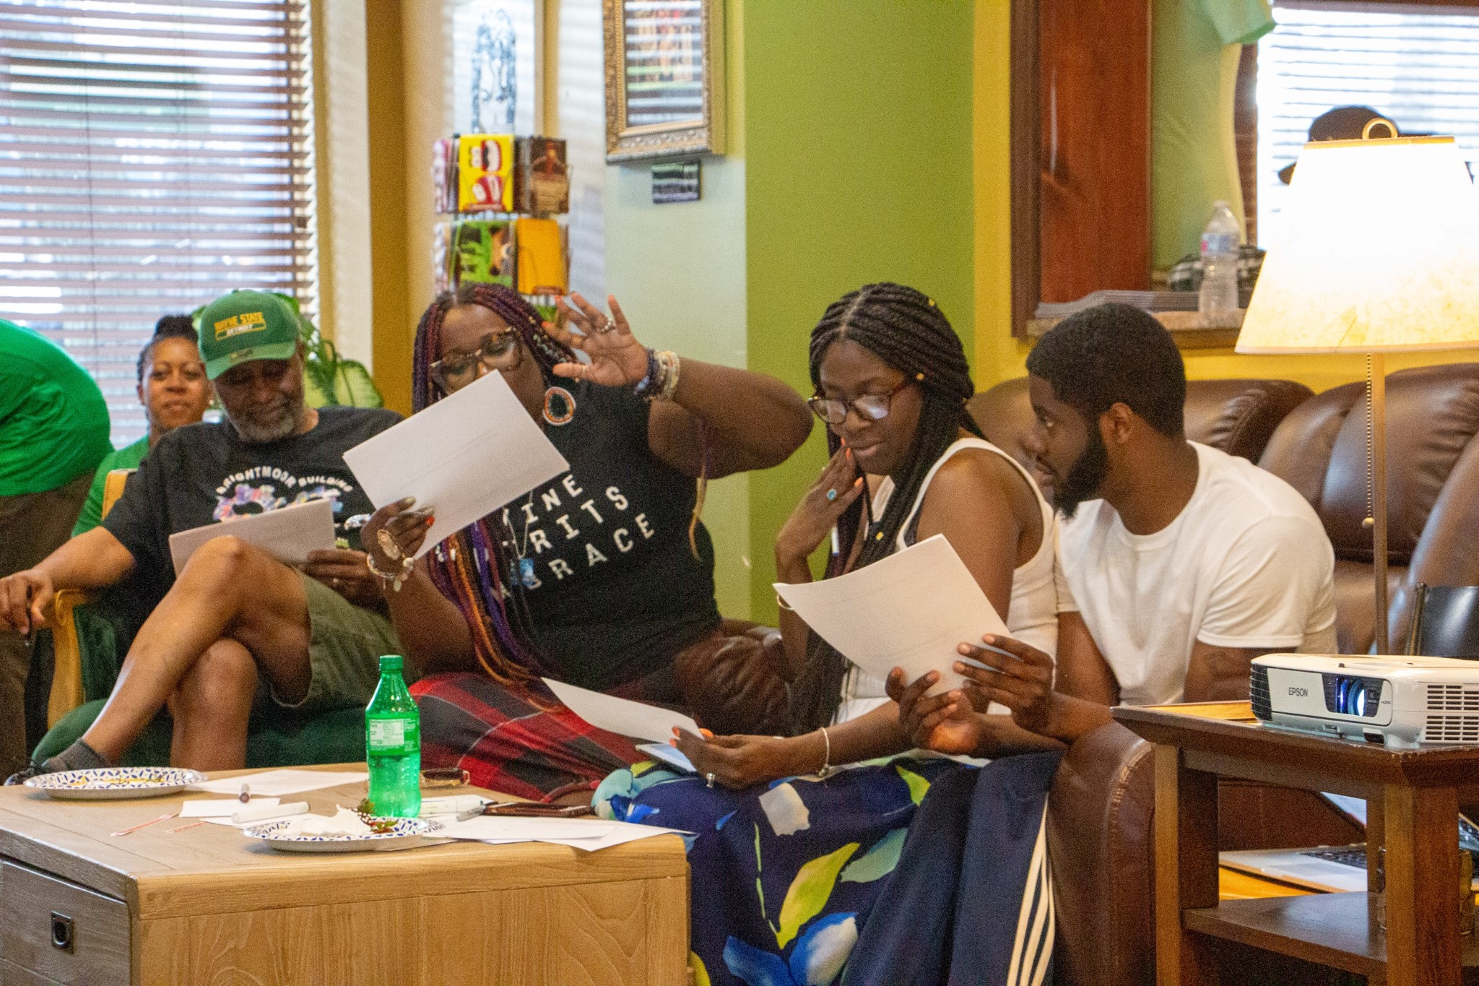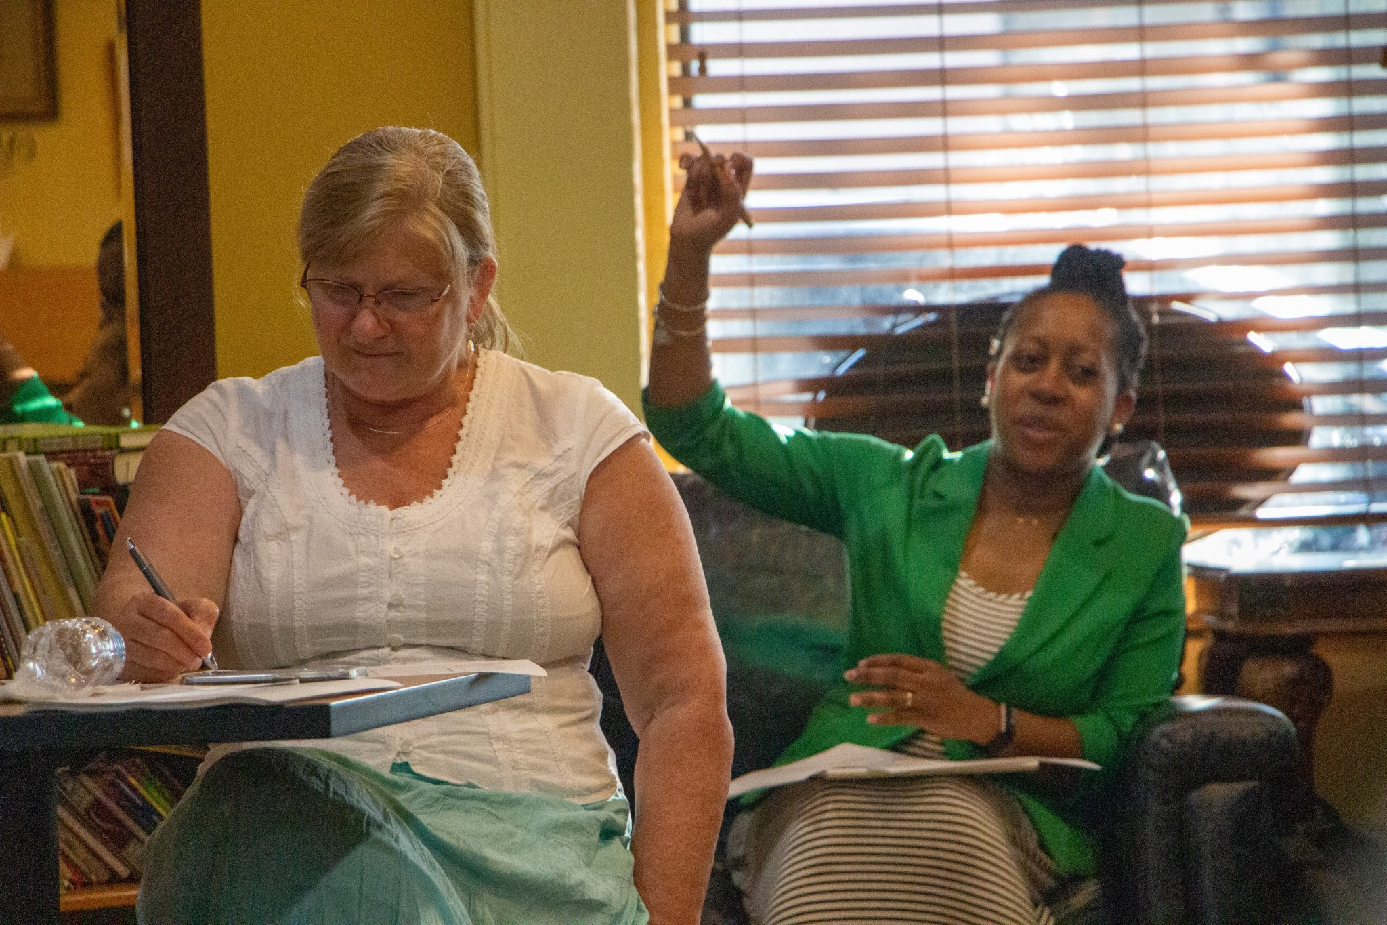

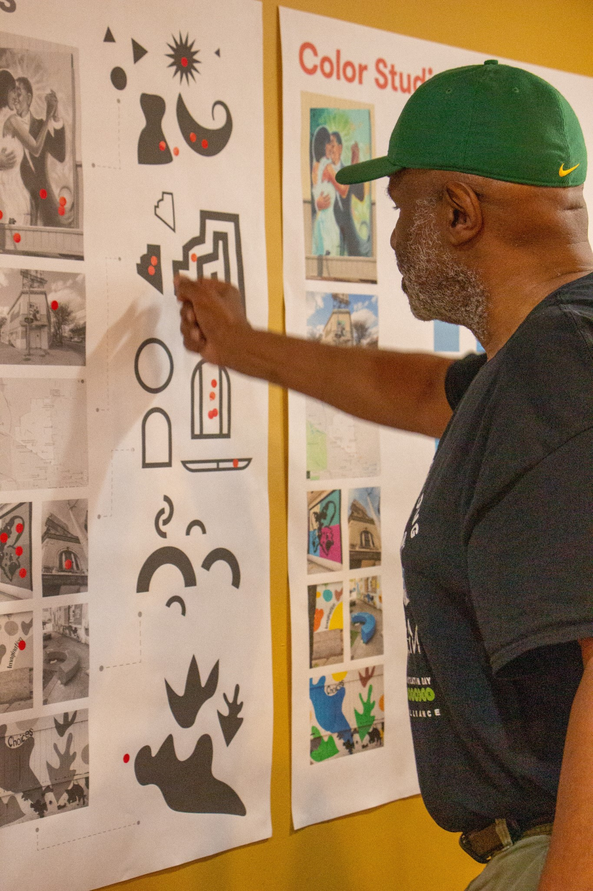

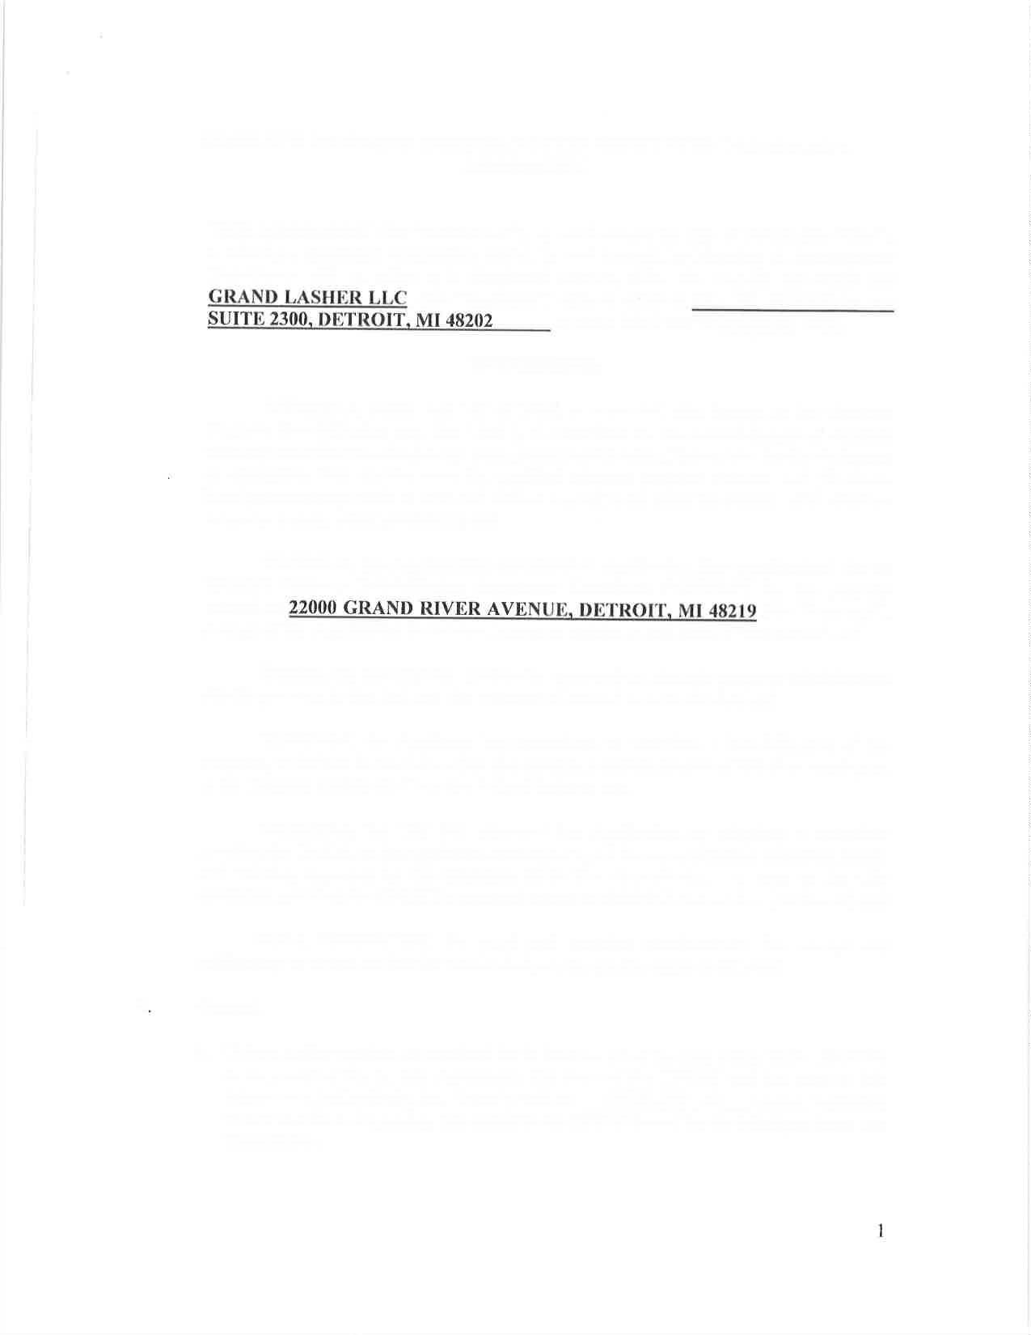
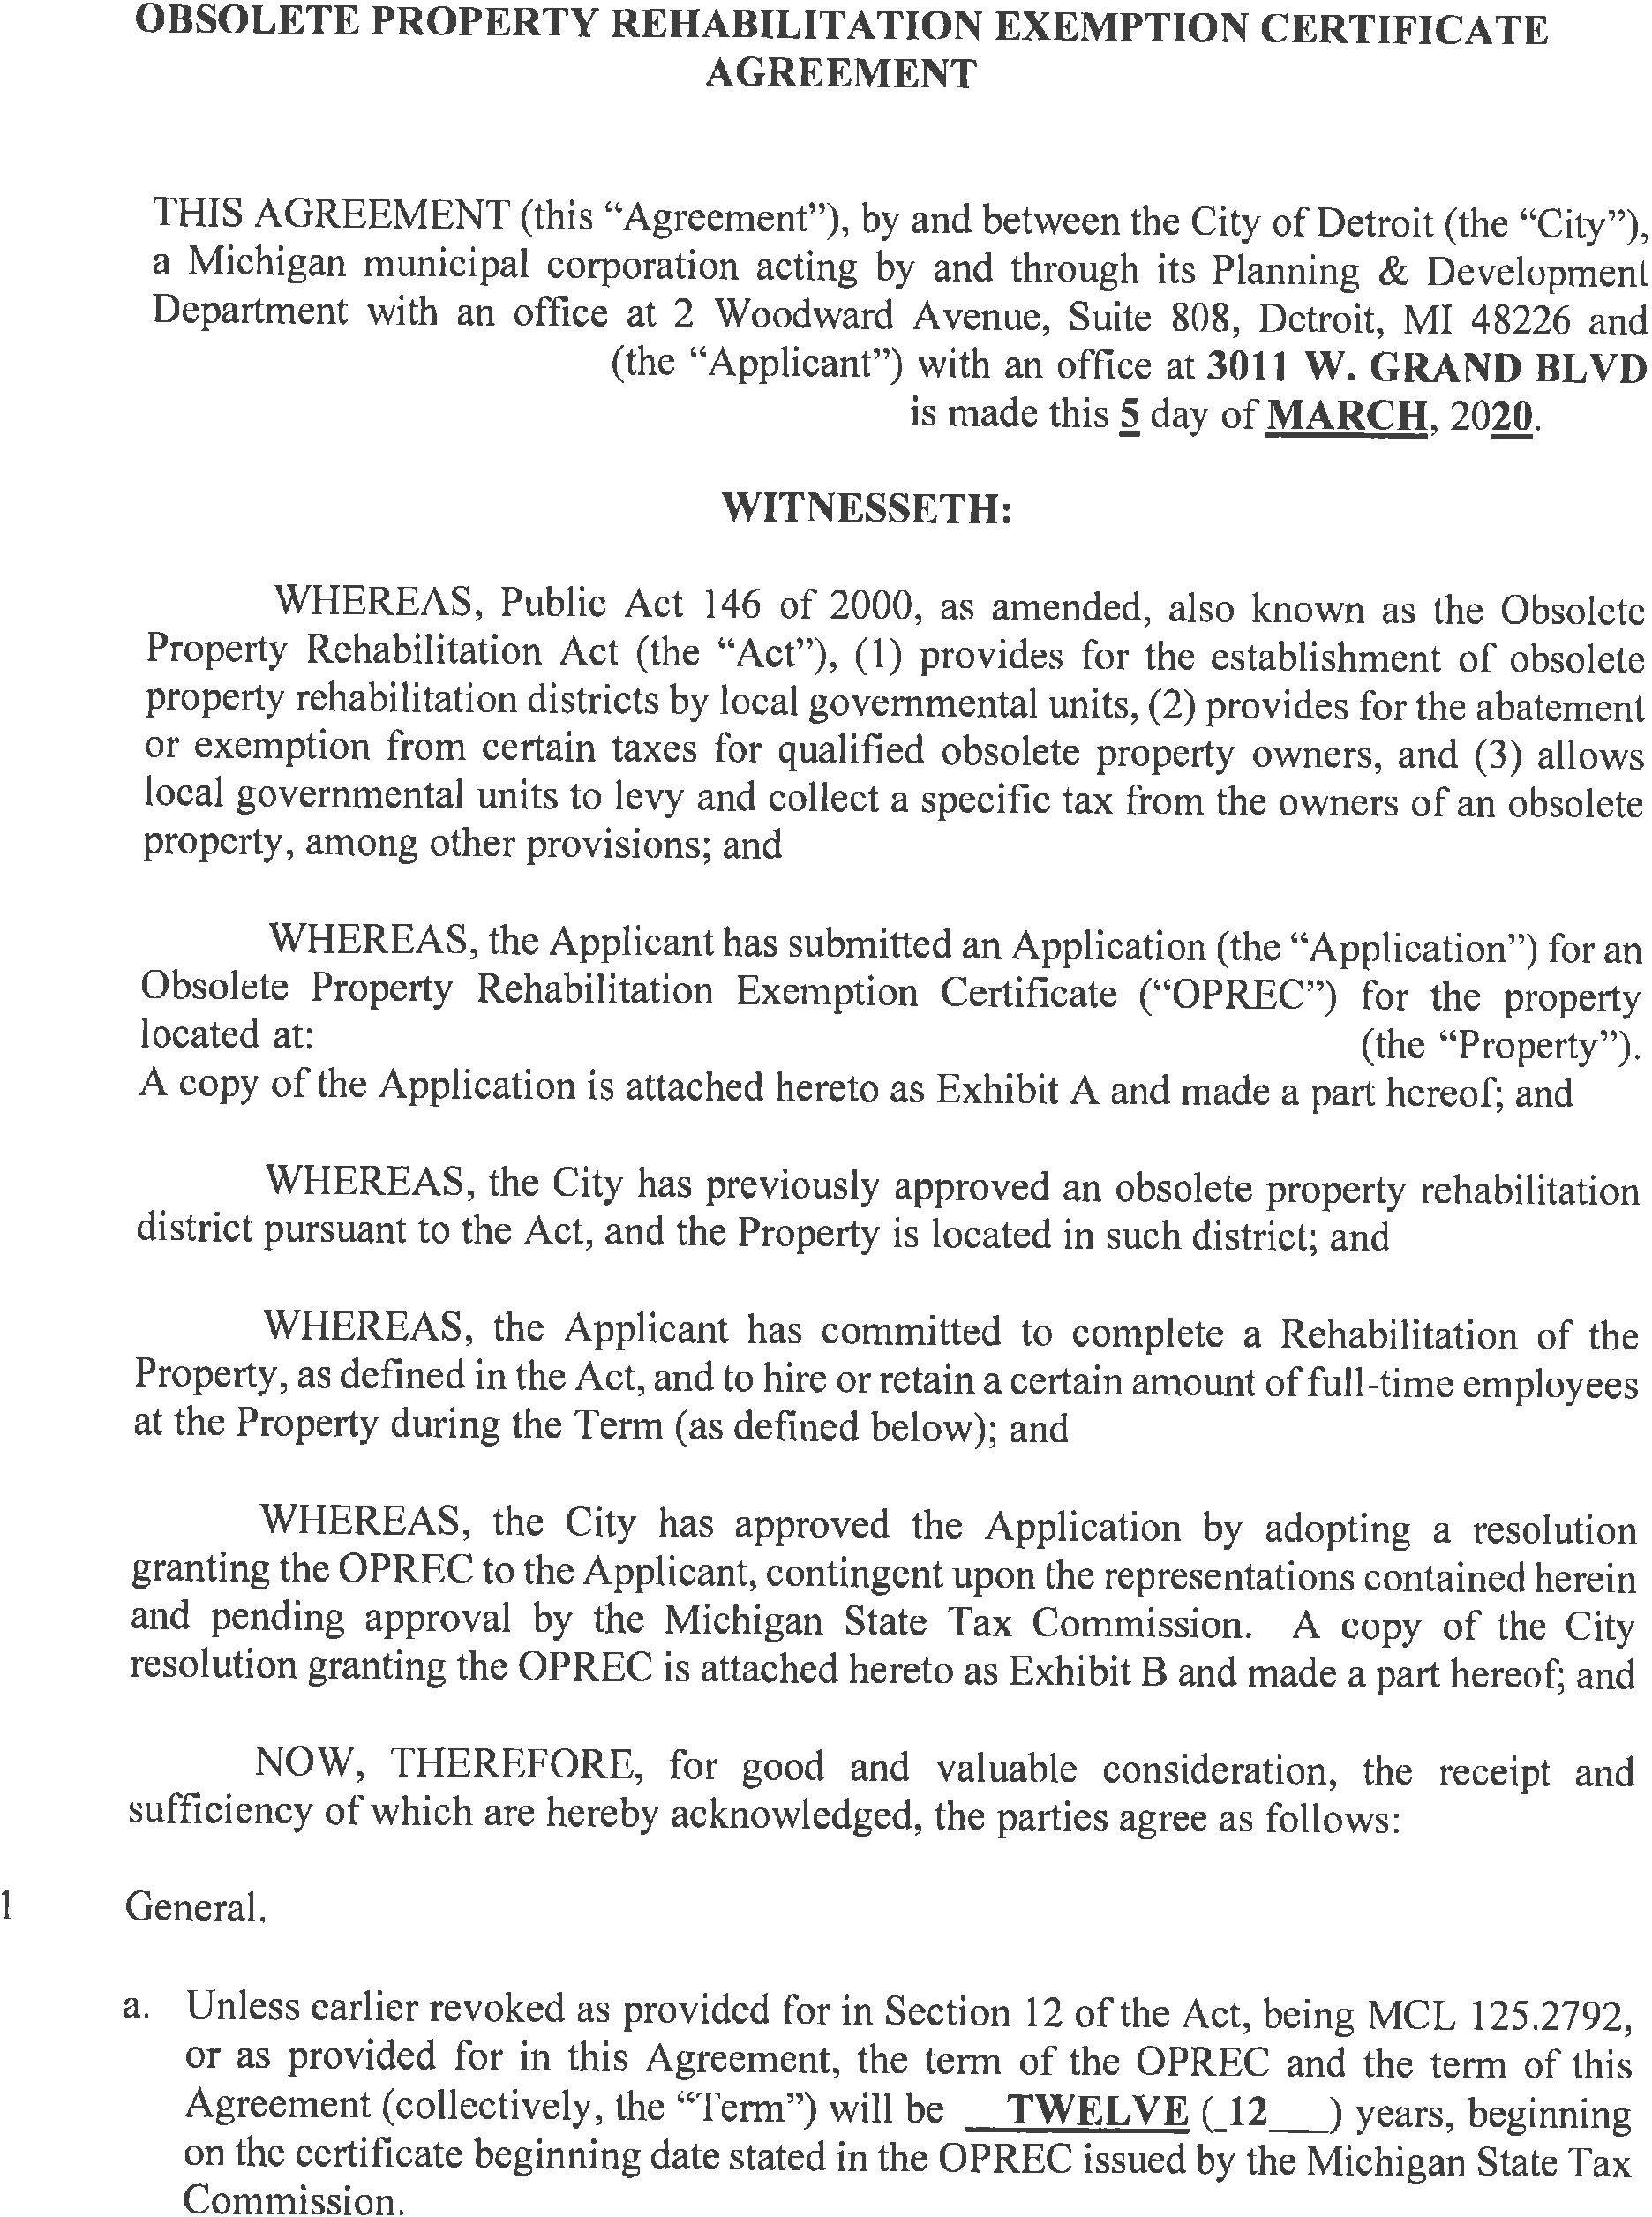
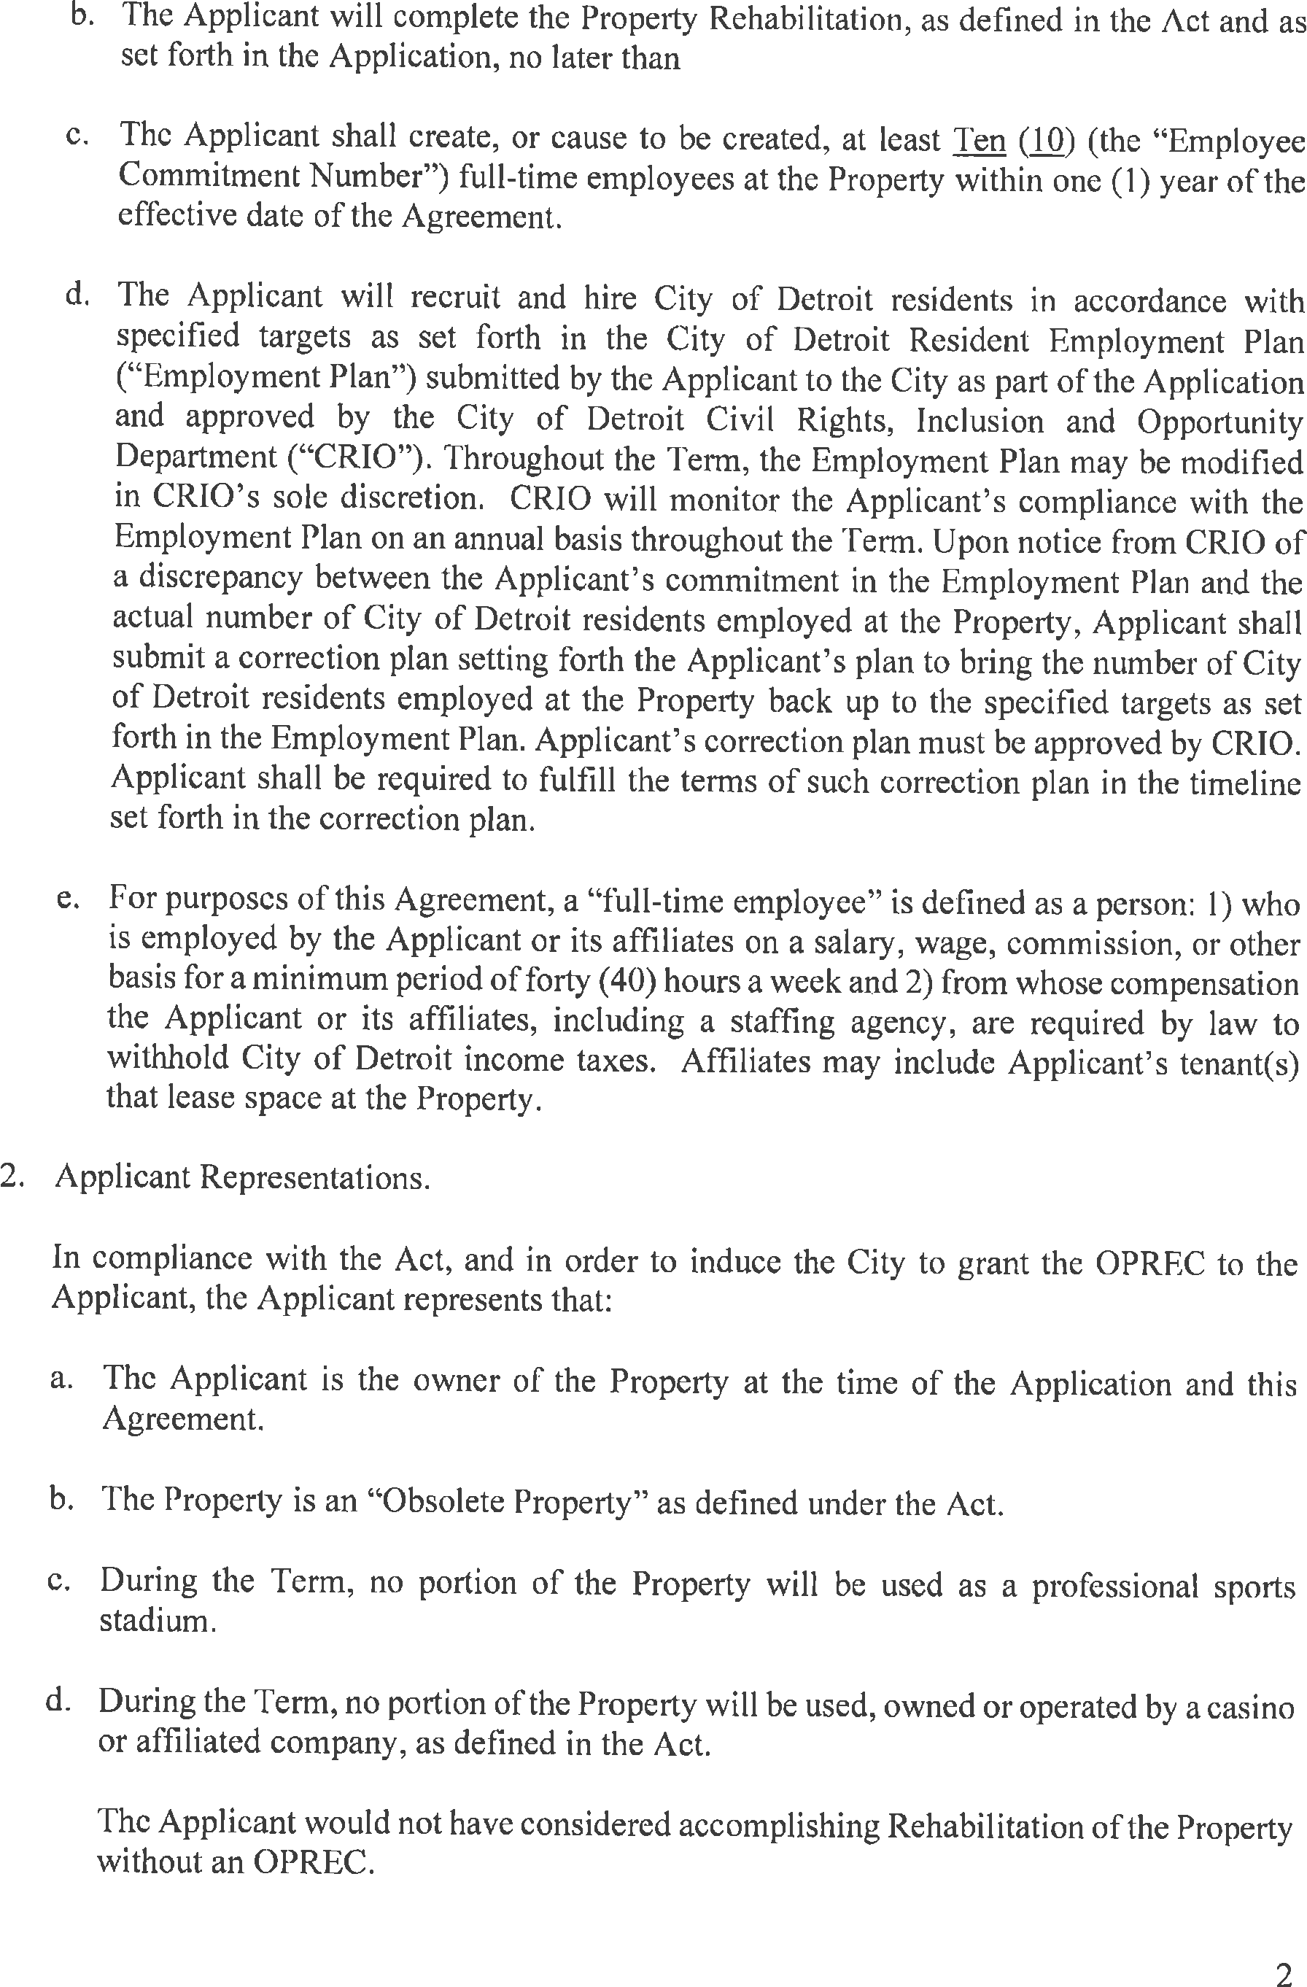
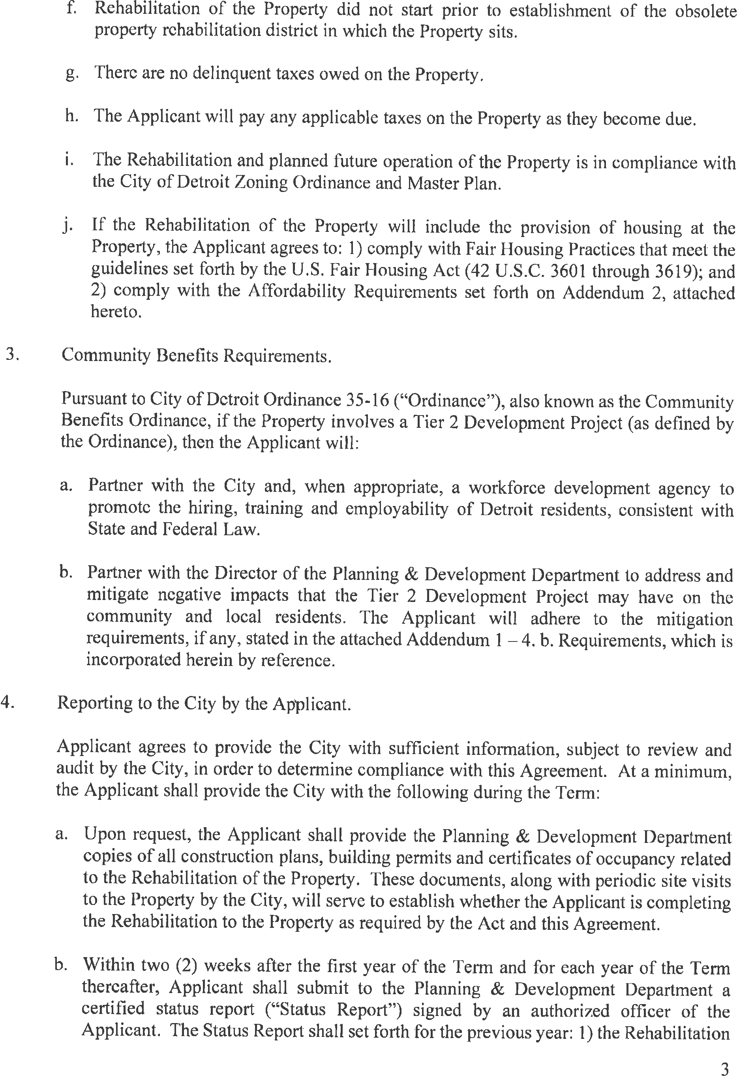
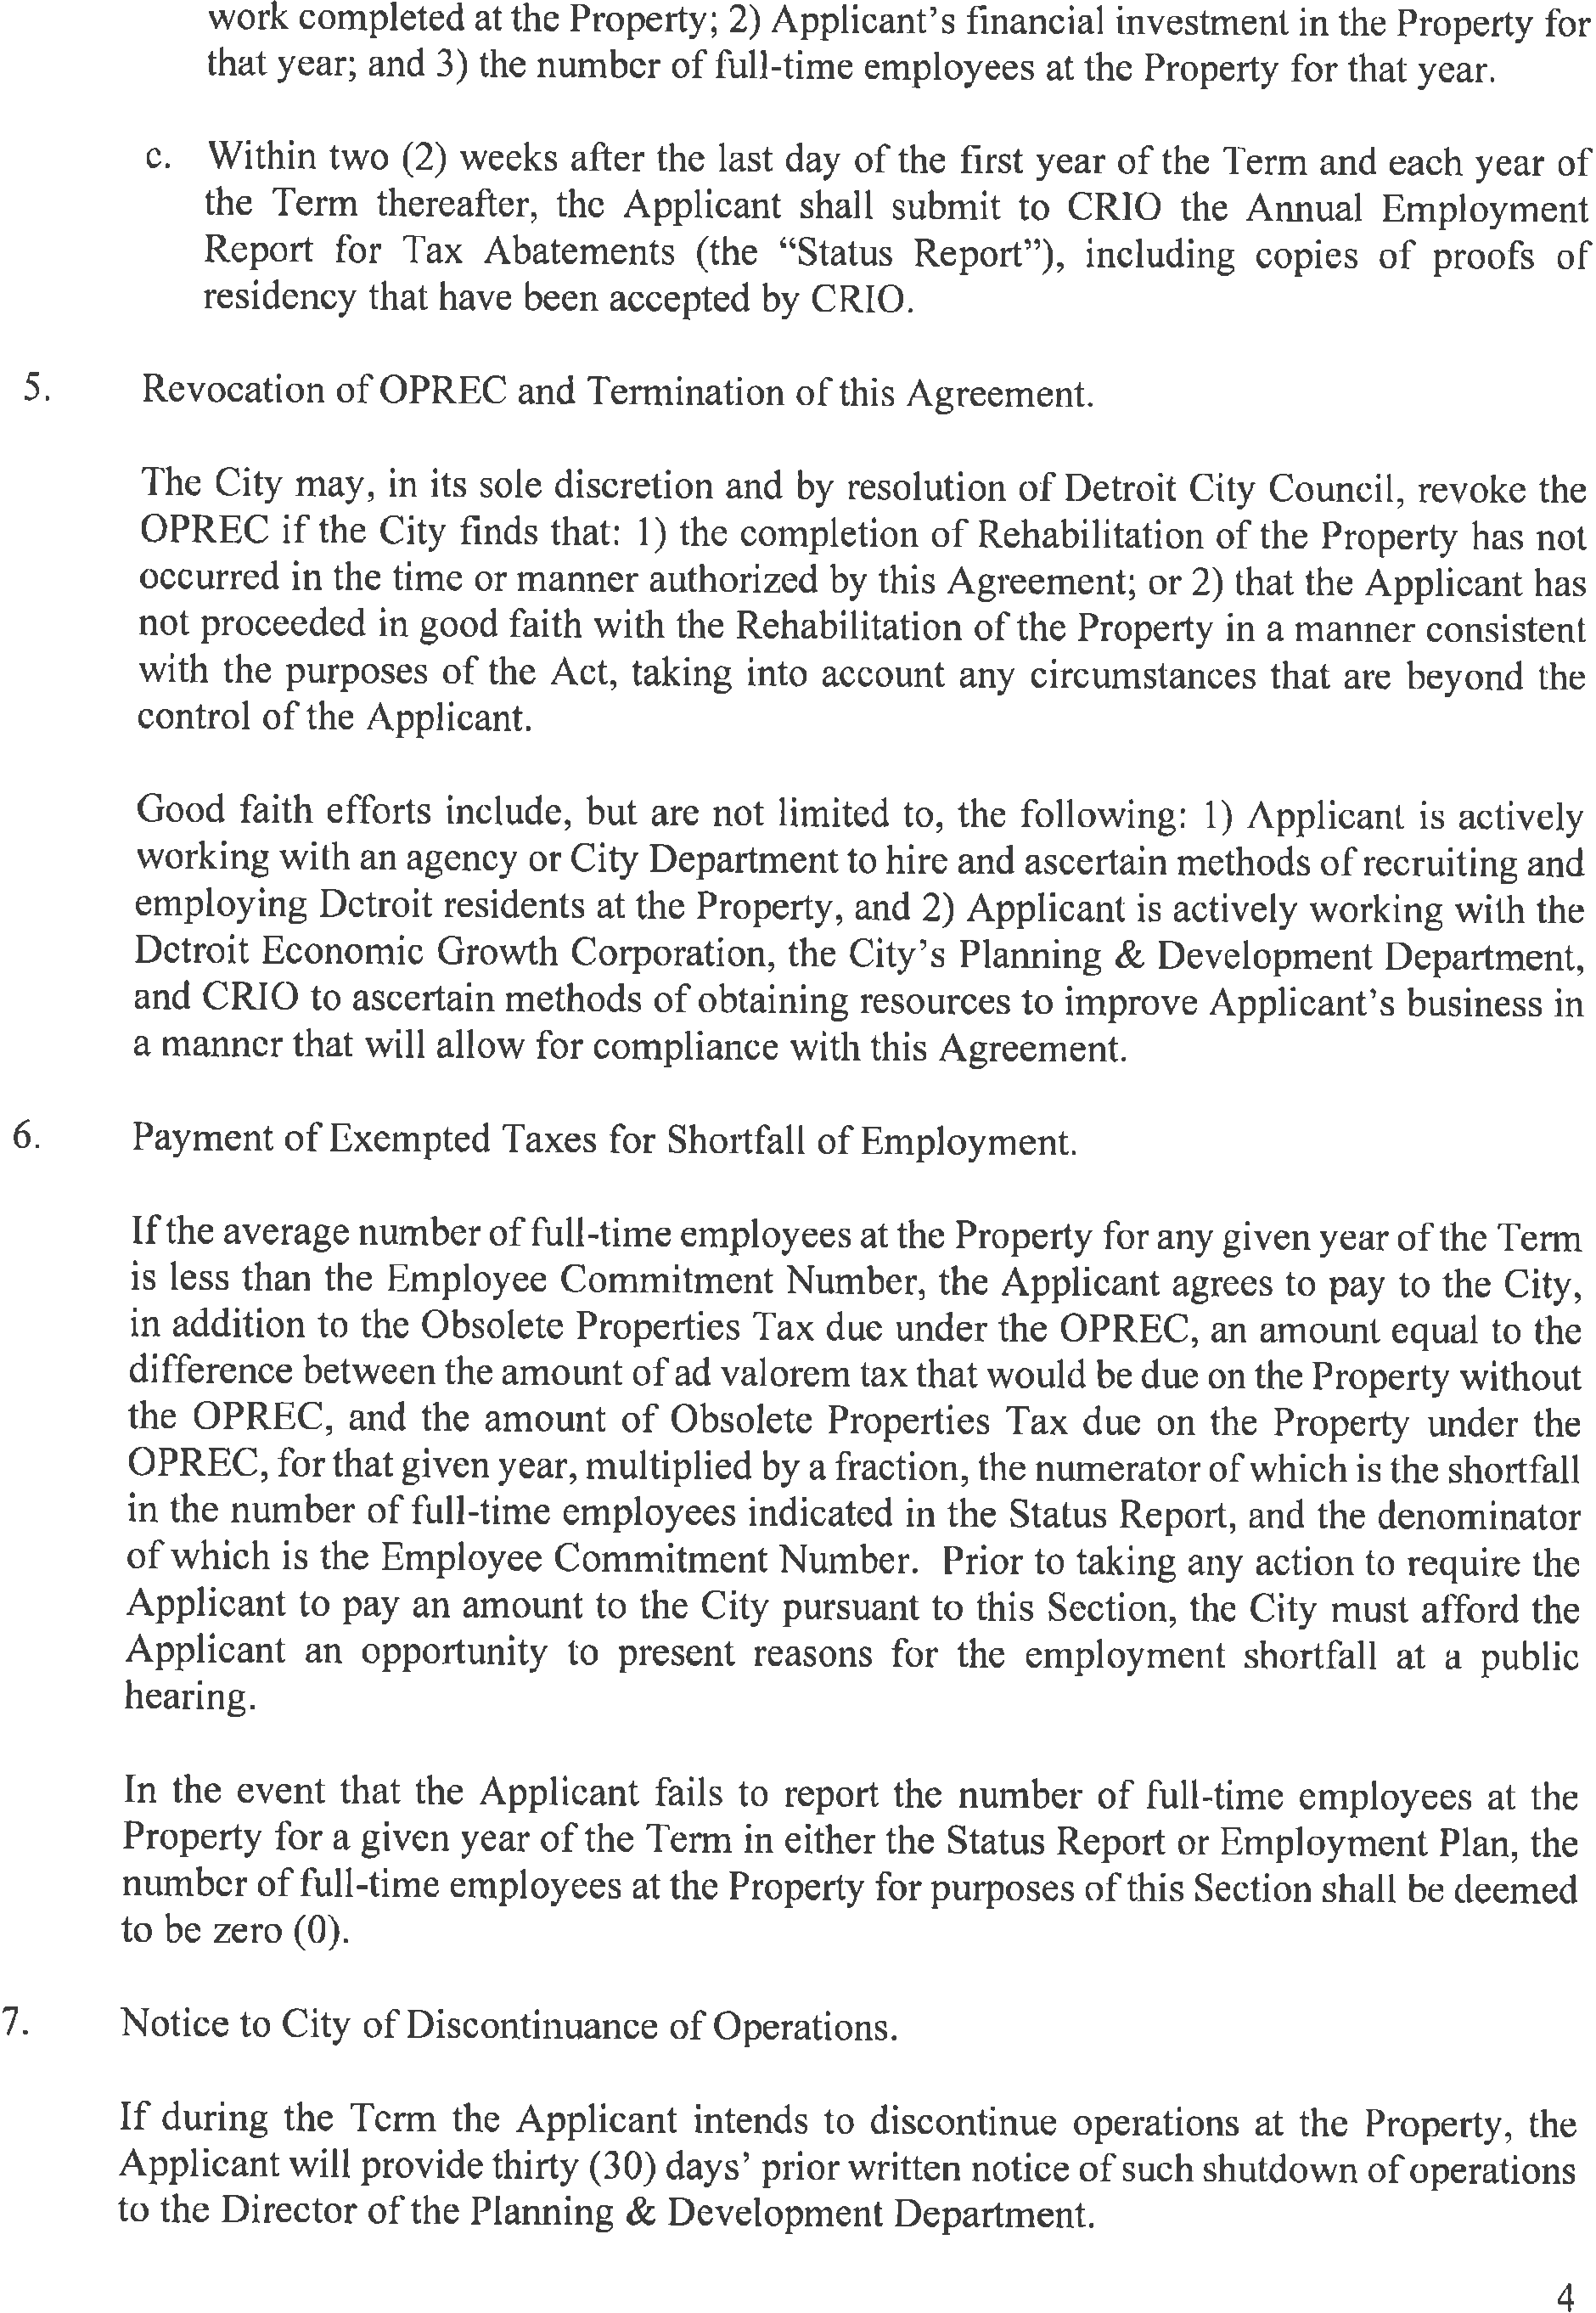
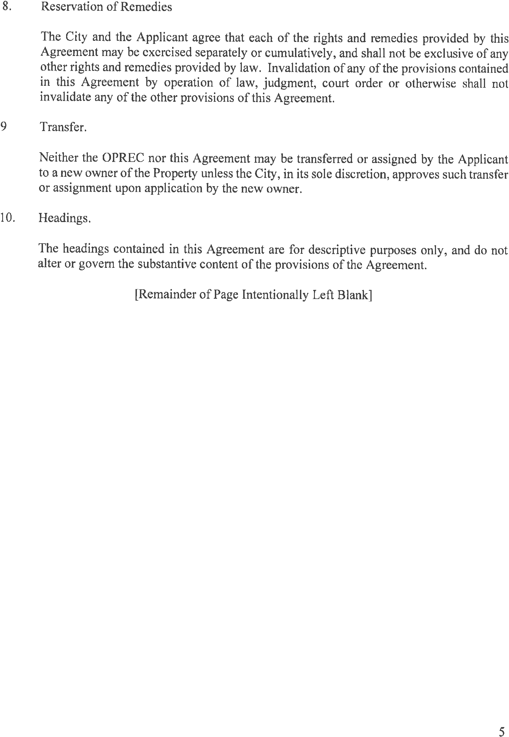
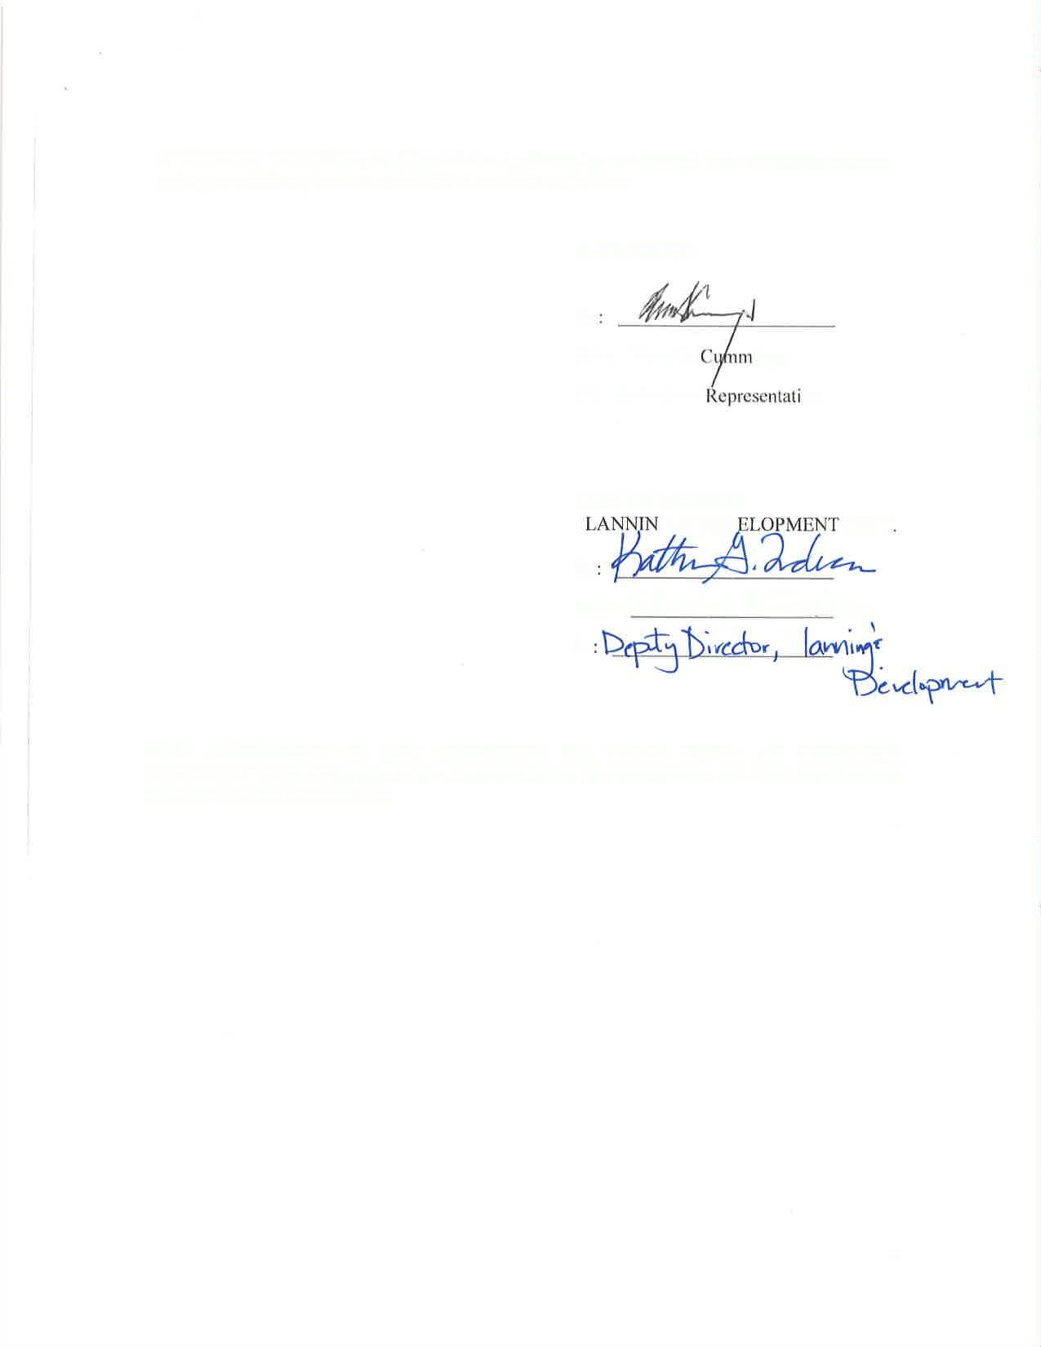
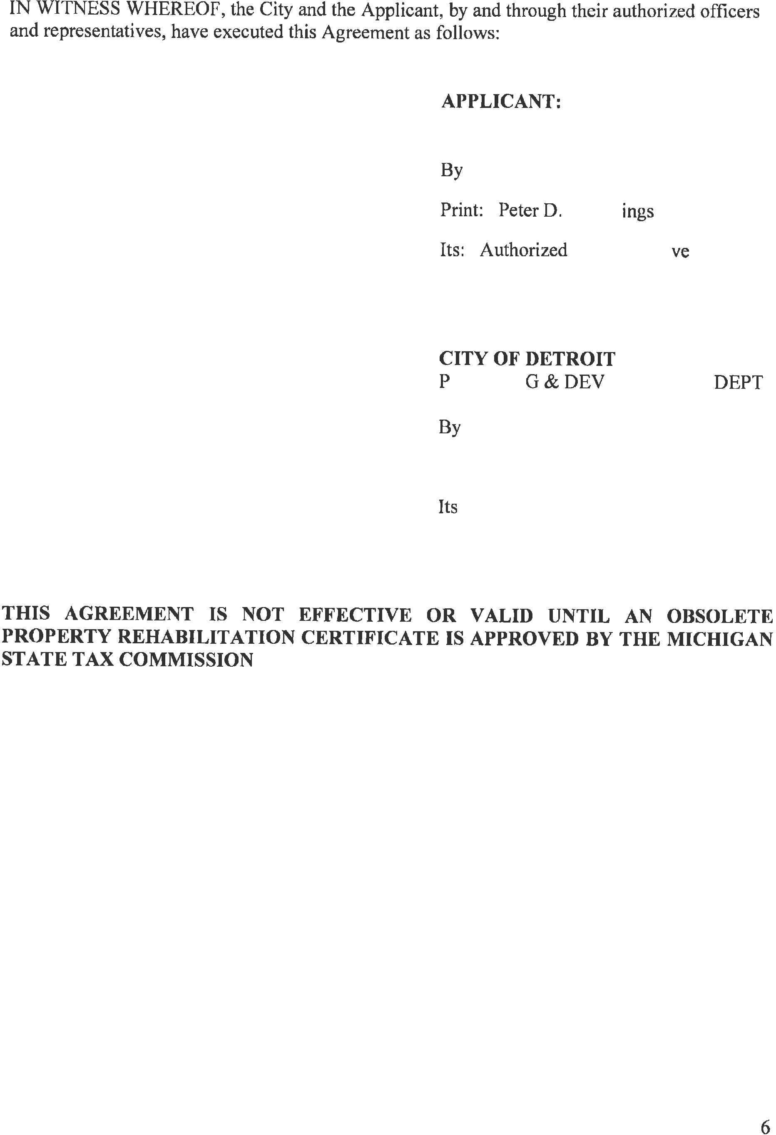
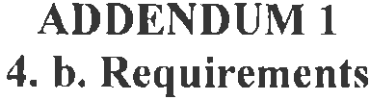
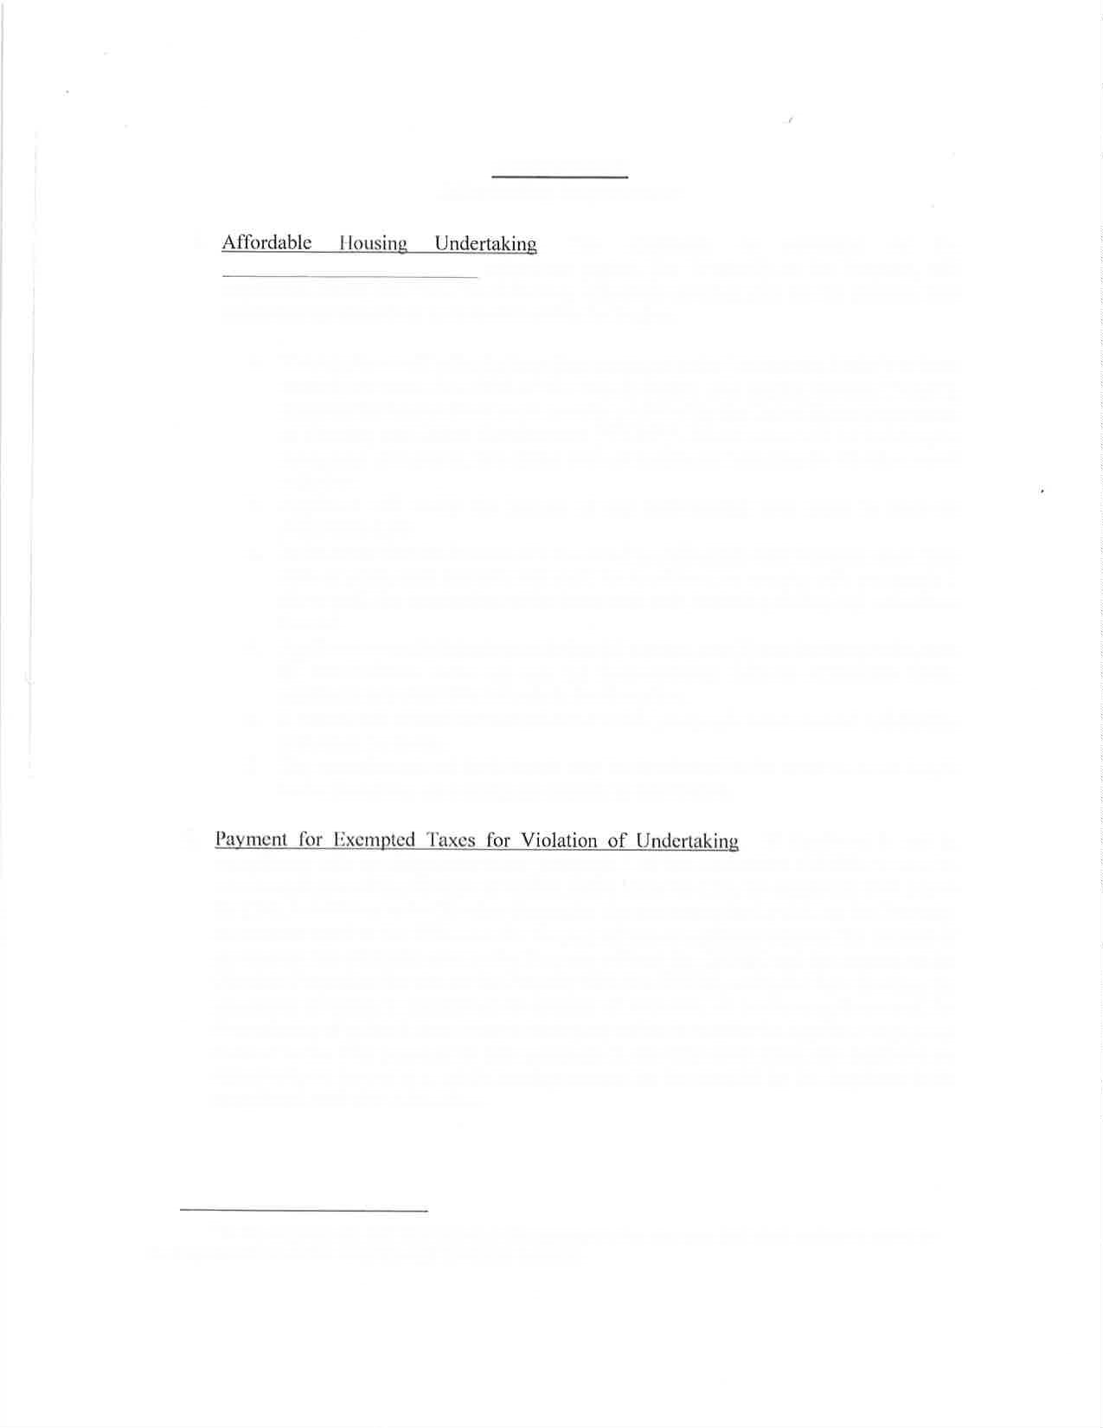
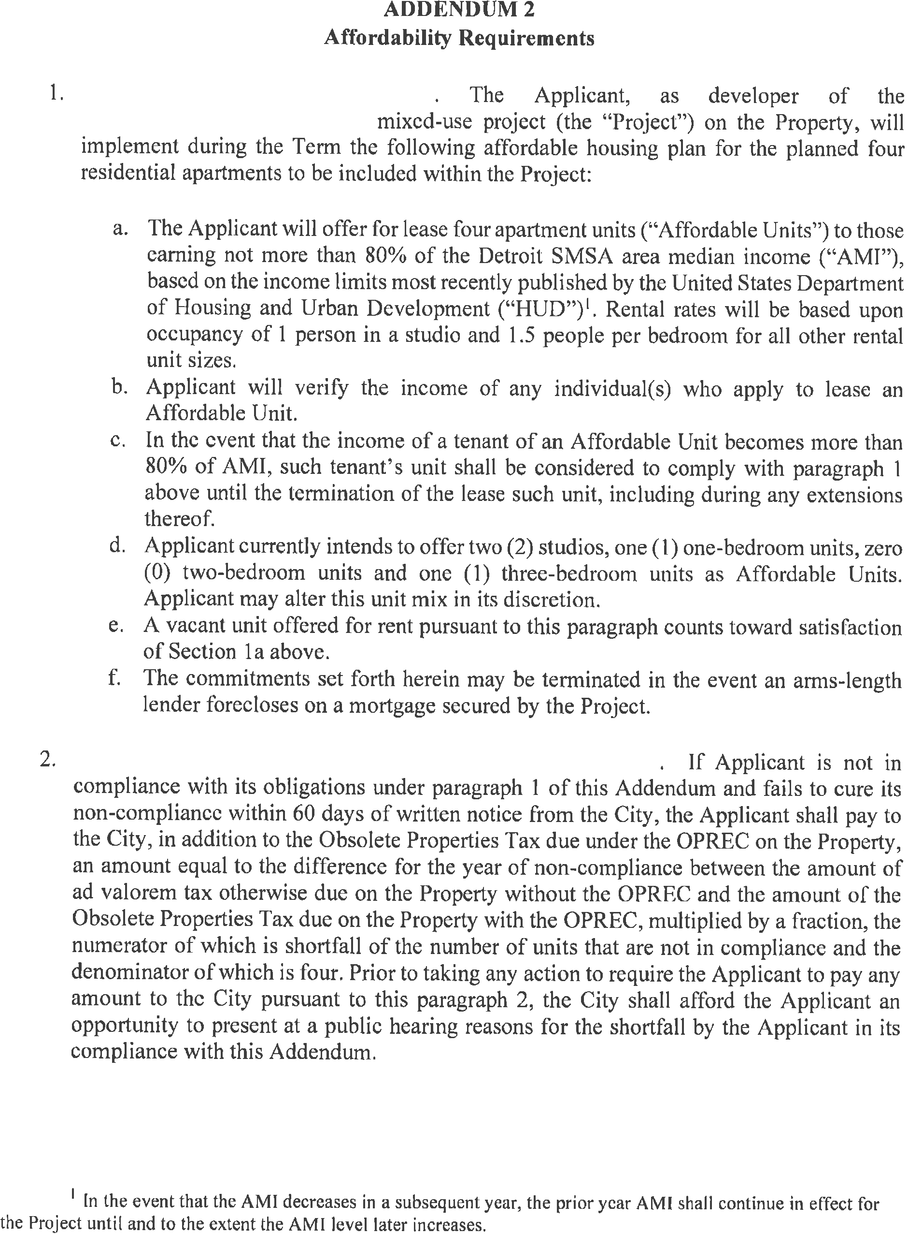

Incentive Information and Hiring Addendum

Project Type: Mixed Use Rehabilitation of Vacant Retail Space
Incentive Type: PA 146 OPRA Tax Abatement
Investment Amount: $3.6 Million Dollars

District: 1

- In order to incentive long term hiring of Detroit residents, the developer will incorporate a local hiring incentive in all commercial leases signed for the retail spaces. When employees are hired from surrounding zip codes, the tenant will be eligible for $.25/sf reduction in rent up to $.75/sf. We believe this will incentivize retail tenants to provide more opportunities for Detroiters who live in close proximity to the site. We will also be providing a landscaping and maintenance contract for Motor City Blight Busters, an area non-profit.

- All of the jobs at the site will be for retail positions and office employees for any nonprofits that take occupancy. We estimate these figures based on our knowledge of other property types in our portfolio and the square footage of the actual spaces in terms of occupancy loads.

- No, this development will reactivate vacant retail space and create 4 new loft apartments to add density to the immediate corridor.

- Yes, the developer has reached out to multiple stakeholder groups including the D1 monthly council meeting, the local Malvern Hill/Greater Sandhill Block Club, and The Old Redford Business Association. The developer also initiated a community based naming exercise for the building, allowing local community members to solicit feedback on and ultimately vote for the name of the building. Pictures included below:

- Construction commenced on the building in late 2019.

- The estimated completion date is July 2020.

