MEMORANDUM

#10
TO: Lawrence Garcia, Corporation Counsel
City of Detroit

CC: Honorable Colleagues
Janice Winfrey, City Clerk
Tonja Long, Supervising Assistant Corporation Counsel

FROM: Council President Brenda Jones

DATE: May 6, 2020

RE: Opinion on Implementation of Tenant Payment Plans

On Monday, May 5, 2020 the District of Columbia Council passed emergency legislation that requires landlords in D.C. to offer payment plans for rent to tenants who are facing financial hardship due to COVID-19.

Please provide an opinion on the legality of implementing similar legislation in the City of Detroit.
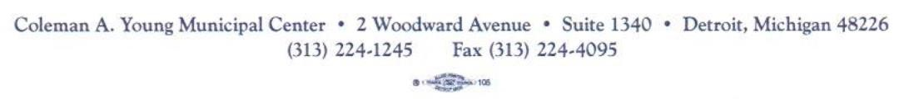
If legal, please draft an emergency ordinance requiring payment plans.

