CITY OF DETROIT

PLANNING AND DEVELOPMENT
DEPARTMENT

COL
E
MAN A. YOUNG MUNICIPAL CENTER

2
WOODWARD AVE SUITE 808
DETROIT, MICHIGAN 48226
(313) 224-1339
. TTY: 711
(313) 224-1310

WWW.DETROITMI.GOV

#104

April 3, 2020

Detroit City Council
1340 Coleman A. Young Municipal Center
Detroit, MI 48226

RE: Property Sale
3392 and 3382 Goldner, Detroit, MI

Honorable City Council:

The City of Detroit, Planning and Development Department (“P&DD”) has received an offer from
Urbano Hernandez (the “Purchaser”), to purchase certain City-owned real property at 3392 and 3382 Goldner (together the “Property”) for the purchase price of Five Thousand 00/100 Dollars ($5,000.00).

Purchaser proposes to utilize the Property as a yard extension for his home at 3376 Goldner.
Currently, the Property is within a R2 zoning district (Two-Family Residential District). Purchaser’s proposed use of the Property shall be consistent with the allowable uses for which the Property is zoned.

We, therefore, request that your Honorable Body adopt the attached resolution to authorize the Director of P&DD, or his authorized designee, to execute a deed and such other documents as may be necessary or convenient to effect a transfer of the Property by the City to Purchaser.

Respectfully submitted,

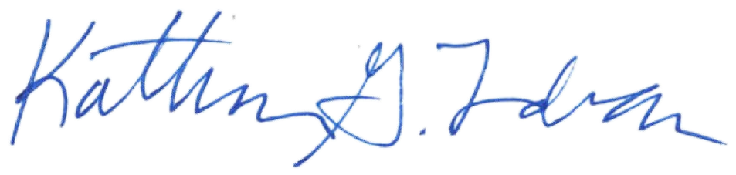
Katharine G. Trudeau
Deputy Director

cc: Avery Peeples, Mayor’s Office

RESOLUTION

BY COUNCIL MEMBER _______________________________________________________

NOW, THEREFORE, BE IT RESOLVED, that Detroit City Council hereby approves of the sale of certain real property at 3392 and 3382 Goldner, Detroit, MI (together the “Property”), as more particularly described in the attached Exhibit A incorporated herein, to Urbano Hernandez (the “Purchaser”) for the purchase price of Five Thousand and 00/100 Dollars ($5,000.00).

RESOLVED, that the Director of the Planning and Development Department (“P&DD”), or his authorized designee, is authorized to execute a quit claim deed and other such documents necessary or convenient to effect transfer of the Property to the Purchaser consistent with this resolution; and be it further

RESOLVED, that the following Property Sales Services Fees be paid from the sale proceeds pursuant to the City’s Property Management Agreement with the Detroit Building Authority (“DBA”): 1) Three Hundred and 00/100 Dollars ($300.00) shall be paid to the DBA from the sale proceeds, 2) Two Hundred Fifty 00/100 Dollars ($250.00) shall be paid to the DBA’s real estate brokerage firm from the sale proceeds and 3) customary closing costs up to Two Hundred and 00/100 Dollars ($200.00) shall be paid from the sale proceeds; and be it further

RESOLVED, that the P&DD Director, or his authorized designee, is authorized to execute any required instruments to make and incorporate technical amendments or changes to the quit claim deed (including but not limited to corrections to or confirmations of legal descriptions, or timing of tender of possession of particular parcels) in the event that changes are required to correct minor inaccuracies or are required due to unforeseen circumstances or technical matters that may arise prior to the conveyance of the Property, provided that the changes do not materially alter the substance or terms of the transfer and sale; and be it finally

RESOLVED, that the quit claim deed will be considered confirmed when executed by the P&DD Director, or his authorized designee, and approved by the Corporation Counsel as to form.

(See Attached Exhibit A)

EXHIBIT A

LEGAL DESCRIPTION

Property situated in the City of Detroit, Wayne County, Michigan, described as follows:

Parcel 1

E GOLDNER LOT 20 STECHER & RATHS SUB L4 P66 PLATS, W C R 16/74 30 X 146.61

a/k/a 3392 Goldner
Tax Parcel ID 16010487.

Parcel 2

E GOLDNER LOT 21 STECHER & RATHS SUB L4 P66 PLATS, W C R 16/74 30 X 146.61

a/k/a 3382 Goldner
Tax Parcel ID 16010486.

