CITY OF
DETROIT

PLANNING AND DEVELOPMENT DEPARTMENT

COL
E
MAN A. YOUNG MUNICIPAL CENTER

2
WOODWARD AVE SUITE 808
DETROIT, MICHIGAN 48226
(313) 224-1339
. TTY: 711
(313) 224-1310

WWW.DETROITMI.GOV

#101
April 1, 2020

Detroit City Council
1340 Coleman A. Young Municipal Center
Detroit, MI 48226

RE: Property Sale
19609 Schoolcraft, Detroit, MI

Honorable City Council:

The City of Detroit, Planning and Development Department (“P&DD”) has received an offer from
Rachel Schumake (the “Purchaser”), to purchase certain City-owned real property at 19609 Schoolcraft, Detroit, MI (the “Property”) for the purchase price of Twenty Two Thousand Seven Hundred Fifty and 00/100 Dollars ($22,750.00).

The Property consists of a 2300 square feet structure situated on land measuring approximately 6300 square feet and zoned M2 (Restricted Industrial District). The Purchaser proposes to rehabilitate and develop the Property as a small retail store. Any use of the Property by the Purchaser shall be consistent with the allowable uses for which the Property is zoned.

We, therefore, request that your Honorable Body adopt the attached resolution to authorize the Director of P&DD, or his authorized designee, to execute a deed and such other documents as may be necessary or convenient to effect a transfer of the Property by the City to Purchaser.

Respectfully submitted,

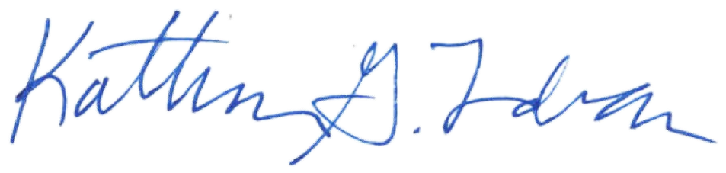
Katharine G. Trudeau
Deputy Director

cc: Avery Peeples, Mayor’s Office

RESOLUTION

BY COUNCIL MEMBER: ______________________________________________________

NOW, THEREFORE, BE IT RESOLVED, that Detroit City Council hereby approves of the sale of certain real property at 19609 Schoolcraft, Detroit, MI (the “Property”), as more particularly described in the attached Exhibit A incorporated herein, to Rachel Schumake (the “Purchaser”), for the purchase price of Twenty Two Thousand Seven Hundred Fifty and 00/100 Dollars ($22,750.00); and be it further

RESOLVED, that the Director of the Planning and Development Department (“P&DD), or his or her authorized designee, is authorized to execute a quit claim deed and other such documents necessary or convenient to effect transfer of the Property to the Purchaser consistent with this resolution; and be it further

RESOLVED, that the following Property Sales Services Fees be paid from the sale proceeds pursuant to the City’s Property Management Agreement with the Detroit Building Authority (“DBA”): 1) Two Thousand Five Hundred and 00/100 Dollars ($2,500.00) shall be paid to the DBA from the sale proceeds, 2) One Thousand One Hundred Thirty Seven and 50/100 Dollars ($1,137.50) shall be paid to the DBA’s real estate brokerage firm from the sale proceeds and 3) customary closing costs up to Two Hundred and 00/100 Dollars ($200.00) shall be paid from the sale proceeds; and be it further

RESOLVED, that the P&DD Director, or his authorized designee, is authorized to execute any required instruments to make and incorporate technical amendments or changes to the quit claim deed (including but not limited to corrections to or confirmations of legal descriptions, or timing of tender of possession of particular parcels) in the event that changes are required to correct minor inaccuracies or are required due to unforeseen circumstances or technical matters that may arise prior to the conveyance of the Property, provided that the changes do not materially alter the substance or terms of the transfer and sale; and be it finally

RESOLVED, that the quit claim deed will be considered confirmed when executed by the P&DD Director, or his authorized designee, and approved by the Corporation Counsel as to form.

(See Attached Exhibit A)

EXHIBIT A

LEGAL DESCRIPTION

Property situated in the City of Detroit, Wayne County, Michigan, described as follows:

S SCHOOLCRAFT S 80 FT OF LOTS 1, 2 AND 3 B E TAYLORS BRIGHTMOOR
INDUSTRIAL SUB L48 P99 PLATS, WCR 22/509

a/k/a 19609 Schoolcraft
Tax Parcel ID 22008970-1

