MEMORANDUM

#9
TO: Lawrence Garcia, Corporation Counsel
City of Detroit

CC: Honorable Colleagues
Janice Winfrey, City Clerk
Tonja Long, Supervising Assistant Corporation Counsel

FROM: Council President Brenda Jones

DATE: May 6, 2020

RE: Amendment to Affordable Housing Ordinance

Many residents often complain of high parking costs in addition to rental rates.

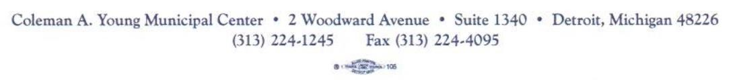
If legally feasible, please amend the affordable housing ordinance or draft an ordinance to include affordable requirements for rental unit parking.

