
Revision 2 6/29/2026

City of Detroit ARPA Oracle Invoicing
American Rescue Plan Act

Supplier Manual
Page 1 of 28

Contents
Supplier Oracle Support 3
Figure 1 3
About this guide 4
Log Into Oracle 5
Create and Submit the Invoice 7
Invoice Review and Approval 13
Additional Information Needed 13
Rejected Invoice 16
Approved Invoice 16
Key Considerations 17
View Invoices 18
Invoice Holds 20
Invoice Payment 21
Supplier Support 22
Using the Supplier Portal Advisor 22
City of Detroit Contacts 25
Appendix 26
Locating Notiﬁcations in the Worklist 26

Supplier Oracle Support
Invoices are submitted via Oracle, so it is important for suppliers to become familiar with Oracle before invoice submission. This link will take you to the Office of Contracting and Procurement (OCP) internet site. There are several supplier resources available from this page.

Figure 1
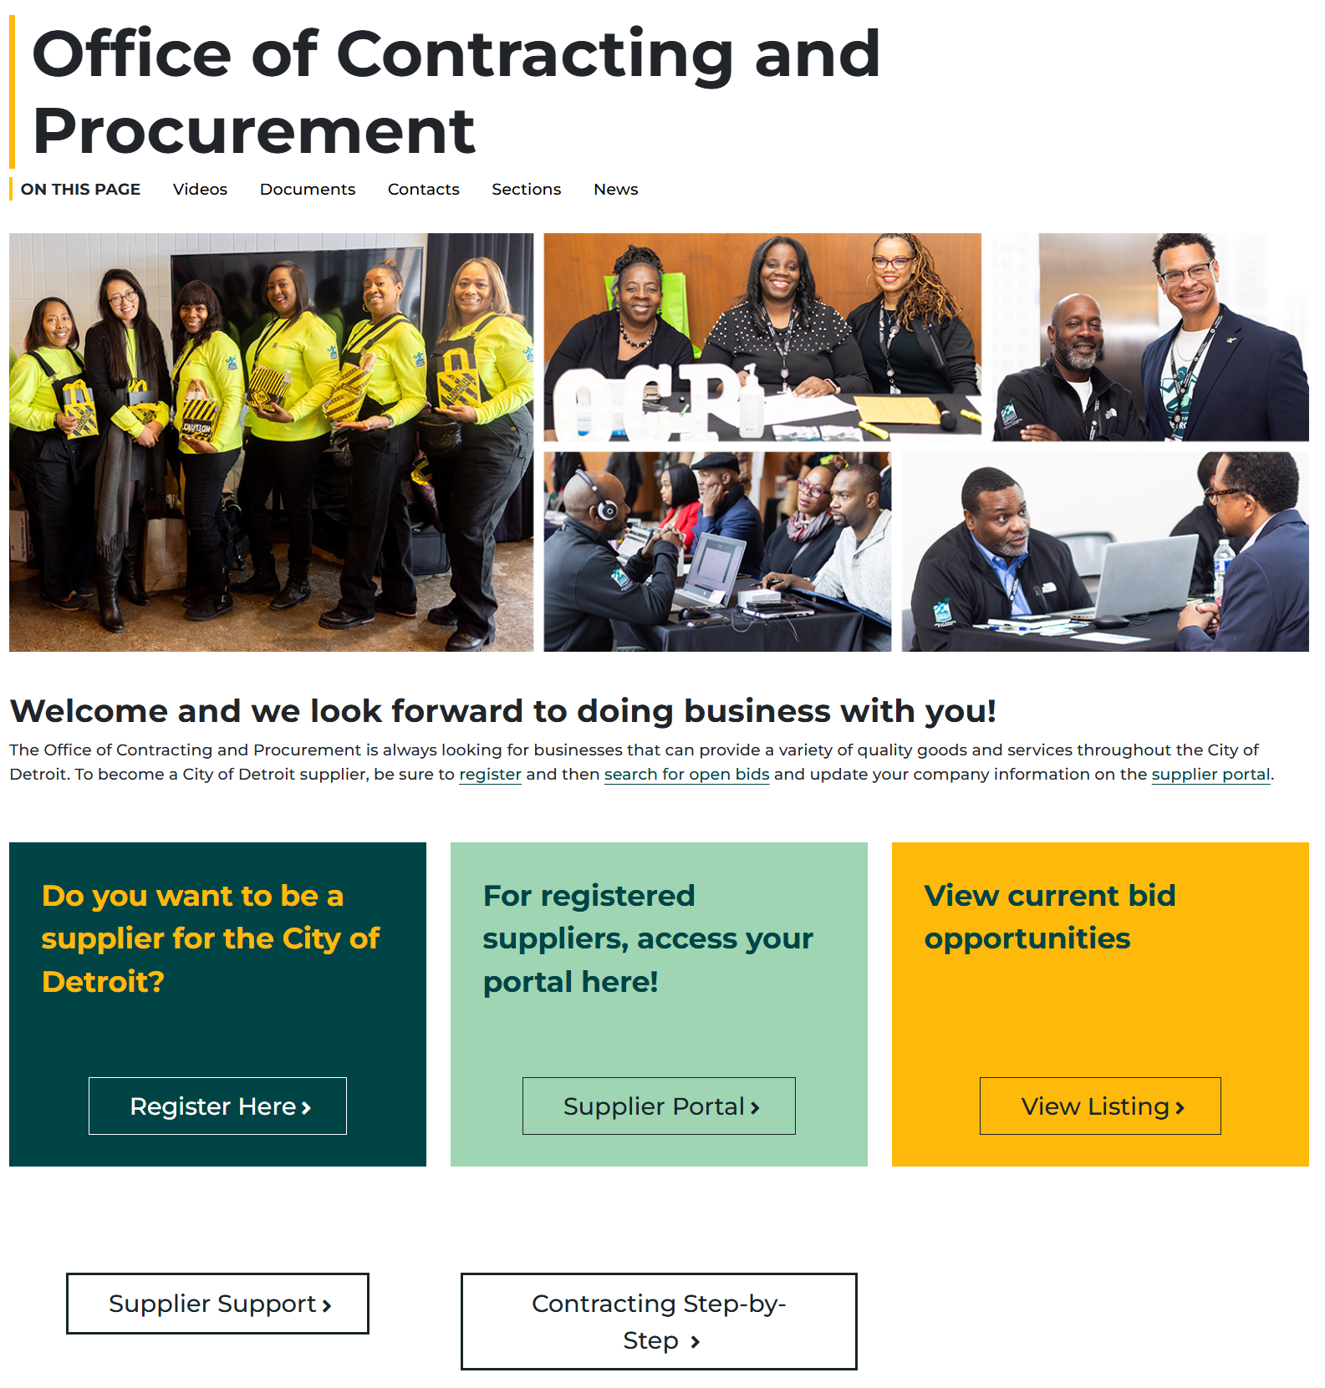

About this guide
Once an invoice is submitted in Oracle, it is routed for several reviews before it is fully approved. There are many actions that a reviewer can take during the review of your invoice. The table below provides the possible actions and expected next steps by you.

Reviewer Action | Supplier Next Steps
Approve the Invoice | No further action is required.
Request Information | Respond to the request in Oracle.
Reject the Invoice | Submit a new invoice in Oracle.

This guide walks you through the steps in Oracle to create and submit invoices for ARPA
projects and the process from submission through invoice approval.

Log Into Oracle
- You can access the Supplier Portal by selecting the Supplier Portal option on the supplier internet page ( Figure 1), or you can navigate to this webpage https://ebkk.login.us8.oraclecloud.com/
- Enter your User ID and Password
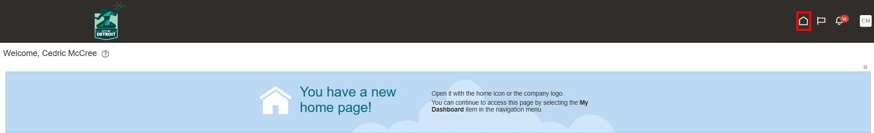
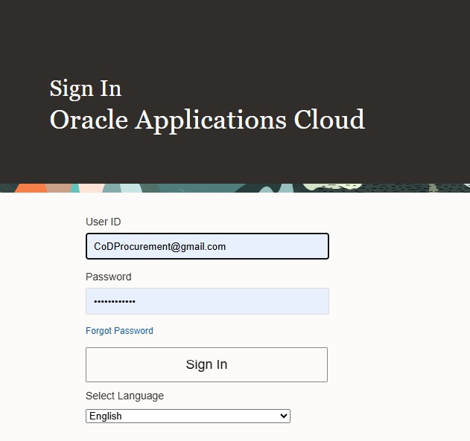

- Select the Home Icon.
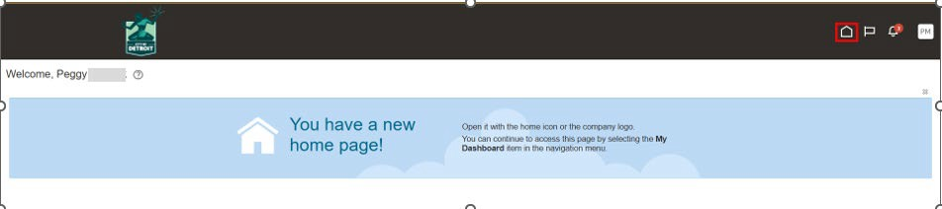

- Select the Supplier Portal tile
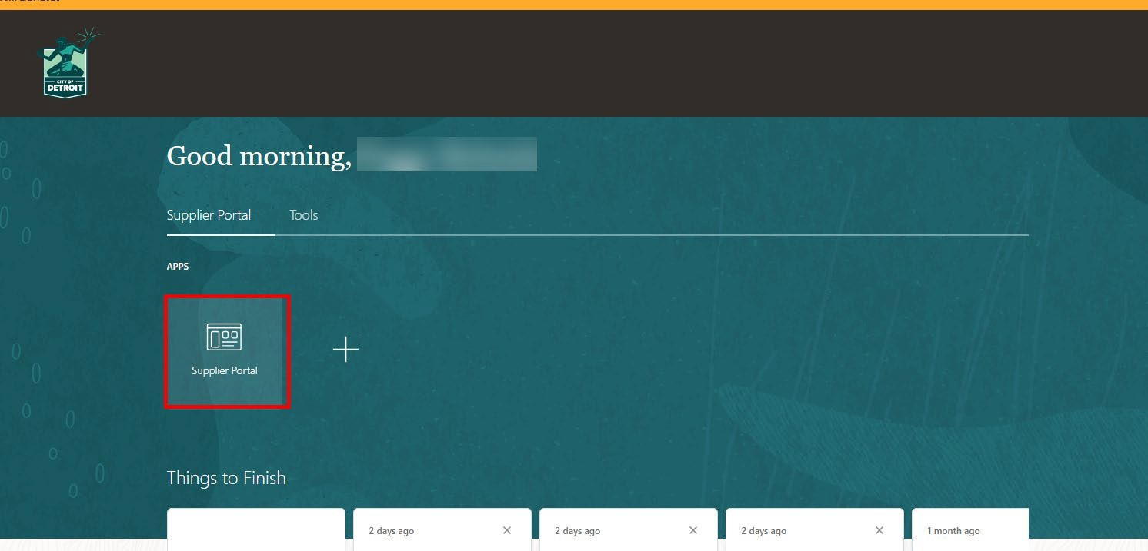

Create and Submit the Invoice
- Click on “Create Invoice” under Additional Links in the upper right corner.
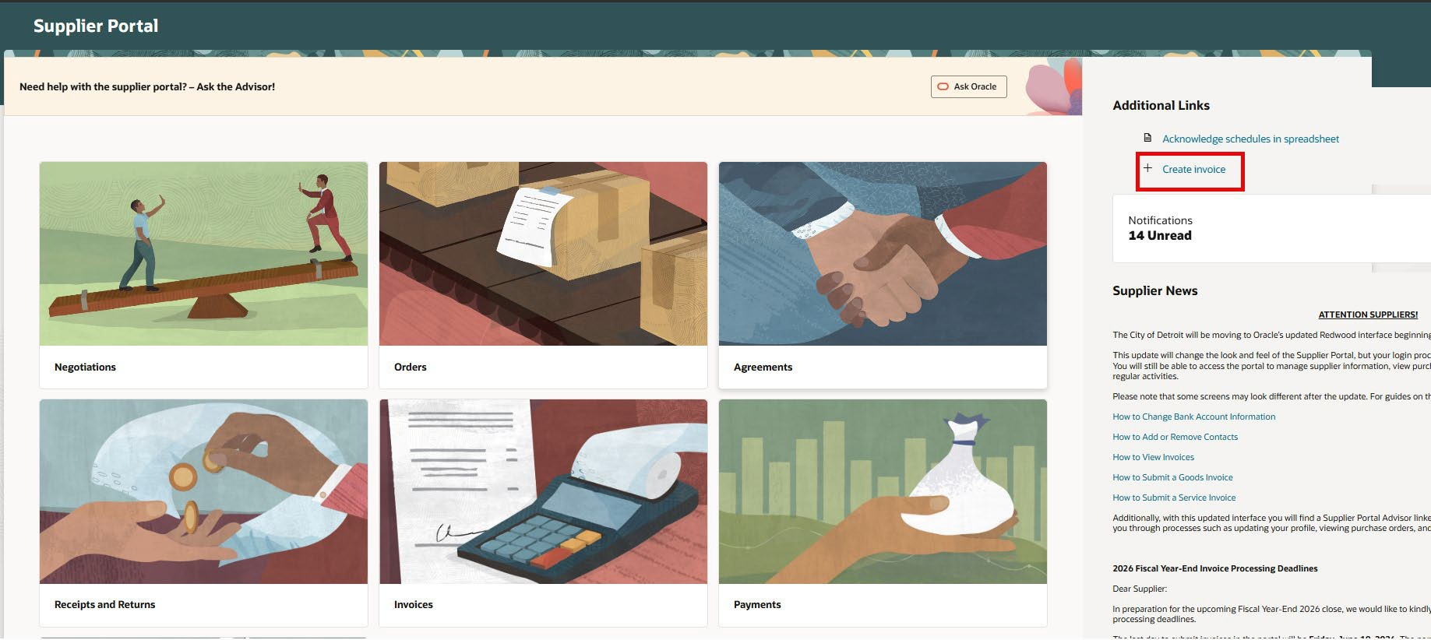

Note: The Supplier Portal Advisor is an online tool for getting answers to your questions on process and policies. Refer to this section for how to use the advisor.

- Enter the PO number in the Identifying PO ﬁeld. You can enter the number directly or click the down arrow and select from the list of your POs.
- Check if the Supplier Site auto populated. If not, select the site from the drop down list.
- Check if the Remit-to Bank Account auto populated. If not, select the account from the drop down list. If no accounts are listed, you will receive payment by check. If you desire ACH payments, save this invoice for later and add a bank account to your supplier proﬁle.
- Enter the invoice number in the Number ﬁeld.
Note: If you are resubmitting an invoice that was previously rejected, use the original invoice number and add a suffix (-RESx ) where ‘x’ indicates the number for the resubmission attempt. For example, ‘-RES2’ is the second time the invoice has been resubmitted. See this section for more information on rejected invoices.

- Enter the Invoice Date or click the calendar icon and select a date.
- The information highlighted in yellow is linked to your PO and supplier account and will be auto populated except as noted above.
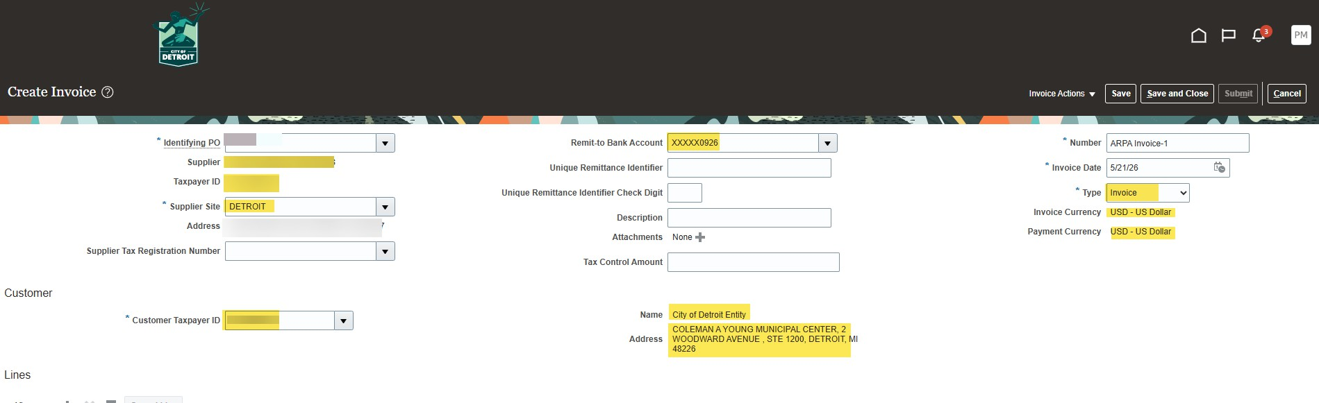

- To add attachments, select the ‘+” next to Attachments.
  - It is necessary to attach all supporting documentation in this step. Once the invoice is submitted, you will not have an opportunity to add additional attachments.
  - It is recommended to attach the invoice and support documentation
separately to keep the information organized for review by the approver.
  - Supporting documentation MUST pertain only to the submitted invoice.
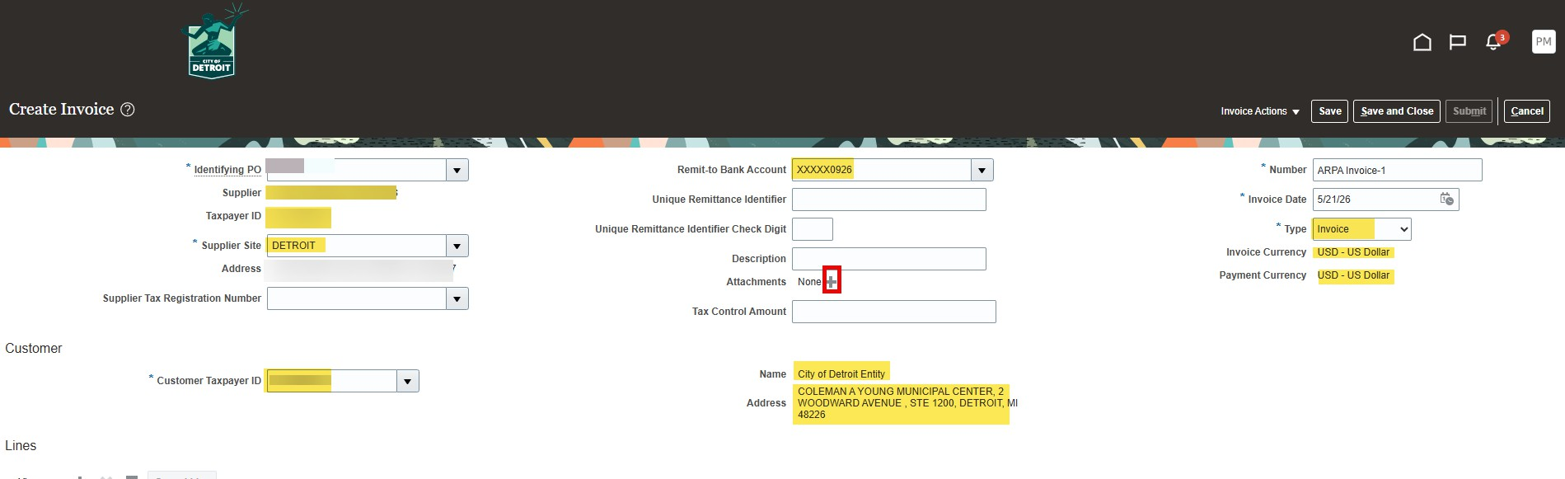

- The screen below will appear.
- Select the Type of attachment (File, text, or URL). Do not change the Category ﬁeld. A ﬁle was selected in this example. The Title ﬁeld will autoﬁll. Enter a description if desired.
- To add more ﬁles, select the ‘+’ icon again and repeat the steps above.
- Select ‘OK’ when ﬁnished.
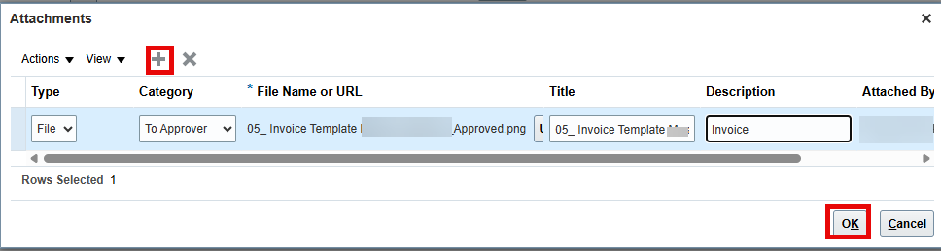

- The ﬁles will appear in the top portion (header section) of the invoice. Hover over them to see the attachment names. Select the ‘+’ to add more Attachments.
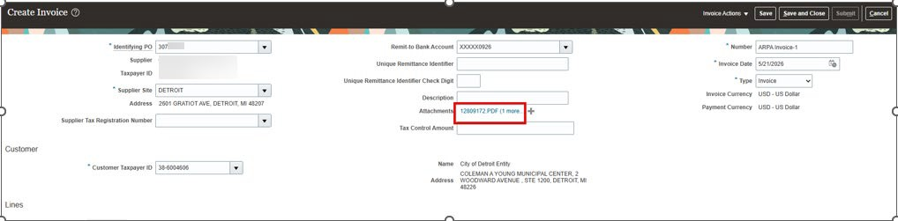

- Scroll down to the Lines section.
- Select the paper icon with a ‘+’ it looks like this:
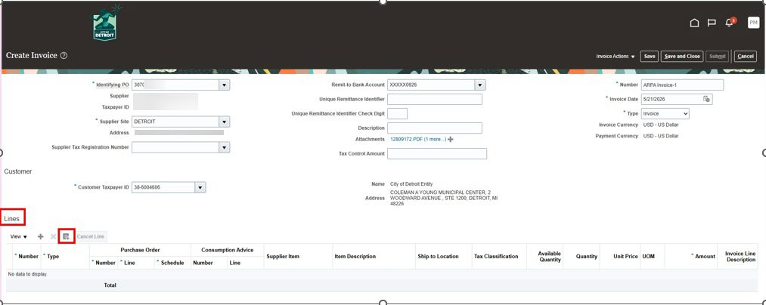

- Select the line or lines you will be using for this invoice. (Select multiple lines by
using the shift key). The selected lines will highlight blue.
- Select ‘OK’.
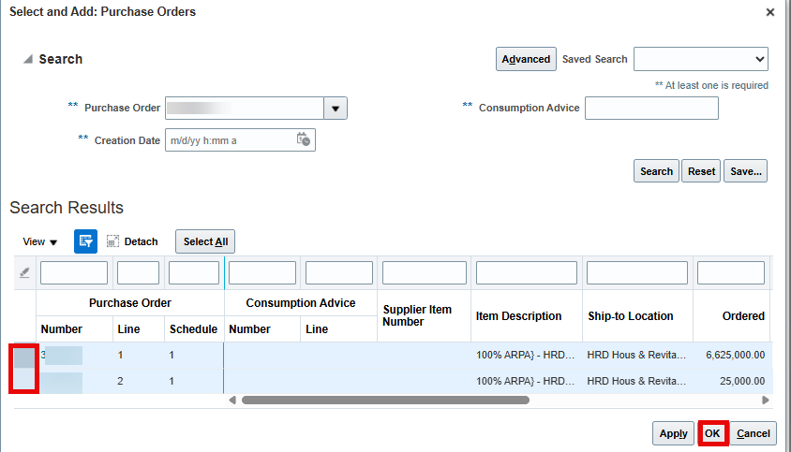

- The information for the selected lines populates in the “Lines” section. The Amount
represents the amount remaining for that line.
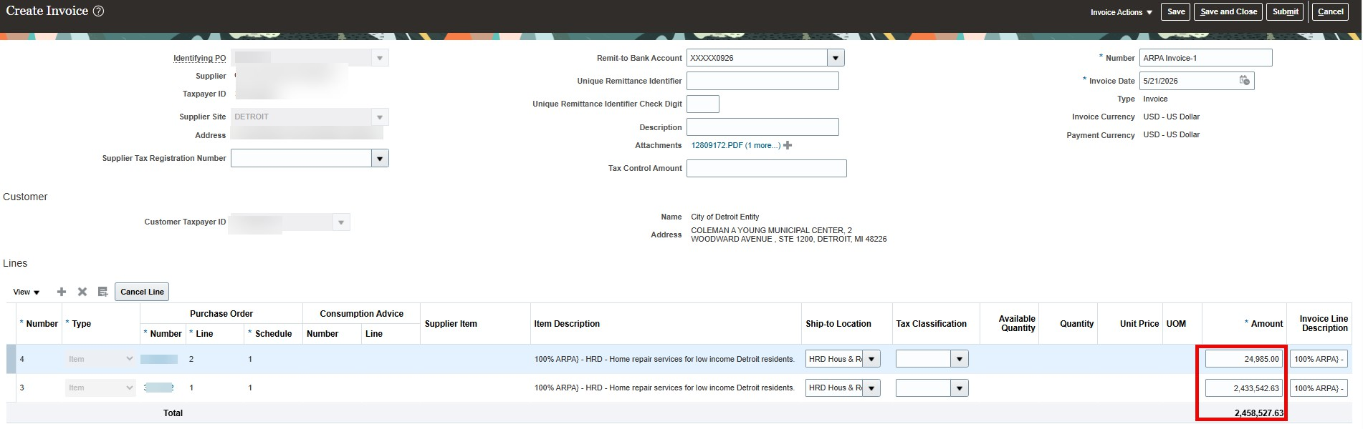

- Enter the amount you will invoice for each line. You can invoice for a portion of the amount or the entire amount.
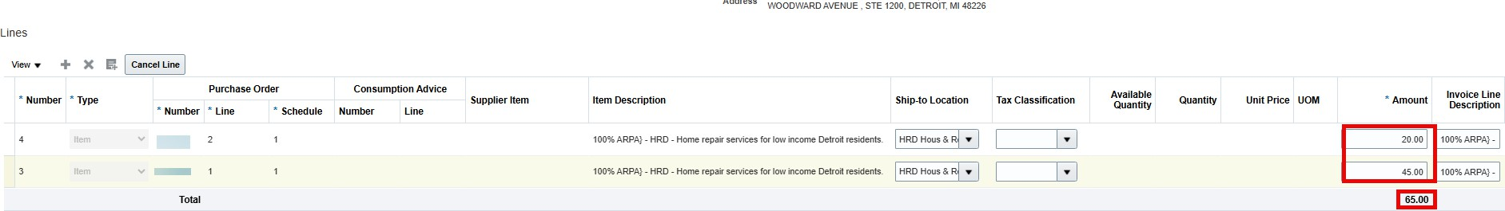

If you invoice for more than the remaining amount, you will receive an error message.
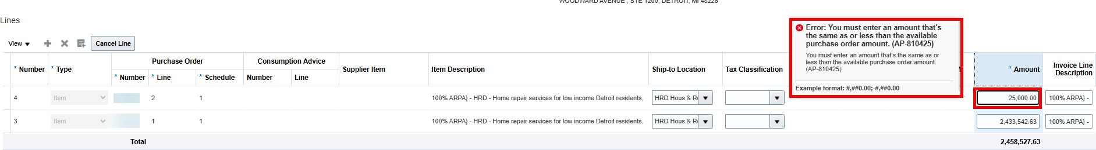

- Scroll to the top and review the invoice for accuracy. Ensure the amounts are correct and all the necessary documentation is attached.
- Select ‘Submit’ in the upper right corner.
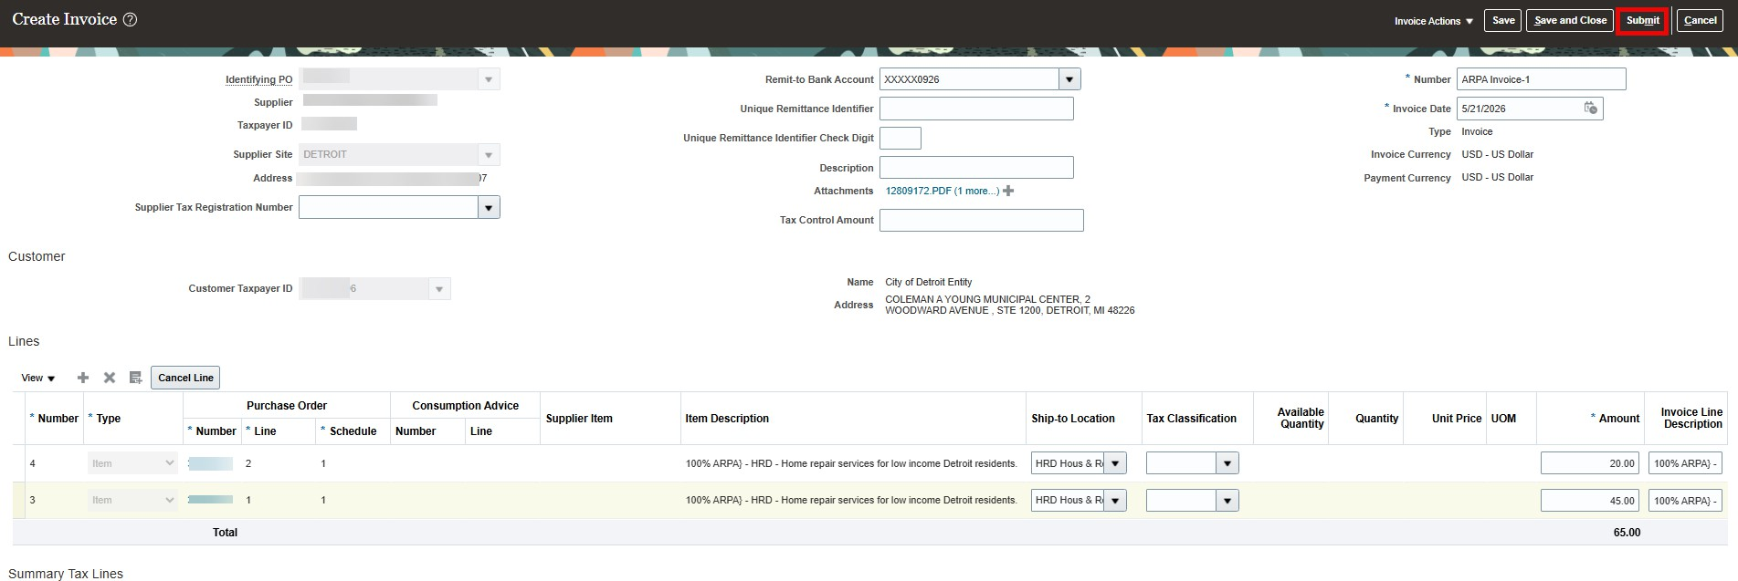
- You will receive a message that your invoice was submitted.
- Select ‘Create Another’ or ‘Done’ if you are ﬁnished. If creating another invoice, repeat the steps above.

- When you are ﬁnished with this session, select the icon in the upper right corner.
- Select ‘Sign Out’.
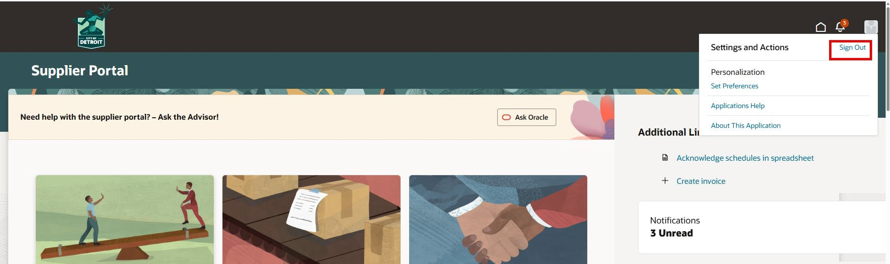

Invoice Review and Approval
When the invoice is submitted, it is sent to several departments for review before it is fully approved. If more information is needed from a reviewer, you will receive a notiﬁcation to provide information. If an invoice is rejected, you will receive an email notiﬁcation and you will need to submit a new invoice. If the invoice is approved, the City will validate the invoice, and payment will be processed according to the payment terms. The sections below provide details for each of these potential outcomes.

Additional Information Needed
During the invoice review, a reviewer may request information from you. You will be notiﬁed
in Oracle.
- Select the notiﬁcation bell and then select the blue hyperlink in the ‘INFORMATION REQUESTED’ notiﬁcation.
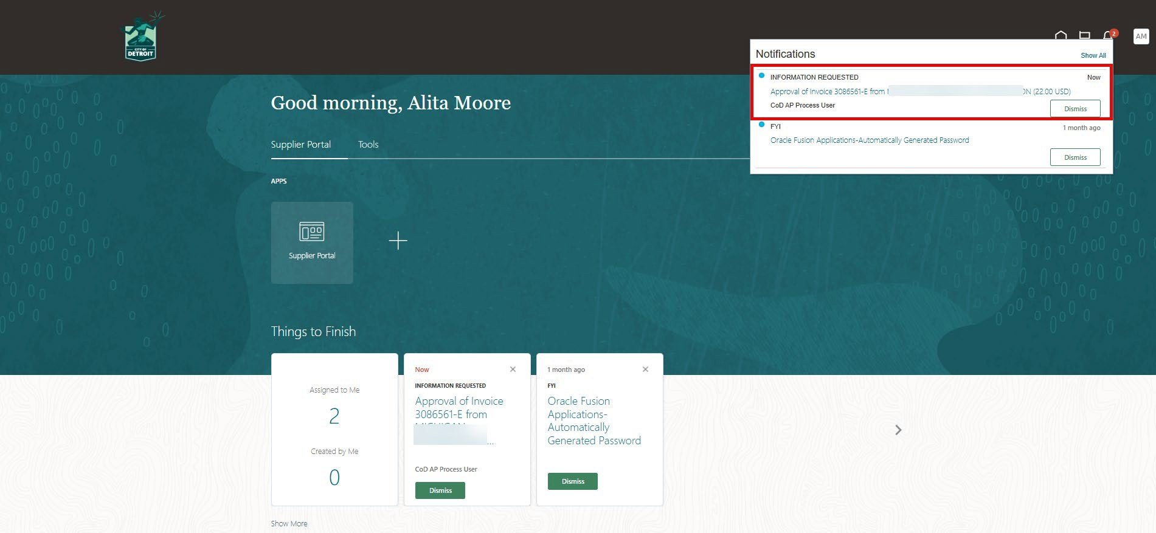

Notiﬁcations will only remain on your home screen for a few days. If you have not logged into Oracle for a while, it is a good idea to look for notiﬁcations in your worklist following this process. You should also check your worklist periodically to ensure there are no notiﬁcations waiting for your response.

- Select the drop down arrow next to Actions.
- Click on ‘Submit Information’
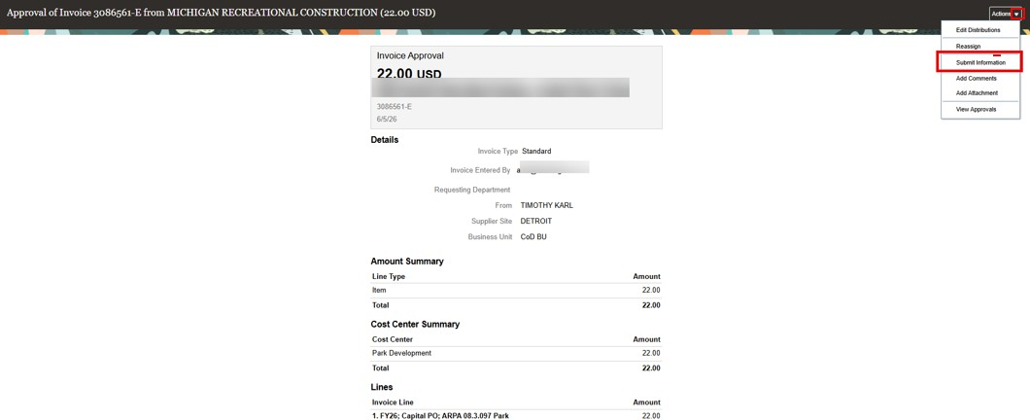

- Review the Requested Information ﬁeld
- Add a comment (required)
- Add an attachment, if required.
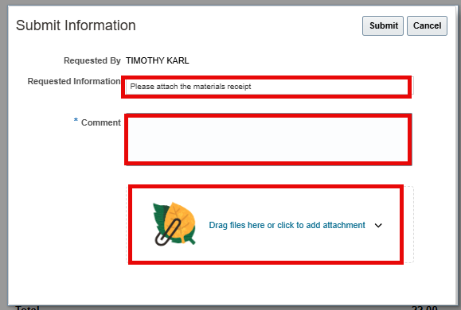

- Click “Submit”. The information will be returned to the person who requested it. You
will not receive conﬁrmation that the information was submitted.
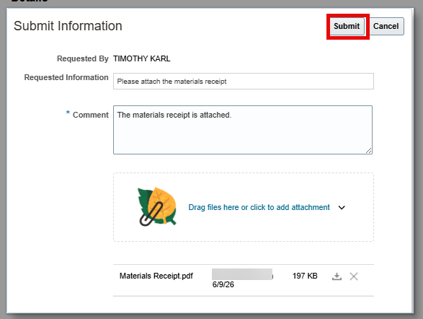

- The Information Requested notiﬁcation will only remain on your home screen for a few days.
- If you receive a request for information and you have not responded in 3 days, you will receive an email notiﬁcation as shown below. You will receive this notiﬁcation daily until you respond.
- Select the hyperlink. The Submit Information screen will appear. (You may be asked to log into Oracle if you are not logged in). If needed, instructions for responding are attached to the email.
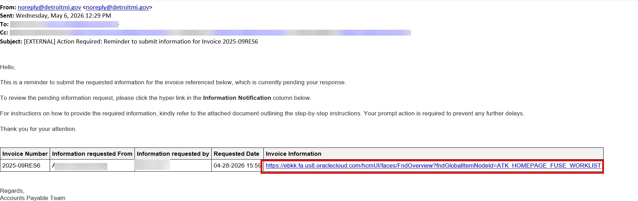

Rejected Invoice
- If an invoice is rejected, you will receive an email notiﬁcation as shown below. It will list invoices rejected and provide the information in the columns. You will not receive notiﬁcation in Oracle.
- Review the rejection comments and select the link to Attachments (if provided).
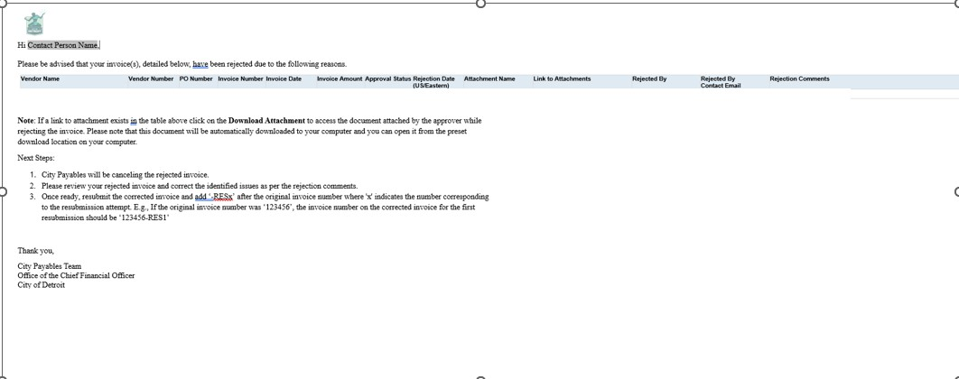
- Once the reason for rejection is understood, prepare and submit a new invoice following the steps in this section. Use the original invoice number followed by a ‘-RESx’ where ‘x’ indicates the number for corresponding to the resubmission attempt. For example, if the original invoice number was ‘123456’, the invoice number for the ﬁrst corrected invoice should be ‘123456-RES1’. The second time the invoice number would be ‘123456-2’ and so on.

Approved Invoice
When an invoice is approved, it is validated and sent to Accounts Payable (AP) for processing payments. You will not receive an email notiﬁcation when it is approved. Refer to the View Invoices section below to check the status of your invoices.

Key Considerations

  - It is recommended to upload the invoice and the supporting information speciﬁc to that invoice as separate attachments, so the information is better organized for approvers to conﬁrm, thereby avoiding any delay in approval.
  - If you have submitted multiple invoices for the same PO and there are issues with any one of the invoices, it can potentially hold and prevent other invoices from being paid. It is important that the supporting information for each invoice is clear and pertains to that invoice only.
  - Invoices resubmitted should use the original invoice number and “-RESx” where ‘x’
indicates the number for additional resubmission attempt.
  - Remember to contact your ARPA departmental contact in case of any issues or questions with the process.

View Invoices
The View Invoices option will allow you to check the status of invoices.
- To view submitted invoices and their status, click on the “Invoices” tile on the supplier portal landing page.
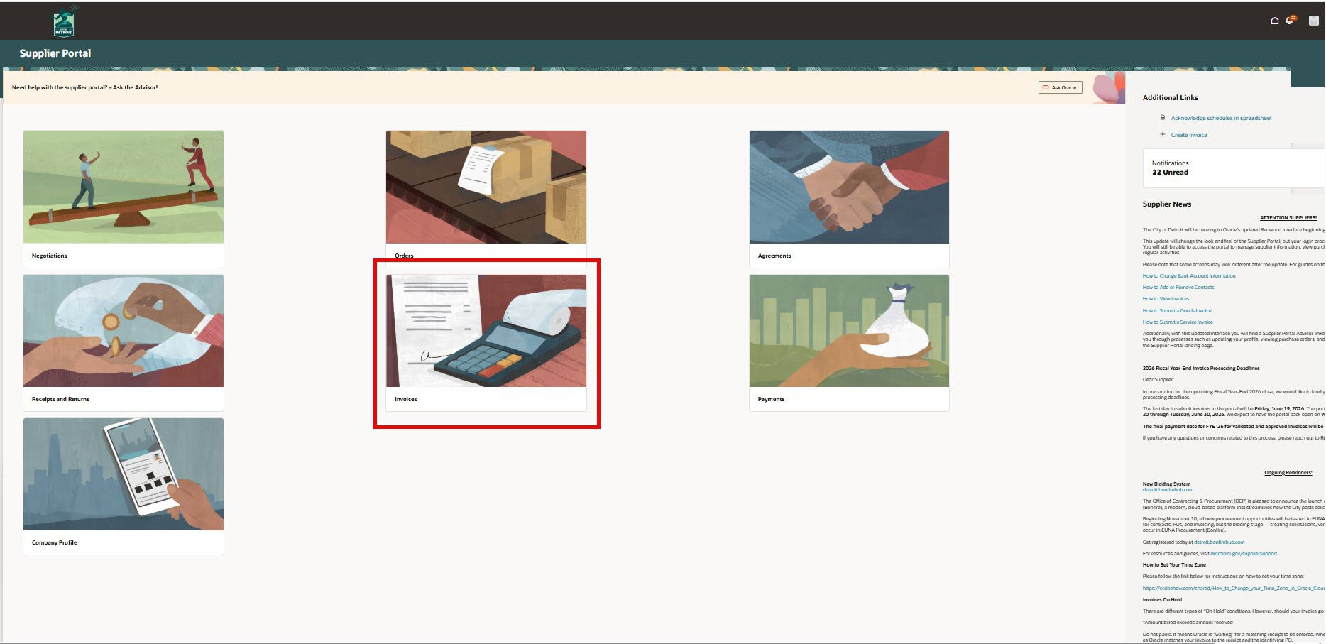

- You can search by one or multiple ﬁelds. At least one of the starred (**) ﬁelds needs to be used. Supplier name is used in this example. Start Typing your Supplier Name (minimum 3 characters)
- Select the down arrow and select your name from the list.
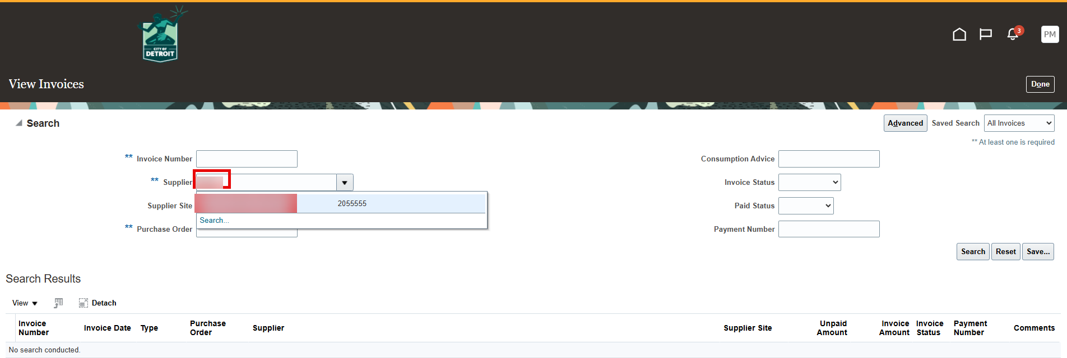

- Select ‘Search’
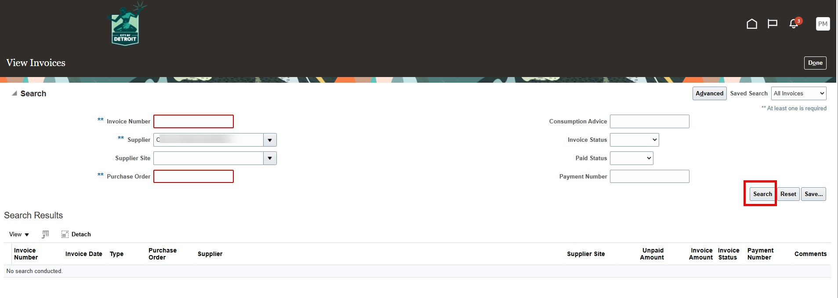
- Invoices that meet your search criteria will be listed. To add columns, select the down arrow next to View.
- Click on the side arrow next to Columns and check the columns to add. For
example, “Paid Status”. You can also uncheck columns to remove them.
- These settings will remain for future invoice searches.
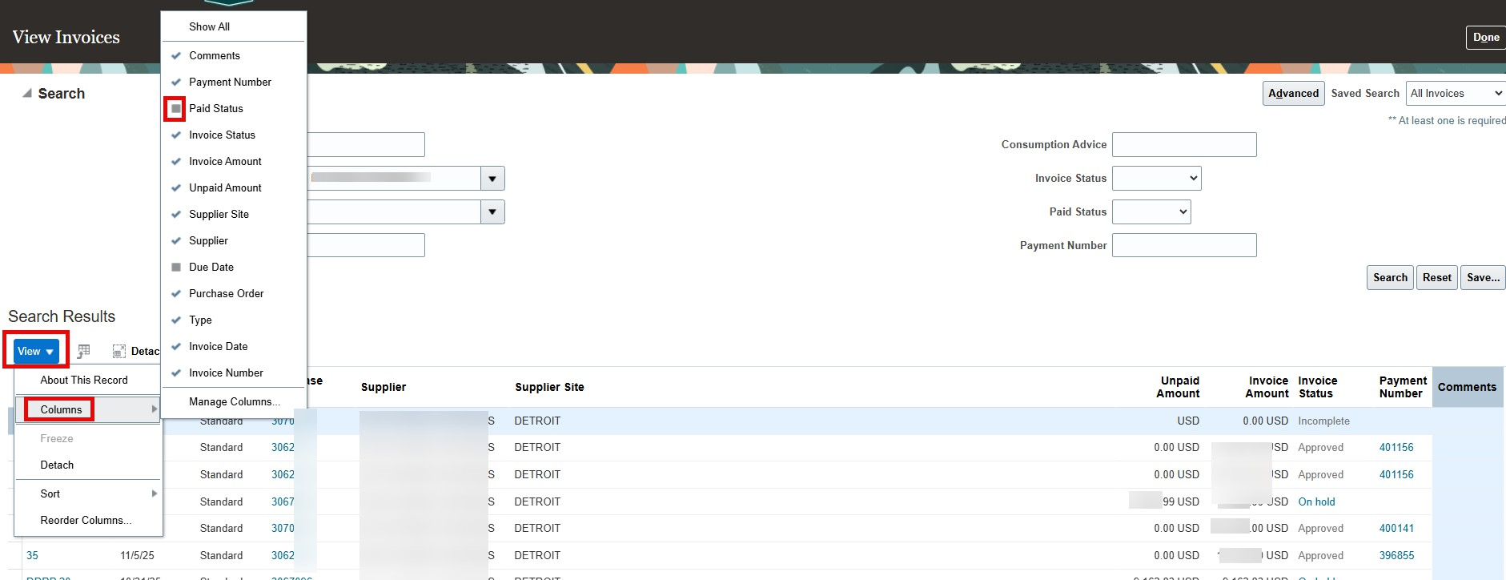

- Review the information.
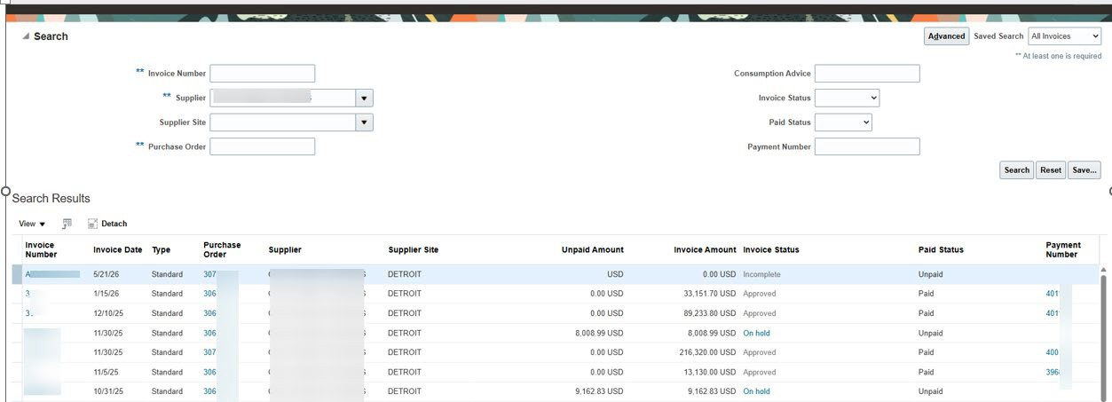

To understand Invoice Status, refer to the table below. This is the list of potential Invoice Status Values.

Status | Description
Approved | The invoice is approved and the City is working to  validate and pay the invoice.
Canceled | The invoice was canceled by the supplier before it  was submitted, or it was canceled by the City.
In process | The invoice was submitted and is in the approval  process.
Incomplete | The supplier started creating the invoice and saved  it but did not submit it
On hold | The invoice is on hold. See explanation here.
Rejected | The invoice was rejected by the City.

Invoice Holds
“On Hold” means the system is waiting for the City to complete required steps (for example, receipt of goods or services against a purchase order) so the invoice can ﬁnish validation. It is not an error. Once the City completes the required items and the invoice validates, the hold will be removed, and the payment will be issued according to the invoice payment terms. You do not need to take action unless Accounts Payable asks for additional information or documentation.

If the invoice stays on hold for a long time:
  - Contact Accounts Payable for help at APInvoice@detroitmi.gov
  - When you contact them, include the invoice number, PO number, invoice date, and any supporting documents to help speed resolution.

Invoice Payment
An invoice is paid according to payment terms in the purchase order and is paid once the invoice is validated. To validate an invoice, the City veriﬁes the goods or services that have been received according to the purchase order terms.
Contact Accounts payable at APInvoice@detroitmi.gov if the goods or services have been provided and the payment date is past due according to the terms in the purchase order.

Supplier Support

Using the Supplier Portal Advisor
The supplier portal advisor is available to answer your questions regarding the Oracle process, and it is easy to use. It is recommended you open an additional tab to use the Advisor. This way you will not need to navigate away from the current Oracle page to ask questions.
- Right Click on the tab for the current page.
- Select “Duplicate”.
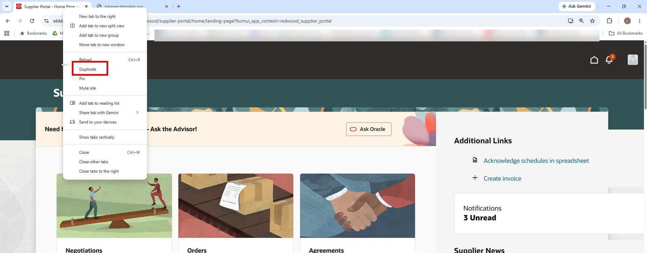

- A new tab will open. There will now be two tabs at the top of your screen for the Supplier Portal. Use the new tab for querying the Advisor. If you are not on the home screen, navigate to it.
- Select “Ask Oracle”.

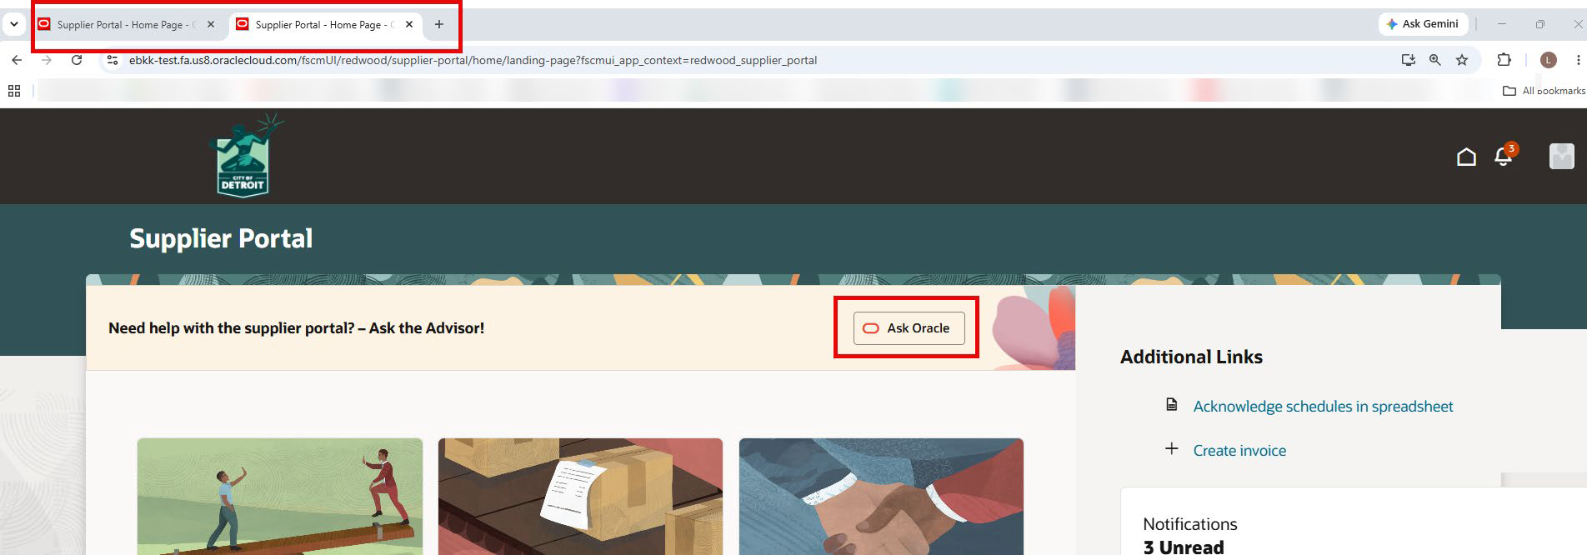

- You can select one of the predeﬁned questions or enter a question in the “Ask Oracle” section.
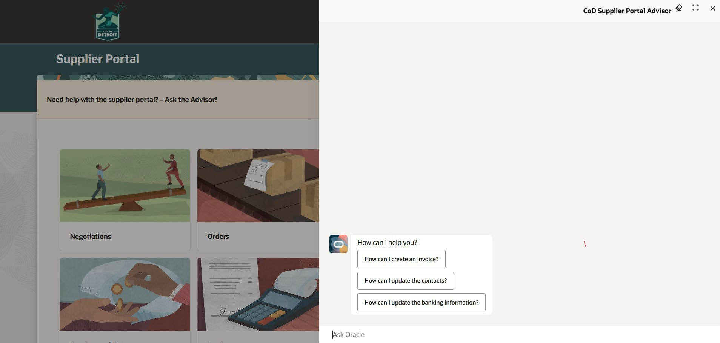

- Select a question or enter your own question. If you enter your own question, hit
‘Enter’ on your keyboard or click the up arrow.
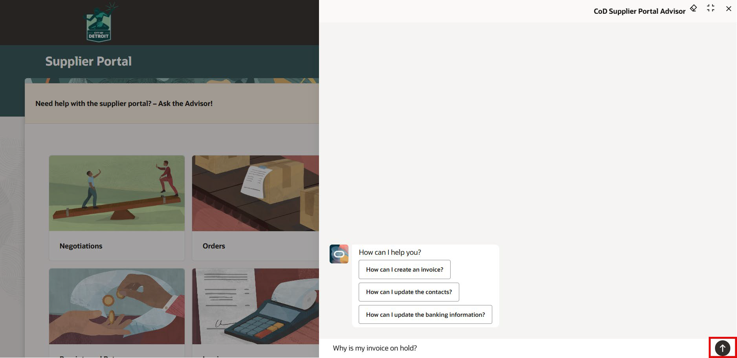

- Oracle will search for the answer by showing the three dots.
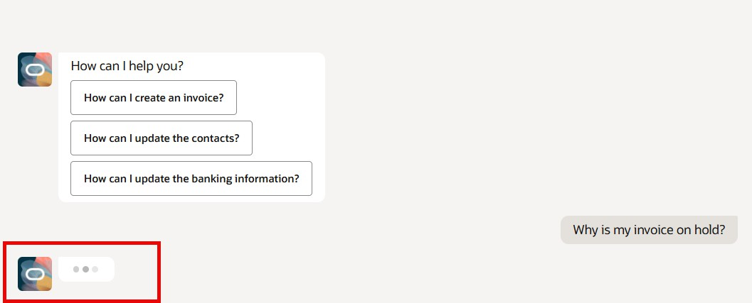

- Review the answer returned.
- Use the “Ask Oracle” ﬁeld to ask another question, if needed.

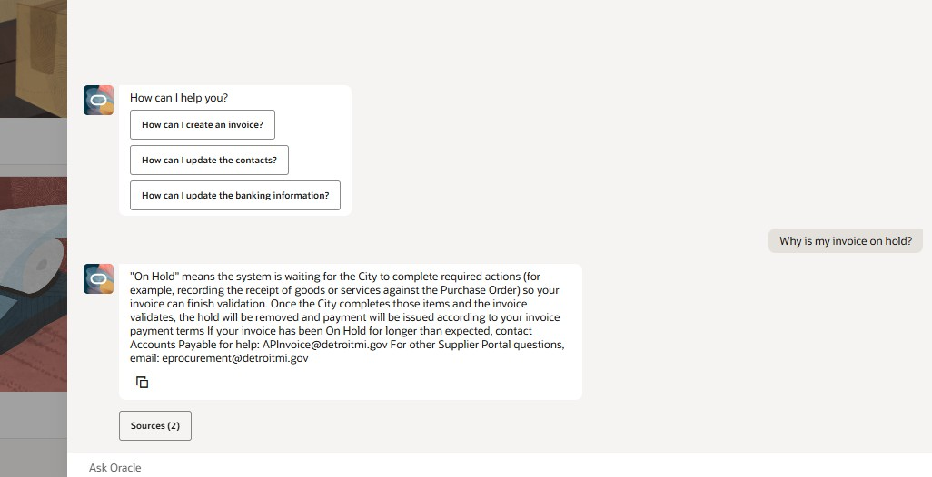

- To return to your Oracle task, select the original Supplier Portal Tab. Keep the
duplicate tab open in case you have more questions for the Supplier Portal Advisor.

City of Detroit Contacts
If questions remain after using the Supplier Portal Advisor, contact the City for support.
For questions regarding the Supplier Portal including submitting invoices, contact eprocurement@detroitmi.gov
For questions on receipts and payments, contact APInvoice@detroitmi.gov
For questions regarding the ARPA process, contact your departmental representative or, Jo Robinson, ARPA Agency CFO
Email: JoRobinson@detroitmi.gov Cell: 313-410-7804

Appendix

Locating Notiﬁcations in the Worklist
Notiﬁcations may no longer be on your home screen if you have not logged in for some time. It is recommended that you check your work list for notiﬁcations requiring your attention. To ﬁnd these notiﬁcations:
- Select the notiﬁcation bell.
- Select “Show All”
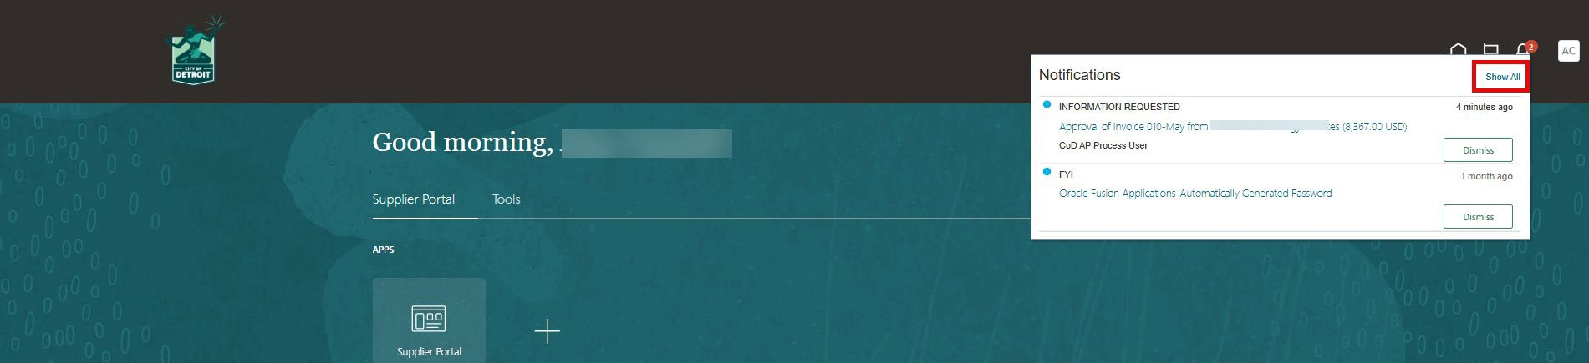
- Select “Worklist”.
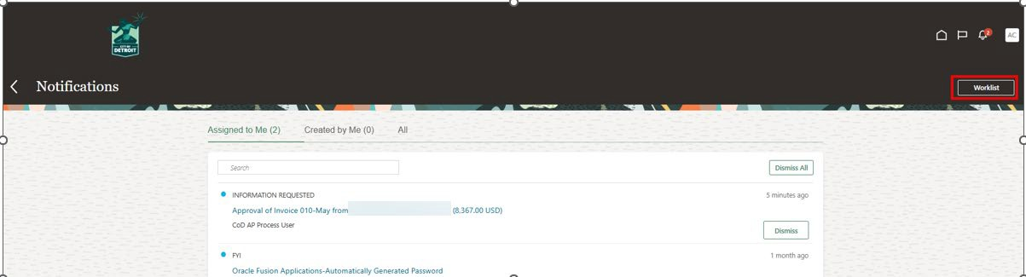

- Select “Assigned” in the ﬁeld shown below.
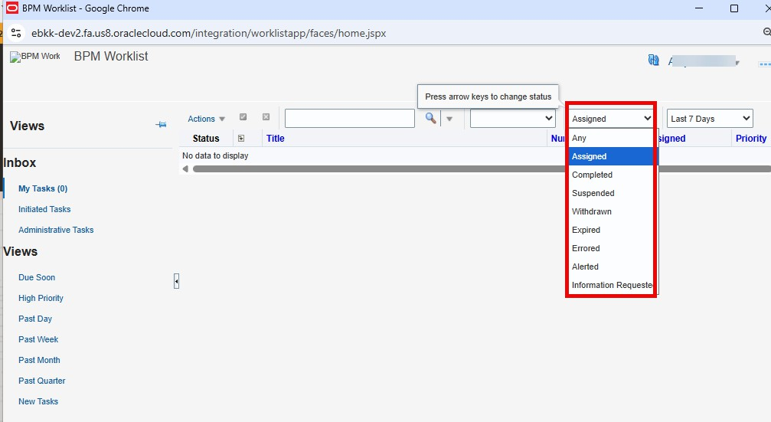

- Select ‘All’ in the ﬁeld shown below.
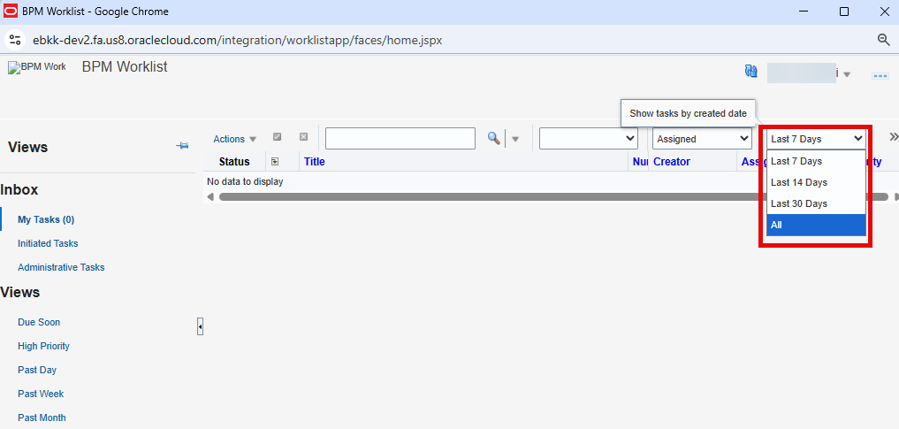

- All notiﬁcations currently assigned to you will be displayed. Select the blue hyperlink to open the notiﬁcation.
- Complete the Action requested using the steps provided in this guide.
