Detroit Department of Transportation (DDOT)
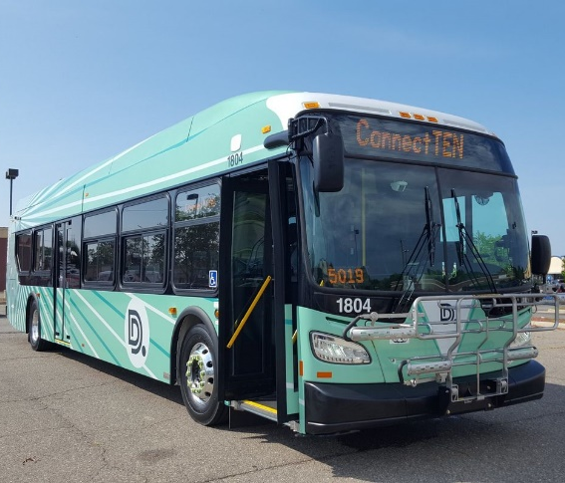
DRUG AND ALCOHOL PROGRAM POLICY
ACKNOWLEDGEMENT OF POLICY ISSUANCE
THIS IS TO CERTIFY THAT THE EMPLOYEE NAMED BELOW HAS RECEIVED THE REQUIRED
2 HOURS OF REASONABLE SUSPICION, EEO, TITLE VI, LEP, and ADA TRAINING,
MATERIALS, AND POLICY.
ISSUED TO:

XXX-XX-
NAME (PLEASE PRINT) SS# (LAST FOUR) ORACLE#/PENSION#

SIGNATURE DATE
DDOT’S Office of Compliance
INSTRUCTORS
Revised May 2023

