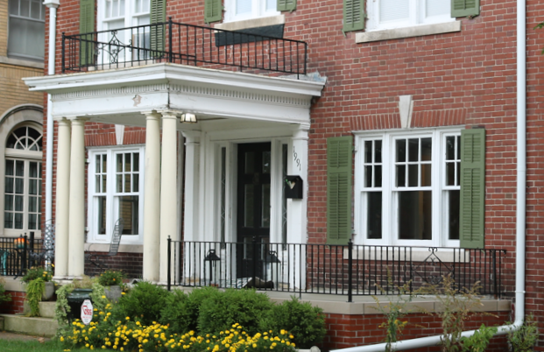

Porches, Decks, and Balconies

Porches

Traditional porches serve as a transitional space between the interior and exterior of the home. As an outdoor gathering space, they serve a social function as well as a domestic one. Historic porches in Detroit may be made of wood—in which case they are always painted and covered for protection from the elements—or of concrete, which may or may not be covered.

Porches are critically important features that define the character and architectural style of a house. As such, historic front porches should always remain unchanged. Porches on side and rear elevations are often less distinctive, and their alteration is sometimes acceptable.

Porch maintenance and repair

Most Detroit porches consist of wood elements that benefit from regular cleaning and painting. Architectural details such as posts, brackets, spindles, fascia, and moldings should be repaired rather than replaced.

As porches are exposed to the elements, however, their components may deteriorate over time. When porch details cannot be feasibly repaired, new elements should be fabricated that precisely match the historic details in dimensions and appearance. Off-the-shelf pieces will rarely be an adequate match. The use of dimensional lumber or decking boards is also rarely appropriate. Further, replacement should be limited to severely deteriorated elements only. Replacement of entire sections of a porch, or entire porches, is usually not necessary.

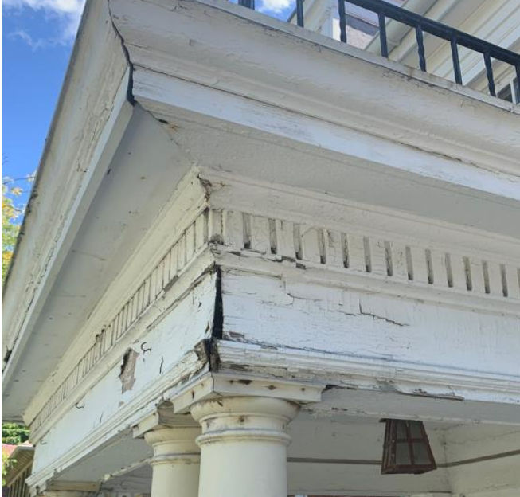
In this example, fastening loose pieces and repainting is the proper course of action. Repairs to integrated gutters and flashing would prevent further deterioration. A few deteriorated details may need to be replaced with matching elements. Removal of large expanses of historic material would not be appropriate.

Alterations and new porches

Relatively small changes to existing porches may be acceptable if the massing (overall shape and size) of the porch remains unchanged and historic materials are not removed. Conjectural features—that is, decorative items that did not exist historically—should never be added. Alterations to existing porches are more acceptable on side and rear elevations.

In some instances, historic porches may be missing entirely. If so, a new porch may be added. The new porch does not have to be a reproduction of the historic porch, but it must be “compatible,” that is, the design should use historic materials and express an architectural style that does not look out of place on the building or in the district.

Decks

An outdoor space for cooking, dining, and entertaining, decks became commonplace after the introduction of pressure-treated lumber in the 1970s. Older examples are very uncommon. This does not mean, however, that a deck cannot be appropriate on a historic house or building. Many examples of compatible decks have been installed within Detroit’s historic districts.

With decks, the key is to design them in such a way that they are not easily mistaken for historic parts of the building and so that, when they are removed in the future, they can be removed without causing damage to the historic building.

Decks should also not damage or block from view any historic porches or entrances or decorative architectural features, or interrupt important outdoor spaces such as gardens, front lawns, or mature trees. Almost always, the appropriate location for a deck is in the rear yard of a house.

Rooftop decks are also sometimes constructed on top of flat-roofed, commercial or apartment buildings. These are generally acceptable in historic districts if they are set back several feet from the edge of the roof so that they are not easily visible from the street. Likewise, any canopies, lighting, or outdoor furniture should also be placed where it is not easily seen.

Balconies

Like porches, balconies are important historic features that should remain unchanged.

Historic railings usually sit at approximately the same height as the adjacent windowsills, generally about 30 inches from the floor. This is noticeably shorter than the 36 inches found on new construction. Due to the difference in height and appearance, replacing historic railings with new railings is almost never appropriate. Should an increased height be desired, this can be accomplished by adding new material in a manner that does not destroy or hide the historic railing.

Further reading

https://www.nps.gov/orgs/1739/upload/preservation-brief-45-wood-porches.pdf

notes below

“Porches traditionally have been a social gathering place as well as the transition area between exterior and interior.”

https://www.aldmn.com/what-exactly-is-the-difference-between-a-deck-and-a-porch

Deck guidelines from Holland

https://www.cityofholland.com/DocumentCenter/View/407/Holland-Historic-District-Design-Guidelines-PDF

19th century uncovered deck
https://www.shconstruction.com/builders-notebook/historic-victorian-porch-or-modern-deck-which-is-it/

