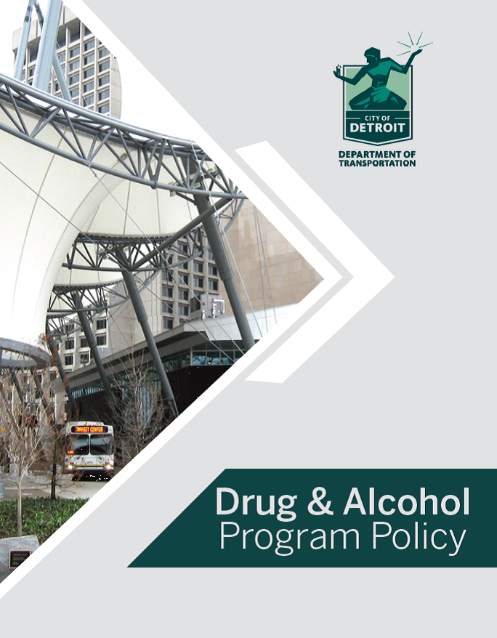
Effective Date: July 1, 2023
TABLE OF CONTENTS

TOPIC PAGE #

Policy Adoption 3
Drug-Free Workplace Act of 1988 Policy Statement 4
Policy Statement 5
Policy Applicability 5
Definitions 6
Prohibited Substances 9
Prohibited Behavior 10
Zero Tolerance 10
Consequences for Violations 11
Required Hours of Testing 13
Testing Procedures 13
Dilute Specimen 19
Legally Prescribed & Over the Counter Drugs (OTC) 19
Searches 19
SAP Employment Assessment 19
MRO Verification Process 20
Right to Examine Records 21
Substance Abuse and Reasonable Suspicion Training 21
Future Changes & Modifications 21
Contractor Compliance 22
DDOT Contact Person 22
Attachments

Substance Abuse Program Affiliates 23
Safety-Sensitive Classifications Positions 25
Acknowledgement of Policy Issuance 26

DRUG AND ALCOHOL PROGRAM
POLICY ADOPTION
The Detroit Department of Transportation (DDOT) strives for excellence in providing public transit services that are reliable, customer-focused, and safe and secure for all users.

This policy was established in order to comply with the ‘Drug-Free Workplace Act of 1988’, the Omnibus Transportation Employee Testing Act of 1991”, and the Federal Transit Administration (FTA) regulations. It applies to all DDOT employees.

The Department will provide employees with a copy of the Drug and Alcohol Program Policy. This policy will be applied consistently and justly throughout the Department.

It is the Department’s foremost objective to provide the most efficient transportation services possible and maintain a model work environment for its employees. With the total cooperation and commitment from all employees at DDOT, we can attain these objectives and take pride in our accomplishments.

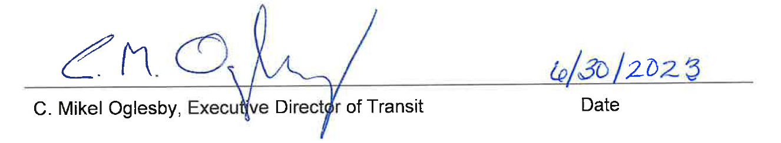

Date Adopted: 07/01/2023

Last Revised: 07/01/2018

DRUG-FREE WORKPLACE ACT (DFWA)
POLICY STATEMENT

The Detroit Department of Transportation (DDOT) requires the workplace to be drug-free. Therefore, the term of this policy is a condition of employment for all DDOT employees (Safety-Sensitive and Non-Safety-Sensitive). Under the requirements of this law, the Department must assure the following:

- The workplace is drug-free

- The unlawful manufacture, distribution, dispensation, possession or use of a controlled substance is prohibited in the workplace.

- An employee who is convicted of any criminal drug statute for a violation occurring in the workplace shall notify their employer no later than five (5) days after conviction.

- Employees shall abide by the terms of the policy statement as a condition of employment.

The above policy can be amended at any time according to FTA regulations
Date Adopted: 07/01/2023

Last Revised: 07/01/2018
POLICY STATEMENT
The purpose of the Detroit Department of Transportation (DDOT) policy is to ensure worker fitness for duty and to protect employees, passengers, and the public from the risks posted by the misuse of alcohol and use of prohibited drugs. We and our affiliates (See pages 23-24) consider this to be of primary importance.

This policy complies with all applicable federal regulations governing workplace anti-drug and alcohol misuse programs in the transit industry which includes 49 CFR Part 655, as amended and 49 CFR Part 40, as amended. In addition, 49 CFR Part 29, “The Drug-Free Workplace Act of 1988,” requires the establishment of drug-free workplace policies and the reporting of certain drug-related offenses to the Federal Transit Administration (FTA).

Portions of this policy are not FTA mandated but reflect the City of Detroit Department of Transportation’s policy. These additional provisions are identified by underline.

POLICY APPLICABILITY

This policy applies to all employees and contractors on DDOT property and/or when performing any transit related safety-sensitive or non-safety-sensitive business. This policy also includes employees scheduled to return to work, during off-site lunch periods and/or breaks. In addition, visitors, vendors, and contract employees are governed by this policy while on DDOT premises and will not be permitted to conduct DDOT related business if found to be in violation of this policy.

Employees who perform “safety-sensitive functions” for DDOT are subject to random drug and alcohol testing and all other unique requirements set forth in this policy.

Pursuant to 49 CFR Part 655, Section 655.4, a safety-sensitive function occurs when an employee is performing, ready to perform or immediately available to perform any duties related to the operation of mass transit services. The following are considered safety-sensitive functions:

- Operating a revenue service vehicle, in or out of revenue service
- Operating a non-revenue vehicle requiring a commercial driver’s license
- Controlling movement or dispatch of a revenue service vehicle
- Maintain (including repairs, overhaul and rebuilding) of a revenue service vehicle or equipment used in revenue service
- Carrying a firearm for security purposes

The City of Detroit Human Resources Department and DDOT management evaluated all job classifications and determined which positions perform safety-sensitive functions. A listing of safety-sensitive positions is included in this policy. All new classifications will be assessed to determine if it is to be categorized as safety-sensitive. For non-safety-sensitive employees only a portion of this policy will apply, and these will be noted.
DEFINITIONS

Adulterated specimen - A specimen that has been altered, as evidenced by test results showing either a substance that is not a normal constituent for that type of specimen or showing an abnormal concentration of an endogenous substance.

Alcohol - The intoxicating agent in beverage alcohol, ethyl alcohol or other low molecular weight alcohols including methyl or isopropyl alcohol. This agent can cause impaired judgment, reduced reaction time, lack of control and coordination, personality changes, and impeded vision.

Alcohol Positive Test - Any result performed by a certified Breath Alcohol
Technician (BAT) using an Evidential Breath Testing Device (EBT) that indicates on the confirmation test a result of 0.04% or more Breath Alcohol Concentration (BAC).

Board Certified – Medical approval by either the American Board of Urology or the American Board of Nephrology is required in processing shy bladder occurrences.

Canceled Test - A drug or alcohol test that has been declared invalid. A canceled test is neither Negative nor Positive. In the case of Pre-Employment, Return-To-Duty, and Follow-Up tests, the employee must be retested.

Confirmatory Test. (Drug Testing) - A second analytical procedure performed on a different aliquot of the original specimen to identify and quantify the presence of a specific drug or drug metabolite. (Alcohol Testing) - A second test that provides quantitative data of alcohol concentration. Its amount becomes the determining result-on-record.

Consortium – A service agent who coordinates a variety of drug and alcohol testing services for DDOT. These include monthly random selections; annual preparation of initial Management Information System (MIS) statistics; daily test result reporting; test recordkeeping to mention a few. These services must comply with FTA regulations.

Controlled Substance - Any illegal drug or a prescription drug that has not been
prescribed for the individual being tested for a condition under current treatment.

Creatinine – A breakdown or waste product of creatinine, which is an important part of muscle tissue.

Department - The Detroit Department of Transportation (DDOT)

Department Premises - Includes, but is not limited to, all property whether owned or leased or used by the Department. For the purpose of this policy, it also includes any other locations or modes of transportation to and from those locations while in the course and scope of employment.
Designated Employer Representative (DER) – An employee authorized by the employer to take immediate action(s) to remove employees from safety-sensitive duties, or cause employees to be removed from these covered duties, and to make required decisions in the testing and evaluation processes. The DER also receives test results and other communications for the employer, consistent with the requirements of the FTA regulations.

DHHS – U.S. Department of Health and Human Services

Dilute Specimen – A urine sample having creatinine and specific gravity values that are lower than expected for human urine.

Disabling Damage – Damage that prevents departure of any vehicle from the scene of the occurrence in its usual manner in daylight after simple repairs. It includes damage to vehicles that could have operated but would have been further damaged because they were operated. It does NOT include damage which can be temporarily remedied at the scene without special tools or parts; tire disablement (i.e., a flat or blowout) even if no spare is available; or damage to headlights, taillights, turn signal, horn, mirrors (unless totally unusable) or windshield wipers that makes them inoperable) and is transported away from the scene by a tow truck or other vehicle.)

Driver - Any employee operating a City of Detroit vehicle.

Drug and Alcohol Program Manager (DAPM) – An individual responsible for the implementation of the drug and alcohol testing program.

Drug Metabolite - The specific substance produced when the human body metabolizes a given prohibited drug as it passes through the body and is excreted in urine.

Drug Positive Test - The result reported by a DHHS-certified laboratory when a specimen contains a drug or drug metabolite equal to or greater than the cutoff concentrations.

Employee Assistance Committee (EAC) – A group of volunteers DDOT employees who, informally, provide assistance and support to other employees who are experiencing personal difficulties. Substance abuse being one of those difficulty areas.

Employee Assistance Program (EAP) - A voluntary, confidential service providing professional counseling and referral services designed to assist Department employees and their families with personal or family-related problems.
Evidentiary Breath Testing Device (EBT) – A piece of clinical equipment approved by NHTSA for the testing of breath at the 0.02 and 0.04 levels of alcohol concentration.

FTA – Federal Transit Administration.

Initial Drug Test (also known as a ‘‘Screening drug test’’) - The test used to differentiate a negative specimen from one that requires further testing for drugs or drug metabolites.

Invalid Drug Test - The result reported by a DHHS-certified laboratory in accordance with the criteria established by DHHS Mandatory Guidelines when a positive, negative, adulterated, or substituted result cannot be established for a specific drug or specimen validity test.

Laboratory - Any U.S. laboratory certified by DHHS under the National Laboratory Certification Program as meeting the minimum standards of Subpart C of the DHHS Mandatory Guidelines for Federal Workplace Drug Testing Programs; or, in the case of foreign laboratories, a laboratory approved for participation by DOT under this part.

Medical Review Officer (MRO) – Receives laboratory confirmed urine drug test results; determine whether there is a legitimate medical explanation for a laboratory-confirmed positive, adulterated, or substituted result; and review and report a verified result to the
employer in a timely and confidential manner.

Metabolite –The specific substance produced when the human body metabolizes a given prohibited drug as it passes through the body and is excreted as urine.

Negative Drug Result - The result reported by a DHHS-certified laboratory to an MRO when a specimen contains no drug, or the concentration of the drug is less than the cutoff concentration for the drug or drug class and the specimen is a valid specimen.

Positive Drug Result - The result reported by a DHHS-certified laboratory when a specimen contains a drug or drug metabolite equal to or greater than the cutoff concentrations.

Possession – The act of owning, having, or controlling alcohol or any substance prohibited in this policy. It includes any prohibited or controlled substance concealed on Department property.

Revenue Service Vehicle - Any vehicle picking up passengers and/or involved in fare collection.
Safety-Sensitive Function – A position in which a momentary loss of concentration, cognition, motor coordination, or spatial or temporal orientation can lead to severe injury, death to self or others or substantial property loss. See the five FTA categories cited on page 5. See page 25 for a listing of our Safety-Sensitive positions.

Shy Bladder - A medical condition known as “paruresis.” Paruresis is defined as a chronic, persistent fear of urinating in a public restroom. In its most severe form, an individual cannot urinate under any circumstances away from home. In this policy, it refers to any physical or psychological condition in which an employee is unable to pass a sufficient specimen.

Split Specimen Collection - A collection in which the urine collected is divided into two separate specimen bottles, the primary specimen (Bottle A) and the split specimen (Bottle B).

Substituted Specimen – A urine sample with creatinine and specific gravity values that are so diminished or so divergent that they are not consistent with normal human urine.

Under the Influence - Any amount of controlled substance or alcohol detected in any
specimen greater than the cut-off levels designated by the National Institute for Drug Abuse or established state or federal levels of impairment (an alcohol level of 0.04% BAC or greater).

PROHIBITED SUBSTANCES

Prohibited drugs includes:

- MARIJUANA
- COCAINE
- OPIOIDS
- AMPHETAMINES
- PHENCYCLIDINES (PCP)

All covered employees are prohibited from performing or continuing to perform safety-sensitive functions while having an alcohol concentration of 0.02 or greater.

DDOT may elect to test for other substances as deemed appropriate. Substances tested under the authority of DDOT must be tested as Non-Regulated, under a separate urine specimen and under separate chain of custody forms.

PROHIBITED BEHAVIOR

- Use of illegal drugs is prohibited at all times. All covered employees are prohibited
from reporting for duty or remaining on duty any time there is a quantifiable presence
of a prohibited drug in the body above the minimum thresholds defined in 49 CFR
Part 40.

- All covered employees are prohibited from consuming alcohol while performing
safety-sensitive job functions or while on-call to perform safety-sensitive job
functions. If an on-call employee has consumed alcohol, they must acknowledge
the use of alcohol at the time that they are called to report to duty. If the on-call
employee claims the ability to perform his or her safety-sensitive function, he or she
must take an alcohol test with a result of less than 0.02 prior to performance.

- All covered employees are prohibited from consuming alcohol within four (4) hours prior to the performance of safety-sensitive job functions.

- All covered employees are prohibited from consuming alcohol eight (8) hours following involvement in an accident or until he or she submits to the post-accident drug and alcohol test, whichever occurs first.

- Be in possession of a controlled substance or an intoxicating beverage regardless of its alcoholic content while on duty or operate a vehicle.

- Refuse to test in any manner.

- Fail to inform appropriate Department officials of a reportable accident or ensure that an FTA drug screen and alcohol test is performed as required by the regulations as soon as possible.

ZERO TOLERANCE

Any employee who tests positive for drugs or alcohol (BAC at or above 0.02 will be referred to the Employee Assistance Program, if the BAC is at or above 0.04) or refuses to test will be referred to a Substance Abuse Professional (SAP) and suspended for 29 days pending termination from employment.

CONSEQUENCES FOR VIOLATIONS

The consequence of violating the drug and alcohol testing requirements contained in this policy and mandated by the FTA is an immediate 29-day suspension pending termination.
This will be imposed when an employee:

- Test positive for drugs;
- Has a breath alcohol test with an alcohol concentration of 0.02 - 0.04 or greater;
- Refuses to test in any way. The following thirteen (13) actions are considered to be a “refusal to test”:

- Fail to appear for any test (except a pre-employment test) within a reasonable time, as determined by the Department, after being directed to do so by the Department.

- Fail to remain at the testing site until the testing process is completed. An employee who leaves the testing site before the testing process commences for a pre-employment test has not refused to test.

- Fail to attempt to provide a urine or breath specimen for any drug or alcohol test required by DDOT or FTA regulations for which, after a required medical evaluation has been performed, no adequate medical explanation can be given.

- In the case of a directly observed or monitored collection in a drug collection, fail to permit the observation or monitoring of your provision of a specimen.

- Fail to provide a sufficient quantity of urine or breath without a valid medical explanation.

- Fail or decline to take a second test as directed by the collector or DDOT’s Designated Employer Representative (DER) or Drug and Alcohol Program Manager (DAPM).

- Fail to undergo a medical examination or evaluation, as required by the MRO or DDOT’s Designated Employer Representative (DER) or Drug and Alcohol Program Manager (DAPM) as part of the verification process.

- Fail to cooperate with any part of the testing processes (e.g., refusal to empty pockets when directed by the collector, behaving in a confrontational way that disrupts the collection process) or verbal or written refusal to provide a required urine specimen.
- Fail to remain readily available at the scene of an accident prior to submission to drug or alcohol tests without a legitimate explanation.
- Refuse to sign the certification at Step 2 of the Alcohol Testing Form (ATF).

- Admit to the adulteration or substitution of a specimen to the collector or MRO. If the MRO reports that you have a verified adulterated or substituted test result, you have refused to take a drug test.

- Possess or wear a prosthetic or other device that could be used to interfere with the collection process.

- Refuses to follow the collector’s instruction to raise or lower clothing during an observed collection process.

- Failure to notify the Department of any criminal drug statute conviction within five (5) days.

- DDOT supervisory or managerial personnel fails to properly apply all aspects of this policy in an unbiased and impartial manner.

- Engages in the unlawful manufacture, distribution, possession or use of prohibited substances on Department premises or in transit vehicles, in uniform, or while on Department business.

- Non-safety-sensitive employees who violate Disciplinary Policy and Work Rule Document, Class IV Offences, Rule H, I and J.

- Any employees who have a confirmed alcohol concentration of 0.02 or greater will be immediately suspended for 29 days pending termination, encouraged to seek the assistance of an EAP counselor and be re-tested before being allowed to return to work. If the employee is currently on a Last Chance Agreement, he/she will immediately be terminated.

- An employee who violates the Drug and Alcohol Program Policy for the second time by failing or refusing a drug or alcohol test will be terminated immediately.

All covered employee, who refuses to take a drug and/or alcohol test, will incur the same consequences as testing positive and will be immediately removed from performing safety-sensitive functions and referred to a Substance Abuse Professional (SAP).

REQUIRED HOURS OF TESTING

Required testing hours for drugs are anytime a safety-sensitive or non-safety-sensitive employee is on duty, whether or not the employee may perform covered duties on that shift, or whenever they must be reasonably available for duty (i.e., on call).

Alcohol testing may be performed before, during and just after performing a safety- sensitive or non-safety-sensitive function.

TESTING PROCEDURES

The Department affirms the need to protect individual dignity, privacy and confidentiality throughout the testing process.

All drug testing shall be conducted in a manner to assure the highest degree of accuracy and reliability and using techniques, equipment and laboratory facilities which have been approved by the U.S. Department of Health and Human Services (DHHS). Testing will be conducted consistent with the procedures in 49 CFR Part 40, as amended.

Breath alcohol testing will adhere strictly with the procedures specified in 49 CFR, Part 40, as amended. It will be conducted using a National Highway Traffic Safety Administration (NHTSA) approved Evidential Breath-Testing Device (EBT) operated by a trained Breath Alcohol Technician (BAT).

A. PRE-EMPLOYMENT TESTING

All safety-sensitive applicants shall undergo urine drug testing immediately following the offer of employment or transfer promotion/demotion into a safety-sensitive position. Receipt of a negative drug test by the Department is required prior to employment or a transfer/demotion. Failure to successfully complete a drug or alcohol test will disqualify an applicant for employment.

Safety-sensitive employees who have not been in the random testing pool for 90 days or more and have not performed safety-sensitive functions must be given a Regulated Pre-Employment drug test before he or she can return to a safety-sensitive function.

To be considered for employment, all applicants for safety-sensitive positions will be asked to give consent to the City of Detroit Human Resources Department for a background check of their previous DOT covered employer(s) over the past two years as defined by 49 CFR 40.25. Information requested will include:

      - Alcohol test results of 0.04 or higher alcohol concentration.

      - Verified positive drug results.

      - Refusals to be tested (including verified adulterated or substituted drug tests).

      - Other violations of DOT agency drug and alcohol testing regulations

      - With respect to any employee who violated a DOT drug and alcohol regulation, documentation of the employee’s successful completion of DOT return-to-duty requirements (including follow-up tests)

An applicant who previously tested positive must provide the Department with proof of having successfully completed a referral, evaluation and treatment plan of a certified Substance Abuse Professional (SAP).

An applicant refuses to test only if he/she fails to complete the testing process once it has begun (acceptance of the collection container) and/or when he/she fails to retest after being requested to do so by the Collector, MRO or the DER/DAPM.
B. REASONABLE SUSPICION TESTING

All safety-sensitive and non-safety-sensitive employees will be subject to urine and/or breath alcohol testing when there are reasons to believe that drug or alcohol use is adversely affecting job performance.

A drug and/or alcohol test will be required when a supervisor(s) or other departmental official(s) who are trained in detecting the signs and symptoms of drug use and alcohol misuse has a reasonable suspicion to believe that the employee has used a prohibited drug and/or engaged in alcohol misuse.

The determination that reasonable suspicion exists shall be based on specific, contemporaneous, articulable observations concerning the appearance, behavior, speech, or body odors of the covered employee. Supervisor(s) or other departmental official(s) who are trained in detecting the signs and symptoms of drug use and alcohol misuse must make the required observations. DDOT would prefer that there be one additional observer to verify the observations.

If an alcohol test required by Reasonable Suspicion is not administered within two hours following the determination, the determining supervisor(s) or other departmental official(s) shall prepare and maintain on file a record stating the reasons the alcohol test was not promptly administered. If an alcohol test is not administered within eight hours following the determination, attempts to administer an alcohol test shall cease and the record shall contain the reasons for not administering the test.

If an employee acknowledges alcohol use prior to coming to work but claims to have the ability to do the work, he/she must be tested.

Non-Regulated Reasonable Suspicion Testing shall occur under DDOT authority in situations involving non-safety-sensitive employees.

All training and documentation requirements that are listed above for FTA authorized Reasonable Suspicion testing also apply to non-safety-sensitive employee testing.

C. POST-ACCIDENT TESTING

The FTA regulations 49 CFR Part 655 requires drug and alcohol testing of covered employees in the following situations:

Fatal Accidents
As soon as practicable following an accident involving the loss of a human life, drug and alcohol tests will be conducted on each surviving covered employee operating the public transportation vehicle at the time of the accident. In addition, any other covered employee whose performance could have contributed to the accident, as determined by DDOT using the best information available at the time of the decision, will be tested.

Non-Fatal Accidents
As soon as practicable following an accident not involving the loss of a human life, drug and alcohol tests will be conducted on each covered employee operating the public transportation vehicle at the time of the accident if at least one of the following conditions are met:

- The accident results in injuries requiring immediate medical treatment away from the scene unless the covered employee can be completely discounted as a contributing factor to the accident.

- One or more vehicles incurs disabling damage and must be towed away from the scene unless the covered employee can be completely discounted as a contributing factor to the accident.

- The vehicle is a rail car, trolley car, bus, or vessel, and is removed from operation, unless the covered employee can be completely discounted as a contributing factor to the accident.

All safety-sensitive and non-safety-sensitive employees will be required to undergo urine and breath testing if they are involved in an accident with a Department vehicle (regardless of whether or not the vehicle is in revenue service) that results in a fatality. This includes all surviving employees who could have contributed to the accident.

All safety-sensitive and non-safety-sensitive employees involved in a non-fatal accident will be tested for drug and alcohol unless their performance can be completely discounted as a contributing factor based on the best information available at the time of the decision.

All safety-sensitive and non-safety-sensitive employees whose performance could also have contributed to the accident, based on the best information available at the time of the decision, will also be tested for the presence of drugs and alcohol.

Following an accident, the Department will attempt to complete an alcohol test within 2 hours of the accident. If not able to obtain the test within 2 hours, file a written report as to why they were not able to test and continue attempts to obtain the specimen. If they are not able to obtain the specimen in 8 hours, cease attempts to obtain the specimen and update the 2-hour written report. The safety-sensitive or non-safety-sensitive employee will be drug tested as soon as possible, but not to exceed thirty-two (32) hours for drug testing. If not able to obtain drug testing within 32 hours a written report must explain the reason for not testing earlier.

Any safety-sensitive or non-safety-sensitive employee who leaves the scene of the accident without justifiable explanation prior to submission to drug and alcohol testing will be considered to have refused the test. All employees involved in this process MUST be readily available for testing. The Department representative MUST, at all times, be aware of their location.

Employees tested under this provision will include not only the operations personnel, but any other covered employees whose performance could have contributed to the accident.

If a decision is made that no testing will occur, the decision-maker MUST document it.

The results of a blood, urine or saliva test conducted by Federal, State or Local officials that have independent authority can be used by the Department ONLY IF FTA testing was not possible in the specified time limits (drug test within 32 hours; alcohol test within 8 hours)

Nothing in the above section shall delay necessary medical attention for the injured following an accident or to prohibit a covered employee from leaving the scene of an accident for the period necessary to obtain assistance in responding to the accident or to obtain necessary emergency medical care.

Non-Regulated Post-Accident testing will occur under DDOT authority. It will be done for all non-bus vehicular accidents involving non-safety-sensitive operators. It will also be done in situations where the accident fails to meet the FTA Post Accident testing criteria

All test time limits and documentation requirements that are listed above for Post-Accident Testing (FTA) shall also apply to non-safety-sensitive employee testing.

D. RANDOM TESTING

Employees in safety-sensitive positions will be subject to random, unannounced, and unpredictable testing and the dates for administering random tests are spread throughout the calendar year. Random testing will be conducted at all times of the day when safety-sensitive functions are performed.

The selection of employees for random drug/alcohol testing will be made using a scientifically valid method that ensures each covered employee will have an equal chance of being selected each time selections are made.

Random testing shall be immediate. Employees are required to submit for testing upon notification and have little opportunity to circumvent the testing procedures.

Federal regulations require the Department to randomly test a minimum of 50% of the safety-sensitive workforce for drugs and, as of, January 2019 and 10% of the safety-sensitive workforce for alcohol.

E. 30-DAY TESTING

Non-Regulated drug testing is required for all safety-sensitive-employees who are returning to work after an absence of thirty (30) days or more.

It is also required that all employees (safety-sensitive and non-safety-sensitive) whose medical release form diagnosis indicates an employee was absent due to participation in a voluntary drug or alcohol rehabilitation program. Drug and/or alcohol testing will be performed.
F. RETURN-TO-DUTY TESTING
An employee who returns to the performance of any safety-sensitive position is required to go through the return-to-duty process. The Return-to-Duty process allows an employee to remain employed and to return pending the fulfillment of an evaluation by an SAP, the completion of the SAP’s prescribed treatment, and the receipt of a negative observed return-to-duty drug and alcohol test and placement into a follow-up testing program (Last Chance Agreement).
The purpose of the return-to-duty test and the evaluation of an individual’s return-to-duty status by the SAP is to provide some degree of assurance to the employer that the individual is presently free of alcohol and/or any prohibited drugs and is able to return to work without undue concern about continued substance abuse.
No one, except the SAP who made the initial evaluation, can change the SAP’s initial evaluation or recommendations. An employee cannot use a “second opinion” to modify either of them.
All return-to-duty testing will be observed collections.
Non-Regulated Return to Duty testing will occur under DDOT authority. This testing is required for all safety-sensitive employees who are returning to work of any absence of thirty (30) days or more.
G. FOLLOW-UP TESTING

Safety-sensitive employees shall be required to undergo frequent unannounced urine and/or breathe alcohol testing following their return-to-duty. The follow-up testing will be performed for a period of twelve (12) months up to sixty (60) months with a minimum of six (6) tests to be performed the first year.

Testing months are not “calendar months;” the requirements will be adjusted for breaks in service.

Cancelled tests cannot be counted as completed tests; they must be recollected.

All follow up testing will be observed collections.

H. EMPLOYEE REQUESTED TESTING (Split Tests)

Any safety-sensitive or non-safety-sensitive employee who questions the results of a required drug test may request that an additional test be conducted. This test must be conducted at a different testing DHHS Certified laboratory. The test must be conducted on the split sample that was provided by the employee at the time the original sample was collected.

DILUTE SPECIMEN

DILUTE-POSITIVE: If the MRO reports a specimen as Positive-Dilute the test will be deemed as a positive test. No additional testing will be administered.

DILUTE-NEGATIVE: When a specimen is reported to DDOT as being Negative-Dilute by the MRO, the employee will be required to take ANOTHER (observed or unobserved, as specified by the MRO) TEST IMMEDIATELY. The result of the second test will be the result on record. If the second test is also a Negative-Dilute, there cannot be a third test.
LEGALLY PRESCRIBED & OVER THE COUNTER DRUGS (OTC)

The appropriate use of legally prescribed drugs and over the counter (OTC) medications are not prohibited. However, the use of any substance that carries a warning label which indicates mental functioning, motor skills or judgment may be adversely affected shall be reported to the Human Resources - Employee Services Department and medical advice must be sought by the employee, as appropriate, before performing work-related duties. The Department of Transportation’s Drug and Alcohol Testing Regulation – 49 CFR Part 40, at 40.151(e) – does not authorize “medical marijuana” under a state law to be a valid medical explanation for a transportation employee’s positive drug test result.

A legally prescribed drug means an individual has a prescription or other written approval from a physician for the use of a drug in the course of medical treatment. It must include the patient’s name, the name of the substance, quantity/amount to be taken and the period of authorization. The misuse or abuse of legal drugs while performing Department business is prohibited.

SEARCHES

Employees, while on Department premises, are required to submit to searches of their vehicles, lunch boxes, lockers, personal effects, desks or similar repositories, etc., when management has a reasonable suspicion to believe that (1) the employee possesses a prohibited substance or (2) the employee ingested a prohibited substance.

SAP EMPLOYMENT ASSESSMENT

The Substance Abuse Professional (SAP) is a licensed physician or licensed certified psychologist, state-licensed or certified marriage and family therapists, social worker, employee assistance professional or addiction counselor certified by the National Association of Alcoholism and Drug Abuse Counselors Certification Commission. The SAP has the knowledge and clinical experience in the diagnosis and treatment of drug and alcohol-related disorders. It is the SAP’s responsibility to evaluate the type and amount of assistance needed to resolve problems associated with drug abuse or alcohol misuse and to recommend a course of action to the employee.

A Safety-sensitive employee who test positive for the presence of illegal drugs or alcohol above the minimum thresholds identified in 49 CFR Part 40, as amended, will be referred for evaluation by a Substance Abuse Professional (SAP).

A Non-safety-sensitive employee who test positive for the presence of illegal drugs or alcohol above the minimum thresholds stated in this policy, will be referred to the Department’s Employee Assistance Program.

Assessment by an SAP or participation in the Department’s Employee Assistance Program (EAP) does not shield an employee from disciplinary action, guarantee employment or reinstatement with the Department. The Department’s disciplinary policy should be consulted to determine the penalty for performance-based infractions and violation of policy provisions.

MRO VERIFICATION PROCESS

A Medical Review Officer (MRO) receives laboratory confirmed urine drug test results, they determine whether there is a legitimate medical explanation for a laboratory-confirmed positive, adulterated, or substituted results, and review and report a verified result to the employer in a timely and confidential manner.

MROs are required to verify a confirmed positive test result for marijuana, cocaine, amphetamines, semi-synthetic opioids (i.e., hydrocodone, hydromorphone, oxycodone, and oxymorphone), and/or Phencyclidine (PCP) unless the employee presents a legitimate medical explanation for the presence of the drug(s) metabolite(s) in their system.

Under 49 CFR 40.135(e) the employee will have an opportunity to work with the MRO and their prescribing physician to change medication prior to the MRO reporting the employee poses a significant safety risk. Employees have five (5) days to have their prescribing physician contact the MRO to discuss an alternative medication.

What happens if MRO identifies an employee to be a safety-sensitive risk?

- Compliance will notify Human Resources – Employee Services and the employee’s manager.
- Human Resources will contact the employee and outline options he/she can take.
- Human Resources will review employee’s medical file to determine whether or not proper notification was given regarding medication
- Human Resources will provide employee with available time, i.e., casual leave days (up to seven days), vacation days or unpaid days off.
- Employee will be removed from their safety-sensitive position until they are no longer a safety-risk per the MRO.
- Employee’s medical condition will be reviewed on a case-by-case basis to determine the length of time allowed to resolve the issue.
RIGHT TO EXAMINE RECORDS

To preserve employee confidentiality, all records related to this policy shall be maintained in a secured area with limited and controlled access. Employees are entitled, upon written request, to obtain copies of any records pertaining to their drug/alcohol tests.

The Department of Transportation is prohibited from disclosing any information concerning employee test results. However, except as provided by law (including court orders or subpoenas) or expressly authorized by DOT regulations, the results of individual drug/alcohol tests shall not be released to anyone without the specific, written consent of the safety-sensitive employee authorizing release of the information to an identified person.

SUBSTANCE ABUSE TRAINING

Covered employees must receive at least 60 minutes of training on the effects and consequences of prohibited drug use on personal health, safety, and the work environment, and on the signs and symptoms that may indicate prohibited drug use.

REASONABLE SUSPICION TRAINING

Supervisors and/or other company officers authorized by the employer to make reasonable suspicion determinations shall receive at least 60 minutes of training on the physical, behavioral, and performance indicators of probable drug use and at least 60 minutes of training on the physical, behavioral, speech, and performance indicators of probable alcohol misuse.

FUTURE CHANGES OR MODIFICATIONS

DDOT, at the direction of the U.S. Department of Transportation, will update this drug and
alcohol policy to reflect all regulatory modifications, clarifications, and Federal Transit Administration (FTA) interpretations that are relevant to our agency. In addition, DDOT reserves the right to change the provisions of this policy and testing program in the future. Employees will be notified in writing of any change(s) pertinent to this policy.

CONTRACTOR COMPLIANCE

Contractor organizations with employees who provide safety-sensitive services to the Department shall adopt an anti-drug and alcohol policy that conforms to FTA requirements. Any contractor who is in violation of this policy will not be allowed to work on Department property or provide the Department with services until this requirement is met.

DDOT CONTACT PERSON

This policy complies with 49 CFR Part 655, as amended and CFR Part 40, as amended. Copies of this policy and the federal regulations are available at DDOT.

For questions or concerns regarding the Drug and Alcohol Program Policy and/or the federal regulations, please contact:

Gabriele B. Honey
Designated Employer Representative (DER)
100 Mack Avenue
Detroit, MI, 48201
Phone: 313-833-4349
Cell: 313-303-1953
Fax: 313-833-1496

Lakeya Mann
Regulatory Compliance Officer
100 Mack Avenue
Detroit, MI, 48201
Phone: 313-833-0159
Cell: 313-421-9155
Fax: 313-833-1496

Alicia Miller
Drug & Alcohol Program Manager (DAPM)
100 Mack Avenue
Detroit, MI, 48201
Phone: 313-833-3658
Cell: 313-244-2327
Fax: 313-833-1496

SUBSTANCE ABUSE PROGRAM AFFILIATES

Listed below are individuals/organizations who partner with DDOT to implement this policy and remain compliant with FTA regulations.
COLLECTION SITES

Concentra Medical Concentra Medical
2630 E. Jefferson 33089 Groesbeck Hwy.
Detroit, MI 48226 Fraser, MI 48026
Phone: 313-259-7990 Phone: 586-296-2800
Fax: 313-259-7294 Fax: 586-296-6190
Email: Downtowndetroit@concentra.com Email: Fraser@concentra.com

Concentra Medical Concentra Medical
10912 Wayne Rd 26185 Greenfield
Romulus, MI 48174 Southfield, MI 48075
Phone: 734-955-7000 Phone: 248-569-2040
Fax: 734-955-7006 Fax: 248-569-2048
Email: Airportromulus@concentra.com Email: Southfield@concentra.com

www.concentra.com/locations

TESTING LABORATORIES
Alere eScreen Quest Diagnostics
140 Ward Parkway, Suite 300 10101 Renner Blvd.
Kansas City, MO 64114 Lenexa KS 66219
Phone: 800-881-0722 Phone: 888-276-5929
www.escreen.com

MEDICAL REVIEW OFFICERS (MRO)
Dr. Brian N. Heinen Michelle Alexander, M.D.
151 Leon Ave 8140 Ward Parkway
Eunice, LA 70535 Kansas City, MO 64114
Phone: 888-382-2281 Phone: 888-382-2281

SUBSTANCE ABUSE PROGRAM AFFILIATES

Listed below are individuals/organizations who partner with DDOT to implement this policy and remain compliant with FTA regulations.

SUBSTANCE ABUSE PROFESSIONAL (SAP)
Health Management Systems of America (HMSA)
601 Washington, Suite 100
Detroit MI 48226
Phone: 313-964-3100 or 1-800-847-7240

CONSORTIUM
Concentra Medical Compliance Association (CMCA)
118 Portsmouth Ave
Stratham, NH 03885
Phone: 800-775-5447 ext. 101
cmcasupport@concentra.com

Alere eScreen
140 Ward Parkway, Suite 300
Kansas City, MO 64114
800-881-0722
www.escreen.com

SAFETY-SENSITIVE CLASSIFICATIONS (07/01/2023)
- Auto Repair Foreman
- Automotive Research Assistant
- Body Shop Foreman – Transit
- Coach Service ATTENDANT (CSA) – not Custodial assigned
- Dispatcher I – Paratransit
- Dispatcher II – Paratransit
- General Auto Body MECHANIC (GABM)
- General Auto MECHANIC (GAM) (Repair Mechanic)
- Instructor – Transportation Equipment Operator
- Loader/TEO – All Current Assignments
- Manager I – Paratransit
- Manager II – Paratransit
- Senior Coach Service Attendant
- Senior Transportation Service Inspector
- Superintendent – Trans. Rolling Stock
- Supervisor – Coach Service Attendants
- Transit Service Quality Supervisor I/II/III
- Transportation Emergency Dispatcher
- Transportation Equipment OPERATOR (TEO)
- Transportation Station WORKER (TSW)
- Transportation Terminal ASSISTANT (TTA)
- Vehicle Maintenance Instructor
- Vehicle Operator I, II, and III
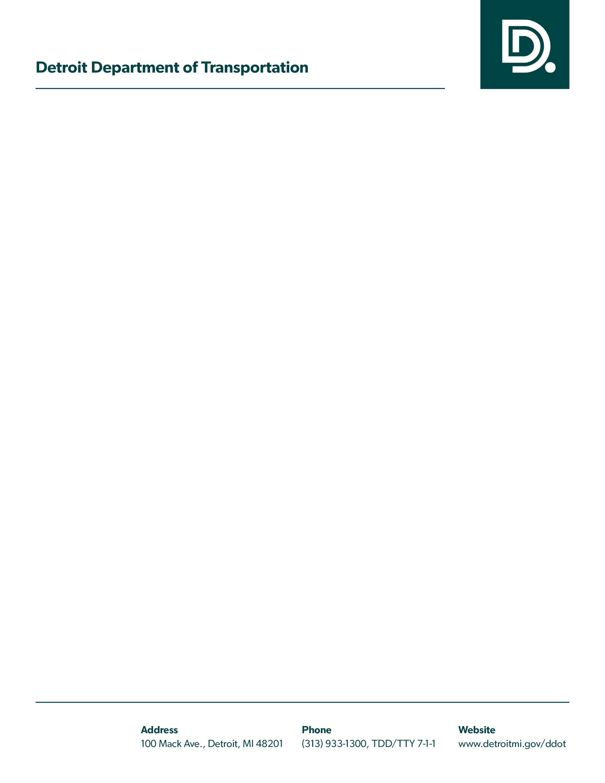
Drug and Alcohol Program Policy
Acknowledgement of Receipt

I hereby acknowledge receipt of a copy of the Detroit Department of Transportation Drug and Alcohol Program Policy with a revision date of
July 1, 2023.
I understand that I am responsible for reading this policy and I hereby agree to comply with the Drug and Alcohol Program Policy in all respects.
Please fill out, sign and return this receipt to your Drug and Alcohol Program Manager (DAPM) or Designated Employer Representative (DER).

Your signature below certifies that you, the employee, has received a copy of the policy.

Employee’s Name (Print): ________________________________________
Employee’s ID Number: _________________________________________

Position/Job Title: _____________________________________________
Signature of Employee: ________________________ Date: ____________

Revised June 1, 2023
The Office of Compliance

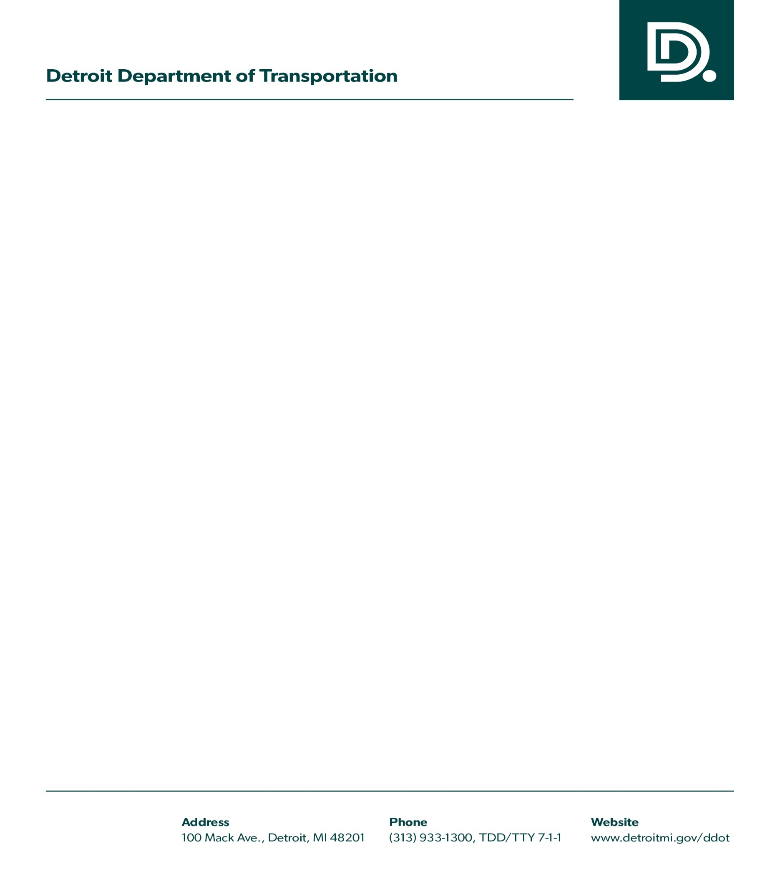

City of Detroit Department of Transportation Employee Handbook

