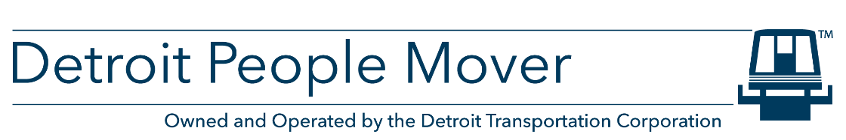
PUBLIC NOTICE
PROPOSED STATE AND FEDERAL APPLICATION
FOR OPERATING AND/OR CAPITAL ASSISTANCE
All citizens are advised that the Detroit Transportation Corporation (DTC) has prepared an application for State of Michigan financial assistance for the fiscal year 2024 as required under Act 51 of the Public Acts of 1951, as amended, and for federal assistance as required under the federal transit laws, as amended.
The DTC is requesting a total of $7,044,730 through the following funding program(s): Section 5307 ($634,854) for infrastructure and equipment upgrades; Section 5310 ($300,000) for accessibility, facility, and equipment improvements; Section 5337 ($1,709,428) for maintaining the Detroit People Mover system, equipment, and facilities in a state of good repair; and Act 51 ($4,400,448) for operating assistance.
The DTC ensures that the level and quality of transportation service is provided without regard to race, color, or national origin in accordance with Title VI of the Civil Rights Act of 1964. For more information regarding our Title VI obligations or to file a complaint, please contact the DTC at the address listed below.

Detroit Transportation Corporation
535 Griswold, Suite 400
Detroit, MI 48226
Written comments or requests regarding the application and/or written requests for a public hearing to review the application must be received by Monday, July 10, 2023. If a hearing is requested, notice of the scheduled date, time, and location will be provided at least ten (10) days in advance. Submittals should be sent via email to DTCGrants@thepeoplemover.com. This document will become final, barring any changes made in response to the written comments.

