October

2021
October 2021 Calendar

Coming up in CRIO  Stay in the know with CRIO! Follow us on social media.  Twitter: @crio_detroit  Instagram: @detroitcivilrights  Facebook: @crio_detroit | 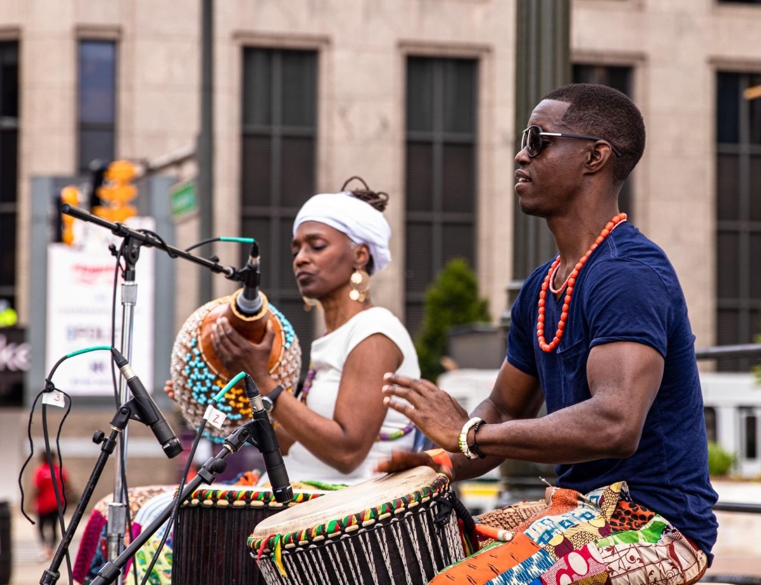

Sunday | Monday | Tuesday | Wednesday | Thursday | Friday | Saturday
 |  |  |  |  | 1 | 2
Cannabis Networking Event
3 - 6 PM
Spirit Plaza
3 | 4 | 5 | 6 | 7  Language Access Program Training  11 AM – 12 PM  EMPLOYEES ONLY  To receive link email us: | 8 | 9
10 | 11 | 12 | 13 | 14 | 15 | 16
Executive Order 2014-1 & 2 (Discrimination, Sexual Harassment, Workplace Violence)
Training
10 AM – 12 PM
EMPLOYEES ONLY
To receive link email us:
17 | 18 | 19 | 20 | 21 | 22 | 23
“All About It: Employment for the disabled”
1-3 PM
Click Here
24 | 25 | 26 | 27 | 28  Human Rights Commission Meeting  4-5 PM  Click Here | 29 | 30
31

