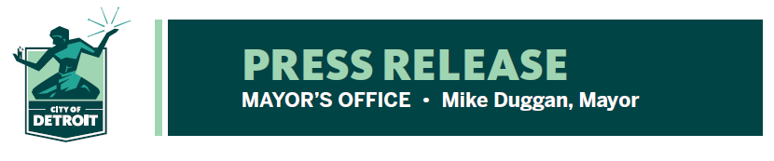

FOR RELEASE: June 4, 2021
MEDIA CONTACT: John Roach, 313-244-7857
roachj@detroitmi.gov
Barb Roethler, 313-400-7107
Barbara.roethler@detroitmi.gov

Mayor joins Nationwide Challenge to Boost Vaccination Efforts
- US Mayor’s Challenge underway for month long vaccination boost
- Month of Action begins today, runs through July 4
- Detroit to find new opportunities, partnerships to increase vaccinations
The City of Detroit is joining cities across the country for a Month of Action to get more Detroiters and more Americans vaccinated against Covid-19. Detroit Mayor Mike Duggan, along with dozens of other mayors, have signed onto the Mayor’s Challenge, a competition to see which city can ramp up its vaccination rates the most by July 4.

The effort is led by the United States Conference of Mayors in conjunction with President Joe Biden, the White House, and the U.S Department of Health and Human Services. Throughout this month-long mobilization, mayors are asked to commit to find new ways to boost their vaccination efforts. The goal is to mobilize a nationwide sprint to get as many people as possible vaccinated by the 4th of July holiday.

In addition to the multiple efforts that are currently taking place, the City of Detroit will announce a major new initiative next week in its commitment to boost vaccinations for everyone in the community.

“The City of Detroit and Detroit Health Department have led the country in innovative strategies to increase vaccination numbers, but we still need to get more of our residents vaccinated,” said Detroit Mayor Mike Duggan. “In addition to ramping up promotion of our existing vaccination locations and opportunities, we expect to announce another important strategy next week to reach even more of our residents.”

Efforts in Detroit already underway include:
- Multiple vaccination sites to remain open throughout the city, including walk-ups, drive-through, weekend and after-hour sites.
- Numerous pop-up clinics in neighborhoods, schools, churches, community centers, grocery stores, parks and more.
- Door canvassing teams will continue to go door-to-door to educate residents regarding the vaccinations and vaccination site locations. Canvassing teams are expected to have reached all Detroit homes by the end of August.
- Good Neighbor Program will remain in effect. People who bring Detroiters to vaccination appointments after scheduling in advance will receive a $50 Visa gift card.
- Detroit Health Department Mobile Unit is a self-sufficient medical unit that can go anywhere to provide vaccinations. It recently provided vaccinations on Belle Isle. It will also be scheduled at events throughout the summer including Flower Days every Tuesday at Eastern Market, Monroe Midway, Riverfront festivals, and concerts.
- Vaccine Site Locator by text message. Text address to 313-217-3732 and find three closest vaccination sites to your location.
- A Nurse Hotline, a daily Power Hour, regular Facebook lives with medical experts to ask questions about vaccines.
- Weekly Town Halls targeted for specific groups such as Barber Shops/Beauty Salons, Youth athletic groups, and the disabled community.

“We will do everything we can to continue getting Detroiters vaccinated and meeting people where they are,” said Chief Public Health Officer Denise Fair. “Now, is the time to come together as a community to save lives. This is a challenge we all want to win.”

For a complete list of vaccination site locations, log onto www.detroitmi.gov.

# # #

