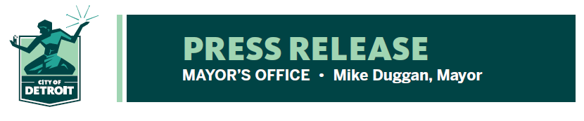

FOR RELEASE: June 23, 2021
MEDIA CONTACT: Barb Roethler: 313-400-7107
Barbara.roethler@detroitmi.gov

City of Detroit Extends Emergency Order Aimed at Reducing Transmission of COVID-19

Detroit Chief Public Health Officer extends OMA order, declares local state of emergency through July 31, 2021, in order to reduce the transmission of COVID-19

DETROIT, June 23, 2021 — In response to the public health emergency and the risk posed by a resurgence of COVID-19, Detroit's Chief Public Health Officer Denise Fair issued an emergency public health order extending the restrictions in place for Open Meetings Act until July 31, 2021. This order, issued today, is aimed at reducing transmission of COVID-19 and variants.

The order states that action is necessary to reduce transmission of COVID-19 and to protect the public’s health in Detroit, citing the following facts and findings:

- Many areas of Detroit have vaccination rates below the level required to achieve community immunity to limit spread of the virus.

- This remains a concern as the spread of COVID-19 may result in emerging and more dangerous variants, such as B.1.617.2, becoming higher proportionally through the interactions of vaccinated and unvaccinated individuals, all of whom can become infected with COVID-19.

“Multiple governmental bodies in Detroit have directly communicated the desire to have the flexibility to hold hybrid meetings, with both in-person and virtual components due to the lack of space to be able to physically distance themselves,” said Chief Public Health Officer Denise Fair. “We recognize the importance of conducting open and transparent government meetings but we need to do so in a manner that does not jeopardize the public's health and safety.”

She added the emergency order could be rescinded prior to July 31, 2021 by a subsequent order, and noted that public bodies subject to the OMA must avoid meeting in person as necessary to reduce the risk of spreading infection.

A copy of the Order can be found here.
# # #

