Denise Fair, MPH, FACHE  Chief Public Health Officer  Detroit Health Department  100 Mack Avenue, Suite 300  Detroit, Michigan 48201 | 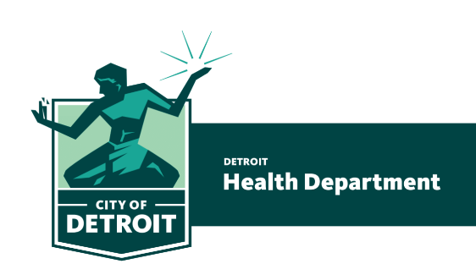 | Najibah Rehman, MD, MPH  Medical Director  Phone 313•876•4000  Fax 313•877•9244  www.detroitmi.gov/health
Detroit Health Department Recommendations for Community Response to Coronavirus
These are the recommendations of the Detroit Health Department in response to questions we have received in the last couple of days. We are deeply grateful to Dr. Marcus Zervos, the Division Head of Infectious Disease at the Henry Ford Health System and Assistant Dean of Global Affairs for Wayne State Medical School.
Schools
- School closures are not recommended at this time. If there is evidence of community spread of the Coronavirus in Detroit in the future, the recommendation may be revised when the medical evidence justifies.
- In the meantime, schools should follow the operating guidelines provide by the State Health Department (link), including restriction of assemblies, tight gatherings in cafeterias, and enhanced cleaning protocols.
- Students or faculty members who are sick should not attend school.
Churches
- Church services should be held only in compliance with State Health Department guidelines (link), including the use of hand sanitizers, restrictions on physical contact during services, and measures to provide as much space as possible around congregants. Churches should use their judgment as to whether to hold services.
- If there is evidence of community spread of the Coronavirus in Detroit in the future, the recommendation may be revised when the medical evidence justifies.
- Sick congregants should remain at home to prevent the spread of illness
Measures to minimize the spread of Coronavirus
- Primary contact:
- If you have been in direct contact with someone who has been diagnosed with COVID-19, then you should self-quarantine for 14 days from the time of the exposure. Direct contact generally means being within 6 feet of the infected person where you may have been subject to coughing, sneezing, or close contact.
- If you have been in direct contact with someone who has symptoms of COVID-19 and is being tested, then you should self-quarantine until the results of the test have been confirmed.
- Secondary contact:
- If you have not had contact with the COVID-19 patients, but someone close to you has, you are considered to have secondary contact. If your only contact has been secondary contact, it is not recommended that you self-quarantine. A person who had secondary contract should see a doctor promptly if you develop symptoms of fever, cough, or shortness of breath.
Resources
- CDC Guidance for Administrators of US Childcare Programs and K-12 Schools: https://www.cdc.gov/coronavirus/2019-ncov/community/schools-childcare/guidance-for-schools.html?CDC_AA_refVal=https%3A%2F%2Fwww.cdc.gov%2Fcoronavirus%2F2019-ncov%2Fspecific-groups%2Fguidance-for-schools.html
- CDC Guidance for Community and Faith Based Organizations: https://www.cdc.gov/coronavirus/2019-ncov/community/organizations/guidance-community-faith-organizations.html

