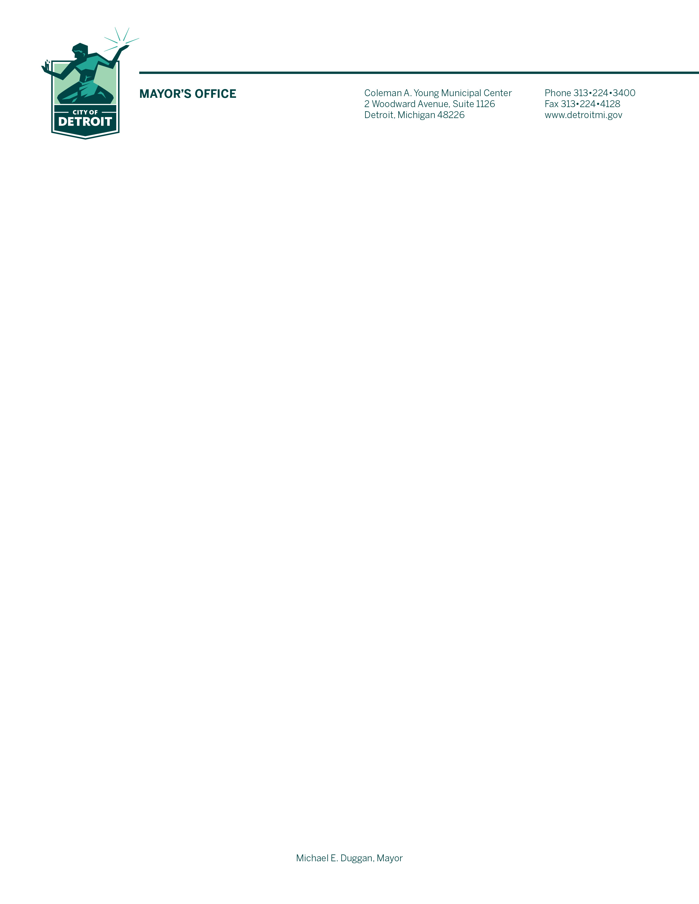

On behalf of the City of Detroit Department of Neighborhoods (DON), we extend our heartfelt appreciation for your support of our Motor City Makeover (MCM) and Halloween In the D (HITD) initiatives. Because of your generosity, we are able to make Detroit a more vibrant and beautiful city, as well as ensure that every Detroit child enjoys a fun and memorable Halloween. In an effort to further streamline our operations and enhance service delivery to Detroit residents, the DON is launching a joint MCM and HITD fundraising campaign in 2020.

Motor City Makeover, our annual citywide volunteer clean-up initiative, will take place on the Saturdays of May 2, 9, and 16. Last year, 8,996 resident, business, and corporate volunteers participated in 755 projects including the cleaning of parks and playgrounds, boarding up homes, planting gardens, and reaching thousands of households through a citywide marketing campaign.

In 2019 we celebrated our second annual Halloween In the D event, where nearly 38,000 Detroiters participated in a host of Halloween activities at Detroit fire and police stations, recreation centers, and ‘haunted’ parks. Further, more than 200,000 pieces of candy were distributed, City parks were transformed into ghostly spaces, and countless smiles were placed on children’s faces. A community dinner was also held recognizing residents who serve year-round as volunteers with their block clubs, community organizations, and area radio patrols. We are proud to continue these traditions in Detroit, and with your partnership, we can make it a reality!

Enclosed, you will find sponsorship materials. It is our hope that you are able to provide either an in-kind or financial contribution to both MCM and HITD. Your contributions are used to provide neighborhood groups with garbage bags, gloves, equipment, and other materials for MCM as well as candy and supplies for HITD.

To learn more about these initiatives and other ways to get involved, please visit  **detroitmi.gov/departments/department-neighborhoods**. If you have any questions, please contact Raymond Solomon II, General Manager of the Department of Neighborhoods, at **(313) 224-4787**, or **solomonr@detroitmi.gov**.

Thank you for your commitment to the City of Detroit and to those who call it home. We look forward to a continued, successful partnership with you.

Sincerely,



Michael E. Duggan

Mayor