Using Improve Detroit
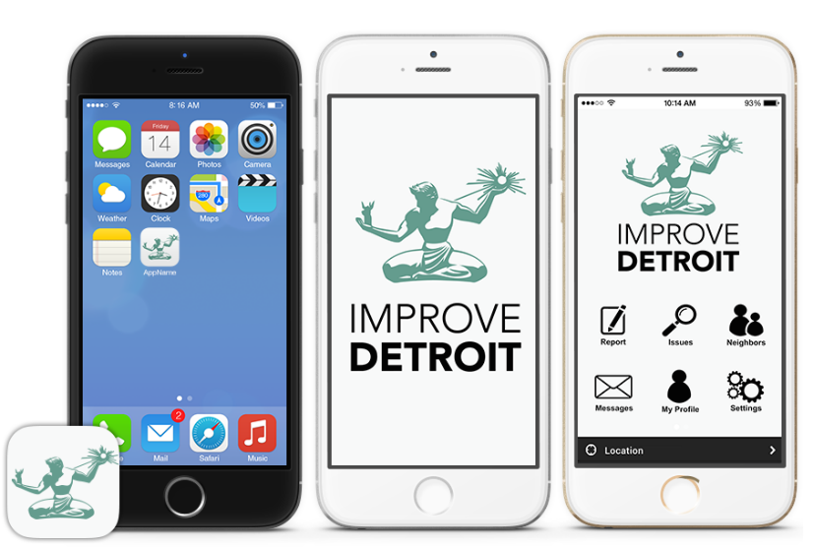

- Use the app OR follow https://detroitmi.gov/ImproveDetroit
- Select report tab
- Type in street address
- Click next!
- Choose the category of issue from the drop-down menu
- Answer all the required questions
- Answering the optional questions are helpful
- The issue title will be prefilled
- Description and image are also optional but helpful

You’re done! Thanks for making the City a better place!

Introduction to the App
Improve Detroit was created so that Detroiters could actively participate in ensuring a clean, safe, and well-run city. Detroit is huge in terms of geographic size. San Francisco, California has the same population (people living within the city) as Detroit, but is almost four times smaller in physical size. Our government, which takes care of streets, parks, and water is funded by taxes that everyone in our population pays. Because we have fewer people in such a big area of land, we do not have as many tax dollars or as much money as other cities do to monitor all of our land constantly. We need Detroiters’ support in determining where we should send our resources.

Back in 2015, Detroiters were calling city hall, not sure of where they should be reporting issues to help the city use its resources. In response, Mayor Duggan created Improve Detroit. With Improve Detroit, Detroiters can make requests about issues such as potholes or broken street lights, and city departments will take care of them.

Open the platform
The first step to using Improve Detroit is to download the app on your phone or find it on your computer. Improve Detroit can be downloaded in the Apple App or Google Play store for free. You can also access the platform online: https://detroitmi.gov/ImproveDetroit. Internet access is available at all of our city’s public libraries. Locations can be found here: https://detroitpubliclibrary.org/locations.

Use of the App
Using the App is easy.
- First, open the app. At the bottom right corner of the app, you should see a Profile button where you can build your own account. Go ahead and register in the system. Your email will be the main way the app communicates with you, so be sure to enter one that you check. Based on the intersection (joining of two streets) you enter in this section, and the app will send you updates about issues identified and fixed nearby.
- There are five main buttons at the bottom of the screen:
  - Starting on the left, the first button and screen, “Place,” has links to other important city resources - Water Bill payment, Facebook, Detroit’s bus app, Instagram, and YouTube. If you go ahead and click on the, “Photos,” button, that is the city’s Instagram (@cityofdetroit). Go ahead and follow us for important updates on our work.
  - The second button and screen are, “Notices,” or updates about the issues that you report.
  - The middle plus button is how you make a request.
  - The fourth button, “Issues,” showcases nearby issues or requests from residents, so you can see what others have submitted. Green pins represent active and non-complete requests. Blue pins are completed requests.
  - The final button is your profile screen where you can update information about yourself.
- Now, time to make a request! Hit the middle orange plus button. Challenges that we spot in the city are called “Issues” in this app. First, select a picture of the issue you are reporting. Either take one on your phone or choose one from your photo library. I would recommend taking a picture and submitting an issue as soon as you see one. If you try to report an issue later, you might forget details, like your exact location, and might forget to report the issue altogether. You can submit a request without a picture, but a picture will make the request easier to identify when a team is deployed. After you submit your picture, choose a location. Be as exact as possible. Only submits requests within the city of Detroit - nearby towns will have their own process for responding to issues. If your phone location services are turned on, the app will locate you automatically. If you are reporting the issue after you identify it, be sure to record the exact details of where the issue was located. Click “Next” at the top right of the screen. Select the category of issue. Not every issue you see will be available for a report. We will talk a bit later about how to report issues you do not see on this screen.

After you select your category, you can write a description about the issue. The app will ask you a few questions depending on which category you select. You will also choose whether you want your profile to be public on the system when you complete the request. Hit submit and you will be all set.

Immediately, you will receive an email letting you know that the request has been recorded within the system. Within about two days, you will receive another email letting you know that the request is being processed by the correct department who will eventually send out a team to fix the issue. A city department responsible for tackling the issue is now aware of the issue and has added it to their agenda. When the issue has been fixed, you will receive a final notification. If you turn on push notifications, you can also be alerted of these updates through your smartphone.

If your issue is not listed, you have another option. Every single Detroiter lives in one of the city’s districts (we have seven total districts). If you go to our city’s website: www.detroitmi.gov, you will find a section on our homepage called, “Get Info on Your Home & Neighborhood.” If you type in your address or the address of where you are located, a menu will appear with your district information. Each district has a District Manager and a Deputy District Manager. These folks work for you - they are responsible for hearing your concerns and making sure they are solved. Try Improve Detroit first, but if your issue is not listed, call or email your district team. You can also reach out to your District team if your Improve Detroit request has not been solved for some time. They should be able to figure out why. They work closely with city departments and city leadership, including the Mayor. District Managers are different than your City Councilors. City Councilors are elected by their district. City Councilors create laws and policy and approve budget. District Managers are the district’s connection to city information and services. If you or others are immediately in danger, call 911.

Appendix List of Issues

Detroit Water & Sewage
Cave-In Over the Sewer - hole nearby or around drain
Investigate Blocked Basin Alley - blocked drain in an alley
Investigate Blocked Basin Street - blocked drain in the street
Investigate Cave-In (Sink Hole) - hole over sewage system (typically goes very far down)
Investigate Fire Hydrant Related Issues - leaking, damaged, or lopsided hydrant
Investigate Manhole Cover - missing or displaced cover to hole on street/sidewalk
Investigate Missing Catch Basin Cover - missing drain cover
Investigate Restoration - unfixed damage (torn up driveway) after Water & Sewage repair work
Investigate Running Water Vacant Property - water running from vacant (unoccupied) homes
Investigate Water Main Break - flooded street due to a broken underground water pipe

City of Detroit
Abandoned Vehicle - unused car on the side of the road
Cemetery Issue - trash or damage in cemetery (graveyard)
Curbside Solid Waste Issue - trash bins, bulk waste, or yard waste left out at the wrong time
Dead Animal Removal - animal out in public
Marina Issue - issues within marinas (waterfront areas) such as parking, docks, gate access
Illegal Dump Sites - place where individuals illegally dump trash (side of the road)
Illegal Dumping in Progress - seeing individuals dumping trash
Park Issue - anything, like signs or benches, broken or destroyed in public parks
Potholes - holes in the middle of the road
Squatters Issue - individuals who are staying in homes that are not their own (many times abandoned properties)
Residential Snow Removal Issue - streets not plowed
Street Light Out - broken lights by side of road
Street Light Pole Down - broken poles that hold up lights on side of road
Traffic Complaints - general road or street issues
Traffic Sign Issue - broken stop, yield, etc sign
Traffic Signal Issue - broken stop-light
Tree Issue - fallen tree in the middle of the road or sidewalk

Community
Post to Neighbors - an announcement to just individuals that live or work near the reported issue (e.g. could be a notice about a road closure)

