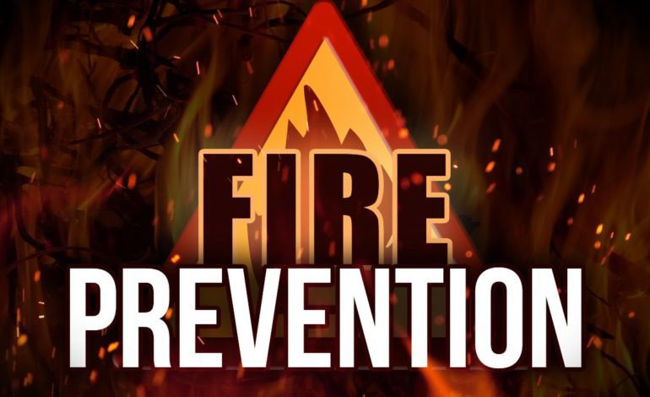

Small Business Self Inspection

Program
DETROIT FIRE MARSHAL DIVISION
Detroitmi.gov/firemarshal

To be included in program you must be a low hazard small business less than 5000 sq.ft. If an occupancy has technological fire safety devices such as cooking exhaust equipment, fire alarms, sprinkler systems, standpipe systems, or smoke control systems that would require the inspector to have special knowledge to ensure that the devices work properly, those occupancies cannot be included in the self-inspection program.

CHIEF DENNIS HUNTER | FIRE PREVENTION | 2022

Detroit Fire Marshal Division

Small Business Self Inspection Explanation Sheet

This page is provided as guidance on how to conduct a self- inspection, what to look for, and why issues are considered a violation. The sheet is divided into the same sections as the inspection checklist to make it easier for the self-inspector to understand explanations for each section on the inspection checklist. Use this sheet in conjunction with the inspection checklist while performing inspection. If problems are noted they need to be taken care of immediately. To access Self-Inspection Checklist type Detroitmi.gov/firemarshal into your search bar.
Download check list, Email Completed Checklist to: DFDFMDGeneral@detroitmi.gov

Business Section:

This section of the inspection is designed to make sure that the licensing for the business is correct and that the address numbers are posted so that fire and emergency personnel can locate your facility easier in the time of need.

Electrical Section:

This section is designed to help identify potential concerns before they become a problem, listed are a few common areas. Electrical boxes shall have proper covers. The breaker/fuses shall be labeled for easy identification in case they need to be turned off. Extension cords are not allowed to be used as permanent wiring.

Storage & Precautions Section:

This area is designed to identify storage and situations that place combustibles to close to a heat source. Identifying and correcting these areas will reduce the chances of a fire occurring from this type of situation. Buildings without sprinklers, storage shall be no closer than 24inches from the ceiling area.

Exits Section:

Exits are designed to allow occupants a safe way out of a building and maintaining all the exits and egress components will reduce the chance that someone will become trapped or lost in a building. Exits cannot be blocked or locked while a building is occupied. Internally illuminated exit signs are to be illuminated at all times.

Fire Extinguisher Section:

Fire Extinguishers for commercial buildings shall be available to help the occupant/owner to extinguish a small fire if one occurs. They need to be maintained in good working order at all times. They must be service annually by a certified fire extinguisher company. Everyone that works for your business needs to be familiar with how a fire extinguisher works.

Fire Protection Systems (Fire Suppression Systems, Fire Alarm Systems)

If fire suppression systems or fire alarm systems exist please call 313-596-2954 to schedule a fire inspection.

Small Business Self-Inspection Checklist
Detroitmi.gov/firemarshal

Fire Prevention
Email Completed Checklist to: DFDFMDGeneral@detroitmi.gov
Be Sure To Add Your Address in Email Subject Line
Business

Fire Permit Posted | Yes | No | N/A | Corrected
Business License Posted | Yes | No | N/A | Corrected
Address Posted on Building | Yes | No | N/A | Corrected

Electrical Systems

Breaker Boxes are Accessible | Yes | No | N/A | Corrected
No Extension Cords Are In Use | Yes | No | N/A | Corrected
All Junction Boxes Are closed | Yes | No | N/A | Corrected
No Electrical Cords Under Carpet | Yes | No | N/A | Corrected

Storage and General Precautions against Fire

Storage & Combustibles Areas Neat | Yes | No | N/A | Corrected
Combustible Wastes Removed Daily | Yes | No | N/A | Corrected
No Storage in Mechanical/Water Heater Rooms | Yes | No | N/A | Corrected
Candles Not Allowed in Building | Yes | No | N/A | Corrected

Exits

All Exits are Unlocked & Not Blocked | Yes | No | N/A | Corrected
Exit Doors Open Easily | Yes | No | N/A | Corrected
Exit Signs are Posted Above Doors | Yes | No | N/A | Corrected
Corridors & Exits are Illuminated | Yes | No | N/A | Corrected

Fire Extinguishers

Total Number of Fire Extinguishers | Floor 1 | Floor 2_
All Extinguishers Have a Valid Inspection Date | Yes | No | N/A | Corrected
All Extinguishers Are Hung On Walls | Yes | No | N/A | Corrected
All Employees Know How to Use Fire Extinguisher | Yes | No | N/A | Corrected

To be included in program you must be a low hazard small business less than 5000 sq.ft. If an occupancy has technological fire safety devices such as cooking exhaust equipment, fire alarms, sprinkler systems, standpipe systems, or smoke control systems that would require the inspector to have special knowledge to ensure that the devices work properly, those occupancies cannot be included in the self-inspection program.

